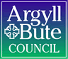

Standards and Quality Report 2024 - 2025

Small Isles Primary



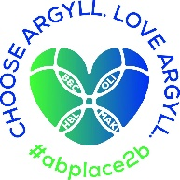


Context of the school
Small Isles Primary and ELC is a non-denominational and co-educational school situated in the village of Craighouse on the Isle of Jura. In session 2024/25, we had 18 children ranging from P2-7 (no P1 or P4 cohort) in August 2024 and 4 children in our Pre 5 unit. The Pre 5 roll decreased to 3 in January 2025.

School staffing is 2.96 FTE. This consists of a full time class teacher for P5-7 who is also the Principal (0.6 and O.4) and our P1/2 class is shared by two teachers (0.8 and 0.2) A Shared Head Teacher works 2.5 days (0.5). We also have a 0.4 Class teacher covering NCCT and P2/3. We have a 9.5hr classroom assistant for the school. A new Principal Teacher was appointed in April 2025.

In ELC, we have two full time Childcare and Education workers for Pre 5 and an ELC Classroom assistant. A new CCEW joined in November 2024. The ELC unit had a Care Inspectorate Inspection in June 2025 and we await the outcome of this.

The school is a relatively modern single storey building, situated close to the shore, with one large open plan classroom which provides teaching bases for both school pupils and those pupils who attend the Pre 5 unit. There is a small hall which functions as a meeting room, a dining room and a work space for pupils when required.
Including ELC, 47% of our children live within 2 miles of the school within the village of Craighouse. The remaining children are split between local settlements ranging between 4 and 10 miles away.

At Small Isles, we strive for our children to flourish, be caring local and global citizens, be themselves and be celebrated for who they are.

Our values are: Ambition, Respect and Compassion.

We aim to:
O Ensure our children reach their potential and be ambitious by supporting them to achieve and persevere through a Growth Mindset.
O Recognise our children’s’ achievements inside and outside of school.
O Display kindness and empathy towards all, supporting each other on our school journeys.
O Listen to each other and make sure everyone has a voice.
O Ensure that Children’s Rights are at the heart of everything we do!

Small Isles Primary is situated in the village of Craighouse on the Isle of Jura. Craighouse is the main village and is located on Jura’s sheltered east coast. Main industries on Jura are; Whisky Distilling, Farming, Fishing, estate work and Tourism. Access to the island is by ferry from Islay or rib from Tayvallich.
Being an island school within a strong local community rightly influences our place-based learning curriculum design.
In June 2025, Small Isles PS earned GOLD status in the Rights Respecting schools Award. A Rights Respecting Gold school in Scotland is a school that has achieved the highest level of the UNICEF UK Rights Respecting Schools Award (RRSA). This Gold accreditation signifies that the school has fully embedded children's rights throughout its policies, practice, and ethos, using the United Nations Convention on the Rights of the Child (UNCRC) as its foundation.

Review of SIP | Priority 1
QI approach to improving writing
Progress and Impact:
At the beginning of the year, we were unable to take part in this CYPIC Writing Programme. This was due to clash with the class teacher undertaking the Aspiring to Headship programme and training dates overlapped. It was decided that we would focus on the ‘Talk for Writing Programme’ in P5-7. This is a programme that the CT was previously trained in.
Work on this priority has led to the following outcomes as observed by the class teacher and during HT observations:
Familiarisation:
By "talking like the text," children evidenced building a strong foundation of vocabulary, sentence structures, and genre features before they even put pen to paper. This helps them meet outcomes related to using appropriate vocabulary, organizing ideas, and understanding text types.
Changing the Text:
Children built confidence and bridged the gap between imitation and independent writing. Talk for Writing let children practice adapting text structures and vocabulary to their own ideas, thus addressing outcomes related to producing their own ideas and creating varied texts.
Independent Application:
Children demonstrated their ability to write independently for a specific purpose and audience, drawing on all they have learned.
Children were able to independently writing, plan, demonstrate effective use of language, and meet the demands of different audiences and purposes.
The multi-composite P5-7 class had clear stretch aims for overall pupil progress. This was set at all (75%) of pupils to be expected to achieve or to exceed appropriate level by May 2025. 25% to be working towards.
By May 2025 all the above targets were met with one of the P5 learners making increased progress over time and a P7 learner exceeding the level.
All pupils were be able to talk about their progress and next steps both individually and as a class. This was evident in teacher observations.
Before and after measurements of pupil engagement demonstrated an increase in enjoyment of writing. This was evident through the pupil voice statements. Comments included:
This work gives me thinking time (P5).
I like the feedback I get from my teacher, especially what went well’ (P6)
I am able to write more! (P5)
I like it when my friend marks my work (P7)
It’s easy when we have the writing criteria (P6)
Through discussion with HT, teachers overwhelmingly reported enjoying teaching writing during this project including indicating a positive and engaging learning environment for pupils.

This work provided a structured and engaging pedagogical framework that effectively supports the teacher and children with their writing outcomes as outlined in Curriculum for Excellence. It supported the building a strong foundation in oral language and text understanding before guiding children towards independent, purposeful, and creative writing.

Next Steps:
Continue to embed this writing strategy and include the new P4 cohort in this work next session.
Look at involvement of parents and seek views on how we can increase parent engagement and understanding i.e. Parent workshops, display of learning, sharing practice on learning.

Review of SIP | Priority 2
Whole School Play Pedagogy (Year 2)
Progress and Impact:

This session the SIP Key actions were as follows:
The following Play policies and rationales to be created:
Practitioner Policy
Parent Friendly leaflet detailing the policy
Child friendly policy

Due to staffing and focus towards a shift towards RRSA Gold preparation, the practitioner policy was developed but not yet launched. A parent and child policy will be developed and detailed in SIP for next session.

We were also aware that the Scottish Government Play Vision Statement and Action Plan was to be launched in Spring 2025 so we adjusted our timescales to take this into account.

Our Play policy was developed in line with the Government Play Vision and shares the vision that play is
welcomed, celebrated and nurtured. That every child is able to play across all stages and aspects of their life to support their social development, resilience, language and communication development, health,
physical and mental wellbeing.

All pupil and staff views were sought to assist in development of the policy.

Pupil focus groups, led by the class teacher evidenced that the majority of pupils are able to confidently talk about the rationale behind play and how it is being implemented at school. P2/3 understood the benefits of play and what play opportunities were presented to them on a daily/weekly basis.

P5-7 demonstrated that they understood the benefits of play and that play in the upper stages may look different to lower. They demonstrated a good understanding of ‘child led/initiated learning’ and recognised this as an important aspect of play.

Play rationale/Child led learning is apparent within whole school planning for curricular areas. Quality Assurance procedures evidence this (Forward planning reviews/classroom observations)
Next Steps:
Launch the Practitioner policy with new staff in August.
Co create the following:
Parent Friendly leaflet detailing the policy
Child friendly policy

Review of SIP | Priority 3
Revisit IDL and curriculum design rationale
Progress and Impact:
All school staff, led by HT, worked through the following components of the Northern Alliance Curriculum Rationale Toolkit:
1. What is your Moral Purpose?
2. What is your Why?
3. Vision Values and Aims
4. What is meant by curriculum?
5. What is a Curriculum rationale?
6. Our Curriculum Rationale
Sessions prompted a deeper thinking of what is important in the current culture of education and views were sought to determine if our curriculum matched these needs. Staff engaged well and reflected on current practice. There was a high level of agreement on what our curriculum should prioritise. HT observations and staff views evidenced a clear and sound understanding of Curriculum Rationale in the current climate.
A parent workshop was held to gain views on what is important to parents in terms of curriculum and what makes Keills unique.
Views were collated and included common themes between staff and parents including, island rural context, outdoor learning, Rights Respecting, VVA at the heart, Early Years, skills for lifelong learning and child led learning/play pedagogy.
Before the start of this work, staff had limited knowledge of Curriculum Rationale, as result of these sessions, staff are able to talk confidently about their progress though the development of a curriculum and the benefits to learners.

Next Steps:
The final session in September 2025 will focus on designing a curriculum Rationale. Following this, the following consideration will be discussed ( Year 2 actions will be detailed in SIP)
● How will this be shared with all stakeholders across your school community?
● How is this lived in the experiences, spaces and interactions within your school or setting?
● How does everyone know it, see it, live it?
● What does this mean for your curriculum?
● What needs to be adapted, adopted or abandoned?
- How does our Curriculum Rationale fit with the new A&B Vision ‘Thriving Together’?

Review of SIP | ELC Priority
Self Evaluation and Improvement planning
Progress and Impact:
Practitioners undertook the following actions:
Joint Training sessions with HT and shared ELC held to build knowledge and understanding of the following Indicators:

How Good Is Our Early Learning and Childcare (1.3/2.2/2.3/3.1/3.2)

Care Inspectorate Quality Framework (CIQF) (1.1/1.3/2.2/3.1/4.3)

Practitioners evaluated and created action points for each indicator along with proposed dates for completion.

This was supported by QI visits from EY team and HT walk rounds focussing on the QIs.

Impact:

Evaluation is now increasingly based on concrete evidence rather than assumptions.

The new Childcare Worker's confidence in the guiding frameworks that underpin our principles has grown significantly.

A culture of continuous reflection and improvement within the ELC has been established. It has helped track progress against established goals and adapt strategies as needed.

A culture of professional learning among practitioners. By reflecting on their own practice, engaging with research, and receiving feedback, practitioners have identified areas for improvement within the ELC.

Staff now possess a significantly clearer and deeper understanding of the HGIOELC Quality Indicators and their associated themes, leading to more informed practices.

All CCEWS have developed a clearer understanding of High-Quality Practice Features and Challenge Questions, demonstrating how these tools facilitate effective self-evaluation for continuous improvement. This is clearly evidenced in Head Teacher discussions.

Improvement folders and self-evaluation floorbooks have been established to systematically track and showcase our continuous progress, offering a clear narrative of improvement over time.

All staff can confidently articulate our improvement journey, highlighting the direct impact each action has had on learners
Next Steps:
Continue to embed the ongoing process of self-evaluation linked to QIs.

1.1 Attainment Data
Attainment of Literacy Curriculum for Excellence levels 2020/21, 2021/22, 2022/23, 2023/24 and 2024-2025 (teacher judgement – confirmed levels – 5 year trend).
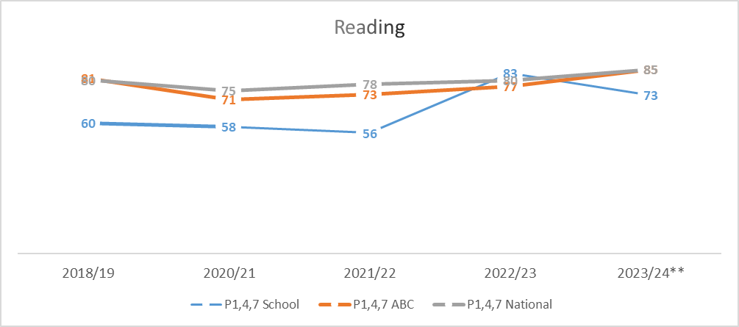
Example – Replace with school-specific data when provided
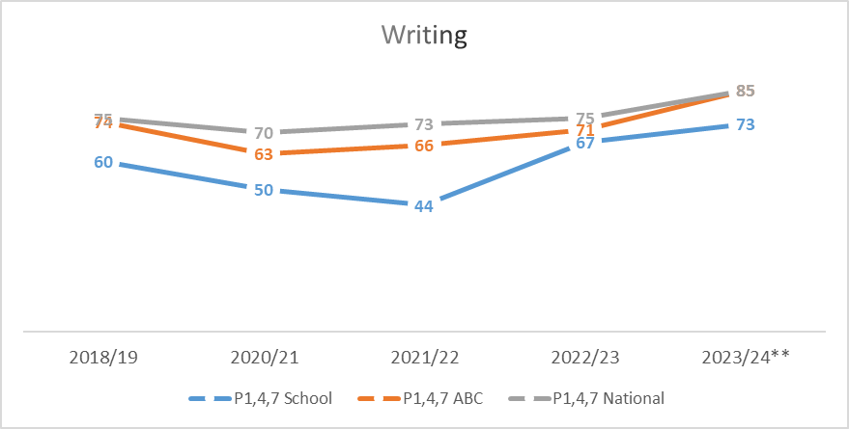
Example – Replace with school-specific data when provided
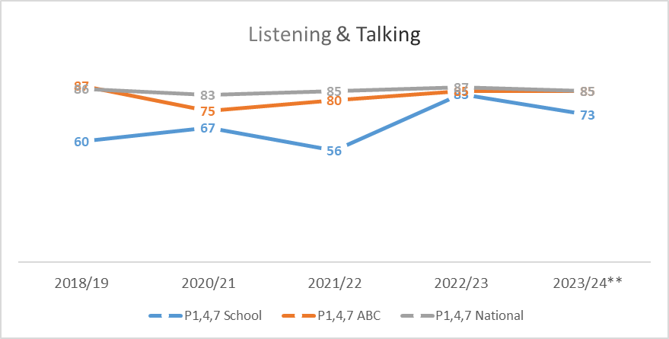
Example – Replace with school-specific data when provided

Please Note:
The above data (1.1 and 1.2) reports achievement of a level – P1/P4/P7 combined.
Due to the Covid 19 pandemic, there was no collection of ACEL data by Scottish Government in 2020.
1.2 Attainment Data
Attainment of Numeracy Curriculum for Excellence levels 2020/21, 2021/22, 2022/23, 2023/24 and 2024-2025 (teacher judgement – confirmed levels – 5 year trend).
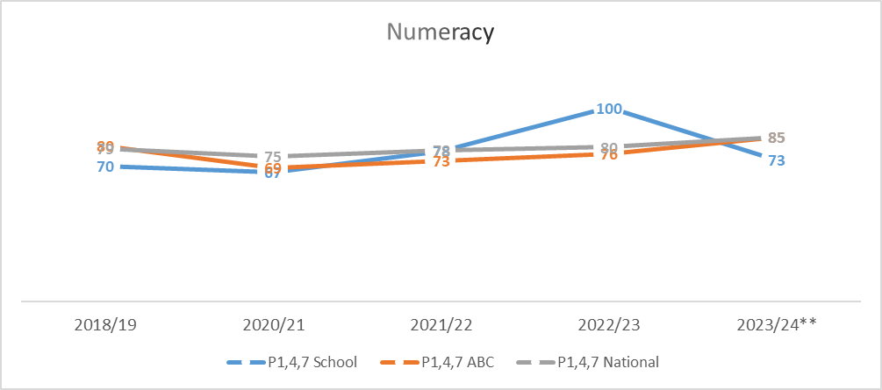
Example – Replace with school-specific data when provided

Please Note:
The above data (1.1 and 1.2) reports achievement of a level – P1/P4/P7 combined.
Due to the Covid 19 pandemic, there was no collection of ACEL data by Scottish Government in 2020.

Wider achievements
- What opportunities for wider achievement were offered?
- What systems are in place to track and monitor participation?
- How have you addressed any gaps in participation?
Wider Achievements are celebrated across the school. An Achievements wall highlights children’s achievements outside of school. These are also celebrated in weekly assemblies and on Seesaw. Children also share wider Achievements with teachers via Seesaw.
Our new Pupil Profiles also celebrate wider achievements. Children have regular opportunities to reflect on achievements, link to skills, share and celebrate these with their peers.
After school clubs aimed at all children took place this session.
P1-7 games club: 83% attendance
P2/3 Football Club 90% attendance
P5-7 Running Club: 50% attendance
Each year, all children performed the yearly Pantomime to the local community. Again this was well attended in the school and provides a platform for all our children to be part of a whole school expressive arts performance.
The school has been received funding from YMI for the past 9 years. A local music tutor, Giles Perring, delivers a block of singing and percussion lessons to P1-7. For the third year running, we continued our link with the Jura Music Festival and our whole children performed at the event for a wider audience to much acclaim.
Children continue to be involved in fundraising events over the year. This is taken on by our Pupil Council and Rights Steering groups this year we have supported Children in Need and UNICEF as well as a pupils organising a school ‘Santa Ramble’ fundraiser to purchase new loose parts play equipment.
Our children have regular opportunities to showcase their work to the community and these events are well attended by families. These opportunities lead to increased confidence and self-belief, resilience, communication skills, teamwork and collaboration, problem solving, planning and organisation. This particularly evident in our yearly ‘Endeavour’ projects.
Highlights this years also include:
Coram Shakespeare Project: Small Isles became one of the smallest schools, with some of the youngest students, to ever take part in the Coram Shakespeare School’s International Film Festival. The 25 minute version of Shakespeare’s ‘Twelfth Night’ was shot around the island in eight outdoor locations, plus onboard the local bus service, and inside two of the island’s stately homes. Small Isles Primary’s original version of Twelfth Night was submitted to the Shakespeare Schools Festival website in November, alongside films from 27 other participating schools from as near as Glasgow and as far away as China. The children got to preview the finished film just before Christmas. They also held a community premiere in the Jura Village Hall.
STEMovators: P5-7 As written by the children:
The P5-7 class at Small Isles Primary has recently been working on renewable and sustainability lessons and finished by making a STEM Climate Smarter model of a future Small Isles Primary School. On Monday 5th and Tuesday 6th May we went on a trip to Oban to present our model with our mind set on celebrating our learning.
On Monday, we travelled with children and teachers from Port Ellen Primary and Bowmore Primary. The journey to Oban was long and winding and we stopped at Kilmartin Museum, which was very interesting. We learned about the history in Kilmartin Glen. We then carried on our journey and when we arrived we went shopping around Oban, more specifically Waterstones.
On Tuesday (the morning of the event) there was a bit of nervousness in the air, but I think when we got started it all wore off. The judging itself was really easy and we did our presentations. They asked a few questions and it really just felt like a normal conversation. There was no pressure to be perfect and it was over in no time. There were many other schools from Argyll & Bute there, but at the end of the day we were presented with the ‘Climate Smarter Winner’ prize.
The Stemovator Team – Small Isles Primary, P5-7.
Beach of Dreams;
The school, led by P2/3, took part in a Climate Change project this session. This learning was a campaign to highlight plastic pollution and clean beaches. Children presented to the local community and were involved in litter picks out with school. The project culminated in a beach celebration at a weekend. Ongoing work also involves setting up litter picking stations over Jura to for a ‘legacy’. The work was part of a wider national movement titled ‘Beach of Dreams’.
Keills Primary also gained the GOLD Rights respecting award in June 2025. Comments from assessors included:
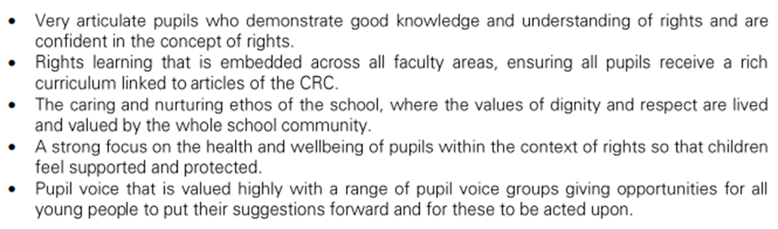

Quality Indicator | How are we doing? | How do we know? (Evidence) | School Self-Evaluation (1-6) *
1.1 Self-Evaluation for Self-improvement | All staff, parents and pupils are regularly consulted and involved in improving life and work of the school.  Regular opportunities for parent views through Google Forms and PC meetings.  Regular opportunities for pupil views through weekly assemblies and consultations.  Staff work effectively as a team. All involved in SIP.  Children involved in aspects of school improvement.  Children regularly reviewing own learning.  Staff engage in up to date research and relevant literature to inform practice.  Parents have regular opportunities to support improvement. | Collegiate Calendar developed in consultation with staff. Quality Assurance Calendar developed.  Regular staff meetings through course of the year to address SIP priorities.  Parent and pupil consultations. Results actively used in SIP planning.  All pupils in Improvement Teams. Views sought and acted upon.  Regular opportunities for joint planning within school and between cluster schools.  Pupils review work and set next steps both verbally and by recording in jotters.  Pre 5 staff engaged in reading tasks relating to Realising the Ambition document, Literacy and Numeracy tracking and assessment.  PTA support with funding resources and transport. | 4
1.3 Leadership of Change  This QI also focusses on the following aspects of empowerment:  - curriculum;  - improvement activities;  - parental and community engagement; and  - pupil participation. | All staff have high expectations of all learners.  All staff have a clear understanding of local context and use this to shape vision.  All staff clear on areas of improvement and future vision of school.  Staff are involved in leading change throughout the school.  Children are involved in leading change across the school | Regular dialogue at staff meeting regarding expectations, vision, evaluations and improvement.  Staff live locally and have established relationships with families.  Children involved in redesigning VVA. Linked to HWB curriculum and RRSA work.  Children involved in developig a new relationships policy.  Opportunities for staff to attend collegiate meeting with cluster schools eg. TLC and Moderation meetings.  Regular HT consultations with stakeholders on areas for improvement.  RRSA GOLD Status Award.  PRD meetings highlight areas for staff CLPL and opportunities to lead aspects of school improvement.  Staff attending CPD events relevant to SIP and own development needs.  Staff are given areas of SIP and are supported by HT.  PT supports CT and Pre 5 staff when HT not in school. | 5
2.3 Learning, teaching and assessment | Children are motivated and active participants in learning.  New planning formats developed to allow for high quality learning experiences.  Learning experiences are varied and use high quality resources now including digital technologies.  Learners receive high quality feedback and create own next steps.  Learners are involved in learning process.  Tracking and monitioring is now in line with XBRA and being used effectively. | Robust Quality assurance calendar created to ensure a variety of evidence (Observations, pupil conversations, jotter monitoring, peer shadowing)  HT and CT tracking meetings taking place using various evidence including assessments and teacher professional judgemements alongside benchmarks.  Pre 5 milestone and tracking meetings take place to assess progress and plan next steps.  Pre 5 Literacy and Numeracy tracking meetings.  Shared expectations across learning community and authority wide with moderation activities (TLCs and INSET Moderation session)  Learners activley involved in decision making around planning across school and including Pre 5. | 4
3.1 Ensuring wellbeing, equality and inclusion | Staff and Pupils Wellbeing placed as high priority each year.  Staff and pupils have a shared understanding of wellbeing and learners can demonstrate how to be safe, healthy, achieving, nurtured, active, respected, responsible and included.  Positive relationships across school community.  Staff model behaviour which supports wellbeing of all.  Children are active participants in discussions and decisions.  Children with additional learning needs supported with interventions.  Outdoor space used more to enhance learning experiences and wellbeing. | Rights Respecting School award: GOLD  Regular staff check in meetings.  Regular Leavens observations for children and scores tracked, interventions in place if required.  Weekly whole school and Pre 5 assemblies on Wellbeing Indicators, school values and Rights.  Staff, pupil and parent feedback on positive and supportive ethos of school.  School Improvement Teams actively involved in leading school change.  HT observations, term 1 based on learning environment.  Improvement Teams led by children  Regular involvement of children in discussions around school improvement at assemblies.  Allocated classroom assistant time given to interventions to raise attainment and support pupils.  Island partnerships established and new partnerships recently formed. | 5
3.2 Raising attainment and achievement | Attainment levels are a central feature of SIP.  Interventions/catch up plan/additional teacher put in place to support pupils not on track to achieve a level.  Children involved in decision making relating to own learning. | Literacy and Numeracy Data tracked from termly Progress and achievement tracking meetings. XBRA tracking used.  HWB information tracked over time using Leuvens Scales.  Interventions planned, monitored and evaulated termly.  Teaching judgements are made using benchmarks and range of assessments including baselines, standardised assessments and evidence from forward plan evaluations.  Planned time for pupils to be active participants in learning process. Setting Success criteria, self assesment and setting next steps all part of class practice.  Attendance levels are high. No exclusions.  Achievements regulary celebrated by CT and HT.  School and individual achievements shared with local paper, school Twitter and Seesaw. | 4

Evaluation 6-point Scale
6 Excellent
5 Very Good
4 Good
3 Satisfactory
2 Weak
- Unsatisfactory

