Gravity and Air Resistance
When you drop something it falls to the ground. This is because it is pulled by the gravity of the Earth. You’ll notice that some things drop faster than others, this is because of air resistance.
The pupils can try dropping a piece of paper and a lego brick, and a variety of other things in the classroom they would like to test. Which drops the fastest?

This experiment involves dropping an egg on its own, dropping an egg attached to a parachute and an egg in a basket under a balloon parachute

What you need
- Bin bag
- 4 pieces of string
- sellotape
- 3 eggs (boiled)

Instructions
- Lay a bin bag out flat and cut out a big square (pupils can extend this to investigate using different materials rather than just bin bags to see if that makes a difference, and investigating using different sizes of bin bag/ other material)
- Make a hole in each corner, thread a piece of string though it and tie a knot.
- Tie all 4 pieces of string together and sellotape the egg to the bottom

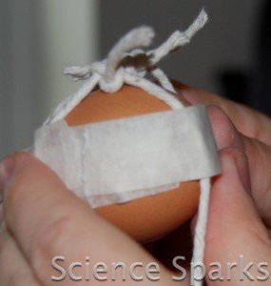
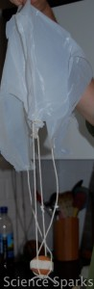

Balloon and basket
What you need
- Cardboard made into a basket shape
- Balloon blown up
- 4 pieces of String
Instructions
- Sellotape some string to your balloon
- and attach the basket.
- Place the egg in the basket
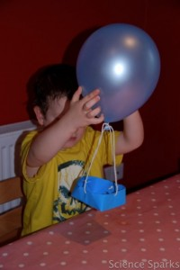
Drop an egg on its own, the egg in the basket and the egg in the parachute (ideally from a height if possible – the teacher dropping these from the desk will work)

< http://www.youtube.comor enable JavaScript if it is disabled in yser.</div></div>
The Science bit
If you tried dropping paper and a lego brick or similar, the paper should have dropped to the floor more slowly than the brick, this is because the paper has a larger surface area, so has to push against more air as it drops, which means the air resistance is greater and it drops more slowly.
An egg dropped without anything to slow it down will fall fast and break, the parachute and balloon add air resistance slowing the fall, and stopping the egg from breaking.
The parachute falls much more slowly than the balloon, again this is because the parachute has a larger surface area than the balloon, slowing down the fall.
If we dropped a hammer and a feather we would expect the hammer to fall fastest, however if we did this on the moon where there is no air resistance they would hit the ground at the same time (you can demo this with a pencil v’s a full pencil case – drop at the same time – the children usually predict the heavy pencil case will fall first but they land at the same time)

More ideas
Record the time taken for all three to drop and see how much slower the parachute is.
Try different sizes of parachute and see which drops more slowly.

Tweet

