Make a Balloon Rocket

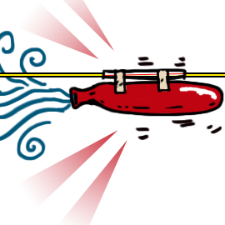
You will need
- Assorted balloons (round ones will work, but the longer “airship” balloons work best)
- Long piece of string (about 10-15 feet long)
- Plastic straws and Masking tape

What to do
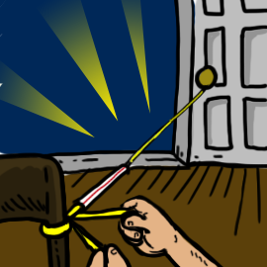
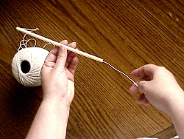
1. Tie one end of the string to a chair, door knob, or washing line if outdoors.

2. Put the other end of the string through the straw and pull it tight before tying it to another support.

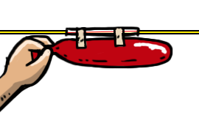
3. Blow up the balloon (but don’t tie it.) Pinch the end of the balloon and tape the balloon to the straw as shown above. You’re ready for launch.
- Let go and watch the rocket fly!
Try to answer these questions:
- Does the shape of the balloon affect how far or fast it travels?

- Does the length of the straw affect how far or fast it travels?

- Does the type of string affect how far or fast it travels? (try fishing line, nylon string, cotton string, wool).

- Does the angle of the string affect how far (or fast) the rocket travels?

How does it work?
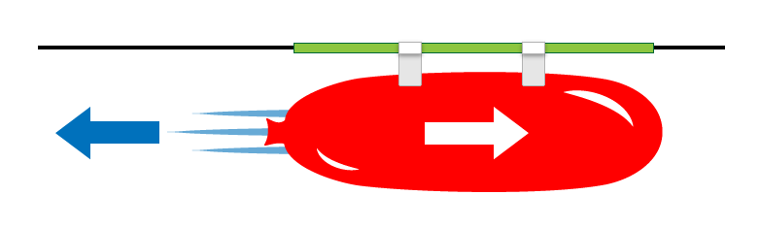
It’s all about the air…and thrust. As the air rushes out of the balloon, it creates a forward motion called THRUST.
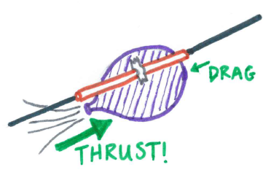
Thrust is a pushing force created by energy. In the balloon experiment, our thrust comes from the energy of the balloon forcing the air out. Different sizes and shapes of balloon will create more or less thrust.
DRAG is a set of factors which slow the balloon down such as the shape of balloon or the smoothness of the string. Fishing line is very smooth so has less drag and the balloon should travel faster than wool!
In a real rocket, thrust is created by the force of burning rocket fuel as it blasts from the rockets engine – as the engines blast down, the rocket goes up!
Science Bob

More Images & Vi
Download the PDF

