Make a Paperclip Float
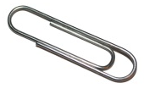 | 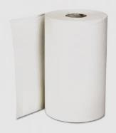 | 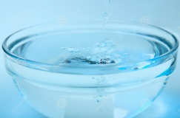 | 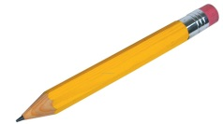
clean dry paper clips | Kitchen roll | a bowl of water | pencil with rubber
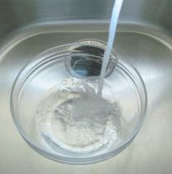
What to do
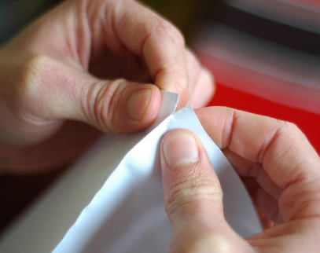
1. Fill the bowl with water and try to make the paper clip float?

2. Tear a piece of kitchen role into quarters.
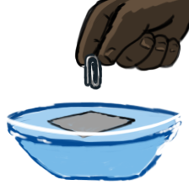
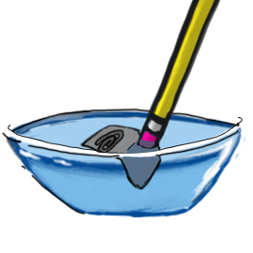
3. Put the piece of kitchen paper onto the surface of the water and gently place a paper clip on top of it.

5. Use the rubber end of the pencil to carefully poke the piece of kitchen roll until it sinks.
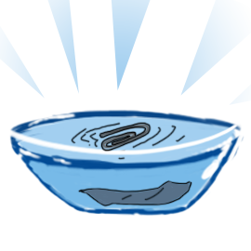
6. With some luck, the tissue will sink and leave the paper clip floating!

How does it work?
How is this possible? With a little thing we scientists call surface tension.
Basically it means that there is a sort of skin on the surface of water where the water molecules hold on tight together. If the conditions are right, they can hold tight enough to support your paper clip.
The paperclip is not truly floating, it is being held up by the surface tension. Many insects, such as water striders, use this “skin” to walk across the surface of a stream.

To make it a true experiment, you can try to answer these questions:
1. How many paperclips can the surface tension hold?
2. Does the shape of the paperclip affect its floating ability?
3. What liquids have the strongest surface tension?
4. Can the surface tension of water be made stronger? (try sprinkling talcum powder on the surface)
Science Bob

