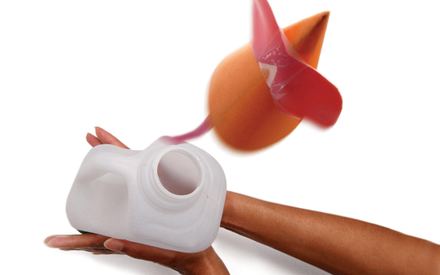
Rocket Mice
Make and propel a ‘rocket mouse’ using forces and the power of air.

You will need

1 mouse template

1 plastic milk bottle (2 litre or 3 litre bottles work best)

Selotape and safety scissors

Tape measure

What to do

1. Print the Rocket Mouse Templates on different thickness paper and card.

2. Use safety scissors to cut out the Rocket Mouse Templates.
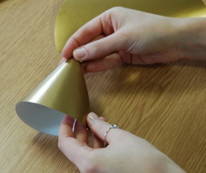

3. Shape each template into a cone so they fit snugly over the milk bottle and use selotape to hold it together.
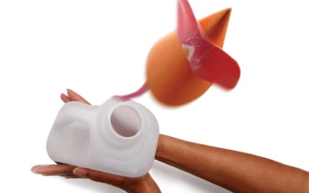

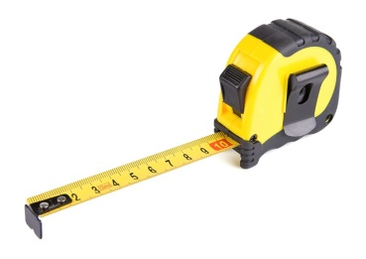
4. Lean back and squeeze the milk bottle to launch the rocket mouse.

5. Use the tape measure to measure how far each rocket mouse travels.
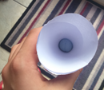
6. Add blue tack to the inside of the mouse’s nose cone and launch each rocket mouse again.
7. Measure how far each rocket mouse travels with blue tack inside the mouse cone.

How Does it Work
What is making the mouse move? Which direction are you applying a force? Which direction is the mouse travelling? What difference do the size of the bottle and the force of the push make? Can you think of any other ways to make the mouse move?
This activity can help pupils to understand that:
- Air can move objects.
- Squeezing air through a small opening gives enough force to move objects.

Extensions
- Can you direct the mouse to hit a target?
- What can you do to make the mouse travel further or faster?
- What is the heaviest mouse you can launch?

Links to everyday life
A pneumatic drill uses compressed air to move the drill bit into the concrete or rock that it needs to break. Not only is the force strong enough to break very hard materials, but also the air explodes producing noise up to 100 decibels and vibrations that can cause a condition known as ‘white finger’. Air bags are used to raise delicate artefacts from shipwrecks, e.g. the Titanic. The pressure of the air inside is powerful enough to lift the huge weight of objects, or even pieces of the ship, through the water pressing down on them.

