These holistic assessment tasks have been created specifically for training purposes and are deliberately of varying quality.
Reflect on the key features of a holistic assessment task and discuss with colleagues which of these you feel are high quality examples, which clearly do not meet the standard of a good quality holistic assessment and those which ‘could be improved’. Traffic light these accordingly, recording reasons for each response, and make suggestions for improvements for those you have labelled as ‘amber’.

Experiences and Outcomes |  | Holistic Assessment Task
Reading  Writing | I enjoy exploring and playing with the patterns and sounds of language and can use what I learn.  LIT 0-01a / LIT 0-11a / LIT 0-20a  I explore sounds, letters and words, discovering how they work together, and I can use what I learn to help me as I read and write.  ENG 0-12a / LIT 0-13a / LIT 0-21a  To help me understand stories and other texts, I ask questions and link what I am learning with what I already know.  LIT 0-07a / LIT 0-16a / ENG 0-17a  I explore sounds, letters and words, discovering how they work together, and I can use what I learn to help me  as I read or write.  ENG 0-12a / LIT 0-13a / LIT 0-21a  Within real and imaginary situations, I share experiences and feelings, ideas and information in a way that communicates my message.  LIT 0-26a | 1.) Read the sentence aloud and draw what you have read:  ‘The ball is red with blue spots.’  Design your own ball and write a sentence about it.  Can you read your partner’s sentence?  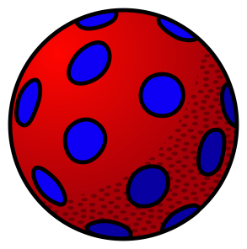

These holistic assessment tasks have been created specifically for training purposes and are deliberately of varying quality.
Reflect on the key features of a holistic assessment task and discuss with colleagues which of these you feel are high quality examples, which clearly do not meet the standard of a good quality holistic assessment and those which ‘could be improved’. Traffic light these accordingly, recording reasons for each response, and make suggestions for improvements for those you have labelled as ‘amber’.

Experiences and Outcomes |  | Holistic Assessment Task
Reading  Listening and Talking | I enjoy exploring and playing with the patterns and sounds of language and can use what I learn.  LIT 0-01a / LIT 0-11a / LIT 0-20a  I enjoy exploring and choosing stories and other texts to watch, read or listen to, and can share my likes and dislikes.  LIT 0-01b / LIT 0-11b  I enjoy exploring events and characters in stories and other texts, sharing my thoughts in different ways.  LIT 0-19a  I enjoy exploring and  choosing stories and other texts to watch, read or listen to, and can share my likes  and dislikes.  LIT 0-01b / LIT 0-11b  I enjoy exploring events and characters in stories and other texts, sharing my thoughts  in different ways.  LIT 0-01c  As I listen and talk in different situations, I am learning to take turns and am developing my awareness of when to talk and when to listen.  LIT 0-02a / ENG 0-03a | 2.) Favourite Fairytales:  Now that we have come to the end of our topic about Fairytales work with your talk partner to select your favourite from:  1.) The Three Little Pigs  2.) Goldilocks  3.) Little Red Riding Hood  Share with the class why you have chosen that fairytale.  Use the picture cards to put the story into the correct sequence of events. Practice re-telling the story together and record it using your talking tins.  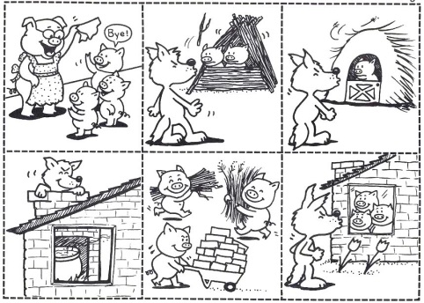
These holistic assessment tasks have been created specifically for training purposes and are deliberately of varying quality.
Reflect on the key features of a holistic assessment task and discuss with colleagues which of these you feel are high quality examples, which clearly do not meet the standard of a good quality holistic assessment and those which ‘could be improved’. Traffic light these accordingly, recording reasons for each response, and make suggestions for improvements for those you have labelled as ‘amber’.

Experiences and Outcomes |  | Holistic Assessment Task
Reading  Writing | I explore sounds, letters and words, discovering how they work together, and I can use what I learn to help me as I read and write.  ENG 0-12a / LIT 0-13a / LIT 0-21a  I use signs, books or other texts to find useful or interesting information and  I use this to plan, make choices or learn new things.  LIT 0-14a  Within real and imaginary situations, I share experiences and feelings, ideas and information in a way that communicates my message.  LIT 0-26a  I enjoy exploring events  and characters in stories  and other texts and I use what I learn to invent my  own, sharing these with others in imaginative ways.  LIT 0-09b / LIT 0-31a | 3.) ‘Sign hunt’  Walk round the school, inside and outside looking for as many signs as you can.  Can you read the signs?  What do the signs tell you?  Are there any signs missing?  Work with your group to create some more signs for your classroom and areas of the school.  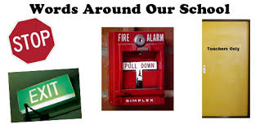
These holistic assessment tasks have been created specifically for training purposes and are deliberately of varying quality.
Reflect on the key features of a holistic assessment task and discuss with colleagues which of these you feel are high quality examples, which clearly do not meet the standard of a good quality holistic assessment and those which ‘could be improved’. Traffic light these accordingly, recording reasons for each response, and make suggestions for improvements for those you have labelled as ‘amber’.

Experiences and Outcomes |  | Holistic Assessment Task
Reading  Writing | I enjoy exploring and choosing stories and other texts to watch, read or listen to, and can share my likes and dislikes.  LIT 0-01b / LIT 0-11b  I explore sounds, letters and words, discovering how they work together, and I can use what I learn to help me as I read and write.  ENG 0-12a / LIT 0-13a / LIT 0-21a  I use signs, books or other texts to find useful or interesting information and  I use this to plan, make choices or learn new things.  LIT 0-14a  As I play and learn, I enjoy exploring interesting materials for writing and different ways of recording my experiences and feelings, ideas and information.  LIT 0-21b  Within real and imaginary situations, I share experiences and feelings, ideas and information in a way that communicates my message.  LIT 0-26a | 4.) Nocturnal Animals  We have been learning about nocturnal animals. Working with your partner, look at the 3 texts about different nocturnal animals. Choose one of the animals and find 3 facts about the animal, looking at the pictures and words in the books.  Cut out a picture of the animal you have chosen and write a fact in each bubble around it.  Create a question about your animal.  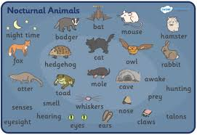
These holistic assessment tasks have been created specifically for training purposes and are deliberately of varying quality.
Reflect on the key features of a holistic assessment task and discuss with colleagues which of these you feel are high quality examples, which clearly do not meet the standard of a good quality holistic assessment and those which ‘could be improved’. Traffic light these accordingly, recording reasons for each response, and make suggestions for improvements for those you have labelled as ‘amber’.

Experiences and Outcomes |  | Holistic Assessment Task
Reading  Writing | I explore sounds, letters and words, discovering how they work together, and I can use what I learn to help me as I read and write.  ENG 0-12a / LIT 0-13a / LIT 0-21a  To help me understand stories and other texts, I ask questions and link what I am learning with what I already know.  LIT 0-07a / LIT 0-16a / ENG 0-17a  I explore sounds, letters and words, discovering how they work together, and I can use what I learn to help me  as I read or write.  ENG 0-12a / LIT 0-13a / LIT 0-21a | 5.) A New Classroom  Read the story aloud with your partner.  Read the sentences and fill in the missing gaps using the words at the bottom of each sentence.  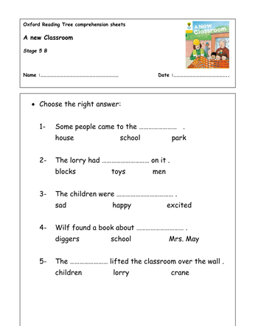

These holistic assessment tasks have been created specifically for training purposes and are deliberately of varying quality.
Reflect on the key features of a holistic assessment task and discuss with colleagues which of these you feel are high quality examples, which clearly do not meet the standard of a good quality holistic assessment and those which ‘could be improved’. Traffic light these accordingly, recording reasons for each response, and make suggestions for improvements for those you have labelled as ‘amber’.

Experiences and Outcomes |  | Holistic Assessment Task
Reading  Listening and Talking | I enjoy exploring and choosing stories and other texts to watch, read or listen to, and can share my likes and dislikes.  LIT 0-01b / LIT 0-11b  I explore sounds, letters and words, discovering how they work together, and I can use what I learn to help me as I read and write.  ENG 0-12a / LIT 0-13a / LIT 0-21a  To help me understand stories and other texts, I ask questions and link what I am learning with what I already know.  LIT 0-07a / LIT 0-16a / ENG 0-17a  I enjoy exploring events and characters in stories and other texts, sharing my thoughts in different ways.  LIT 0-19a  I enjoy exploring and  choosing stories and other texts to watch, read or listen to, and can share my likes  and dislikes.  LIT 0-01b / LIT 0-11b  To help me understand stories and other texts, I ask questions and link what I am learning with what I already know.  LIT 0-07a / LIT 0-16a / ENG 0-17a | 6.) The Very Hungry Caterpillar  Read the story again together as a group.  Work with your group to make finger puppets for the caterpillar and the food he ate each day. Practice retelling the story. Create some questions for your audience to answer about the story.  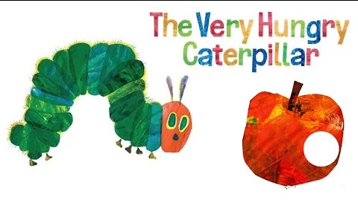  Can you tell everyone your favourite part of the story?

These holistic assessment tasks have been created specifically for training purposes and are deliberately of varying quality.
Reflect on the key features of a holistic assessment task and discuss with colleagues which of these you feel are high quality examples, which clearly do not meet the standard of a good quality holistic assessment and those which ‘could be improved’. Traffic light these accordingly, recording reasons for each response, and make suggestions for improvements for those you have labelled as ‘amber’.

Experiences and Outcomes |  | Holistic Assessment Task
Reading  Listening and Talking | I explore sounds, letters and words, discovering how they work together, and I can use what I learn to help me as I read and write.  ENG 0-12a / LIT 0-13a / LIT 0-21a  I enjoy exploring and choosing stories and other texts to watch, read or listen to, and can share my likes and dislikes.  LIT 0-01b / LIT 0-11b  I use signs, books or other texts to find useful or interesting information and I use this to plan, make choices or learn new things. LIT 0-14a ENG 0-17a  I enjoy exploring events and characters in stories and other texts, sharing my thoughts in different ways.  LIT 0-19a  I enjoy exploring and  choosing stories and other texts to watch, read or listen to, and can share my likes  and dislikes.  LIT 0-01b / LIT 0-11b  I enjoy exploring events and characters in stories and other texts, sharing my thoughts  in different ways.  LIT 0-01c | 7.) Favourite Character  Choose one of the characters from your reading book. Tell your reading group about what you like and dislike about the character and why.

These holistic assessment tasks have been created specifically for training purposes and are deliberately of varying quality.
Reflect on the key features of a holistic assessment task and discuss with colleagues which of these you feel are high quality examples, which clearly do not meet the standard of a good quality holistic assessment and those which ‘could be improved’. Traffic light these accordingly, recording reasons for each response, and make suggestions for improvements for those you have labelled as ‘amber’.

Experiences and Outcomes |  | Holistic Assessment Task
Reading  Listening and Talking | I enjoy exploring and choosing stories and other texts to watch, read or listen to, and can share my likes and dislikes.  LIT 0-01b / LIT 0-11b  I explore sounds, letters and words, discovering how they work together, and I can use what I learn to help me as I read and write.  ENG 0-12a / LIT 0-13a / LIT 0-21a  I use signs, books or other texts to find useful or interesting information and  I use this to plan, make choices or learn new things.  LIT 0-14a  I enjoy exploring events and characters in stories and other texts, sharing my thoughts in different ways.  LIT 0-19a  I enjoy exploring and  choosing stories and other texts to watch, read or listen to, and can share my likes  and dislikes.  LIT 0-01b / LIT 0-11b | 8.) Class Library  We have been given a box of books, fiction and non-fiction to choose from for our class library. Each table has been given 10 books to look at, and each pair must select one to keep for the class library.  Talk to your partner about the books on your table and select one you would like to keep for our class library.  Tell the class:  1.) What you liked about the book (front cover, pictures, blurb)  2.) Whether your book is a fiction or non-fiction book  3.) What you think the book will be about (storyline or information) based on the front cover, pictures and blurb  4.) Read a page from the book together (or more if you can)  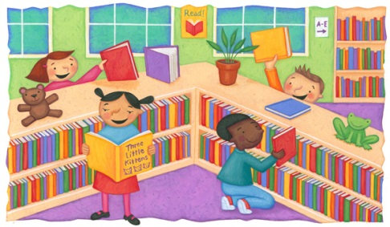
These holistic assessment tasks have been created specifically for training purposes and are deliberately of varying quality.
Reflect on the key features of a holistic assessment task and discuss with colleagues which of these you feel are high quality examples, which clearly do not meet the standard of a good quality holistic assessment and those which ‘could be improved’. Traffic light these accordingly, recording reasons for each response, and make suggestions for improvements for those you have labelled as ‘amber’.

Experiences and Outcomes |  | Holistic Assessment Task
Reading  Listening and Talking | I enjoy exploring and playing with the patterns and sounds of language and can use what I learn.  LIT 0-01a / LIT 0-11a / LIT 0-20a  I explore sounds, letters and words, discovering how they work together, and I can use what I learn to help me as I read and write.  ENG 0-12a / LIT 0-13a / LIT 0-21a  I enjoy exploring and playing with the patterns and sounds of language, and can use what I learn.  LIT 0-01a / LIT 0-11a / LIT 0-20a | 9.) Gruffalo Rhyme Hunt  Previous learning – the class know the story of the Gruffalo well and have shared it together several times.  You and your partner have been given two words from the story. Can you find the rhyming word to go with the two words you have? The rhyming words are hidden in different places around the room.  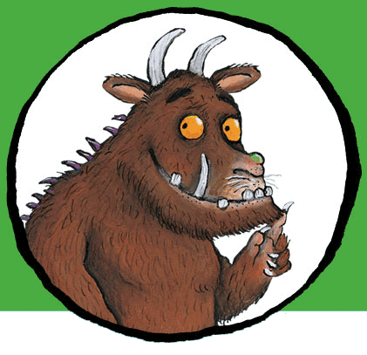
These holistic assessment tasks have been created specifically for training purposes and are deliberately of varying quality.
Reflect on the key features of a holistic assessment task and discuss with colleagues which of these you feel are high quality examples, which clearly do not meet the standard of a good quality holistic assessment and those which ‘could be improved’. Traffic light these accordingly, recording reasons for each response, and make suggestions for improvements for those you have labelled as ‘amber’.

Experiences and Outcomes |  | Holistic Assessment Task
Reading  Writing | I explore sounds, letters and words, discovering how they work together, and I can use what I learn to help me as I read and write.  ENG 0-12a / LIT 0-13a / LIT 0-21a  I use signs, books or other texts to find useful or interesting information and  I use this to plan, make choices or learn new things.  LIT 0-14a  To help me understand stories and other texts, I ask questions and link what I am learning with what I already know.  LIT 0-07a / LIT 0-16a / ENG 0-17a  Within real and imaginary situations, I share experiences and feelings, ideas and information in a way that communicates my message.  LIT 0-26a  I enjoy exploring events  and characters in stories  and other texts and I use what I learn to invent my  own, sharing these with others in imaginative ways.  LIT 0-09b / LIT 0-31a | 10.) Summer  Previous learning – the class have been learning about the different seasons.  Look at the poem and the non-fiction book about summer. Create a mind map with the word ‘summer’ in the middle. Draw or write 4 pieces of information you have found from the poem and book.  What do you like most about summer?  (Talk to your partner)  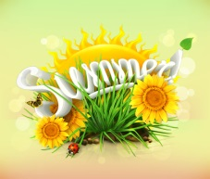
These holistic assessment tasks have been created specifically for training purposes and are deliberately of varying quality.
Reflect on the key features of a holistic assessment task and discuss with colleagues which of these you feel are high quality examples, which clearly do not meet the standard of a good quality holistic assessment and those which ‘could be improved’. Traffic light these accordingly, recording reasons for each response, and make suggestions for improvements for those you have labelled as ‘amber’.

Experiences and Outcomes |  | Holistic Assessment Task
Reading  Listening and Talking | I enjoy exploring and playing with the patterns and sounds of language and can use what I learn.  LIT 0-01a / LIT 0-11a / LIT 0-20a  I enjoy exploring and choosing stories and other texts to watch, read or listen to, and can share my likes and dislikes.  LIT 0-01b / LIT 0-11b  I explore sounds, letters and words, discovering how they work together, and I can use what I learn to help me as I read and write.  ENG 0-12a / LIT 0-13a / LIT 0-21a  I use signs, books or other texts to find useful or interesting information and  I use this to plan, make choices or learn new things. LIT 0-14a  I enjoy exploring events and characters in stories and other texts, sharing my thoughts in different ways. LIT 0-19a  I enjoy exploring and  choosing stories and other texts to watch, read or listen to, and can share my likes  and dislikes. LIT 0-01b / LIT 0-11b  I enjoy exploring events and characters in stories and other texts, sharing my thoughts  in different ways. LIT 0-01c | 11.) My favourite book  Bring in a favourite book from home or choose one from our class library.  Share your favourite book with the class during your show and tell time. Can you tell the class:  - The title and author  - What the book is about (storyline or information)  - Characters in the book (if fiction)  - Why you like the book  Read your favourite page or section from the book. Answer any questions the class have about your book.

These holistic assessment tasks have been created specifically for training purposes and are deliberately of varying quality.
Reflect on the key features of a holistic assessment task and discuss with colleagues which of these you feel are high quality examples, which clearly do not meet the standard of a good quality holistic assessment and those which ‘could be improved’. Traffic light these accordingly, recording reasons for each response, and make suggestions for improvements for those you have labelled as ‘amber’.

Experiences and Outcomes |  | Holistic Assessment Task
Reading  Writing | I explore sounds, letters and words, discovering how they work together, and I can use what I learn to help me as I read and write.  ENG 0-12a / LIT 0-13a / LIT 0-21a  I use signs, books or other texts to find useful or interesting information and  I use this to plan, make choices or learn new things.  LIT 0-14a  I enjoy exploring events and characters in stories and other texts, sharing my thoughts in different ways.  LIT 0-19a  As I play and learn, I enjoy exploring interesting materials for writing and different ways of recording my experiences and feelings, ideas and information.  LIT 0-21b  Within real and imaginary situations, I share experiences and feelings, ideas and information in a way that communicates my message.  LIT 0-26a | 12.) Jack and the Beanstalk – character descriptions  Look at your copy of the story and choose some words to describe Jack and the Giant from the story.  Challenge – can you add some of your own words?  