Assessment and Moderation in the BGE

National Context

The National Improvement Framework for Scottish Education sets out the vision and priorities for continually improving Scottish education and closing the attainment gap, delivering both excellence and equity.

One of the 6 key drivers within the National Improvement Framework is the assessment of children’s progress. This focuses on a range of evidence, demonstrating what children learn and achieve throughout their school career. This includes Curriculum for Excellence levels, skills, qualifications and other awards.

The Framework sets out plans to collect teacher judgement data on achievement of CfE levels in literacy and numeracy. When this data is consistent and well moderated, we will be able to focus more accurately on the difference in attainment between the most and least disadvantaged children and take further action as a result. This data will be informed by a range of evidence, including standardised assessment, holistic assessment, summative and formative strategies and ongoing classwork. This data will help teachers to identify areas where good practice exists and which high-impact interventions should be shared. It will also help us to identify areas where, collectively, we need to do more. There is a need to use robust and consistent evidence to help us in raising attainment and closing the gap.

By encouraging all teachers to take part in regular moderation activities, from the planning stages throughout, we are encouraging them to develop as enquiring professionals who are experts in teaching literacy, numeracy and health and well-being. This is critical to ensure the strongest possible progression in learning for all children.

John Hattie (2009) argues that the greatest single issue facing the further enhancement of students is the need for teachers to have a common perception of progress. When a learner moves from one teacher to another, we must be able to guarantee that he or she will experience increasingly challenging tasks and similar expectations of progress. Teachers must have the knowledge and skills to grow learners from where he or she is, as opposed to where they believe they should be at the start of the year. Moderation activities across and between schools is therefore essential, particularly at times of transition.



Local Priorities

In Argyll and Bute, our vision is clearly stated in *Our Children, Their Future:* **together we will realise ambition, excellence and equality for all.**

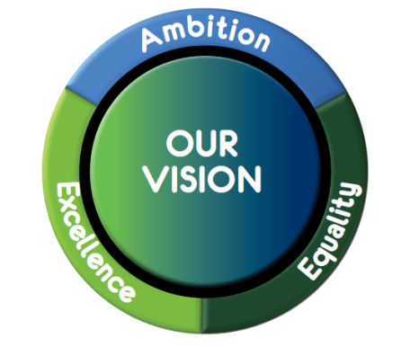

Schools with effective planning, assessment and moderation cycles in place have reported a number of key benefits that link directly to this vision and the 6 key objectives outlined in *Our Children, their Future,* including:

* Raised levels of attainment as practitioners build a better understanding of progression throughout the school, ensuring levels of pace and challenge remain high and avoiding dips in progress.
* Improved quality of learning experiences as learners better understand their learning and therefore become more motivated and engaged.
* Practitioners work together more effectively, building capacity and confidence in themselves and each other, particularly when making professional judgements.
* More effective assessment, tracking and monitoring systems are put in place to allow the monitoring of progress of all learners.
* Improved partnership working between early years’ practitioners and teachers, leading to more depth of understanding around planning for CfE and the developmental milestones in the early years.
* Development of leadership skills in staff as Head Teachers and Department Leaders are able to rely on the growing expertise of teachers, facilitated by Assessment and Moderation facilitators.
* Improved partnership working as schools have developed innovative ways of involving the wider community in moderation projects e.g. talking to business leaders about the skills that they are looking for in our young people and developing progression frameworks for these.

As an authority, we have set our Service Plan targets to be achieved within the 2017-2018 session and these include:

* 100% of establishments engaging in moderation activity in line with national advice and led by assigned, trained, Assessment and Moderation Facilitators (AMFs).
* Delivering two local authority quality assurance moderation events in order to validate teacher professional judgement across settings.
* As a result of effective support in moderating standards, children and young people are attaining in line with or above the national expectations in literacy and numeracy.

More information relating to the national and local picture regarding Assessment and Moderation can be found in **Appendix A - Assessment and Moderation - Setting the Context (PPT).** This can be used for training purposes, led by AMFs.

The Planning, Assessment and Moderation (PAM) Cycle – Developing a Consistent Approach

For a number of years now, practitioners across Argyll and Bute have been encouraged to use the NAR model for planning, assessment and moderation in order to ensure learning experiences are in line with the Experiences and Outcomes set out in CfE and meet the needs of every child. Through the use of this process, a firm foundation is in place to improve quality professional dialogue on teaching and learning.

However, as education can be a fast developing landscape, some of the key features of the NAR flowchart have become outdated and we have therefore devised an Argyll and Bute Planning, Assessment and Moderation Cycle that lies at the heart of our Assessment and Moderation strategy:

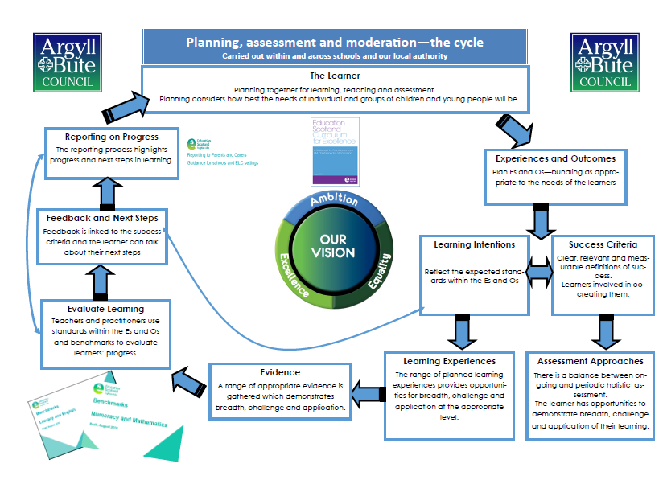

This closely reflects the NAR process and should not be viewed as ‘something new’. The key messages remain the same but a number of connections have been more clearly established:

* This a cyclical process – we do not reach ‘the end’. Rather, we reflect and evaluate against our understanding of the PAM cycle and BtC5 before deciding on how best to move forward.
* We must be looking for opportunities to bundle Es and Os, not only across curricular areas for IDL but also across organisers, particularly when planning for literacy and numeracy.
* The Learning Intentions directly inform the learning experiences. These should provide breadth, depth, challenge and application based upon the planned learning.
* The Success Criteria are used for assessment purposes – children and teachers should be assessing progress against the agreed success criteria and it is essential that these are relevant and measureable.
* The Benchmarks are to be used for assessment purposes. These should inform professional dialogue and **not** be used as a checklist for planning.
* Recent guidance has been released from Education Scotland on reporting to parents and carers.

It is the expectation that all teachers use this model for planning learning experiences within their classroom, and where possible, this model should be used for collaborative planning - particularly within literacy and numeracy.

This cycle is broken down in detail in **Appendix B - The Planning, Assessment and Moderation Cycle (PPT)**. **Appendix C** also provides support in **‘What Makes a Good Learning Intention’**. Again, AMFs are able to lead this development within schools and clusters.

We have also provided some examples of planners being used in schools and ELC settings **(Appendix D)** that reflect this process and include each of the 7 key elements of effective planning, assessment and moderation:

* Bundled Experiences and Outcomes
* Learning Intentions
* Success Criteria
* Learning experiences
* Planned assessment approaches (including hinge questions and summative/holistic tasks)
* Feedback and next steps
* Evaluation

While there is no expectation that each of these elements should be written and no set planning format that has to be used, it is expected that schools are ensuring that these key elements are at the forefront of the PAM cycle.

Achievement of a Level

*Achievement of a Level data (NIF) should only be based on literacy and numeracy experiences and outcome and not English and mathematics.*

You should be able to evidence that learners have:

* achieved a breadth of learning across **each** of the different organisers at their level.
* have a depth of understanding across most aspects - but not all and responded positively to the level of challenge set within the Es and Os.
* applied their learning in new and unfamiliar contexts – holistic assessments provide strong evidence of this. In Secondary evidence would be taken from a range of subject areas.
* Pupils have **moved towards** working at the next level for **some** aspects.

Benchmarks and the Argyll and Bute Numeracy Progression Framework should be used to support professional dialogue when making judgements. The Argyll and Bute Assessment Toolkit can be used for moderating and assessing literacy and numeracy.

Robust procedures for recording, tracking and monitoring are essential in providing efficient and effective systems for tracking progress throughout a level and should allow schools to draw on a wide range of evidence for each learner with ease.

Moderation judgements should be made following moderation discussions, considering a range of evidence.

Support

We recognise that different establishments are at very different places within their assessment and moderation journey and would like to offer a loose guide/breakdown of activities that might support you in moving forward. This is not a definitive list but may provide you with some ideas for taking the next step (e.g. some schools may be starting on number 1, others may be ready to start at number 5)

1. Self-evaluation – where are you now in terms of assessment and moderation? (**Appendix E - Journey to Excellence Indicators** are a good tool for starting your journey).
2. Revisiting BtC5 – linking this to The NIF and Our Children, Their Future – setting the context training can be very important for all practitioners to understand why we are on this journey and the impact that it can have on our learners.
3. Training on the PAM cycle – encouraging practitioners to build confidence using this cycle in their classrooms, ensuring planning across your school reflects the 7 key elements.
4. Looking specifically at Learning Intentions and Success Criteria – what is the difference? What makes good Learning Intentions/Success Criteria? This has been highlighted at national moderation events as an area of concern – is it worth revisiting in your setting?
5. Providing effective feedback for children – this is vital in raising attainment and closing the gap. It may be worth exploring the benefits of written/verbal feedback and considering the language used in this.
6. Choosing an aspect of literacy/numeracy to plan for collaboratively (or revisiting an area of your BGE) – work through the PAM cycle and build up an idea of what progression in that area looks like within your school/between schools/across your department. At this stage you should be thinking carefully about bundling Es and Os to get the most from your project – what links exist across organisers? How might you plan for these collectively?
7. Embed practices of moderation – do you have a termly focus across the school/between schools? Have you revisited your BGE course and ensured that it reflects the PAM model? (**Appendix F - Rolling this out in different settings** provides examples of good practice from primary and secondary schools that may provide support at this stage).
8. Creating holistic assessment tasks – training shared with all practitioners. Staff should then ‘have a go’ at creating a holistic assessment task as part of the PAM Cycle – these can be planned for collaboratively and should provide breadth, challenge and application (**Appendix G - Creating Effective Holistic Assessment Tasks PPT** can support this as well as additional resources provided on SALi). These can then be moderated across or between schools and feedback given.
9. Achievement of a Level – exploring as a staff what ‘Achievement of a Level’ means and what kind of evidence might be referred to. Moderation of the evidence at each level in schools/departments.
10. Tracking and monitoring: could your AMF lead a session with school staff reviewing the tracking and monitoring systems within the school – is there a good balance of summative and formative assessment? Is there regular professional dialogue regarding pace, challenge and progress? Are interventions put in place and monitored?

A range of resources have also been uploaded onto SALi, including all of the training documents referred to within this overview.

**Appendix H - People Who Can Help** provides a list of names and contact details for members of the central team who can offer you support as well as the names and email addresses of all AMFs and QAMSOs. We are very keen to encourage networking between AMFs and QAMSOs and hope that you may take this opportunity to contact one another and offer support and guidance.

August Inservice Day

As you may be aware, we are strongly advising schools and clusters spend one of the August Inservice days focusing on Assessment and Moderation. It is essential that AMFs take time to talk to their head teachers about this day and begin to put plans in place. At this stage, some clusters have started working together to form a plan for this day. **Appendix I - Possible Structure for Cluster Work** provides some ideas for taking this forward as a cluster.

Conclusion

Effective assessment and moderation practices align a large number of local and national priorities in education, simultaneously raising attainment levels and allowing us to accurately focus on the gaps in learning and address these effectively. They improve learning and teaching experiences for children and ensure that all staff have a deep understanding of their learners’ progress and how this relates to national standards and expectations.

The schools that have reported the most success in driving forward their assessment and moderation practices have ensured that time has been given over to this in their Working Time Agreements and we therefore urge schools to consider this carefully when planning the collegiate calendar for the 2017/18 session.

N.B. Following the appendices are a range of resources/tasks that may be used at different stages throughout your journey. Some of these are referred to within this document or the appendices.