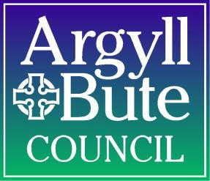
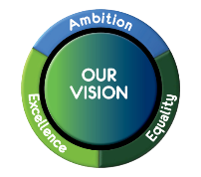
Scottish National Standardised Assessments (SNSA)
Fact Sheet
These Are | These Are Not
- The Scottish Government has commissioned the SNSA as part of the National Improvement Framework.  - SNSA data provides additional information to the teacher regarding how a child is progressing in school.  - Diagnostic assessments which provide information on some elements of reading, writing and numeracy.  - Delivered online and automatically marked through the online system.  - Adaptive to the ability of the pupil, so that if a child is struggling with the questions they will get easier, and if a child is doing well, questions will become more challenging.  - Very useful for understanding the development of each child and next steps.  - Can provide a national picture to show where a learner sits in relation to their whole cohort across Scotland.  - The decision about when in a year the SNSAs will be used should be made at school level.  - Pupils will be assessed once in each of the relevant school years, P1, P4, P7 and S3.  - P1s sit 2 assessments; 1 in Literacy and 1 in Numeracy, P4,P7 and S3 sit 3 assessments;1 in Reading, 1 in Writing and 1 in Numeracy.  - The assessments can take place at beginning, midway through or at the end of the session.  - Should be part of normal learning activities.  - The assessments aim to be as inclusive as possible to accommodate the needs of children and young people who require additional support.  - These assessments are expected to replace the variety of existing standardised assessments that local authorities and schools use at the moment.  - Providing teachers with objective and nationally consistent information on children’s progress. | - Like the old National Assessments  - Providing evidence of all learning in Literacy and Numeracy  - Providing a pass or fail or scoring out of 10.  - These do not carry more weight than jotter work, holistic assessments, observations etc. in forming teacher professional judgement.  - They do not cover all the Benchmarks and so cannot be used to say whether a pupil has achieved a level.  - The assessments should not be used in isolation and should not be viewed as a replacement for the ongoing assessment of children's progress that is central to Curriculum for Excellence.  - A child will not be expected to take assessments covering reading, writing, and numeracy in one sitting.  - This type of assessment is not suitable for assessing listening and talking or extended writing.

Points to note -
Evaluation of attainment of a level should still be done by looking at a range of evidence (which may include the SNSA) and making a holistic judgement about whether, in general, the Benchmarks are being overtaken.
Parents and carers will not routinely see the outcomes after children and young people complete the assessments. The reports produced by the online assessment system are intended to support teachers professional judgement of a child or young person’s progress. Teachers will use this information, together with evidence from a range of other sources, to form the basis of discussion with parents about children and young people’s progress in learning.
Scottish Government will have access to national level assessment data only. This is to identify trends and drive national policy and improvement priorities. Scottish Government will continue to publish data on the percentage of children and young people who have achieved the Curriculum for Excellence levels in literacy and numeracy relevant to their stage at local authority and national levels.
If a school has significant difficulties with providing online assessments that cannot be overcome, SNSA will make sure that the assessments can be taken in another way.
Practicalities
- To use the SNSAs you need a log in / authority access through GLOW. Please contact Susan Tyre if your school does not have a login
- Learners will need access to tablets / computers to do the assessments.
- It is preferable for P1s to use tablets due to motor control issues.
- There is technical help available for schools through SNSA info@snsa.org.uk.
- All schools have now been provided with Phase A training and Phase B training will take place during inset on 15th and 16th February (apart from Helensburgh who will receive training on 25th May). This training will support the analysis of data. Any questions regarding training, please contact Susan Tyre.

Pauline Inglis and Clare Bryden
January 2018

