(
February 2017

Numeracy and Mathematics
Resource Guide
Note: All links have been hyperlinked to take you directly to the resource so this guide is best used electronically.

National Numeracy and Mathematics Hub (click this link to access)
The National Numeracy and Mathematics Hub is an interactive, virtual learning environment. It provides an innovative approach to career-long professional learning for all practitioners in all sectors. It offers practitioners;
- Professional learning in different aspects of numeracy with a focus on progression, numeracy and mathematics skills, numeracy across learning, assessment and moderation and teaching.
- Career-long professional learning opportunities such as broadcasts, professional reading and action research.
- An easy to use environment to share and work with colleagues from across Scotland, as well as those from your own school or authority​.
Access to key documents and resources relating to Numeracy and Mathematics, from Education Scotland’s website.
Explanation of hub’s purpose, sign up links for glow broadcasts and watch again links for past broadcasts.

Presentations, supporting documents and recordings of past broadcasts along with broadcast schedule for 2016/17.
Research articles covering a range of topics on Numeracy and Mathematics and access to online journals.

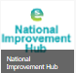
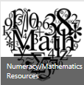
Collection of online guidance and support focused around improving the quality of learners’ experiences and their outcomes.

Numeracy and Mathematics Resource area where practitioners can upload and share resources and ideas.

* There are module broadcasts on most Tuesdays at 4pm. See the Modules and Sessions area of the hub for more information. All broadcasts are available to watch again on Glow TV or the National numeracy and Mathematics channel. Links are also posted on the hub.

Education Scotland website:
Education Scotland Website: https://education.gov.scot/
National Improvement Hub Website: https://education.gov.scot/improvement

These sites provide practitioners with a range of resources and guidance to help develop learning and teaching in Numeracy and Mathematics including;

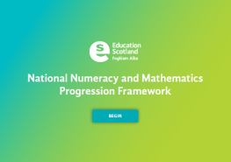
National Numeracy and Mathematics Progression Framework - This resource has been created to deepen practitioners' knowledge and understanding of progression within the experiences and outcomes for numeracy and mathematics. It includes progression pathways with key milestones and building blocks for each of the numeracy and mathematics organisers. Exemplification of all building blocks is available for Number and Number Processes. Previous knowledge and understanding is provided for all other numeracy organisers. Please see the a related module HERE

Professional Learning Resources - These professional learning resources provide guidance and advice to help inform learning and teaching practices in line with the main objectives of the Scottish Survey of Literacy and Numeracy (SSLN). There are PLR’s for;
- Number and Number Processes
- Time
- Measurement, Fractions, decimal fractions and percentages, Ideas of chance and uncertainty
- Pupil performance in estimating and rounding
This session we have created Professional Learning Resources, in the form of broadcasts, based on the 2015 SSLN results. These can be found HERE
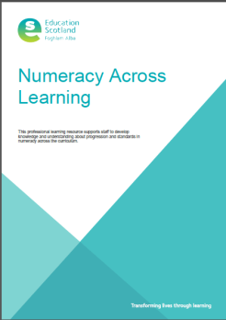
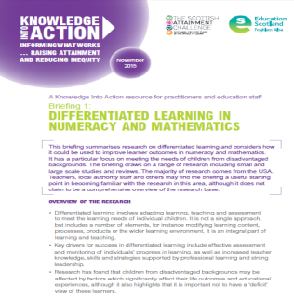

Differentiated learning in
numeracy and mathematics
Higher Order Thinking Skills
in numeracy and mathematics

Numeracy in Social Studies
Numeracy Across Learning

Delivering excellence and equity in Scottish education: A delivery plan

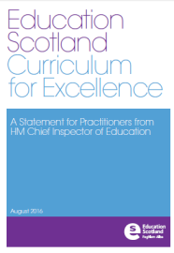
The Delivery Plan outlines the steps the Scottish Government will take to achieve key improvements in education, building on the work contained in the National Improvement Framework which was published in January, and addresses the recommendations of the OECD review. The suite of documents below provides clear, practical advice for teachers and practitioners on planning learning, teaching and assessment. This streamlined approach includes a definitive Statement on Curriculum for Excellence and Benchmarks to support assessment in Literacy and English and Numeracy and Mathematics. Benchmarks for other curriculum areas will be available by the end of 2016.

Draft Benchmarks: Tell us what you think
The Benchmarks for both literacy and English and numeracy and mathematics have been published in draft form. The reason for this is because Education Scotland wants to engage with teachers and practitioners, as they begin to use the Benchmarks to support professional judgement of both progress towards and achievement of a level. Feedback on specific Benchmarks is also welcome. All feedback will be considered when finalising the Benchmarks. The consultation will finish on 31/03/17 and the finalised benchmarks will be published in June 2017.
Give us your feedback on the draft Benchmarks

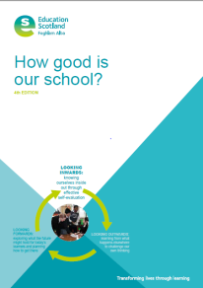
Other key links and websites to support the development of Numeracy and Mathematics:
Film materials include topics from space, measurement, shape, number, algebra, statistics, probability and a history of maths. TWIG Film list for National 4 and National 5

Qualifications

HGIOS 4
Key document designed to promote effective self-evaluation as the first important stage in a process of achieving self-improvement. It features a toolkit of illustrations, exemplar features of highly-effective practice and challenge questions. See Quality Indicator 3.2 for particular reference to raising attainment and achievement in numeracy and literacy.

National Numeracy and Mathematics Channel
Catch up with past numeracy and mathematics broadcasts on Glow TV, Watch Again on our very own Mathematics Channel! Click here. (glow login required)

Past and upcoming modules and sessions include:

- Mathematical Anxiety/Mathematical Resilience (3-18)
- Teaching and learning approaches around the world (3-18)
- Developing Number Knowledge - 6 sessions (Early/Primary)
- Transition – nursery to P1 and P7-S1
- Financial Education Updates (3-18)
- Early Number – Developing Number Sense (3-18)
- SSLN 2015 Support
- Using census data in the classroom
- SQA key messages
…and many more!

Broadcast Schedule available in Modules and Sessions Area of the Hub.
Watch again links are also available in this area.

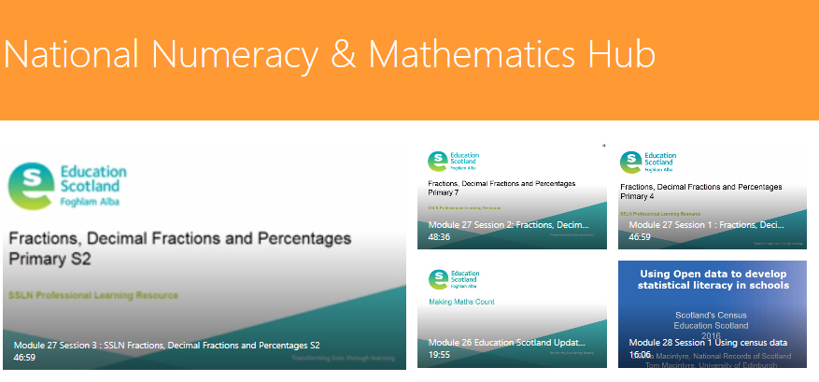

SSLN 2015 Numeracy Results
In 2011, 2013 and 2015, the Scottish Survey of Literacy and Numeracy took place across schools in Scotland to gain a snapshot of pupil performance in numeracy at that point in time. The results for the 2015 numeracy survey were published on Tuesday 31st May. The numeracy and mathematics team presented a live hub broadcast to summarise and discuss the results. The hub broadcast is available afterwards to watch via National Numeracy and Mathematics Channel

Read, Write, Count
Read, Write, Count will be gifting bags to every P1, P2 and P3 child in Scotland, with the aim of giving parents ideas and materials to use to support their children’s learning outside the classroom.
The bags will be packed full of books, writing materials and numeracy games to make reading, writing and counting fun and easy at home.
For CLPL materials visit www.scottishbooktrust.com/readwritecount

Numeracy and Mathematics Glossary

This glossary has been developed for parents and carers of children and young people in the broad general education in Scottish schools. It provides clear definitions of some of the commonly used terms in numeracy and mathematics.

Making Maths Count
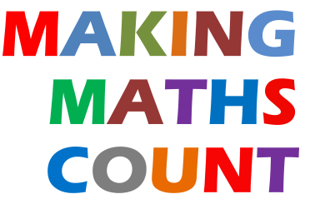
“Making Maths Count” is a Scottish Government initiative that has two broad aims:
1. to encourage greater enthusiasm for mathematics amongst children and young people, their parents, carers and the wider public; and
2. to provide support for teachers and help raise attainment in Mathematics National Qualifications.

Aim 1 has been developed through the ‘National Raising Profile Group’ who have produced a final report detailing the work they have been developing. Click here for the report.
Aim 2 has been developed through the ‘National Mathematics Development Group’. The resources produced were created by practitioners around Scotland and can be accessed HERE. Postcards have been sent out to all mathematics departments.

The Open Laboratories network (OPAL) website provides resources and surveys for citizen science projects . It has a huge variety of excellent, relevant and current links to numeracy and mathematics. http://www.opalexplorenature.org/
Click here to explore the CfE links to numeracy and mathematics in Primary. At secondary, OPAL supports learners collecting quantitative measurements about a habitat or ecosystem to record information numerically and graphically for comparison and display. The completion of an OPAL survey also contributes to the John Muir Award.

Other interesting and relevant contexts for exploring data handling, classifying and much more include:

Plant Tracker iRecord Butterflies Great British iRecord Ladybird
Bee Count
Galaxy Zoo
Classify hundreds of new galaxies.

Click on each of the links above to further explore these resources.

Main Contact for Numeracy and Mathematics Team at Education Scotland:
Lorna Harvey, Education Officer
Optima Building, 58 Robertson Street
Glasgow
G2 8DU
Tel: 0141 282 5119 lorna.harvey@educationscotland.gsi.gov.uk

