**Next Steps for Individual Children:**

**Learning/Development Outcome(s) Discussed:**

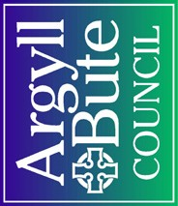

**Date**

**Outstanding Aspects Identified:**

Learning and Development Meeting

Community Services: Education

**General Comments / Issues**

**Key Worker**