Accessing in a Glow Meet Session

When you are attending a meeting as a participant you must first ensure that you have the correct URL to access the meeting room from your Host. It will be similar to this URL - https://meet.glowscotland.org.uk/testroom/

If you are already logged in to Glow the URL will automatically launch the meeting room for you. If you aren’t logged in you will be asked to do that first on the usual login page.

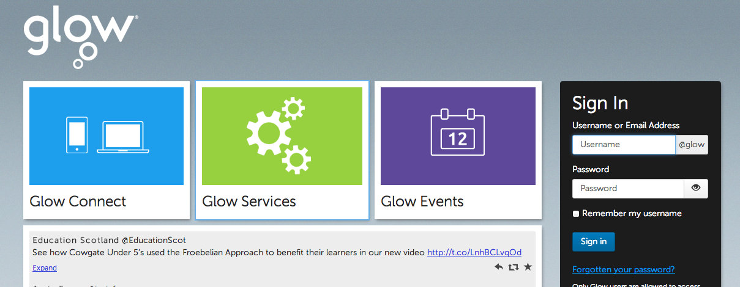

The Adobe Connect software will then launch and you will see this final loading screen before you access the room:

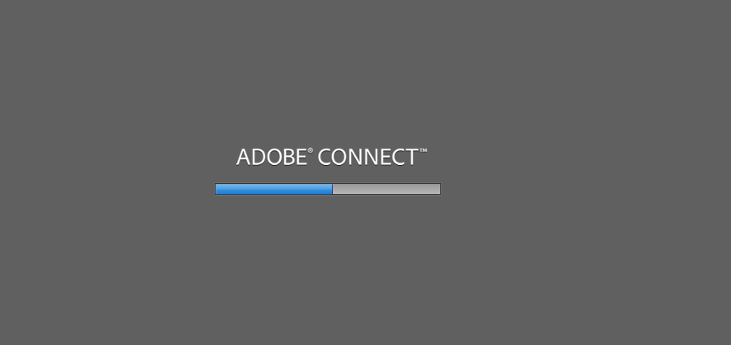

If you see the following screen and message after final loading screen:
‘The meeting has not yet started. You will be able to access the meeting once the host arrives. Please wait.’
This means that the Host hasn’t arrived in the room yet. When they do they will grant you access.

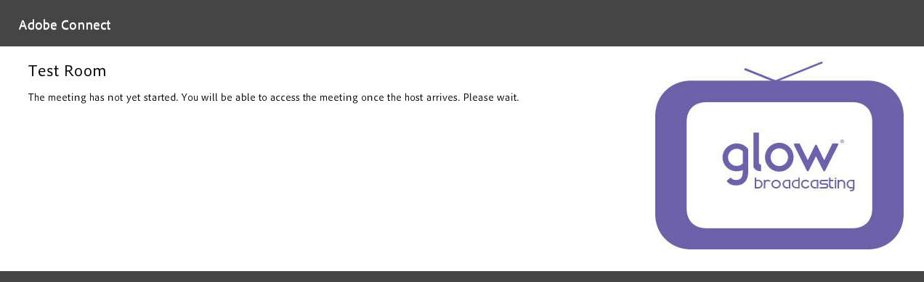

However if you see this screen and message:
‘This is a private meeting. Your request to enter has been sent to the host. Please wait for a response’
This means that the Host is already in the room and will be able to grant you access as soon as possible.

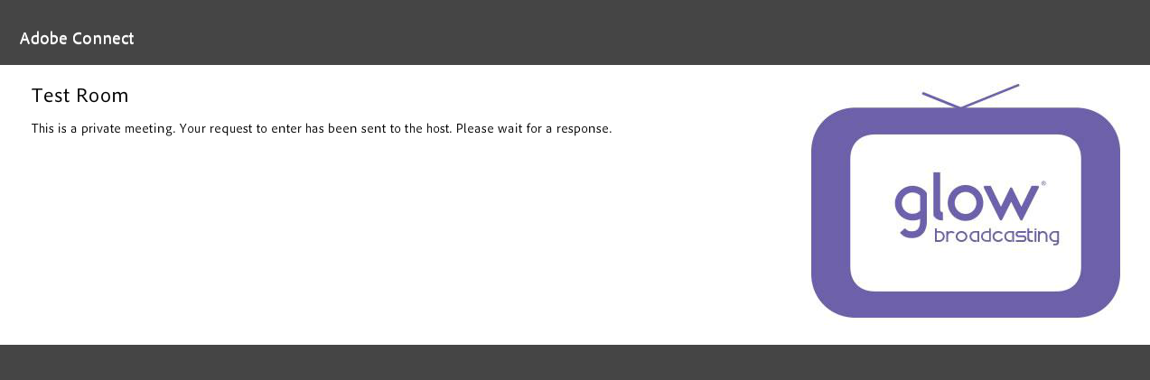

Once the Host has granted you permission to access the room you will be able to see the room with whatever layout the Host has chosen. This can vary from Glow Meet room to room depending on what the session will be about.

Participating in a Glow Meet Session

Once you have accessed the room, typically, you should be able to see a video pod where you will see the Host/Presenters and maybe a pod for sharing or a PowerPoint presentation but this can vary.

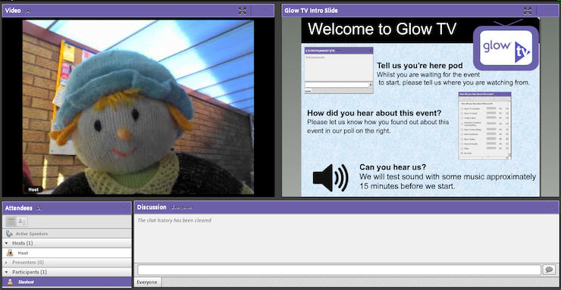

You are able to interact with the other participants and the Host/Presenters using a Chat/Discussion box.

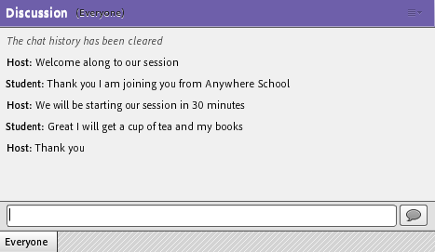

You can type in your text here and then press RETURN or this icon for it to be made visible to everyone.

Setting your Status
During an event you may wish to use the status icons located at the top of the page to indicate to the Host/Presenters that you are expressing an opinion/indicating a problem or raising your hand to be noticed. Once you have selected your icon it will be displayed next to your name in the Attendee pod.
To remove/change the icon just return to the menu again and deselect/select your choice.
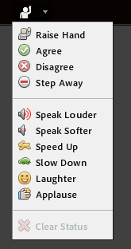

Additional Permissions in a Glow Meet Session

During the session the Host may want you to put on your camera or speak using the microphone. If this is the case the Host will let you know when they have given you the necessary permissions.

Using Your Microphone
If you are asked to put on your microphone you will see the microphone icon come up beside your name in the Attendee list and a message will appear in the top right of your screen:

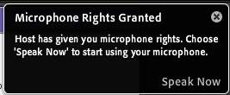
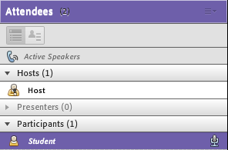

Using Your Camera

If you are asked to put on your camera you will see a START button appear at the top of the video pod:

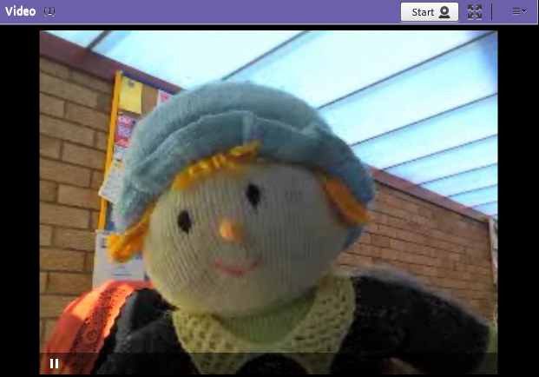

Remember that your Host will be able to help throughout the session if you are required to use camera/microphone.

Leaving the Glow Meet

If you wish to leave the meeting before it has ended you can do so by going to Meeting and selecting Exit Adobe Connect:
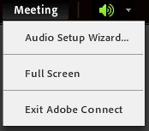

Alternatively you can close the window and that will remove you from the room.

When your session is finished the Host will end the meeting and you can close the window to finish.

