Tunnagan Beaga

Tunnagan Beaga aon dhà trì
Toonakan bake-a aon ga tree

Casan beaga buidhe ceithir còig sia
Casan bake-a booya kay-hir co-aick sheea

Tunnagan beaga spàg spàg spàg
Toonakan bake-a spak spak spak

Sìos chun an lochainn guag guag guag
Shee-os chun an lochain quack quack quack

Little ducks
Little ducks one two three
Little yellow feet four five six
Little ducks waddle waddle waddle
Down to the pond quack quack quack
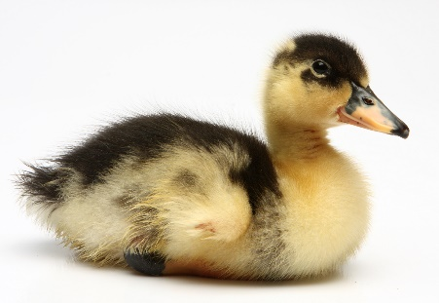
Aon Dhà Tri

Ceithir Còig Sia
c

