Crois crois loidhn’ loidhn’
(Cross cross line line)

Crois crois loidhn’ loidhn’
Crosh crosh lu-ine lu-ine

Damhan-allaidh suas do dhruim
davun alley soo-us doh gh-rime

Seideadh air do cheann
shayj-ugh ayur doh ch-yeh-oun

Cudail teann
cuddle ch-eh-oun
(this ch is like chair all other as in loch)

Abair spòrs is fealla-dha
ah-bur spawrs iss f-yella ghaa

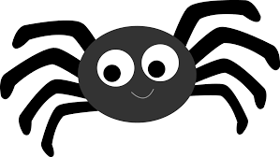
Cross Cross line line
Spiders crawling up your spine
Cool breeze
Tight squeeze
Now you’ve got the shiveries!!

