
Building the Ambition
National Practice Guidance on Early Learning and Childcare

Section 7 Putting pedagogy into practice

Title of Session: Help me find out more about my world

Time allocation: 60 minutes approximately

Focus:

To explore how staff can promote curiosity, inquiry and creativity with toddlers.

Preparation:

Read section 7.4.3 of Building the Ambition
Copies of questions and photographs
Flipchart and pens

Leader’s notes:
Please try to encourage discussion that reflects the capacity toddlers have for learning rather than having a focus on resources.

The purpose of this activity is to explore how staff can promote curiosity, inquiry and creativity with toddlers. It would be useful to support staff to present their ideas in whatever creative way they would like.

When participants have reflected on the questions, note key areas for promoting toddlers’ curiosity, creativity and inquiry on the flipchart. Refer participants to Section 7.4.3 for further reading.

A focus on toddlers – what do they need?

Participant activity.

Promoting curiosity, inquiry and creativity with toddlers.

Please read the following extract:

Children are born curious and with an inquiring nature. All children need access to well thought out experiences which will help them develop their inquiry skills to be successful and competent learners

Inquiry is about being curious and persistent. For young children it is about finding out things for yourself and being able to come to a self-satisfying answer often with the gentle support from a key person. It allows a child to appreciate when something actually has been learned and to know this for themselves. The sense of achievement in inquiry learning is a key motivator to learn more.

Creativity sits alongside inquiry and problem solving. Being creative is not just about painting and model making or making music, although these are highly important for children, but also includes reasoning out, testing and solving problems, putting things together and taking them apart and figuring out how things work. Early mathematics and numeracy are closely interlinked with inquiry and creativity and is best achieved in practical meaningful contexts for children where they make sense of the
world about them.
Building the Ambition

Activity 1

Think about what your understanding and experience of promoting curiosity, inquiry and creativity is. Note down key points from your discussion and share with others.

What activities do you enjoy where you get to be creative and curious?

How do you feel when you get absorbed in a task where you are exploring how things work or creating something new?

Often, when we are being creative we can be completely absorbed in what we are doing. Has anyone ever interrupted you when you have felt like this? How did it feel?

Activity 2
Now think about your own setting

Can you think of any objects that have fascinated children as they investigate, try to take them apart or figure out how they work?

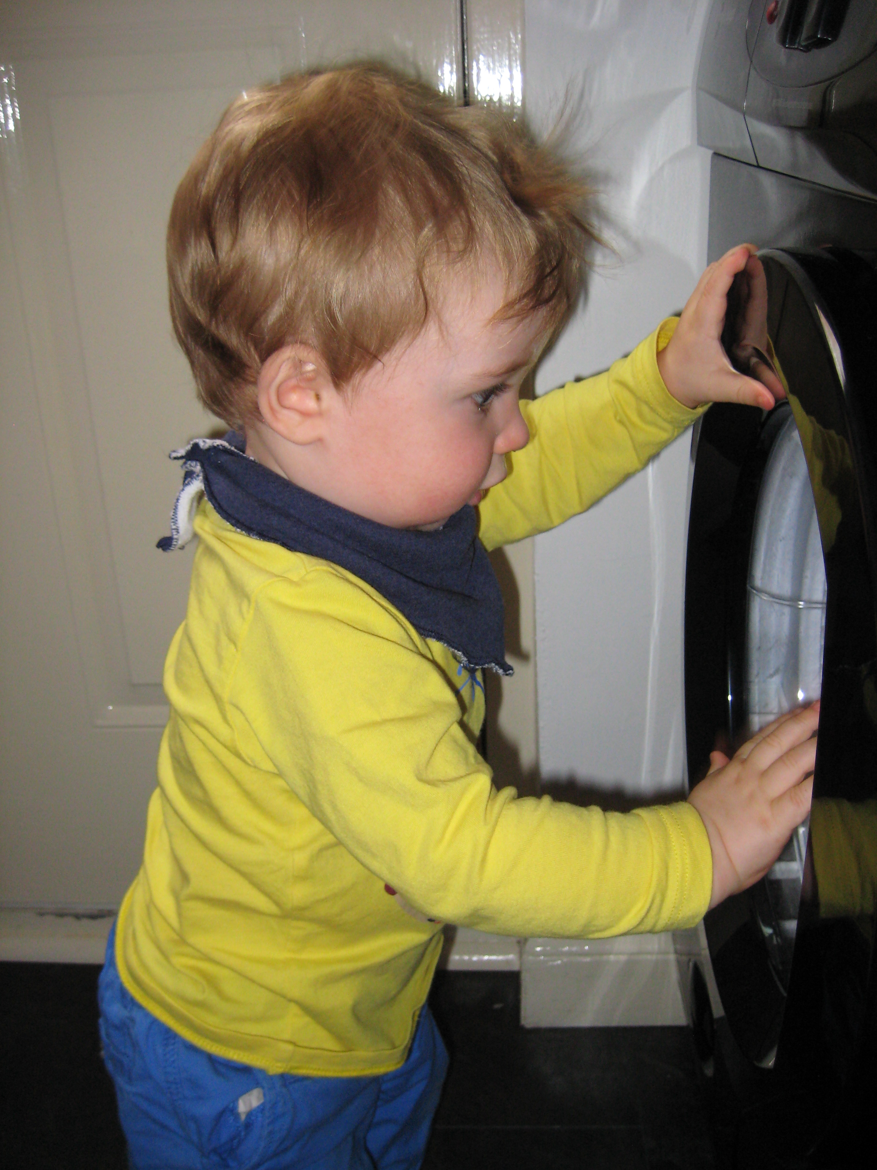

When and how does your setting support children to be creative and curious?

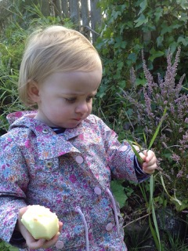

How could the following environments support creativity, curiosity and inquiry for toddlers?

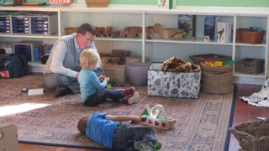

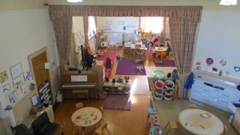

What works well in your setting?

What changes would you make following your discussions?

Take a moment to note down for yourself what changes (if any) you would like to make back in your setting.

