Early Years Collaborative
Argyll and Bute CPP
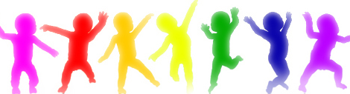

Overview of the
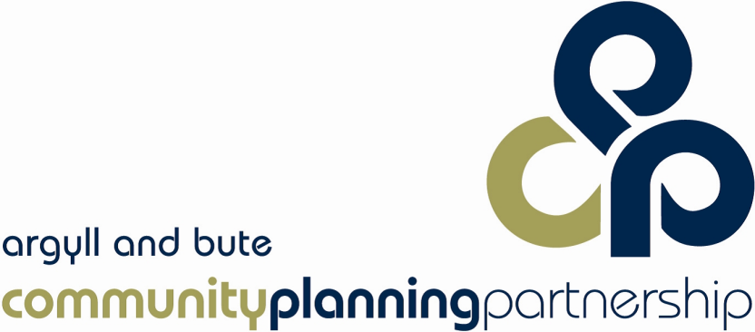
Model for Improvement
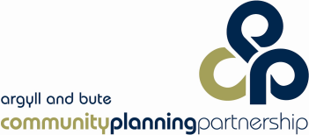

Using the Early Years Collaborative Model for Improvement
The Model for Improvement is a simple yet powerful tool for measuring improvement which has two parts. The first part asks three fundamental questions which can be addressed in any order:
- What are we trying to accomplish?
- How will we know that a change is an improvement?
- What change can we make that will result in improvement
Setting Aims
This model for improvement requires setting aims. The aim should be time specific and measurable. It should also define the specific population that will be affected.
Establishing Measures
Teams use quantitative measures to determine if a specific change actually leads to an improvement.
Project Charter
A project charter helps you to plan out your project – it enables you to identify what it is you want to accomplish and to identify how you are going to measure your project. This should be completed before you start the PDSA cycle (see appendix 1)
Plan Do Study Act Cycle
The second part is made up of the PDSA (Plan-Do-Study-Act) cycle to test and implement changes. The PDSA cycle guides the test of a change to determine if the change is an improvement. This cycle enables us to test a change in the real work setting by planning it, trying it, observing the results and acting on what is learned.

Help in Selecting Changes
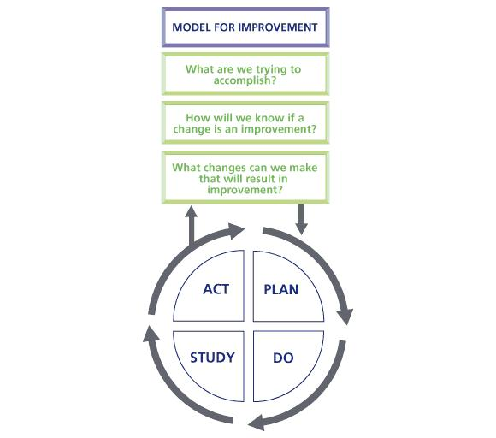
All improvement requires making changes, but not all changes result in improvement. Organisations therefore must identify the changes that are most likely to result in improvement. The PDSA cycle enables us to test whether a change is an improvement.
Part One of the Model for Improvement

Part Two of the Model for Improvement

Learning From Tests of Change
The first thing to remember is that even if something does not work it is not a failure. Every test of change is a chance to learn, and that learning is applied the next time you set out on a test of change. Sharing this learning with others may also mean that they do not spend time on things that are not likely to work and can therefore concentrate on different approaches.
Before you start your test of change, you should always discuss with your work stream lead the improvement issue and predict how your change will impact on what you are doing. Consider what you are testing, what is the aim, what is being tested, what are you trying to achieve by how much and by when. During your test of change, you gather information to see if your prediction is correct. You do this over a period of time which you have defined at the outset to see if there are any patterns in the information or data. Do not just look at snap shots in isolation as there may be natural variations that even out over time.
If your results are not what you expected, think about why this is.
- Maybe you asked the wrong question
- Maybe the data you really wanted was unavailable so you settled for something else which was not as effective.
- Maybe your assumptions were wrong and you have had to rethink your assumptions. It may be that your results point to positive impacts that you did not predict that might be the focus for your next cycle of change.
Remember you may need to carry out several PDSA cycles to get from your starting point to where you want to be at the end of your improvement journey. The important thing is that you keep learning and bring this learning into each successive improvement cycle.
Data can be collected for a number of reasons :
- Judgement- is the one we are most familiar with, as data on our activity is collected and used to judge our performance. Many organisations use a traffic light system to judge whether performance is on target (green), slipping but will recover (amber) or not going to achieve target (red).
- Research – we are exploring a research question and we use data to help us to answer this question
- Improvement – this is where we use information to help us to understand whether our work is doing what we set out to do. In this sense the data is for you and only then for your manager and for others.
Data can:
- help you to see if you have achieved what you have set out to do
- be an aide in putting forward a case
- be a mate when showing that your way works
- be an ally if challenged on what you are doing
- be a tool when designing and testing new areas of work

How do I know if the data I collect will actually help me?
The first thing you need to think about is what you need to know. Before you start collecting data, you need to be very clear what you want to know, why you want to know it, and what it will tell you when you collect it. This might sound obvious, but too often we collect data without knowing why – and this might mean that we collect data that doesn’t actually tell us what we want to know. Spend time planning your improvement work really trying to get at the heart of what you want to know. Start thinking about what you are going to measure, and why, when you are doing the planning part of the PDSA cycle. Put time into your planning and you should be able to save time later on.
Use a Driver Diagram
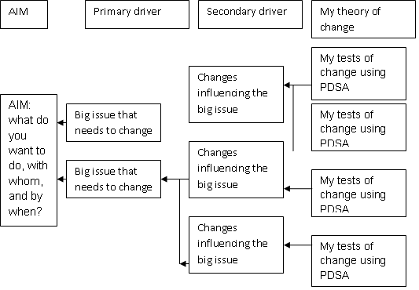
At their most simple, Driver Diagrams are a plan on a page. Starting with your aim on the left of the page, you identify the big issues (primary drivers) that you need to change in order to achieve your aim; then work back to the next level of things that need to change (secondary drivers) in order to change your big issues; finally think about what changes you would try in order to start your process of change.

Impact
In order for us to test full impact, it is important to capture not only quantitative data, but qualitative data too – people’s voices, opinions, feelings. This can also be captured through carrying out case studies (see appendix 2).
Interventions and Learning
It is very important to take the time to look at the outcome of the test cycles – what is the data telling you? Are there elements which have not worked? Are there parts which have been successful and can be shared more widely? It is good to spend time as part of a team to discuss the data you have as a result of testing
Spread
If you have made a change which has resulted in improvement, it should be shared more widely. However, this will need to be ‘scaled up’ in a sustainable way – just because a change works well with one family or one child, things may change when more families and children are added! Therefore when you do decide to scale up your testing, the recommended process is:
- start small with one child / one family / one practitioner
- scale up to 3
- Then 5
- Then 10
- 25
- Full implementation
Conclusion
If your data does not lead to the outcome you hoped for, do not worry – we learn from all tests of change. Take the time to evaluate your progress and work out why your change did not lead to an improvement this time.
If you your data is displaying consistent success as you ‘scale up’, it is important to share your success with the Early Years Collaborative Workstream Leads – see next page for contact details.

Argyll & Bute CPP – Workstream Leads

Patricia Renfrew - patricia.renfrew@nhs.net
Workstream 1 (Pre-birth – 10 days)
Workstream 2 (10 days – 3 years)

Kathleen Johnston - kathleen.johnston@argyll-bute.gov.uk
Workstream 3 (aged 3-5 yrs)

Don McAllister - Don.McAllister@argyll-bute.gov.uk
Work Stream 4 (aged 5- 8 yrs)

Appendix 1: Sample of a Project Charter
Project Name: Using the Getting it Right Antenatal( GIRAN) Wellbeing tool to support families to meet negotiated outcomes

What are we trying to accomplish?
Using the well-being indicators to ensure timely and proportionate care assessment and planning from conception to birth. Previously the antenatal plan incorporating the wellbeing indicators was only used with those who were deemed to have additional needs but this is now being rolled out to all expectant mothers.

This information will also allow us to look at how many go on to have a Antenatal child’ plan.

It will also be used to aid Handover to Health visitor postnatally
How will we know a change is an improvement?
Regular review of parents scores against the wellbeing indicators and referral to appropriate services.

Measurements that will be affected: Current Level
Numerator – Number of women with new antenatal plan completed at booking appointment.
Denominator – Number of women attending booking appointment.

(What changes can we make that could result in improvement?)
Referral to appropriate services should increase parent’s scores across the wellbeing indicators.

Initial Activities/Cycles

- Monitoring the use of the antenatal plan.

- Auditing quality and impact of antenatal plans.

- Monitor use at handover of care to health visitors
Originator: Senior Midwife – WS1 Lead
People to Involve:
Midwives
Parents to be
Mental Health Services
Health Visitors
Social Work services
Addiction services
Citizens Advice Bureau and Welfare Rights Service
Fire Service - Home Safety checks
Other services as deemed appropriate. eg Homestart, Womens Aid

Appendix 2: Case Study
Getting it Right Antenatal case study

Charlie is a 27 year old woman, she has a partner and 7 year old son and is now pregnant with her second child.

She has a history of chaotic lifestyle, including previous domestic violence,drug and alcohol use, poor housing and parenting issues which have become evident with her 7 year old son

Charlie had admitted to drinking alcohol since discovering she was pregnant, the episode led to overnight stay in jail. Charlie is also known to use prescrition and street drugs.

At booking the Argyll and Bute Pre-birth pathway was followed. This involves an antenatal assessment being completed by the named midwife using:
- Scottish Women’s Held Maternity Record V6 ( which includes the GIRFEC practice Model)
- Vulnerable families pathway (0 - 3)
- Universal antenatal plan

Through the use of the well-being indicators pressures were identified, the outcome of the assessment placed Charlie in the ‘Additional’ health plan indicator (HPI) category.

In undergoing the assessment the named midwife highlights how the pressures may impact on outcomes with women and unborn baby. The midwife also completes the Additional Antenatal Plan and commences a chronology, this is then shared electronically with appropriate agencies

A multi-agency antenatal planning meeting was convened by the Sue the named midwife, the meeting was attended by:
Charlie and her partner John
Social Worker Jane
Addictions nurse Julie
Housing Officer Jack
Third sector support worker Jan

Charlie and John were aware of the reason for the meeting and were fully engaged.

Charlie stated in times of stress and anxiety she resorts to using Cannabis, she also is a heavy cigarette smoker.

Immediate pressures requiring action:
- Previous drugs and alcohol use
- Smoking Cessation
- Housing
- Parenting

Following the Getting it Right for Every Child approach it was agreed that the Lead Professional for Charlie and John would be Sue the named midwife. The partners to the plan were the other attendees at the meeting where specific short and long term actions were identified. A review meeting date was set for 6 weeks and the named health visitor would also be invited to attend this meeting

Actions from the meeting
- Charlie and John agreed to work with the addictions nurse to look at alternative coping mechanisms and diversion to help mange her stress
- Charlie to be referred to the smoking cessation service
- A housing assessment to be completed
- Charlie has agreed to attend mellow bumps parenting programme and to undergo 1:1 work with the support worker on intensive parenting

In addition to Antenatal planning meetings, Getting it Right Antenatal Meetings (GIRAN) monthly multiagency meetings take place. These meetings are chaired by the locality senior midwife to update antenatal plans, discuss any relevant issues and promote any additional work required with the family to strengthen assets. The meetings are attended by health visitors, midwives, social work, addictions, CPNs, Housing and other relevant agencies as required. These meetings do not take over from the 1:1 meetings but are used as a mechanism to ensure nothing is missed and updates are happening on a regular basis

