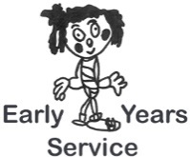
Checklist Title: Equality & Fairness – Standard 8 Involving the Community – Standard 9

Setting: Manager:

Date:
Evaluation | Scoring  1-5 | Action Points | Date for completion
Standard 8
Staff make sure that all children, parents, carers and the members of staff themselves are treated with respect and in a fair and just way, respecting the needs and characteristics of the individual
Staff assist families who experience difficulties in accessing support services.
If parents and carers face any barriers which prevent them from playing an effective part in their child’s care and early learning staff will work to reduce these barriers.
Standard 9
The service:
- contributes to the life of the community
- has effective links with community organisations
- makes information about its provision readily available to members of the community
- makes efforts to provide information to parents and carers about community resources
- knows about and makes effective use of community facilities (where appropriate)
- provides opportunities for children to take part in the wider community.

