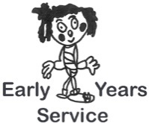
Checklist Title: Support and Development – Standard 6

Setting: Manager:

Date:
Evaluation | Score 1-5 | Action Points | Date for Completion
Staff are flexible and responsive to children’s personal, emotional, educational and physical
needs.
Staff are responsive to the support needs of children and families and are sensitive to individual circumstances including disabilities
Staff work effectively with parents, carers and children to support each individual child or young person’s development and learning.
Staff establish effective working relationships with support agencies. These may include medical services, teachers, therapists, educational psychologists and learning support staff and social workers.
Staff share information with the child as appropriate, with parents and carers and others professionally involved in the child’s development
Staff draw up and put into practice individualised programmes and plans to support children and families where appropriate. They do this in consultation with parents and carers, children and professionals.
staff are knowledgeable about, and have a clear understanding of, relevant legislation relating to children, including those with additional needs
Activities provided by staff will allow the children to enjoy both organised and free play, including quiet times.
Parents and carers have help to use services, aids and equipment for communication if their first language is not English or if they have any other communication needs.

