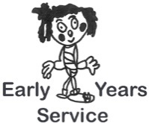
Checklist Title: Improving the Service – Standard 13

Setting: Manager:

Date:
Evaluation | Scoring  1-5 | Action Points | Date for completion
Staff are involved in the systematic evaluation and discussion of their work and the work of the service, including the use of assessment information
Parents/carers, children and staff have the opportunity to contribute as appropriate to evaluation
Evaluation is continuous and takes account of relevant national and local advice
Staff have clear plans for maintaining and improving the service

