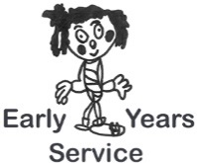
Checklist Title: Involving other Services – Standard 10 Access to Resources – Standard 11

Setting: Manager:

Date:
Evaluation | Scoring  1-5 | Action Points | Date for completion
Standard 10
There are well-developed links between the service and other relevant childcare services, schools and agencies such as health and social work services in the local area
Parents, carers and children benefit from the way in which the service links with relevant national and local organisations
Standard 11
Children have access to equipment and materials – including multi-cultural materials – which are effectively organised by staff and used to support key aspects of children’s development and learning.
Children’s interests are encouraged through displays that are attractively presented and include a variety of examples made by them. Staff change the material regularly.
Children find their quality of experience enhanced by the effective use made of skills and ideas from staff, parents and carers,
the children themselves, and from visitors.
Children benefit from the use that staff make of a range of outside resources and information and communication technology.

