Nursery Application Management System
Revision Date:

01/01/2016

This course covers the core functionality necessary for the efficient completion of the new Authority Nursery Application Form. The NAMS Application (Nursery Application Management System) is used to enter details of children who are to be considered for a nursery place. The course includes adding, editing a new application, recording placements and placement decisions and creating the various reports available on the application.

This course will be particularly useful for administrative staff in nursery schools or for council headquarters staff who deal with nursery applications.

Manual
Contents
NAMS Access 1
Logging in (Local Authority) 1
Network Connections 2
Logging in (Private Partner / Local Authority – Remote Access) 2
Changing Password 3
Memorable Phrase 3
Home Page 4
Settings 5
Application Form 5
Authorisation Periods 6
Option - Add 6
Option - Edit 7
Option - Delete 7
Time Block Setup 8
Capacity Model Setup 9
Option - Delete 9
Option - Copy 9
Option - Import 9
Option - Edit 10
Option – Add 10
Option – Rotation 11
Site Capacity 12
Example for Lemons & Limes nursery 13
Default Hours 14
Authority Default Hours 14
Add Site Specific 14
USAGE LIMITS 15
Option - Add 15
Option - Edit 15
Option - Delete 15
Payment Rates 16
Option – Add 16
Option - Edit 16
Option - Delete 16
Calendar Override 17
Add a Closure 17
Remove a Closure 17
APPLICATION 18
Create & Manage 18
New Application 18
Child Details 18
Contact Details 18
Office Use Only 19
Nurseries Requested 19
Places Requested 20
Family Details 21
Named Person 22
Ethnic Background 22
Child Health Information 22
Looked After 23
Remove LAC 23
Additional Information to Support Application 23
Intended Primary 23
Marketing Information 23
Manage Existing Application 24
Filtering Data 24
Add to List 24
Filter Existing 24
Edit Breadcrumb 25
Refresh List 25
Clear List 25
Deleting an Applications 25
Nursery List 26
Nursery List Application Status 27
Details display 27
Placements display 28
Offer/No Offer Letters 30
Record Placement Decision 31
Application Status 32
Temporary Identification Codes 33
Editing Temporary Codes 34
HQ Received (Authority Specific) 35
Records 36
Accept/Reject Enrolments 36
Edit 37
Basic 37
Address 38
Hour’s placements 38
HQ Received 42
Deferred Entry 42
Adjust Hours 42
LAC 43
HEALTH 44
Named Person 45
Mark Leavers 46
Capacity Conflicts 47
Funding 48
Generate Authorisation Code 48
Enter Authorisation Code 49
Manage Payment Adjustments 50
Remove a payment 50
Generate Payment 51
Authorise Payment 52
Reports 53
Available Spaces Report 53
View Existing Authorisation Codes 54
View Existing Payment Report 55
Authorisation Code Status Report 56
Breadcrumb Report 57
Cross Boundary Report 59
Apendix 60
Saving Report Data 60
Sorting Data 60
Multiple sorts 60
Selecting Data 61
Multiple Selection 61
Column Manipulation 61
Moving Columns 61
Application Status 62
Printing/Saving Options 62
PDF 62
CSV 62
Using the Calendar 63

NAMS Access
To access the Nursery Application Management System your local authority will need to give you access to the ‘NAMS’ application from the ‘Authority Access Control’ system. This will give you access to your nursery site as well as menu privileges. If you do not believe that the access you have been given is correct, please contact your local representative at HQ. If you are a partner provider for the authority, they will supply nominated users a username, password, and a memorable phrase, once again if you believe any of this to be incorrect please contact your HQ representative.

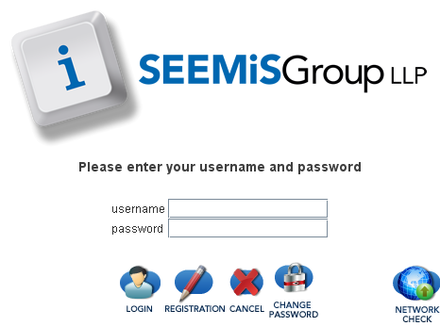
Logging in (Local Authority)
You will access the NAMS application from your SEEMiS icon, or programs list. Once the dialogue box appears on your screen enter the following:
- Username
- Password

At this point you would normally click on ‘Login’.
Other option that are available from this popup are
Login |  | Login will allow you to select that application you wish to use
Registration |  | Is used by class teachers to go straight to their class register
Cancel |  | Will close the dialogue box and return you to your desktop
Change |  | This is used to change your password at any time before the auto prompt
Network Check |  | Will allow you to run a check on the status of the network

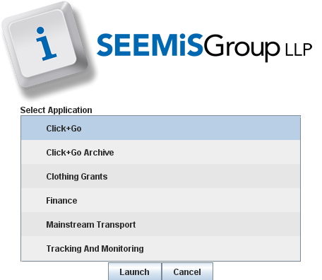
Select NAMS from the available list of applications
Click ‘Launch’

Network Connections
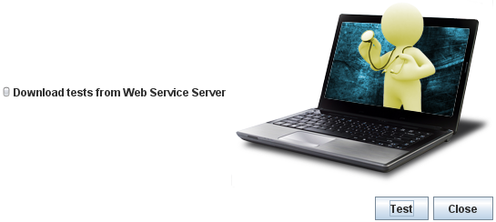
If there are issues logging into NAMS, there may be problems with the Network Connections.

To check your network connection click ‘Network Check’
- Click ‘Test’

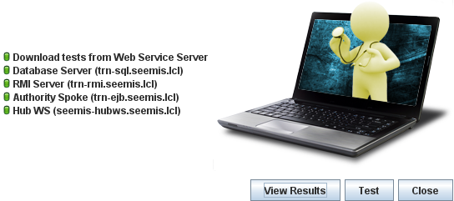
Test results will be listed
- Click ‘View Details’ to see details of the results

Note: Any problems will be highlighted in red and should be reported to your IT Support

Logging in (Private Partner / Local Authority – Remote Access)
Private Partners will access the application through the SEEMiS website, and also Local Authority users who have been given access to work from home will also be able to access NAMS via the SEEMiS website.
NOTE: Users should ensure that they have Java installed on to their device. Below is a link to the setup document which will help support you through setting up Java on your windows based device
Java setup Guide - PC only
The procedure to access NAMS via the SEEMiS website is as follows:-
- Enter http://www.seemis.gov.uk into the address bar, and press return
- Select ‘NAMS Access’ from the Useful Links section at the bottom of the page. (You may need to scroll down to see this)
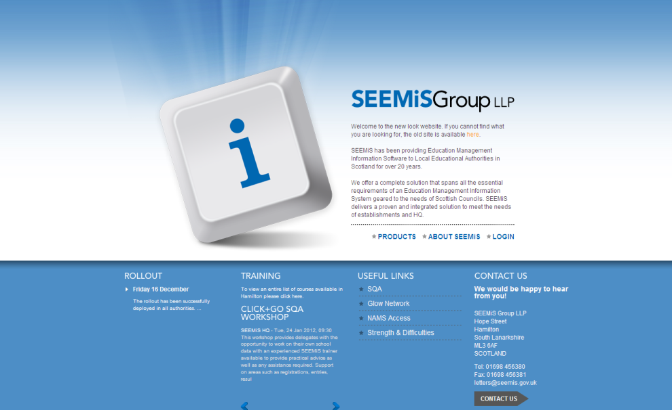
- Choose the appropriate Authority for your nursery
the first time NAMS is accessed a Security Warning is displayed. Click ‘Run’ to continue, others may be encountered so ensure the ‘Always trust’ option is selected.

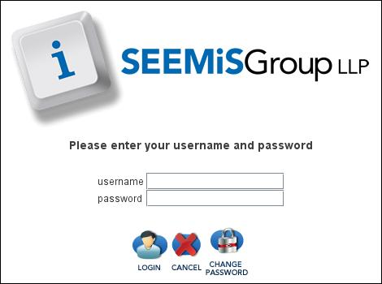
Once the dialogue box appears on your screen enter the following:
- Username
- Password

At this point you would normally click on ‘Login’.

Other option that are available from this popup are
Login |  | Login will allow you to select that application you wish to use
Cancel |  | Will close the dialogue box and return you to your desktop
Change Password |  | This is used to change your password at any time before the auto prompt

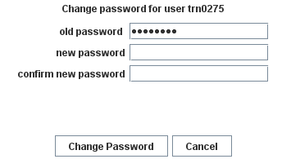
Changing Password
Passwords can be changed at any time, and expire every 50 days. A warning message appears in advance, advising that it should be changed. It is recommended that an alphanumeric password containing a capital letter is used, although each authority provides their own guidelines. Passwords cannot be reused.

- Click CHANGE PASSWORD
- Enter the new password, and confirm new password, click CHANGE PASSWORD

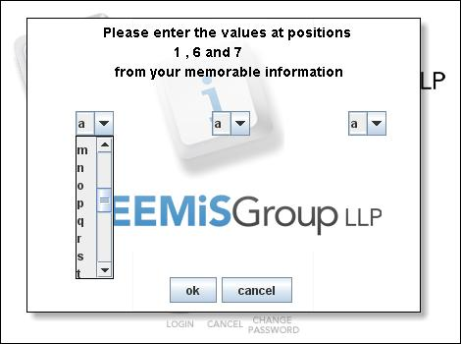
Memorable Phrase
You will be requested to provide three characters of your memorable phrase. Use the drop down menus to select the relevant characters
Note: The memorable phrase for Private Partners will be supplied by the authority. Local Authority users can set this in Click+Go.
Click ‘ok’ and you will now be directed to the NAMS home screen

Home Page
The homepage is the first screen shown when entering NAMS. The site you are currently logged into will be displayed at the top left of the screen.
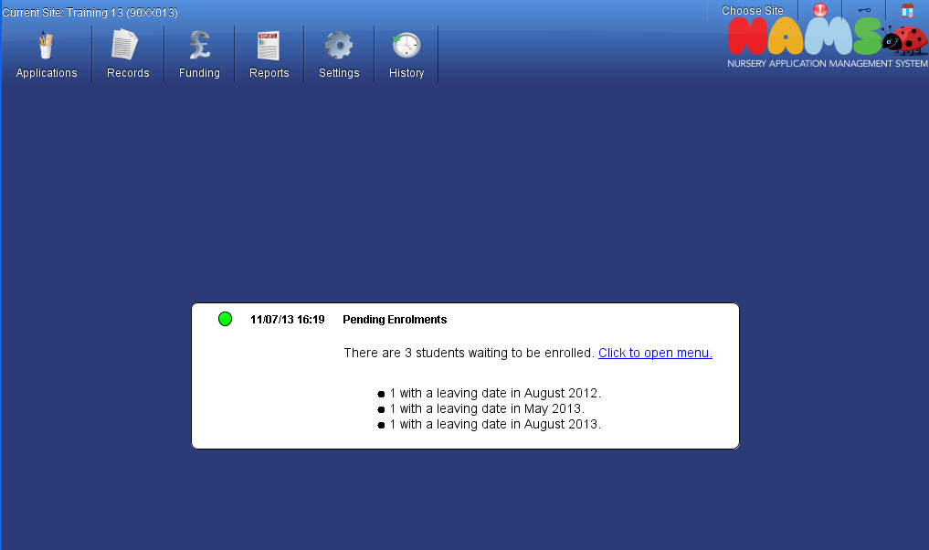

The top right of the screen displays the following options:
This enables the user to select another nursery to view, if they should
have access to other sites. Normally this would be used by headquarters staff who have access to multiple sites.
This will show 2 tabs:- Text & Log. The log should be used when reporting errors to SEEMiS. Please click on the send to SEMiS button at the bottom of the pop-up and log a helpdesk call give as much information as you can as to what you were doing, which screen, and any other relevent information
This is the lock icon. Once locked, the user will be required to enter their password to unlock the application
To return to the Home screen at any time click this icon
This icon is located at the top right of the screen and will allow the user to exit the application

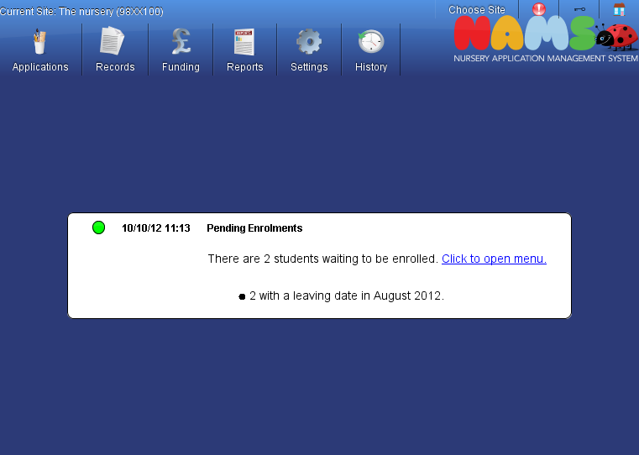
Screen Messages: Messages will alert you to pupils waiting to be enrolled. This is only displayed if you ave access to the ‘Records – Acept/Reject’ menu

Settings

Application Form
The majority of sections in the application form and some of the details within these sections can be altered as required by Headquarters. If a section is optional, headquarters staff will have the facility to remove the selection, and this will be removed from the application form.
- Settings
- Application Form

- To change the order of display, select a section and hold the mouse button then drag to the required position
- To remove a section in the application form, uncheck the box on the left of the screen
- Some sections have additional settings. To edit these settings, click the icon at the relevant section
- Click ‘Accept’ to confirm changes to the section
- Once required changes have been made, click ‘Save’

Click ‘Revert’ to undo changes
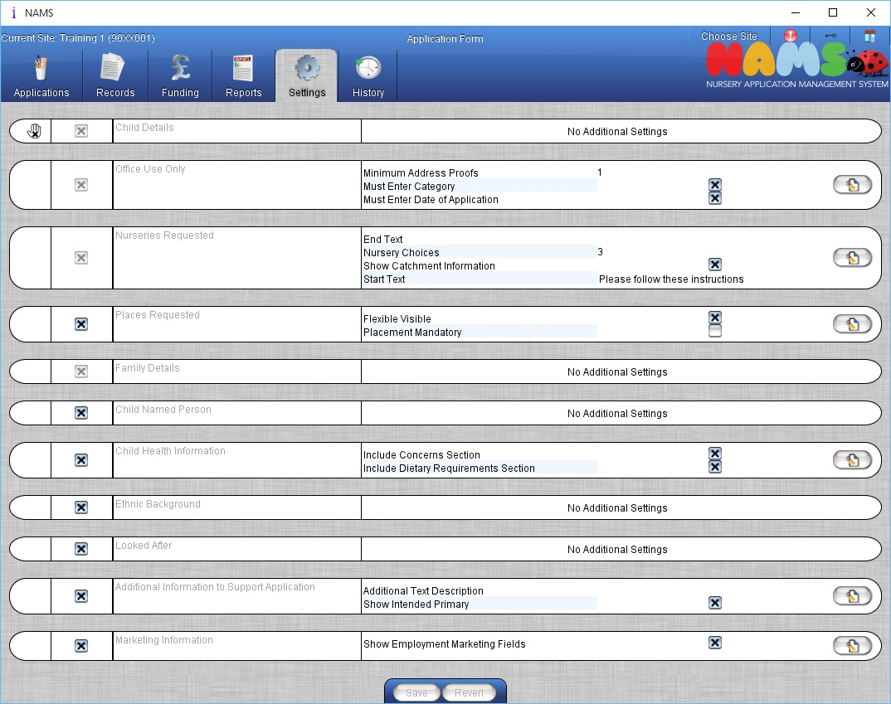

Note: The nurseries requested section allows the user to alter the text, which appears before and after the nursery list. The appropriate text, required by the local authority, can be entered and will appear on all application forms.

Also available is the option to show if the selected nursery sites are within the catchment area for the address in the application form.

Authorisation Periods
The authorisation period screen is used to complete the funding period setup which was previously sent to SEEMiS to be entered on your behalf.
Each funding period should contain the following:
- Start and End date for each payment period
- The minimum date of birth that will be included into the calculation along with the maximum date of birth.
- A setting for the Minimum hours that can be taken, and the maximum for the date range entered above.
- A check in the relevant ‘Active’ check box to identify if the date range is active and visible

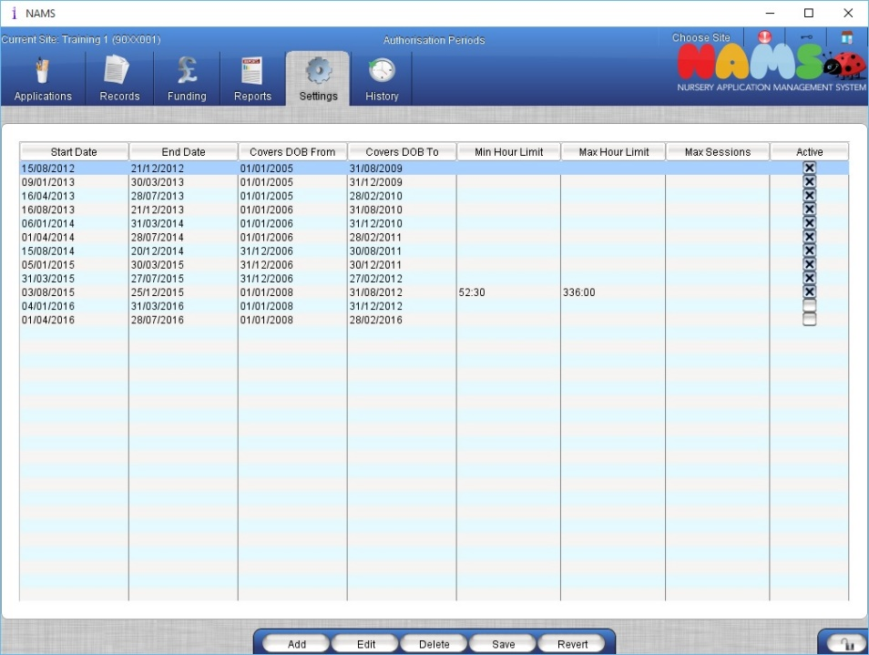

Note: the hours should be calculated in minutes and converted to hours as a decimal, and it is not necessary to log out to see the changes that have been made.
The calculation used is as follows:
21 week *

Option - Add
- Settings
- Authorisation periods

- Unlock the screen by clicking on the padlock
- Click ‘Add’
- Enter the details of the new period including Start and End Date, Covers DOB from and To Date
- If required enter Minimum and Maximum periods
- Check Active Period if required
- Click ‘Add’
- Click ‘Save’

NOTE: Clicking ‘Revert’ will undo any changes since the last ‘Save’.
Authorisation periods cannot be edited or deleted if Payment has already been accepted.

Option - Edit
- Settings
- Authorisation periods

- Unlock the screen by clicking on the padlock
- Click ‘Edit’
- Change details as required
- Click ‘Add’
- Click ‘Save’

NOTE: The data will not save if the end date is before the start date ,a period cannot overlap with an existing period, the minimum limit must be less than or equal to the minimum limit and the dates must lie within a recognised academic year.

Option - Delete
- Settings
- Authorisation periods

- Unlock the screen by clicking on the padlock
- Hi light the period to be deleted
- Click DELETE
- Click SAVE

NOTE: Clicking REVERT will undo any changes since the last SAVE.
Authorisation periods cannot be edited or deleted if Payment has already been accepted.

Time Block Setup
This screen is designed to allow the user to setup blocks of time, and provide a name for each block defined, so that they can be used to create a pattern for attendance in a specific nursery. If you have setup this screen, and find you require additional block(s) or do not require some of the block which are defined you can add and remove with causing any issue. The following list is the minimum requirement to use the system to record the statutory 600 hours allocation.
- Time Block Setup
- Capacity Model Setup
- Site Capacity – Hours Based

- Provide a meaningful name for the allocation block i.e. Full Hour etc.
- On the second box enter the time value i.e. 1:00

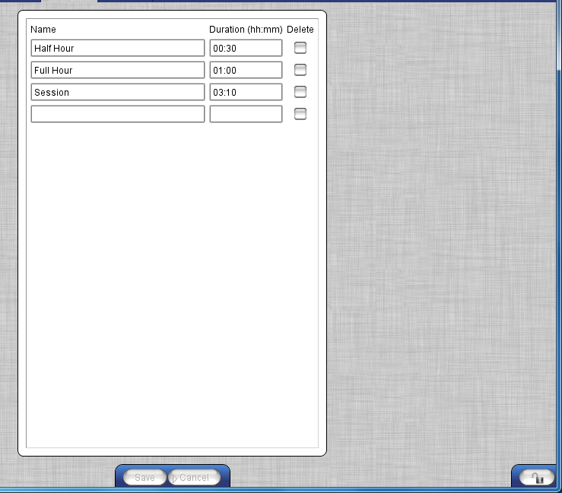

- If you wish to remove the value completely then check the box under ‘Delete’ heading. And then click ‘Save’

Capacity Model Setup
The capacity model setup is used to define a pattern of attendance in blocks of time across the week. The opening and closing times are set by SEEMiS, and is part of a setup procedure. Once the capacity is setup for each of the stages i.e. N1/2, N3, or N4/5 this will be used on the application form. The setup will be replicated across all sites. You can only use one name per any given stage.

- Settings
- Capacity Model Setup

When this screen loads the View/Edit button will be the only option available until you select a function.

Option - Delete
- Unlock the padlock to edit screen
- Select the configuration to delete from the List
- Click ‘Delete’, then click ‘Save’
NOTE: Deleting a capacity may affect funding applied

Option - Copy
- Unlock the padlock to edit screen
- Select the configuration to copy from the list
- Click ‘Copy’, and Provide a name for the copied profile
- then click ‘Save’

Option - Import
- Unlock the padlock to edit screen
- Select the establishment you which to copy the setup from
- Select the configuration to copy from the list
- Provide a name for the copied profile and the stage to be used against.
- Click ‘Confirm’
- If the imported information’s timeframe differs from your own only areas which match will be imported.

Option - Edit
Note: See Add for more details
- Unlock the padlock to edit screen
- Click on the ‘Edit’ button
- Provide a name for this capacity model i.e. Toddlers
- Provide a stage for the model i.e. N3
- Select time slots from left of the table, these were created using the ‘Time Block Setup’ screen, and drag the block to the time required.

Option – Add
- Unlock the padlock to edit screen
- Click on the ‘Add’ button
- Provide a name for this capacity model i.e. Toddlers
- Provide a stage for the model i.e. N3
- Select time slots from left of the table, these were created using the ‘Time Block Setup’ screen, and drag the block to the time required.

Note: You can double click on the timeslot you have dragged across and set the capacity i.e. the maximum number of children that can be in at that time i.e. 25

You can set that time block to say that it attracts authority funding (default setting), or remove the check mark from the box, which means this time will be funded by the parent/carer.

Non Funded Time blocks can be optionally allocated as required e.g. ether breakfast or lunch, those were created using the ‘Time Block Setup’ screen

You can also amend the name of the block but this would be optional.

Click on the ‘Confirm’ button to save any changes made.

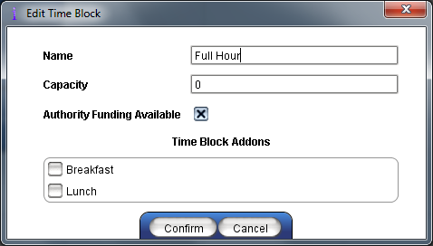
If you right click over a block you can Delete, Fill the week with that block, Copy the block to another location, and Edit the information contained in the block.

The screen should now look similar to the screen below.

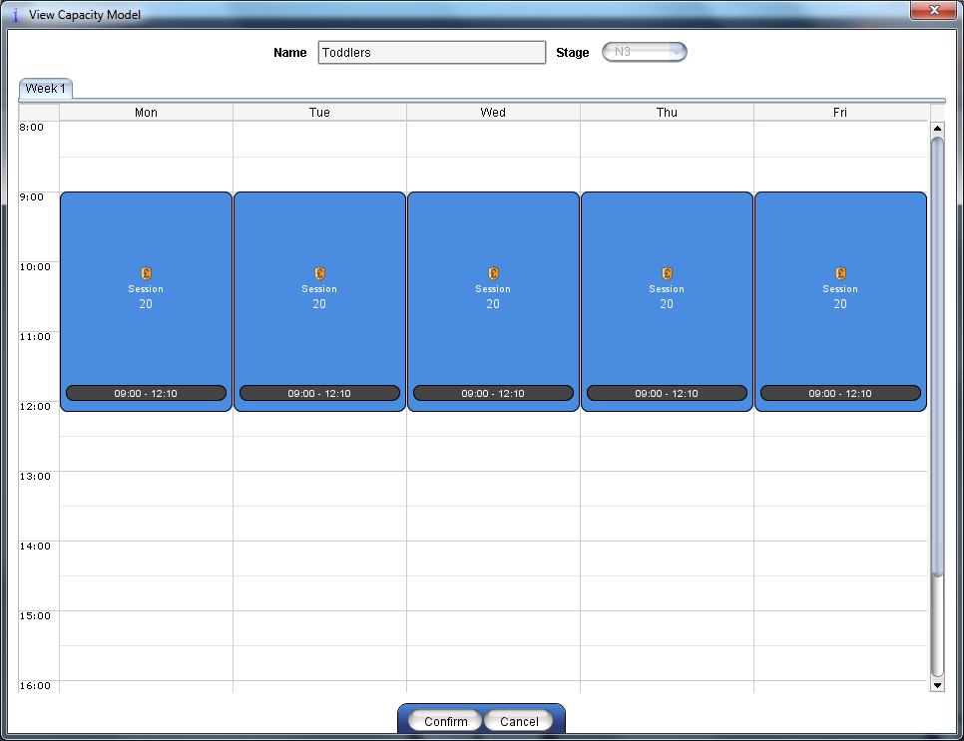

Option – Rotation
When you enter this screen it will have a week one tab shown. But to the right there is a plus on a tab, by clicking on this you can create a week 2 etc. This might be used where a nursery is closed 1 day each fortnight, so one pattern could have that day omitted, and the week 2 would include that day.
You can delete additional tabs by clicking on the ‘Red Cross’ to the left of the name.

Site Capacity
This facility allows the user to set up what looks like a calendar for the time blocks. Again only one block can be used against any stage.
You will need to select a stage, and a pattern which was defined earlier, with a start date. If you do not supply an end date then this will run to the end of the authority session. The number of places available per block in each nursery site is shown along with the funded and non-funded section in the day, the funded portion shown in dark blue, and the non-funded shown in the lilac blocks.
Note: You can enter non-funded time into an authority block but not the other way round. The defined non-funding block can only accept non-funded places

- Settings
- Site Capacity
- Hours Based

- Select a stage for this pattern.
- Select a capacity model for the stage
- Provide a start date for this pattern (You do not need to provide an end date unless this change is for a specific duration)
- Click on ‘Apply’, and then ‘Save’

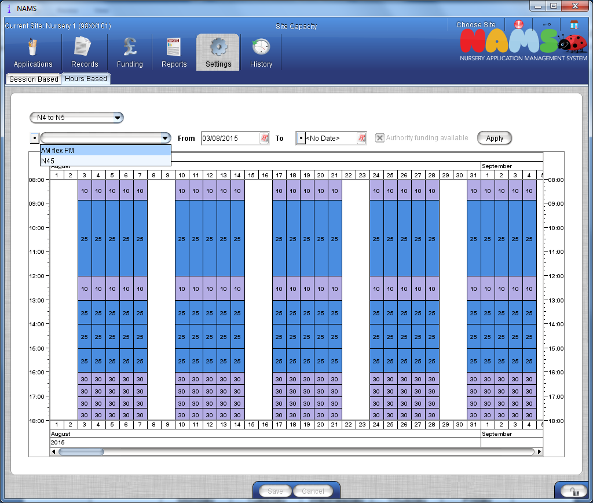

Example for Lemons & Limes nursery
Our nursery will be open from 8 am and close at 6 pm how do we set this up.
First off decide what the smallest block of time might be, that we will offer. So if we decide that we will offer places on blocks of 2:30 mins then full hours thereafter, then the min time block would be 0.30 mins (to make up a full hour). So given the above

Time Block requirements are
Half Hour 0:30 Full Hour 1:00 Session 2:30

 | Monday | Tuesday | Wednesday | Thursday | Friday
8:00
0:30
9:00
Etc.

So Child ‘A’ wishes a place in the morning, and would like to arrive at 8 am stay for 4 hours and stay for lunch each day, except a Wednesday they would like to stay all day until 5:30 when they will get picked up.

 | Monday | Tuesday | Wednesday | Thursday | Friday
8:00 | 1 Hour slot
0:30
9:00 | 2:30 Slot
0:30
10:00
0:30
11:00
0:30 | 0:30 min slot
12:00 | 1 Hour slot
0:30
13:00
0:30
14:00
0:30
15:00
0:30
16:00
0:30
17:00
0:30

So the parent is paying for violet (grey) segments and the authority is paying for the Blue (black).

Default Hours
All sites will have by default 600 hours in every nursery. If you which to alter the default across the authority this can be accommodated within this screen. But if a specific nursery is open for longer or shorter, then an adjustment may need to be made to individual sites to accommodate this.

- Settings
- Default hours

Authority Default Hours
- Unlock the screen by clicking on the padlock
- Enter the Academic year and number of hours
- Click SAVE
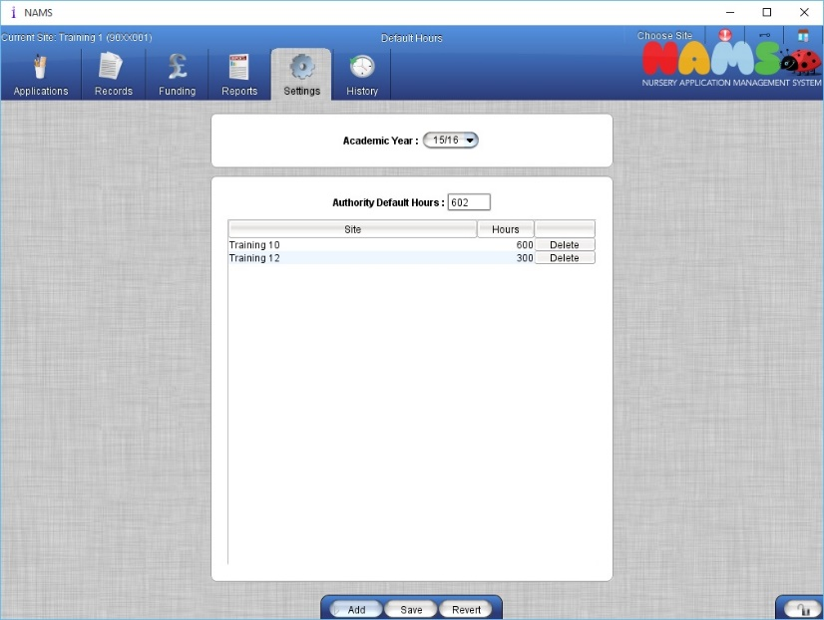

NOTE: There is NO EDIT facility available you must delete and re-enter the information.
REVERT will undo any action since last save.

Add Site Specific
- Click ADD
- Select Site from dropdown list
- Enter Default Hours
- Click ADD
- Click SAVE

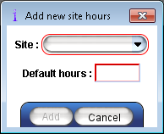
NOTE: This function can be restricted to Authority level Access. Clicking ‘Revert’ will undo any changes since the last ‘Save’. It is not possible to add more than one set of default hours to the same site, per Academic year thus eliminating the possibility of duplicate sites with different hours.

USAGE LIMITS
This screen will allow you to define the minimum and the maximum number of hours available to a child on a weekly or monthly basis. This will affect your payments. This screen is optional if you have setup the hours within the ‘Authorisation Periods’.

- Settings
- Usage Limits

Option - Add
- Unlock the screen by clicking on the padlock
- Click ‘Add’
- Enter Effective from Date
- Enter Type
- Enter Minimum and Maximum hours if required
- Click ‘Ok’
- Click ‘Save’

Option - Edit
- Select Effective from Date
- Click ‘Edit’
- Make required changes
- Click ‘Ok’
- Click ‘Save’

NOTE: The data will not save if a limit shares a start date and time with an existing limit or the minimum limit must be less than or equal to the maximum limit.

Option - Delete
- Select Effective from Date
- Click Delete

Note: Clicking ‘Revert’ will undo any changes since the last ‘Save’.

Payment Rates
As part of the Hours Based functionality, payment rates need to be created with the ability to edit and delete payment rates. More than one payment rate can be added but, both rates cannot be applied to the same nursery, stage group and effective from date.

➢ Settings
➢ Payment Rates

Option – Add
1. Unlock the screen by clicking on the padlock
2. Click ‘Add’
3. Enter details of the new payment rate as required ensuring that mandatory fields highlighted with either a red border or a red field are populated
4. If payment rate is nursery specific, click on the drop down for Nursery field and select required nursery otherwise this will be authority wide.
5. When all mandatory fields have been populated, click ‘Ok’
6. Click ‘Save’

Option - Edit
1. Unlock the screen by clicking on the padlock
2. Select a payment rate
3. Click ‘Edit’
4. Change details as required
5. Click ‘Ok’
6. Click ‘Save’

NOTE: Two rates cannot be applied to the same Nursery, Stage Group and Effective from fields.

Option - Delete
1. Unlock the screen by clicking on the padlock
2. Select a payment rate
3. Click ‘Delete’
4. Click ‘Save’

Calendar Override
During the turnaround process every establishment receives the authority holidays which was entered into the SEEMiS budget system. The calendar override provides the facility to each nursery to add or remove any closure entered for their nursery.

- Settings
- Calendar Override
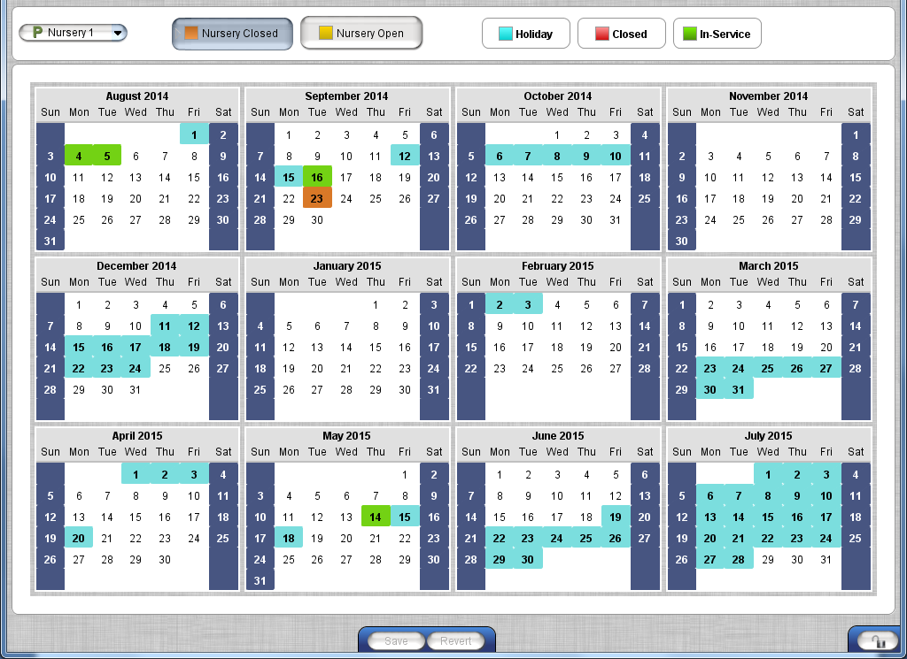

Add a Closure
To mark the nursery as closed, click on the NURSERY CLOSED button, then go to the date for the closure. The date will show 2 triangles, the upper one is the am portion, and the lower one would be pm portion. To close for any duration click on either or both to signify closed full day.

Remove a Closure
To mark the nursery as closed, click on the NURSERY CLOSED button, then go to the date for the closure. The date will show 2 triangles, the upper one is the am portion, and the lower one would be pm portion. To close for any duration click on either or both to signify closed full day.

APPLICATION

Create & Manage
This screen allows the user to add a new application and to edit, view and delete existing applications. Applications that have been accepted into the nursery cannot be edited. The order of the application form, relevant and mandatory fields are set by each Authority.

New Application
- Applications
- Create & Manage

- Click ‘New’

NOTE: Mandatory Fields are highlighted with a red border

Child Details
- Enter the child’s details
NOTE: In specific circumstances, HQ’s can issue a Temporary Identification Code. When the Birth Certificate/Passport is not provided, HQ can then update the record
- Click FIND CHILD
NOTE: A check is done against the Birth Certificate/Passport number to identify if this pupil has a record within your authority. If a match is found, click OK, this links the applications. The existing data will be filled in
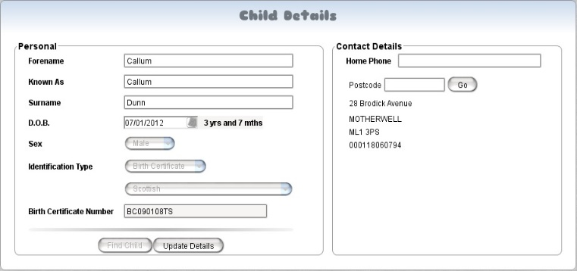
If no match is found, click CONFIRM to create a new record
If you notice an error in the following details:’ D.O.B, Sex, Identification Type or number’, please contact you HQ who will be able update the information using the ‘Update Details’ button.

Contact Details
Enter the child’s contact details
- Enter Home Telephone Number
- Enter Postcode and click ‘Go’
- All addresses associated with this postcode will be displayed, select the relevant address and click ‘Confirm’
- If the address is not listed, click ‘Not Found’
- Enter address details in fields provided, click CONFIRM, the address will now be displayed

Office Use Only
- Complete each field as appropriate

Note: Proof of address, and Category are provided by your authority and will differ from the screen shot. The area entitled ‘Are you or another parent/carer in …’ is used in the funding of 2 year olds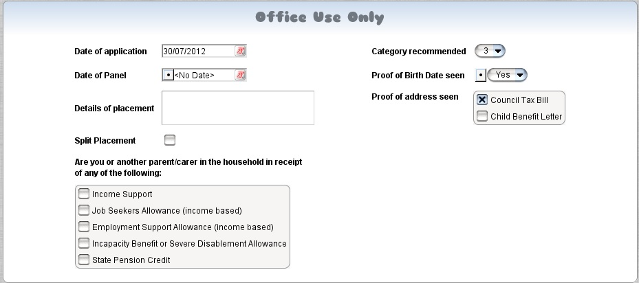

Nurseries Requested
- Your own nursery is displayed by default as the first choice
- Select the second and third choice of nursery as required

NOTE: A tick will be displayed before the nursery name if it is within catchment, if not a cross will be displayed. If this cannot be determined a ‘?’ will be displayed. This is not active in all authorities

Places Requested
This section is used to record information regarding the start date, stage, and the pattern of attendance.
- Enter an expected start date and start time
- Select the intended stage, and or confirm this.
- Select the stage group associated to the application
- If you completed the section ‘Household in receipt’ section check the two year old funding option if applicable.
- Using a combination of funded and non-funded icons select the patter of attendance

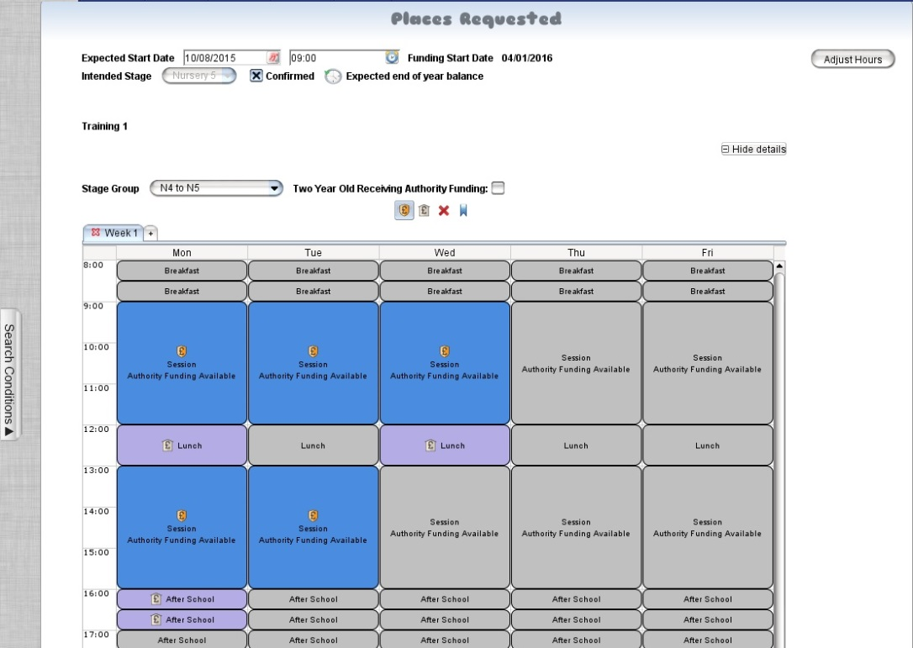

Explanations
Expected start date | The date the child is expecting to start or the next intake date. You can also enter a start time, but both can be altered later on in the process
Funding start date | Given the rules in the background and the child’s date of birth. The system will predict the funding start date.
Adjust Hours | If you know the child is in receipt of funded places elsewhere you can alter the default hours down
Intended Stage: | This will try and predict the entry stage for the child based on their age
Confirmed: | The check box locks in the stage so it does not default to the one for the date of birth. This is automatically selected if you change stage or save
Expected end of year Balance
Stage group: | This allows the user to select any setup model associated to a stage if more than one exists.
Two Year Old Receiving Authority Funding: | Flags to the system that this is a 2 year old receiving funding, and updates the funding date.
options for funding status: | Shield (£) – the places are required and are to be funded by the authority
 | House (£) – the places are required, but will be self-funded
 | Clear (Red Cross) – will clear the selected session
 | Place Holder (Ribbon) – Reserves a place which may not immediately be taken up
NAMS now supports Rotations in Hours Based Placements. Click on “+” this will now become a week 2 tab.
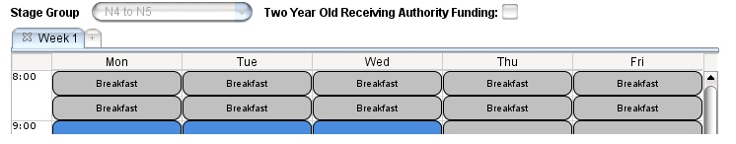
If the applicant has not taken their full entitlement of time there is an option to select from the following. Parental Choice, Cross boundary Placement, or Other. All options have the ability to provide more detailed information on the reason why.
If the second choice nursery capacity differs from your own, you can provide an attendance pattern for this, or select the NO option to say you are not providing this pattern. This is a mandatory question

Family Details
- Enter contact details as required
- If the contact is able to collect the child, click the box CAN COLLECT
- If the contacts address is the same as the child’s, click COPY CHILD’S ADDRESS. If the address is different, enter the postcode and follow the instructions given above under Child Details
- Add telephone numbers as appropriate
- Complete the Involvement section. If the contact is an emergency contact, click CONTACT
- Click OK to save the details

NOTE: If Contact Details are displayed due to a Primary Intake record, the details will be greyed out. Only the Registered School can edit this. Registered Contact shows in blue above the address. Hovering over this will display school that can edit the contact details

- The Authorisation Code is a facility to record how the main contact receives the authorisation code. The system will check to see if either a mobile, or email address is entered if that is what is selected.
- LINK CONTACT enables users to search for a contact already added to NAMS through a sibling’s application. This will not make the children siblings

Named Person
First check the drop down list to see if the person you are adding is not already listed, as once the person is saved, then this is seen authority wide. The system will not allow you to save an application if the named person is already on the list.

Depending on the age of the child or young person, a health visitor or senior teacher, already known to the family, usually takes the role of Named Person. This means that the child and their family have a single point of contact who can work with them to sort out any further help, advice or support if they need it. If the child then goes on to attend another nursery the named person will not transfer.

Ethnic Background
- Complete all selections as required
- Languages – Enter details as required
- REMOVE will remove

Child Health Information
- Any long term illness, medical condition, or disability - if ‘Yes’ is selected, the system will produce a field where any additional details can be entered. Select whether there has been a professional assessment confirming disability
- Doctor’s details - select the appropriate health board and practice from the pick list provided, alternatively, click FIND - enter search details, click NEW LIST and select the appropriate practice
- Click ADD NEW to enter a medical condition
- Select the Condition from the drop down list, click FULL for a full list of conditions
- Enter Date Informed, Informed By, Informed How and details of Medication/Action

- Concerns - select any areas of concern, add additional information in the Details field
- REMOVE removes any areas of concerns which have previously been entered
- Dietary requirements - If ‘Yes’ is selected, additional details can be entered in the field provided

NOTE: Health information entered on the application form will transfer to the pupils Record in the Health tab.

Looked After
This allows schools to record information regarding ‘Looked After Children’.

- In the Looked After By drop down list, select the local authority which is currently responsible for Care/GIRFEC Plan
- Enter the date and click ADD
- Select the Looked After type. If ‘Looked after away from home’ is selected, the ‘Away From Home’ option can be selected if required
- Select the Legislation if required

Remove LAC
Select the LAC detail and click REMOVE

Additional Information to Support Application
This is an area used by the applicant to provide additional information relevant to the application for the child.

Intended Primary
This section captures statistical information on where the applicant believed that the child will eventually progress to for their primary education. This is no guarantee that the child will get a place at the primary

Marketing Information
The Marketing questions are for statistical analysis on how best to get information to perspective parents on where to get information on nurseries. This section can also contain questions on employment status, but can be switched off.

Manage Existing Application
Active applications can be updated, this means the application has been entered but not accepted into the nursery. Accepted applications can be viewed not edited.
- Applications
- Create & Manage

- Select the application, click OPEN
- Click the padlock to unlock the application
- Edit the application as required
- Click SAVE to save changes or REVERT to undo changes

Filtering Data
To filter data, click on the drop down menu next to ‘Search By’ and select the appropriate option. The first time you enter this screen the default will be by ‘Application Status’, but if you select add to list once again it removes this filter and you will see all the data.
The options available are:
Name | Searches can be made for students by Forename and/or Surname using – ‘Starts Text’, ‘Contains text’ etc.
Application Status | Searches can be made for applications by Status e.g. ‘Active’, ‘Offered’, ‘Accepted’ etc.
Date of Birth | Searches can be made for students by Date of Birth and can be filtered to either ‘Before’, ‘After’ or ‘Between Dates’
Date Created | Searches can be made for applications by the date they were created
Last Modified | Searches can be made for applications by the date they were last modified. User can filter to select ‘before’, ‘after’ or ‘between’ specific dates
Number of Applications | Searches can be made for students by filtering the number of applications entered

Add to List
This displays the data which matches the selected search criteria. Changing the search criteria and clicking ADD TO LIST again, will add the new criteria to the existing list.
To remove this criteria from the list, right click on 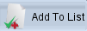 and select REMOVE

Filter Existing
This filters the existing data to show specific information, eg if the main list displays all active applications, the filter can be used to show only those students aged 3 years old. The filter can be used as often as required.
To remove this criteria from the list, right click on 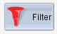 and select REMOVE

Edit Breadcrumb
Some filters can be edited by right clicking on the appropriate filter. This will allow you to add or modify existing criteria for your search.

Refresh List
To refresh the lists click on

Clear List
To clear the lists click on

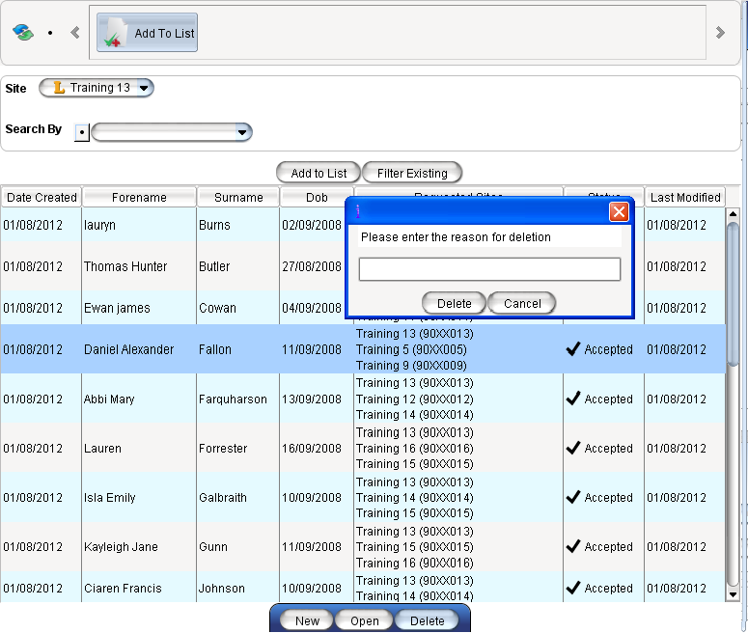
Deleting an Applications
If an application has been entered in error it can be removed using the delete option.
- Applications
- Create & Manage

- Select the application, click DELETE
- Enter the reason for deletion and click DELETE
NOTE: Accepted applications cannot be deleted

Nursery List
This facility allows nurseries to view all current applications, to organise or offer places accordingly, whilst monitoring available capacity. Pupils currently on the role of the school can also be listed for information purposes.

- Application
- Nursery List

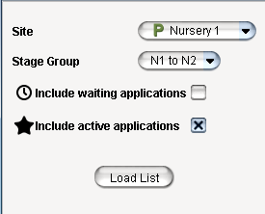
As an HQ user you will be able to change the site from the Site selector, otherwise this will be greyed out.

Filter the nursery list using the Stage Group to select the appropriate year stage, currently

N1 to N2 - 0 to 1 year olds
N3 - 2 year olds
N4 to N5 - Anti & Pre-school years

Finally select the applications that are to be displayed i.e. ‘Active’, or ‘Waiting’; and click LOAD LIST, the list is shown in an order defined by the authority.

Active application are new application forms which have not gone through the admission process as yet.

Waiting application are those which have gone through the admissions process but did not get a place, but wish to remain on your waiting list for next intake.

The nursery list will now be displayed. The site capacity for the given week is displayed on the bar graph at the top of the screen. The capacity is showing in relation to dates from the drop down list. Under the date selector, you have the ability to jump through each week by using either forward ‘>’ or back ‘<’. There is also the ability to jump to the next pupil start date using ‘>>’, or back through the admission dates using ‘<<’.

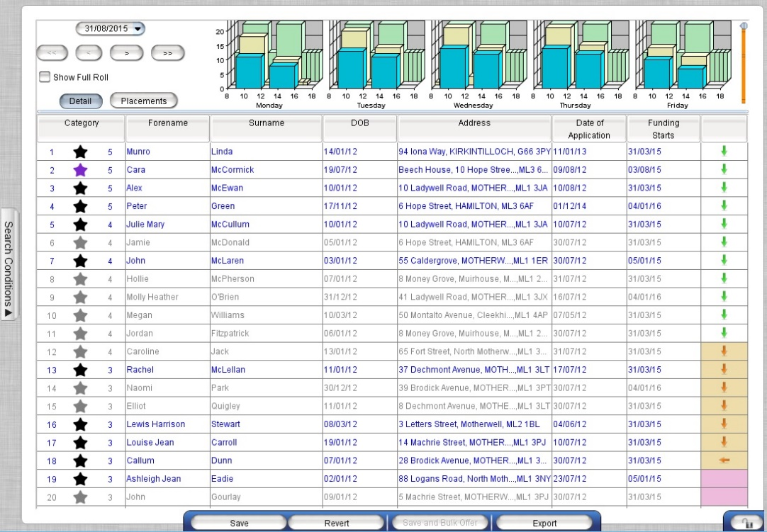

Nursery List Application Status
Child Applications can be at different stages:
 | Active | Application is on the system, but nothing has been done
 | Active | Application is on the system, is a split placement, but nothing has been done
 | Active | Allication is on the system but the start date is in the future
 | Offered | Place offered to parent, waiting on reply
 | Accepted | Place has been accepted
 | Waiting | Application has moved to 2nd or 3rd choice, but waiting in your nursery
 | Pending | Your nursery is 2nd or 3rd choice, but application is still with 1st choice

The site’s capacity is represented as a bar graph detailing the actual capacity, and potential capacity for the nursery in the selected week. You must always unlock this screen to get an accurate representation on the bar graph
This table details what each of the colours represent
Colour |  | Application count consisting of:
 | Green | overall capacity of the nursery
 | Yellow | offered + accepted + bulk offer, potential availability
 | Blue | offered + accepted, current
 | Purple | offered + accepted which is over capacity
 | Orange | offered + accepted + bulk offer which is over capacity

Details display
Within the details display, the application information is displayed detailing child’s details and application and funding dates. Application with blue text are eligible to start nursery that week, whilst application highlighted in grey refers to application which are to start in the future. Any application which shows a purple star is indicating that the application is a split placement, and hovering over the child’s name will give you details of the other nurseries.
Whilst the screen is locked you can sort the order by any of the headings, but once unlocked the list reverts back to the stored sort criteria
To move applicants within their categories, select the applicant to move, and drag it to the new position. Names cannot be moved between different categories.

The ‘Category’ column has 2 sets of numbers on the left, this is only a row number, and on the right this is the applications category.

- To offer applicants, use the arrows (Bulk offer marker), in the last column. This is only displayed when the screen is unlocked. Click next to the last applicant you wish to offer, and then click BULK OFFER. All Applicants above and including the selected applicant will have the status changed to Offered.

Legend for hours based Text Colours
Colour | Description
Red | Child's placement conflicts with the offered capacity at any point
Black | Full roll child without a capacity conflict
Grey | "Active" application for which the start date has not yet been reached
Blue | "Active" application with a past start date which does not have any capacity conflict

- If an application requires the hours requested changed, make sure the padlock is unlocked, and then right click over the child’s name. You will get a prompt to edit the placements, otherwise you will only be able to view the information.
- Place holders are also available in this screen – these remove space from capacity but do not offer space to the child – thus saving a place if the parent wishes to use the space at a later stage

Bulk Offer Column Colours
Arrow | Background | Description
Green | White | The placement can be accommodated for the whole year
Orange | Sandy | The placement can be accommodated for the current week, but not the whole year
None | Pink | The placement cannot be accommodated for the current week, or in the future

Placements display
The placement display represents the time allocation for each application.
Within the placement display, the application information is displayed detailing child’s time allocation. As before applications with blue text are eligible to start nursery that week, whilst application highlighted in grey refers to application which are in the future. Any application which shows a purple star is indicating that the application is a split placement, and hovering over the child’s name will give you details of the placement in the other nurseries.
Whilst the screen is locked you can sort the order by any of the headings, but once unlocked the list reverts back to the stored sort criteria
You can still move applicants within their categories, select the applicant to move, and drag it to the new position. Names cannot be moved between different categories.
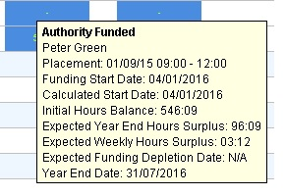
Time Block

Each block represents an allocation of time in relation to the nurseries setup, and by hovering over the block you will be shown a detailed breakdown of the allocation.

Title | Explanation
Placement | This the date the placement starts
Funding start date | Working with the authorities funding rules, this will show the expected date the child will start to receive funding from the authority
Calculated Start date | This is the date used to calculate the funding amount
Initial Hours Balance | Each block will show the hours remaining from the start of school session.
Expected Year End Surplus/Shortfall
Expected Weekly Hours Surplus/Shortfall
Expected Funding Depletion date
Year End Date

Placement View Block Colours
Blue background | Authority Funded block
Lilac background | Non-authority funded block
Green background | Placeholder block
Red Text | Negative remaining hours balance
Green text | Positive remaining hours balance

Offer/No Offer Letters

This menu allows the user to send letters to those students, with the status Offered or No Space, informing the parents of this decision. A file can be generated by the user which can then be used as a mail merge data file or an authority letter can be sent. This menu will also display information on the last letter sent to the student. The output now contains field's specific to the hour's placements.

- Application
- Offer/No Offer Letters

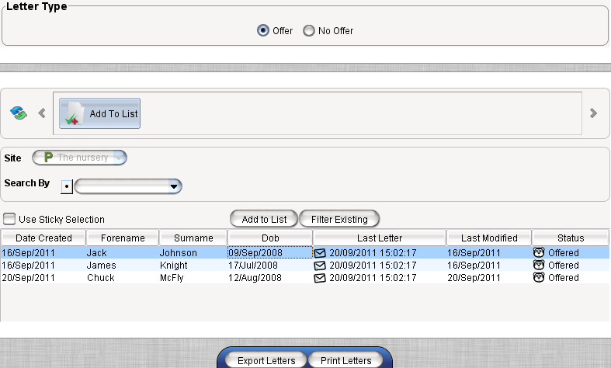
- Select OFFER or NO OFFER in the ‘Letter Type’ section
- Select required pupils
- Click EXPORT LETTERS, the file generated can be used as a database file for mail merge within MS Word

- Selecting PRINT LETTERS will print the letter for the selected pupils (Authority Specific)
- A date and time is added to the Last Letter column to indicate that a letter has been sent

Record Placement Decision

This menu is used to change the application status. This is done individually rather than in bulk. Applications with placements which conflict with site capacity will be shown in red.

- Applications
- Record Placement Decision

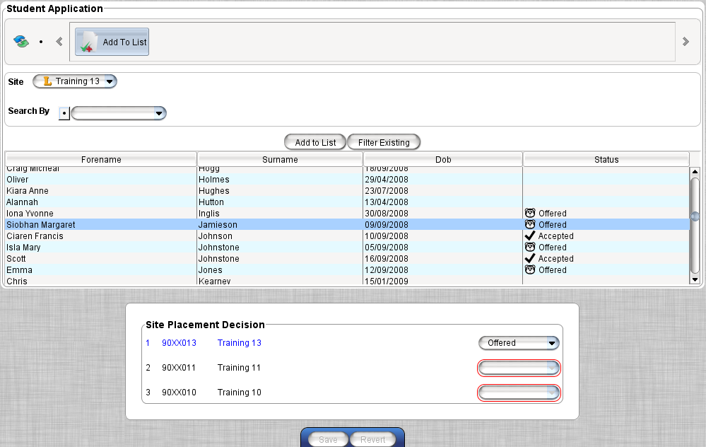
- Select pupil record
- In Site Placement Decision, select the appropriate decision from the drop down, then click SAVE

- Changes can be made to the placement details, as necessary, when changing to ‘Offered’ or ‘Accepted’.
- Click PROCEED

NOTE: Head Quarters may be able to add a fourth choice nursery if the child cannot be placed in the first three choices. This option will only appear after the third choice has set to No Space, and provided this option has been turned on for the Authority.
NOTE: If the status is changed to No Space, users will be asked if the application needs to be added to the Waiting List (Authority Specific)

If an application has moved on to the 2nd or 3rd choice nursery, it can be moved back to the previous choice nursery.

- Set status to Active in the current nursery
- Change the previous choice nursery status from No Space to Offered etc.

When changing to offered, the new placements screen will be displayed. Provision has now been made to add rotations at this point.

As previously you can amend the expected start date and time for the pupil and the funding start date will now also be shown.
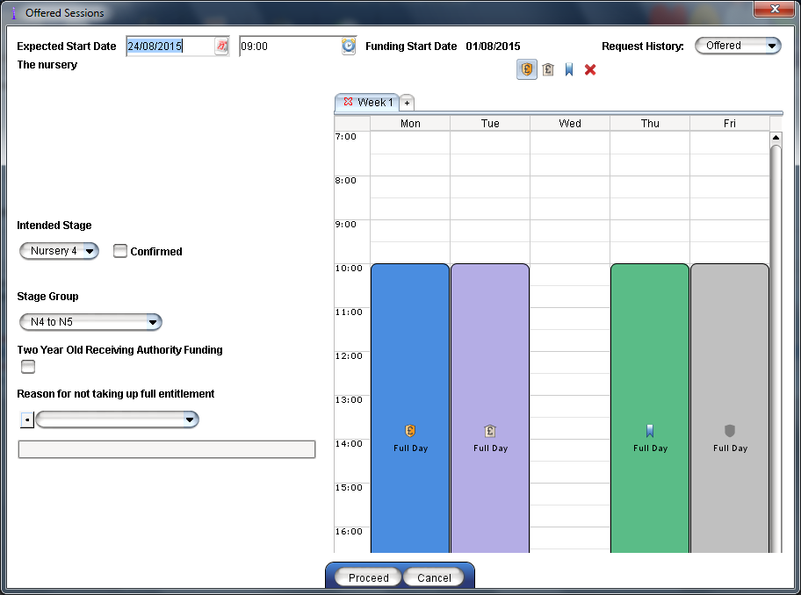

The ‘Intended Start Date’, ‘Stage Group’, ‘Two year olds’, and ‘Reason for entitlement’ can be completed but are not mandatory.

Application Status
Child Applications can be at different stages:
 | Active | Application is on the system, but nothing has been done
 | Active | Application is on the system, is a split placement, but nothing has been done
 | Offered | Place offered to parent, waiting on reply
 | Accepted | Place has been accepted
 | Waiting | Application has moved to 2nd or 3rd choice, but waiting in your nursery
 | Pending | Your nursery is 2nd or 3rd choice, but application is still with 1st choice
 | No Space | Refused in your nursery, this can be moved to 2nd or 3rd choice
 | Not Accepted | Parent has not accepted the place
 | No Response | Parent has not responded

Temporary Identification Codes

This menu is used by HQ in the exceptional circumstance where a Birth Certificate or Passport is not available and therefore a Temporary Identification Code will be required instead. This then enables the nursery to add the application. It is recommended that once a birth certificate or passport is available, that this is then updated in the Temporary Identification Code.

- Applications
- Temporary Identification Codes

- Enter the child details in the relevant fields
- Click GENERATE TEMPORARY CODE
- A message will then appear advising you that a match could not be found and that a Temporary Code will now be generated. Click CONFIRM
- The child will then appear in the Existing Temporary Codes list. The Temporary code displayed can now be given to the nursery to enable them to add the application

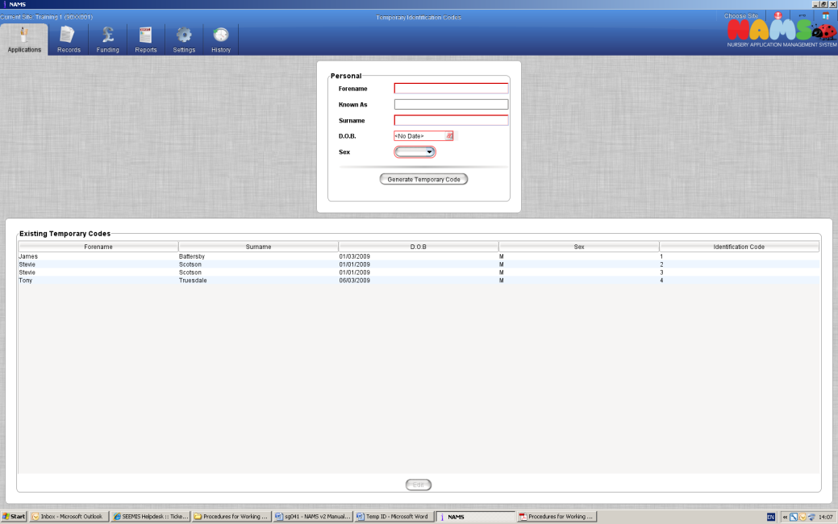

Editing Temporary Codes

When a passport/birth certificate has become available after a Temporary Code has been generated for a child, this information must be entered to replace the Temporary Code.

- Applications
- Temporary Identification Codes

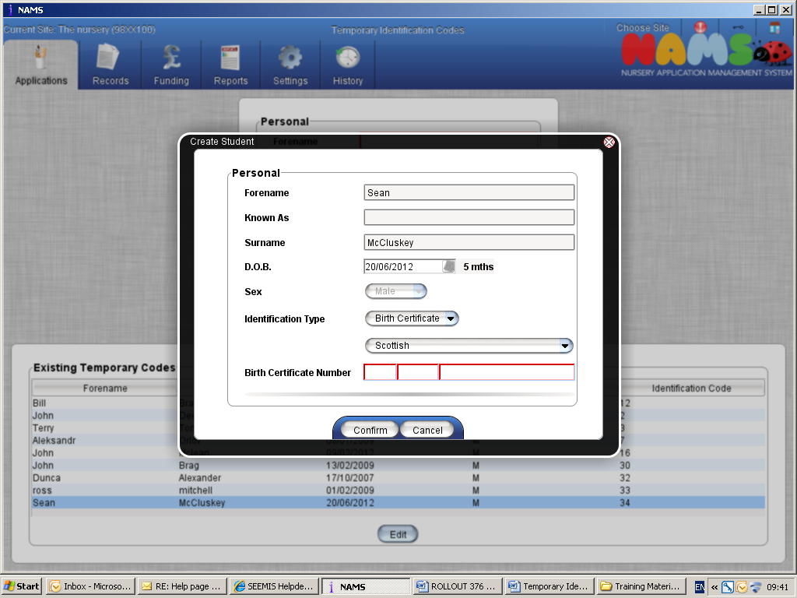

- Select the child that is to be updated with birth certificate / passport
- Click EDIT
- Select the identification type and Country
- Enter the passport number / birth certificate number in the field provided
- Click CONFIRM
- The child will now disappear from the list of temporary identification codes as their record would have been updated with the birth certificate / passport number

HQ Received (Authority Specific)

Some authorities require that some form of confirmation be forwarded to headquarters before funding can be received. Headquarters can use this screen to acknowledge that a form has been received. This action will need to be performed to allow authorisation codes to be generated for students.

- Application
- HQ Received

- Use the filter to display students, check the box in the Acknowledged column
- To select more than one child click USE STICKY SELECTION and select the appropriate students, click on the check box in the Acknowledged column. All selected students will be marked as acknowledged
- Click SAVE to save changes or REVERT to undo all changes

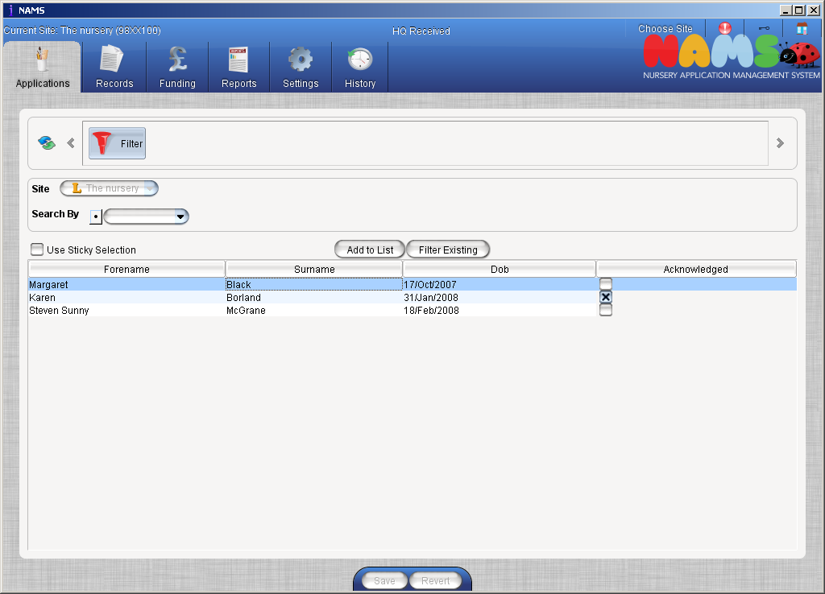

Records

Accept/Reject Enrolments

This facility allows the Nurseries to accept or reject enrolments for the Nursery. Those students, who have been accepted into a nursery, require to be enrolled to allow authorisation codes to be generated and any funding changes made. Any pending enrolments are displayed and the user can select to accept or reject them.

- Records
- Accept/Reject Enrolments

- Click on the start date and a drop down calendar will appear. Select the desired start date by changing the year, month and then double clicking on the specific date
NOTE: This needs to be the date the pupil started attending the Nursery
- Click on the stage and select the appropriate stage from the list displayed
- Click to include the appropriate student
- Use Sticky Selection to select multiple records
NOTE: The control key can also be held to select multiple records
- Click ACCEPT or REJECT
- Clicking RELOAD will refresh the screen if required

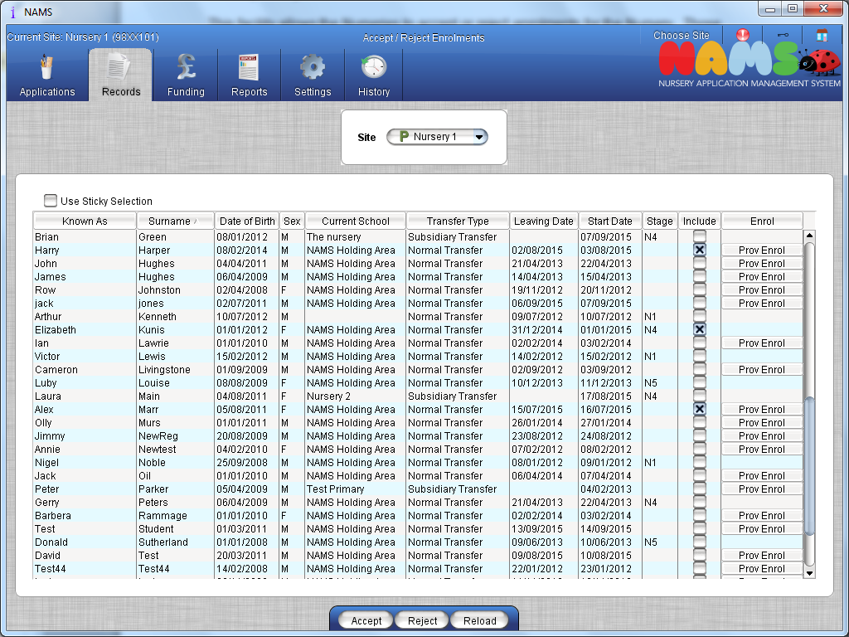
Prov Enrol ?xxxxxxxxxxxxxxxxxxxxxxxxxxx
NOTE: For all Local Authority Nurseries, please ensure once the record has been fully enrolled, that the record has an attendance pattern entering in the ‘Records Edit’. Also add this to the ‘Set patterns’ within the ‘Click+Go’ application.

Edit

The Edit screen is used to ensure you pupil’s data is as up-to-date as can be. This screen contains several tabs to display or used to make changes to the pupils’ details once the pupil is accepted into the nursery.

- Records
- Edit

- Unlock the padlock to activate edit mode
- Click SEARCH CONDITIONS
- Search for and select the pupil, click the ‘Open’ button at the bottom of the window to view the details

The screen below will be displayed. This screen shows the name of the selected pupil towards the top. To the right of the pupils name there are two buttons available. These allow the user to go to the previous or next pupil from the initial search.
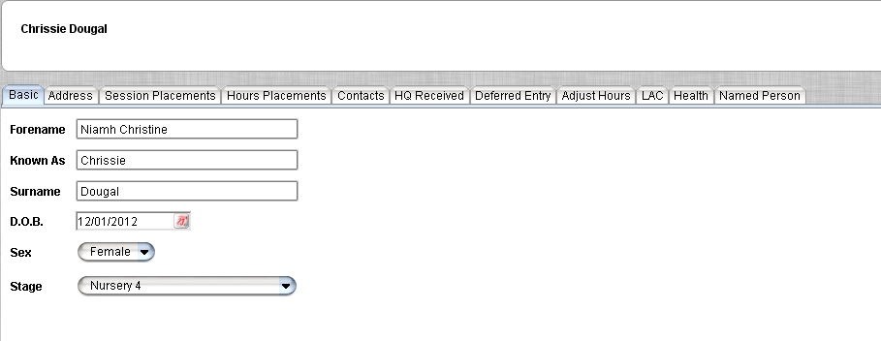
Below this there are the different tabs which hold the information relating to the selected pupil.

Basic
This tab holds the name, date of birth and year stage of the pupil.
Edit the details as required and then click SAVE

Address
The address details are held in this tab.

- Enter Postcode and click ‘Go’
- All addresses associated with this postcode will be displayed, select the relevant address and click ‘Confirm’
- If the address is not listed, click ‘Not Found’
- Enter address details in fields provided, click ‘Confirm’
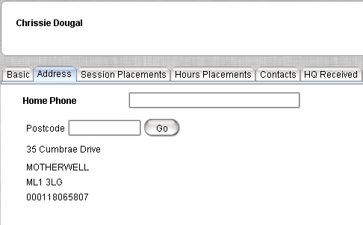
- Click ‘Save’

Hour’s placements

Current, future and previous placement information is shown in this tab. This needs to be accurate before being updated. This will ensure the attendance pattern for the child is recorded correctly and that the capacity within the nursery list reflects this.

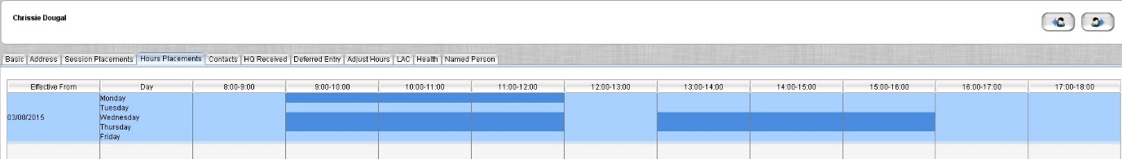

Add
The ‘Add’ function allows you to add another attendance pattern for a pupil enrolled in the nursery
Edit
The ‘Edit’ button allows you to edit existing placement details. You will only be able to make any changes up to 2 weeks, thereafter you can contact your HQ who can make changes after this time. First select on the placement row
Delete
The ‘Delete’ option will delete the attendance pattern. First select on the placement row, then click on ‘Delete’
After using any of the options click on the ‘Save’ or ‘Revert’ to undo the changes you have made.

Contacts
This tab allows contacts to be added, edited, linked, or removed, from the child’s record.
NOTE: You will not be able to remove a contact if they are the Registered Contact within Primary Registration.

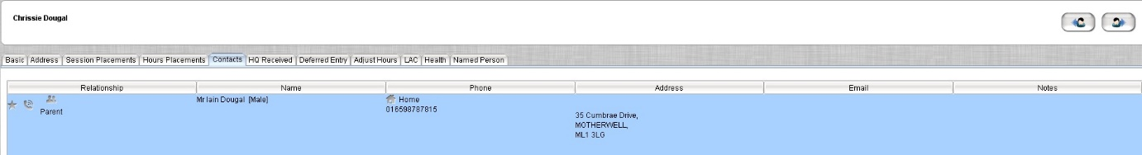

Description of Icons
Represents a Parent, Grandparent, Step Parent or Foster Parent.
Represents a Guardian, Aunt/Uncle, Sibling, Other Family, Social Worker or Educational Psychologist.
- Represents a Doctor.
Represents Emergency contact(s).
- Represents the Main Contact.

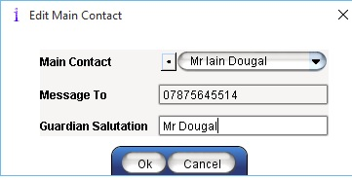
Main Contact
A contact should be selected as the Main Contact to identify the person letters will be addressed to when printed using the Click + Go application. If the record was a NAMS application then the applicant noted on the application form this will be listed as the main contact.

- Click MAIN CONTACT
- Select who is to be the main contact from the drop down list, click OK
- The main contact can be removed if required by clicking on

Message To
A preference may be set to allow SMS or Email details to be added. Messages are then sent to this number or email address for the main contact unless otherwise specified from the message specifier radio button.
Guardian Salutation
Enter how the parent/guardian would prefer their letters to be addressed e.g. Mr Gary Anderson or Mr and Mrs Anderson etc.

- Type in the field how the letters should be addressed
- Click Ok

For Partner Nurseries only

There is a facility to allow an Authorisation Code Delivery to be added or amended for the main contact only. The code delivery can be selected within the Authorisation Code section
Contacts

- Highlight Main Contact
- Click ‘Edit’
- Select authorisation code from the Preference drop down
- Click ‘Ok’
- Click ‘Save’

NOTE: For preferred method, ensure details are present in contact details e.g. Mobile number present if preferred method is SMS

Adding a New Contact

- Click ‘New’
- Complete the contacts details as outlined
- Click ‘Ok’
- Click ‘Save’

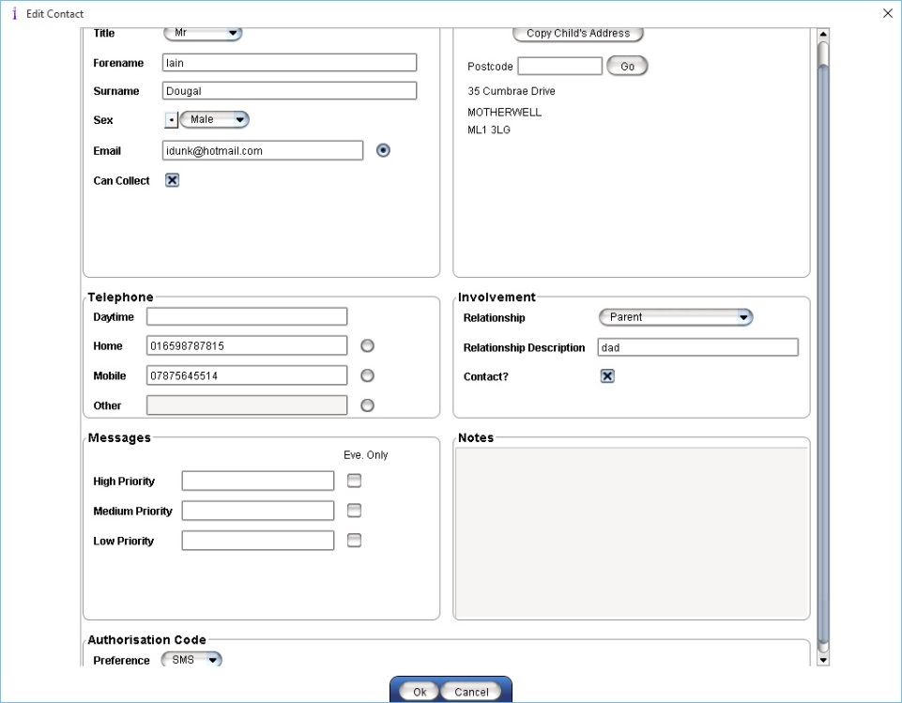

Editing an Existing Contact
This allows for making changes to existing contact data
- Select the contact to be changed
- Click ‘Edit’, alter the details as necessary
- Click ‘Ok’

Removing a Contact
This allows for removing existing contact data
- Select the contact to be removed, click ‘Remove’
- Click ‘Ok’

Emergency Report
The emergency report provides basic information on the child’s address, contacts, and medical conditions if recorded.
- Click ‘Emergency Report’
- Select ‘Open’, ‘Save’ or ‘View’ the PDF document

Linking
The Link option can be used to link contacts. If the link facility is used with parental contacts then the pupils will be marked as siblings

- Click LINK
- Select contact
- Use Relationship drop down to select appropriate relationship
- Select whether the contact will be Emergency Contact, click OK

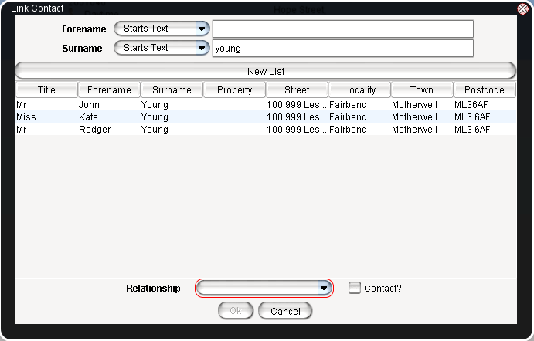

HQ Received
Only used by Headquarter users that have been granted access in the AAC application. Used for headquarters to allow the authorisation code to be generated even if the HQ Received under Applications has not been checked.

- Check the Ignore HQ Received check for authorisation codes
- Click ‘Save’

Deferred Entry
A nursery student can be marked as deferred by ticking the Defer Entry checkbox. The pupil will be ignored by Turnaround and Planning when incrementing the stage, after which the tick will be removed.

- Check the Defer Entry check box
- Click ‘Save’

Adjust Hours
This tab allows the adjustment of student hours for the academic year. Multiple Positive/negative adjustments can be entered.
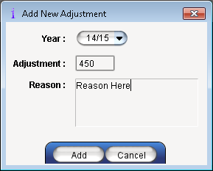
- Click ADD at bottom of the screen
- Select appropriate Year is not current session
- Enter Adjustment and reason
- Click ADD
- Click SAVE

NOTE: Any adjustments made will be reflected throughout the NAMS record

LAC
This allows schools to record information regarding the ’Looked After Children’ status.

- In the Looked After By drop down list, select the local authority which is currently responsible for Care/GIRFEC Plan
- Enter the date and click ‘Add’
- Select the ‘Looked After type’. If ‘Looked after away from home’ is selected, the ‘Away From Home’ option can be selected if required
- Select the Legislation
- Click SAVE

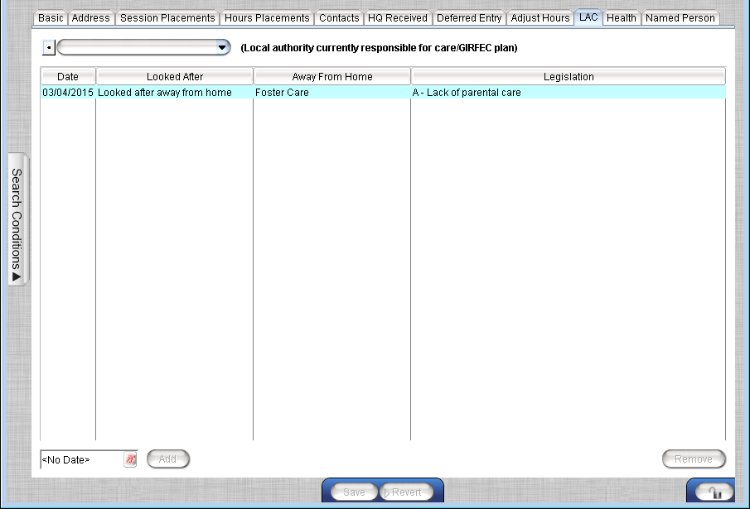

Remove LAC

- Select the LAC detail and click ‘Remove’
- Click ‘Save’

HEALTH
This allows the Heath Board and Practice details to be entered along with any medical Conditions.

Add a Medical Practice

- Select the Health Board and medical practice from the drop downs.

Add a Medical Condition

- Click ’Add New’ to enter a medical condition
- Select the Condition from the drop down list, click ‘Full’ for a full list of conditions
- Enter Date Informed, Informed By, Informed How and details of Medication/Action

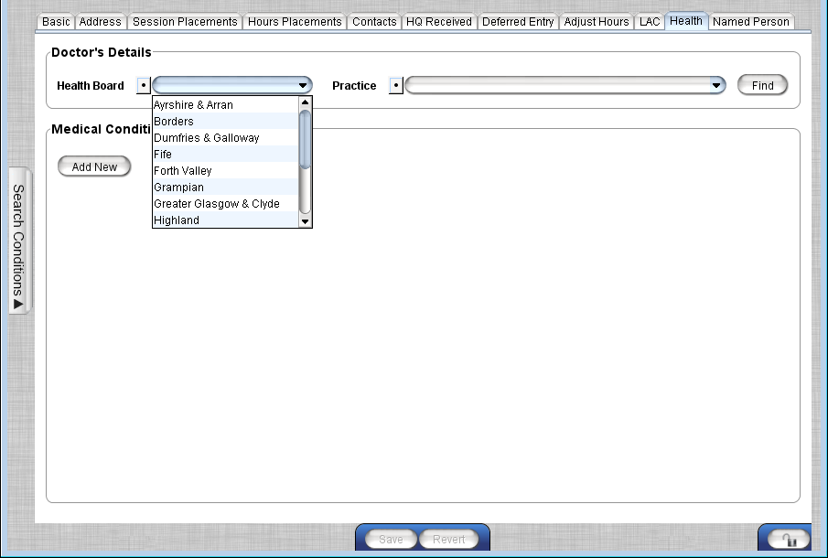

NOTE: It is possible to narrow the search for medical practice by clicking the FIND button, this will open a window which allows you to search by name, or address information from the medical practice list.

Named Person
This tab allows the selection of the Named person or new Named Person data to be entered

To select previously entered Named Person
- Unlock the padlock
- Select Named Person from drop down list
- Click ‘Save’

Add a new person
- Unlock the padlock
- Select Enter New Named Person from the drop down
- Enter new name in Name field
- Enter details as appropriate in remaining fields

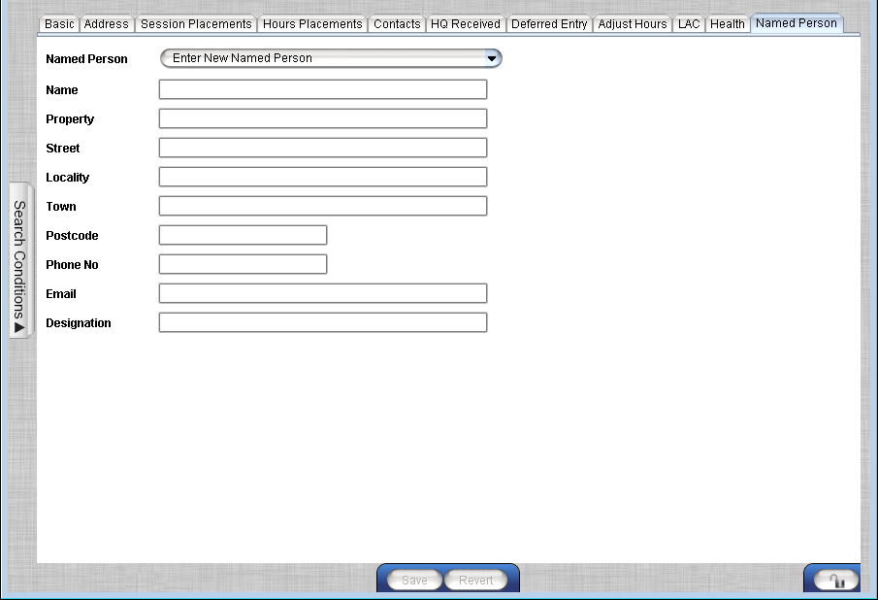

Mark Leavers

Allows pupils to be marked as leavers either to a different nursery school, or to a primary school. If you have the split placement record as indicated by the check mark in the ‘Split’ column, you can then only enter a leaving date.
- Record
- Mark Leavers

- Select the appropriate student(s)
- Select the relevant reason for leaving from the drop down list
- Enter the student’s leaving date
NOTE: This is the exact date the pupil leaves or has left the nursery
- If the transfer is a confidential transfer ,tick the available box
NOTE: HQ will advise whether a transfer has to be marked as confidential
- Filter to select destination, click NEW LIST
- Select relevant destination
NOTE: Unknown is used if pupil has been removed with no further details
- Click MARK SELECTED STUDENTS AS LEAVERS

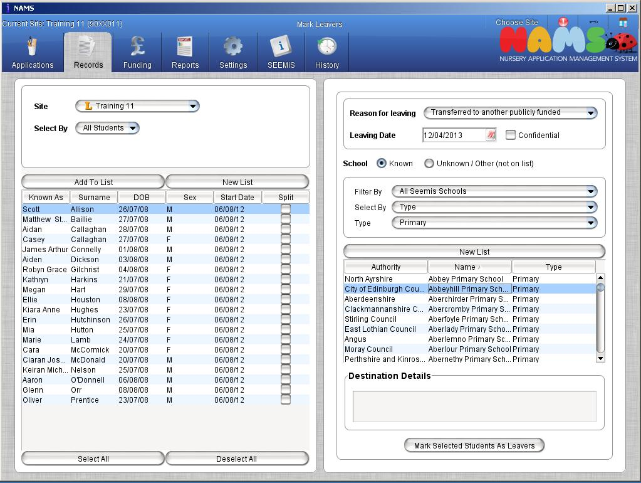

Capacity Conflicts
This screen will display conflicts between changes to a nursery setup, and the application forms already entered. This screen can be used to resolve conflicts between Site Capacity and students placements. Clicking on a conflict will show the pupil(s) affected at the right hand side. By resolving a conflict that is listed for more than one pupil, this will update that pattern for all pupil(s).

- Records
- Capacity Conflicts

The stage group and week displayed can be altered using the dropdown lists at the top of the screen. By using the left and right double chevrons you can move to the next/previous conflict date.

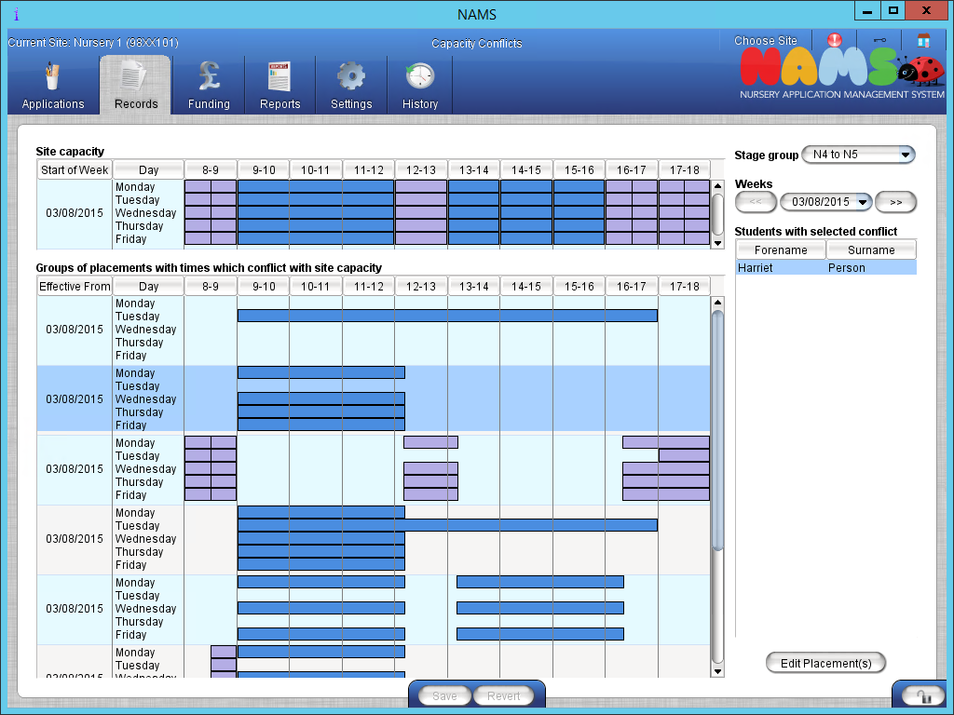
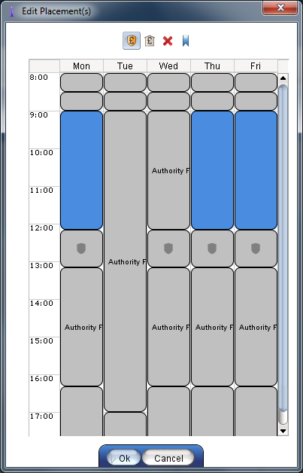
Edit Placement

This screen will allow placements displaying as a conflict to be edited

- Unlock the screen by clicking on the padlock
- Select placement to see pupil(s) affected
- Click ‘Edit Placement’
- Placement details can be added or edited as required e.g. Authority Funded, Not Funded
- Click ‘Ok’
- Click ‘Save’

NOTE: Screen will not show conflicts which have been superseded e.g. if an application form has a request which conflicts with site capacity but the student has been offered a place which doesn’t conflict with site capacity

Funding

Generate Authorisation Code
In order to validate that the students are attending the nursery, the local authority allocate a unique code for the student. This code is sent to the applicant. The code is returned, by the applicant, to the nursery where it will be entered against the application. Students are confirmed based on the code being entered. Codes are generated for a particular nursery and period. 2 year olds which are funded by the authority will not receive an authorisation code

- Funding
- Generate Authorisation Code

- Select the appropriate Nursery, and the appropriate period or select saved criteria
- Click GENERATE AUTHORISATION CODES
NOTE: Codes are only generated if:
- child age is between 3 and 5 years old
- child has been accepted into nursery
- start date is the same or after the funding period start date
- application has been received by HQ (Authority Specific)
- Select to open or save the report in PDF or CSV format
NOTE: The CSV can be used for mail merge purposes

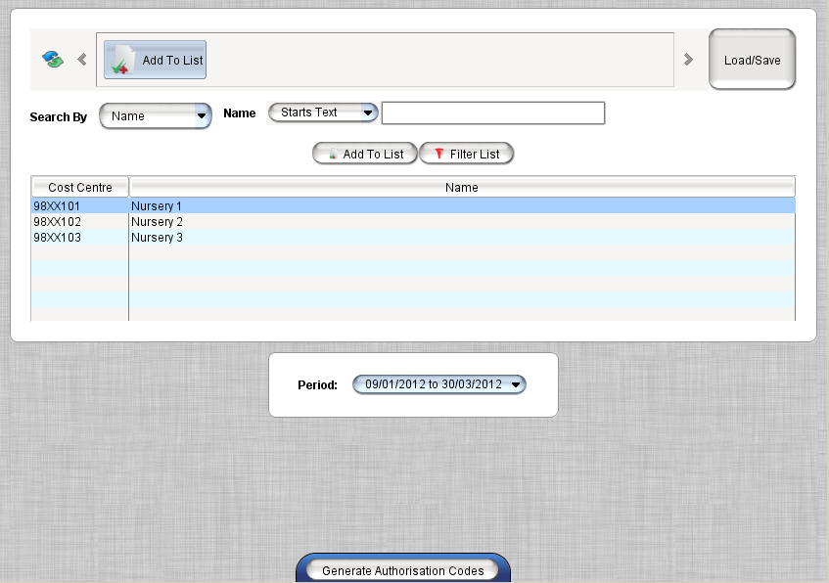

Enter Authorisation Code
This facility allows the user to enter authorisation codes against a particular application. The applicant will provide the authorisation code previously sent to them by the authority, and this code can be entered using this menu item.

For funded 2 year old children HQ users will need to enter the start and end date for those children in each establishment.

- Funding
- Enter Authorisation Code

- Select the appropriate Authorisation Period from the drop down
- Ensure the padlock has been clicked and unlocked
- Double Click into the appropriate Code field and enter the code
NOTE: HQ’s will be able to see the codes. Codes that have been entered will appear in Green, codes that are to be entered will be in Blue
- Enter the start date and end date of funding
NOTE: Available dates will be in black text on the calendar
- Click SAVE
NOTE: Leaving the cursor over student’s details, will show a pop up box of why the code cannot be generated

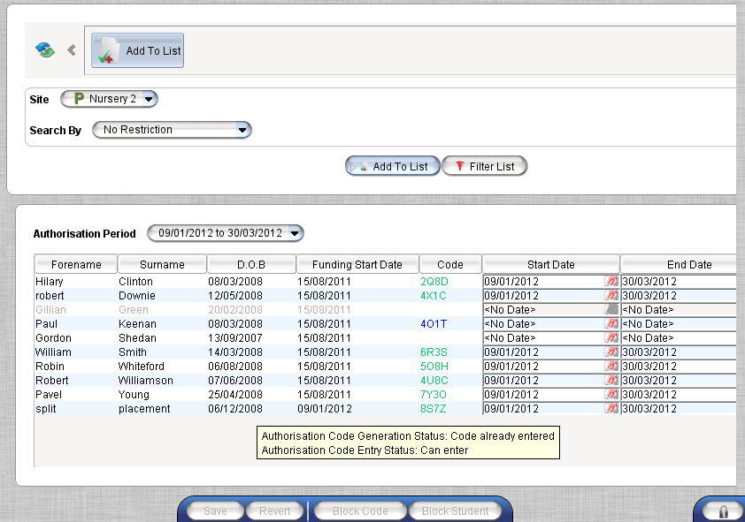

- BLOCK CODE - This stops a Nursery from using a generated authorisation code
- BLOCK STUDENT - This stops an authorisation code being generated for the selected student. If this was done in error contact your early years team who will liaise with SEEMiS to unblock the student.

Manage Payment Adjustments

This menu is used by HQ to enter any manual payment adjustments that may be required for Private Partner Nurseries.
- Funding
- Manage Payment Adjustments

- Click ‘Add’
- Complete each field with the relevant information
- Click ‘Add’. This amount will now appear in the next payment run for the selected nursery
NOTE: when the payment is made, the payment run number will be displayed in brackets in the paid column

Remove a payment
- Select payment
- Click ‘Remove’
NOTE: This can only be done if the payment hasn’t been made yet.

Generate Payment

This facility allows the user to generate payments for partner nurseries. These nurseries require payments for all local authority funded places. Payments are calculated for each period and are based on the accepted places in the nursery.

Payments can be made over the periods covered by the sessions, and hour’s payment methods, although they will need to be individually.

Alternatively users can choose to view a Forecast payment, this allows the nursery to view the predicted amounts for the payment run and can include any students who have still to return the authorisation code.

- Funding
- Generate Payment

- Select either the appropriate Nursery(s) or saved criteria
- Select ‘Forecast’ or ‘Actual’
NOTE: If Forecast is selected, choose the appropriate option from the drop down pick list
- Select the hour or session based period, click ‘Generate’
- Report can be opened/viewed/saved in PDF format or opened/saved in Excel format
NOTE: if selected - Breakdown by day and Breakdown by student will show this information in the printout. Also the excel spreadsheet will provide a more detailed picture of the payments, and reasons.
- If you select ‘Actual’ you will also get the option to generate a CSV file for invoice payment.
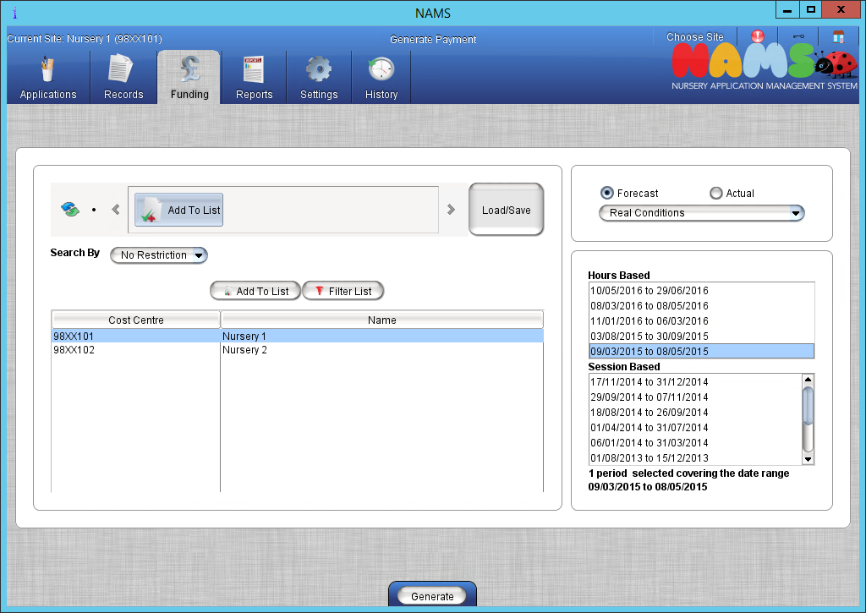

Authorise Payment
Note: Authorise Payment is currently still under development, and not used by all authorities

This screen allows the authorisation of NAMS Payment Feeds and transfer of the data to a Recital file for processing by the authority on ECSU. The screen will show a drop down list containing the payment runs that can be authorised.

If the payment run contains one or more sites that the user does not have access to, then the payment run will not appear in the combo box.

If a payment run has not already been authorised, the Authorise Payment Run button will be enabled. On clicking this button, the system will attempt to generate a Recital File and copy this onto an FTP server. The report dialog will then display, allowing a payment run report to be produced.

If the payment run has already been authorised, selecting a payment run will show the authorisation timestamp underneath the combo box and the Print Report button will be enabled. The Print Report button will show the same report generation dialog shown when finished authorising a payment run.

The screen will be inaccessible if no payment authorisation configuration has been setup.

- Funding
- Authorise Payment

Reports

Available Spaces Report
This report allows the user to gain an overall picture as to the capacity for the selected site. The report will show in a graphical format the available spaces, active applications, and the number of waiting applications. If the nursery is oversubscribed then this is represented by the (Red) hue blocks, if the nursery is full then the (Yellow) hue blocks are shown, and if there are spaces available these are represented as (Green) hue blocks.
- Reports
- Available Spaces Report
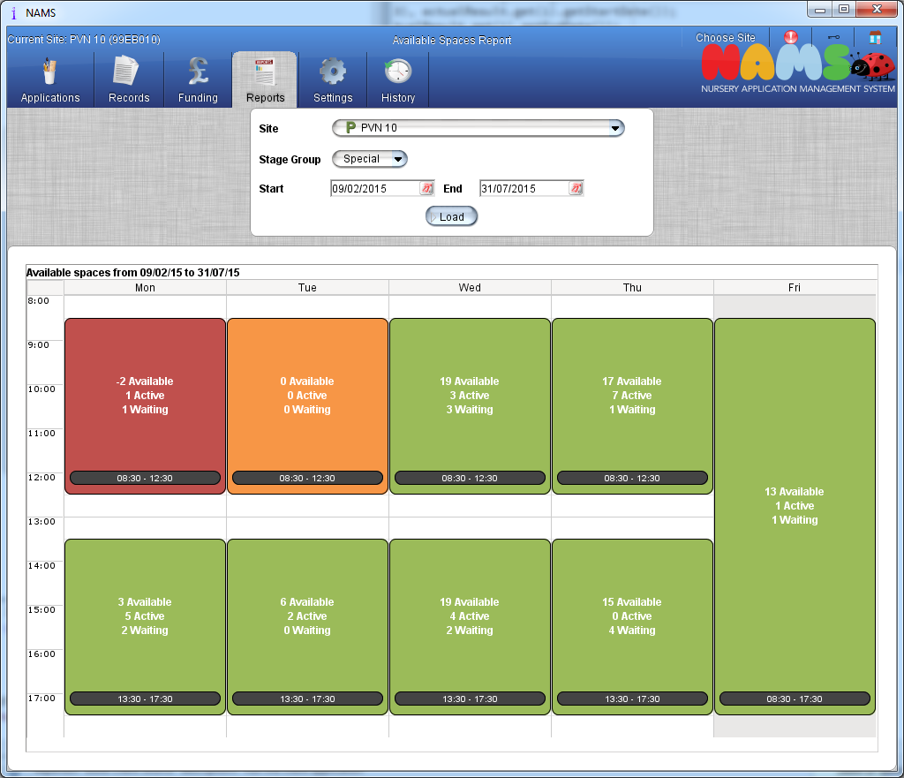

- Select the required site from the selector
- Select the requires year stage from the selector
- Using the ‘Start’ and ‘End’ date selectors provide a date range foe the report to evaluate
- Click on the ‘Load’ option to display the report

If required you can right click over the table and copy this into your spreadsheet, for further use.

View Existing Authorisation Codes

This facility allows the user to view any previously generated codes. This can be used to view the history of codes or to distribute them again if required.

- Funding
- View Existing Authorisation Codes

- Select either the appropriate Nursery(s) or saved criteria
- Select the appropriate period from the pick list of dates available
- Click ‘Export Existing Authorisation Codes’
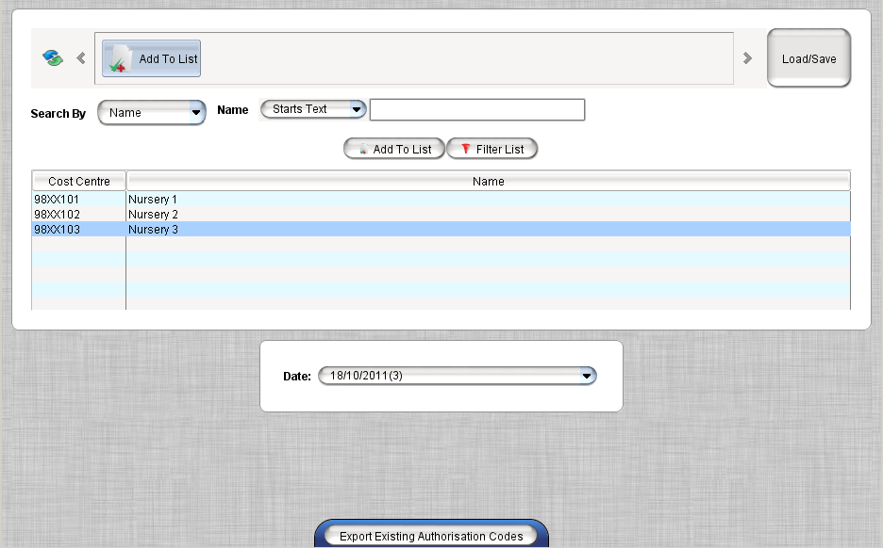

- Report can be opened/viewed/saved in Excel format

View Existing Payment Report
Once a payment run has been generated for a nursery site, the payment can viewed using this menu option. It allows the user to view the history of payments generated to date. The report details a breakdown summary of information by nursery listing all relevant students and also includes a breakdown of student by days attended.

- Funding
- View Existing Payment Report

- Select either the appropriate Nursery(s) or saved criteria
- Select the appropriate payment run, click LOAD PAYMENT DETAILS
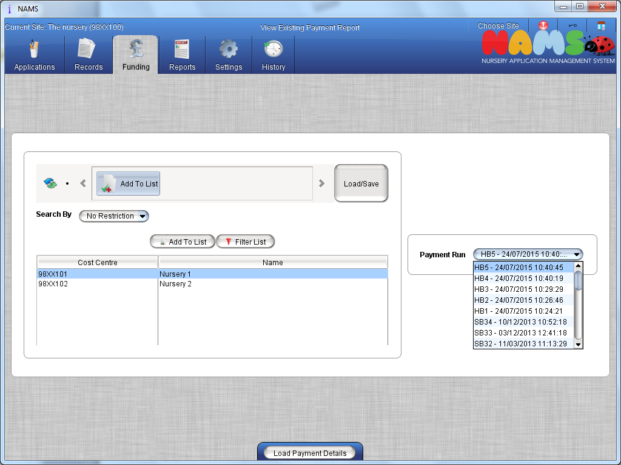
- Report can be opened/viewed/saved in PDF format or opened/saved in Excel format or you will also get the option to generate a CSV file for invoice payment.

NOTE: the letters 'HB' will prefix an hour's based payment run, and the sessions based payment runs are prefixed by the letters 'SB'

Authorisation Code Status Report
Nursery sites require a facility to track the authorisation codes for the accepted applicants. This menu allows the generation of a report which will display the authorisation code status for those applications.

- Reports
- Authorisation Code Status Report

- Select the Nursery
- Select the Period to view
- Click ‘Generate Authorisation Status Report’

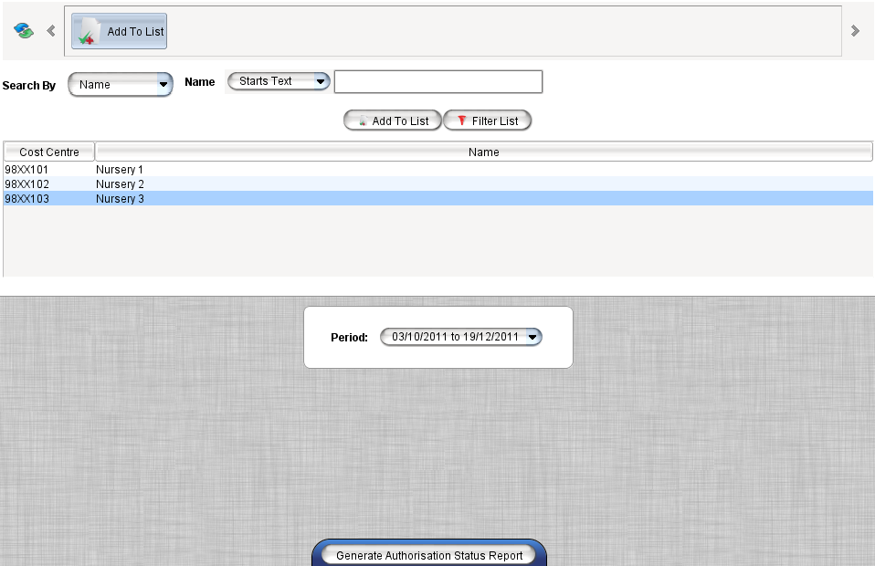

- Report can be opened/viewed/saved in PDF format or opened/saved in Excel format

Breadcrumb Report
This enables reports to be created and saved with information based on either the Application Form or Current Nursery. Columns can be removed / added to view the details. Headquarters can create a report for all Local Authority Nurseries, all Private Partner Nurseries or both. The reports will now include details on Hours, and session for historical use.

- Reports
- Breadcrumb Report

- Select the tab – ‘Application Form Data’ or ‘Current Nursery Data’
- SEARCH CONDITIONS allows the user to select search parameters using the Search by drop down list
- Select the search criteria, by clicking on the button will allow for more criteria to be added, if necessary
- Searches can be done on current site, selected sites, ALL Local Authorities (LA) or ALL Private Partners (PVN) by selecting the relevant option
NOTE: by selecting LA will select all LA nurseries, and show Private Partners for selection, or select both to select all nurseries
- Select the site status, i.e. Is the current site, or is the 2nd choice site, click ‘Add To List’
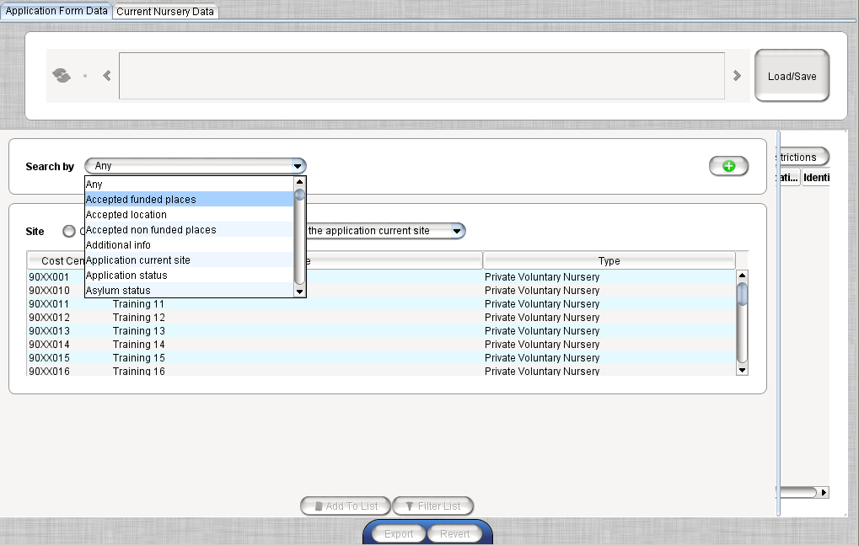

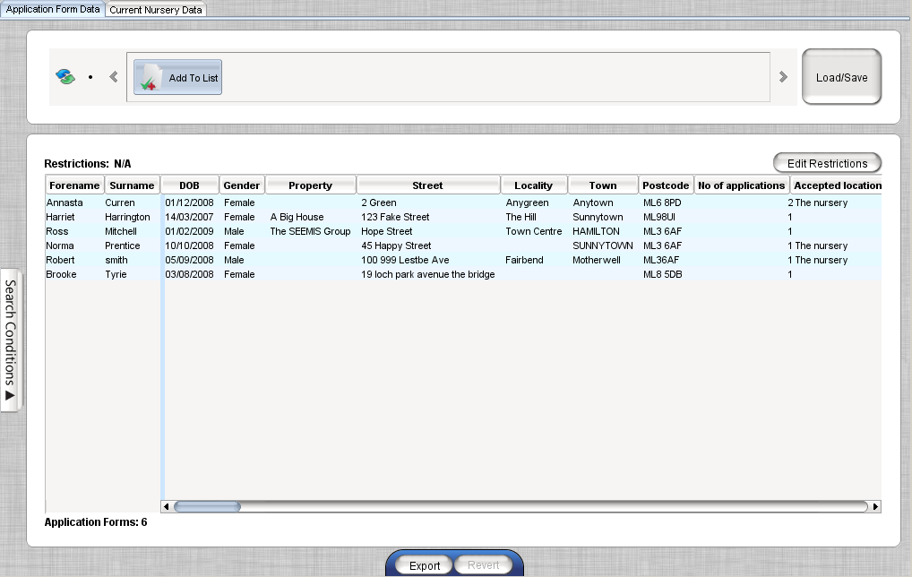

NOTE: To remove a column from the report right click on any column heading and deselect headings to remove from the report
- EDIT RESTRICTIONS will show only the main contact if selected, all other contacts will not be displayed. Deselect to see all contacts, also this can be used to restrict the looked after status to current, and will not display historic events

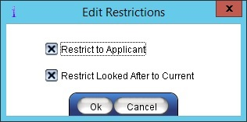

- EXPORT allows the information to be opened/viewed/saved in PDF format or opened/saved in Excel format
- To save, click LOAD/SAVE and enter a name for the document
- Click SAVE CURRENT
NOTE: HQ’s users can have access to enable them to publish a report for all users, before the report is saved, Publish is selected
- To load a saved report, click LOAD/SAVE, select the report to view and click LOAD SELECTED

Cross Boundary Report
This report allows the user to display a list of the students attending the nursery(s) from any other local authority. This is determined by the postcode entered on the application or by the postcode listed in the current student record at the nursery site (which may be different). The report will display the students and the local authority for this postcode, broken down either by nursery site or by external local authority.

- Reports
- Cross Boundary Report

- Select to use either ‘Application Form Address’ or ‘Current Address’
- Select Report Options as required, click EXPORT
NOTE: Can be viewed by individual nursery, or by all (HQ)

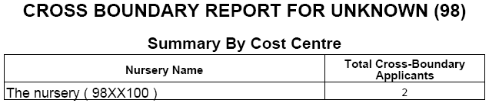
- EXPORT allows the information to be opened/viewed/saved in PDF format or opened/saved in Excel format

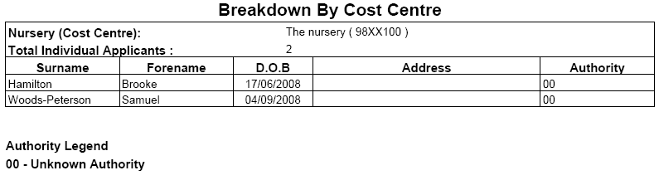

Appendix

Saving Report Data
Specific menus have the option to save the search criteria. Click type in the name, and click SAVE CURRENT
To load the search criteria, click, select the saved report to open, and click LOAD SELECTED
To delete a report, click then click on DELETE SELECTED

Sorting Data
Data within columns can be sorted as necessary. This helps find information in a long list, as the information would be in alphabetical order.

- Click once on the column heading to sort the data into ascending order
- Click twice on the column heading and it will sort by descending order
- Click three times on the column heading will revert the data to its original state
A triangle will appear next to the heading the list has been sorted by
NOTE: this function is not available on all screens.

Ascending order Descending Order

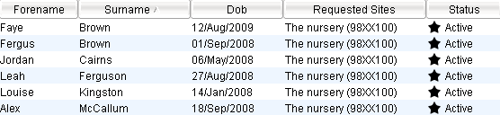

Multiple sorts

- Data can be sorted using multiple headings. Hold down the Ctrl key and select the next column to sort
NOTE: this function is not available on all screens.
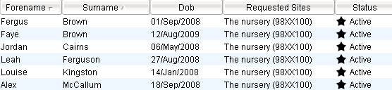

Selecting Data

Multiple Selection
Hold down the Ctrl key and click the records to be selected. To deselect a record selected in error, click it again with the Ctrl key still held down.

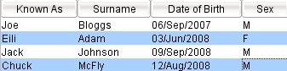

The Sticky Selection option allows the user to select more than one record without holding down the Ctrl key. Select the box next to Sticky Selection and select the required records. To deselect a record selected in error, click it again.

Column Manipulation

Moving Columns
Columns can be moved as required to change the layout of the data. To move a column, click the appropriate grey heading, with the left mouse button held down, drag the column to the desired position. Repeat this process as necessary.
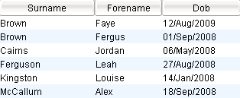
In the example below the Surname column has been moved from the middle column to the left column.

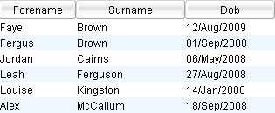
Application Status
Child Applications can be at different stages:
 | Active | Application is on the system, but nothing has been done
 | Active | Application is on the system, is a split placement, but nothing has been done
 | Offered | Place offered to parent, waiting on reply
 | Accepted | Place has been accepted
 | Waiting | Application has moved to 2nd or 3rd choice, but waiting in your nursery
 | Pending | Your nursery is 2nd or 3rd choice, but application is still with 1st choice
 | No Space | Refused in your nursery, this can be moved to 2nd or 3rd choice
 | Not Accepted | Parent has not accepted the place
 | No Response | Parent has not responded

Printing/Saving Options
Reports can be printed or saved using the following options:

PDF
PDF file is for viewing only, changes cannot be made to this file. The document can be printed from within the generated preview window of the document.

OPEN allows the user to view the document
SAVE allows the user to save the file to their computer
VIEW allows the user to view the document

CSV
Changes can be made to this file if necessary. The document can be printed from within the generated preview window of the document. These files are often used in mail merge within MS Word.

OPEN allows the user to view the document
SAVE allows the user to save file to the computer

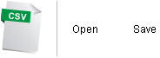

Using the Calendar
A calendar is provided which can be used to enter dates into the calendar fields. Alternatively, the user can chose to enter the date manually into these fields ensuring that the correct date format is entered.

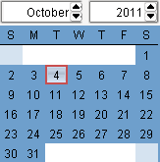
- To select the calendar, click on the next to the calendar field
- Click the arrows next to the month to select the appropriate month
- Click the arrows next to the year to select the appropriate year
- Double click on the appropriate date to select

