Argyll and Bute Early Years Service

Self-Evaluation and Improvement
‘How Good is our Early Learning and Childcare?’

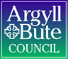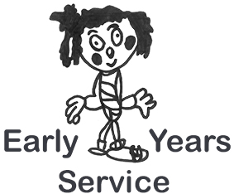
Self-Evaluation

Self-Evaluation is a continuous, reflective process through which Early Learning and Childcare settings get to know themselves well. From August 2016 the new revised framework for self-evaluation for all Early Learning and Childcare settings is 'How Good is our Early Learning and Childcare?’ (HGIOELC). This framework will only be published as a digital resource on the new National Improvement Hub, it is available at https://education.gov.scot/improvement/Pages/frwk1hgioearlyyears.aspx
The National Improvement Hub at https://education.gov.scot/improvement has become the key gateway to educational improvement resources and support.
What is Self-evaluation?

Self-evaluation for self-improvement means carrying out a range of activities to find out your settings strengths so they can be celebrated and good practice shared; it is also to find out what is not going so well so action can be taken to make an improvement. Self-evaluation is not a series of one off events but a continuous cycle of self-reflection and evaluation processes and in best practice involves all children, parents/carers, staff and the local community of the setting.

The three questions that are at the heart of all self-evaluation are;

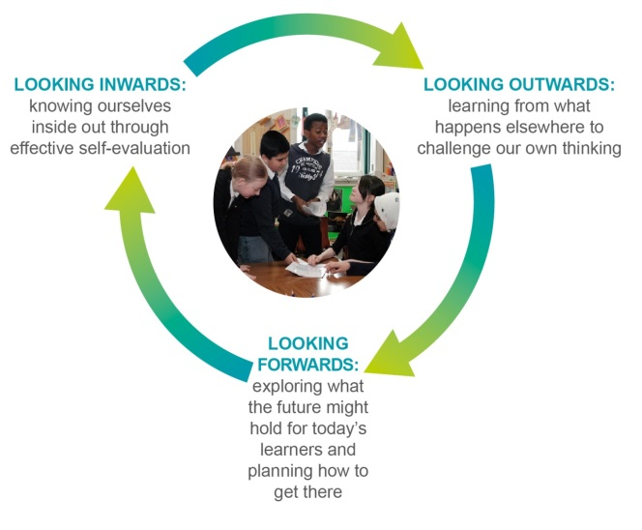
What are we going to do now?
How are we doing?
How do we know?

- How are we doing? The first stage of effective self-evaluation is to know yourself really well – looking inwards. The ‘Quality Indicators’ illustrations in HGIOELC are designed to help you reflect on this.
- How do we know? An important aspect of answering this question is looking outwards to see how your practice relates to what is happening elsewhere. This means looking to other establishments locally and nationally and considering national and international research. The features of ‘highly-effective practice’ in the new HGIOELC toolkit are also designed to help with looking outwards.
- What are we going to do now? Answering this question requires a forward looking approach. The ‘challenge questions’ linked to each of the new quality indicators can support your thinking in this respect.

What is ‘How Good Is Our Early Learning and Childcare?’

‘How Good Is Our Early Learning and Childcare?’ is a self-evaluation framework that takes account of childminders, all private, voluntary and local authority early learning and childcare settings. It is therefore for all practitioners working with children from birth to starting school. It has 15 Quality Indicators (QIs), which are organised into three key categories, these are;

- Leadership and Management: How good is our leadership and approach to improvement?

- Learning Provision: How good is the quality of care and learning we offer?

- Successes and Achievements: How good are we at ensuring the best possible outcomes for all our learners?

In this new framework each quality indicator has 'features of highly effective practice', these are to help you identify the kind of evidence which helps support self-evaluation and also sets out 'challenge questions' to reflect, discuss, and support professional dialogue to support a shared understanding of your setting’s strengths and next steps. Each quality indicator is described further through a number of themes, each of which has illustrations of what a 'very good' level of practice looks like.

Overview of the Quality Indicators

What is our capacity for improvement?
Leadership and Management | Learning Provision | Successes and Achievements
How good is our leadership and approach to improvement? | How good is the quality of care and learning we offer? | How good are we at ensuring the best possible outcomes for all our learners?
1.1 Self-evaluation for self-improvement  1.2 Leadership of learning  1.3 Leadership of change  1.4 Leadership and management of practitioners  1.5 Management of resources to promote equity | 2.1 Safeguarding and child protection  2.2 Curriculum  2.3 Learning, teaching and assessment  2.4 Personalised support  2.5 Family learning  2.6 Transitions  2.7 Partnerships | 3.1 Ensuring wellbeing, equality and inclusion  3.2 Securing children’s progress  3.3 Developing creativity and skills for life and learning

What are the Main Messages within ‘How Good Is Our Early Learning and Childcare?’

The framework has following messages embedded throughout all the Quality Indicators.

- Focus on the child’s lifelong learning journey.
- Family Learning and engagement.
- Equality, Inclusion and Wellbeing.
- Equity and closing the attainment gap.
- Partnerships and Collaborative Approaches.

How the Early Years Service familiarised themselves with ‘HGIOELC’

In order to familiarise ourselves with ‘How Good is our Early Learning and Childcare?’ the Early Years Team members read and individually reflected on the framework document.
To further develop our knowledge of the framework the team divided into three working groups with each group being allocated one of the three key categories and its corresponding Quality Indicators (QI) to look at in depth:
- Leadership and Management
- Learning Provision
- Successes and Achievements
Each team member considered the 'features of highly effective practice’ and the ‘challenge questions’ within their allocated theme from above and identified the main messages and aspects of daily practice that would provide evidence to support this. In order to collate our conclusions a document was created containing the individual QI’s broken down into their ‘Themes’ and ‘Descriptor’ and the QI’s corresponding ‘Features’ and ‘Challenge Questions’. We individually submitted our findings into the table under the Comments/Evidence column to discuss further with our working group. When this group work was completed the team gathered to engage in professional dialogue around the document - this supported the beginning of a shared understanding of HGIOELC. If your setting would like to use the template that our team created, you will find the Early Years Service’s collated document and a blank HGIOELC Template at: https://blogs.glowscotland.org.uk/ab/sali/early-years/

Implementation of ‘How Good Is Our Early Learning and Childcare?’ in your Setting

HGIOELC is your settings self-evaluation framework, please ensure all practitioners familiarise themselves with it. Please collaborate with all your stakeholders on how you will take this forward to support effective self-evaluation. The questions you now need to ask yourself are;
- Who is leading this self-evaluation activity?
- What is the question we want to explore?
- Which Quality Indicators or themes will support our work?
- Who can provide evidence for this self-evaluation?

Support and Guidance

The Early Years Service would like to offer all early learning and childcare practitioners support during the implementation of this new framework. This support could be offered to your setting through one to one sessions with a member of our team and your practitioners or through area cluster twilight training sessions.

To request any support or guidance within your local area, please contact the Early Years Helpline -
earlyyears@argyll-bute.gov.uk
Tel: 01369 708503 / 01369 708517

