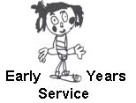
Family Learning and Engagement Guidance

The purpose of this guidance is to support the creation of a family friendly learning environment which will help children to have the best start in life and to strengthen family aspirations.
By offering a high quality service to children and their families in the early years, we can build on family confidence, emotional wellbeing and aspirations to education and lifelong learning. In order to embrace family learning opportunities, we need to provide an enabling, effective environment which supports and caters for our families’ needs within local communities.
To this end it is very important that we consult and work in partnership with parents and partners to provide opportunities for learning which value and respect the opinions and strengths of all in the partnership. By having this shared understanding between parents, ELC providers and agencies we can strengthen community engagement and capacity at the point of delivery.

Our aim in Argyll and Bute is to encourage and support family members to learn together and develop an ethos of lifelong learning.

In order to create a safe, stimulating, challenging environment where children, parents and visitors feel comfortable, we need to ensure we provide:

- A calm, uncluttered secure space, with furniture and resources fit for purpose
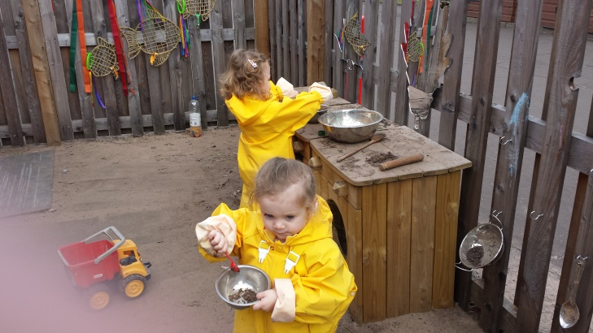
- A warm, bright, clean, friendly and engaging space
- Nappy changing facilities
- Areas spacious enough for both children and adults alike
- A variety of resources which are easily accessible
- Open ended resources e.g. moving away from dressing up outfits to bright shiny material which will allow imaginations and creativity to flourish
- Variety of sensory tactile materials to encourage investigation and language development
- Opportunities and resources to support schematic play
- Defined spaces which protect children’s play, giving them a sense of security that helps them stay focused
- An area that replicates a homely social space (where possible) e.g. a cosy living room where parents can gather with other parents or professionals for 1-1 advice and support. Children will also benefit from a warm inviting space.

By creating a Family Learning Centre which meets the needs of families and other users, there needs to be an innovative, personalised approach at a local level which builds community capacity and empowers families.

One of the philosophies in Early Years is that we believe that when our children pass through their developmental stages, there are points when friendly advice would be welcome. We need to ensure that we have competent knowledgeable staff who can work with parents during these times and encourage them to seek the necessary support, if needed.

To encourage family learning the following list is a sample, but is by no means exhaustive:

Family learning and engagement - based on promoting National and Local Initiatives
Active Play
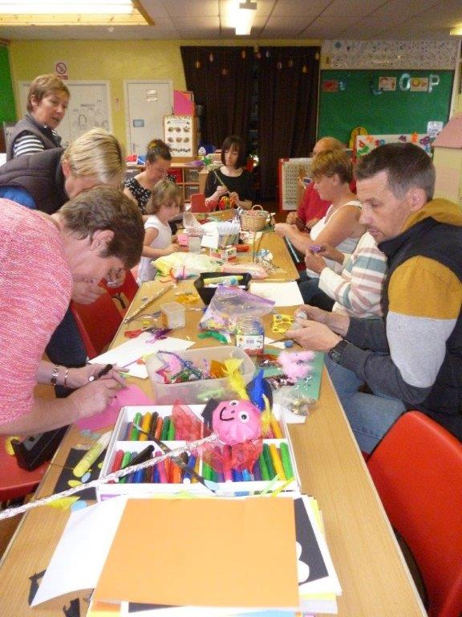
Messy Play
Bookbug
Cooking on a budget
Young Mums
Dads and Lads
Play@home
Brew & Blether
Family Fun Days
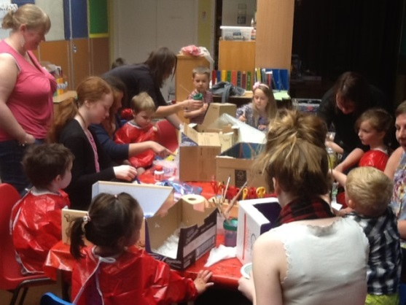
Psychology of Parenting Programme
Tea, Toast and Talk

Family learning and engagement – provided by visiting professionals

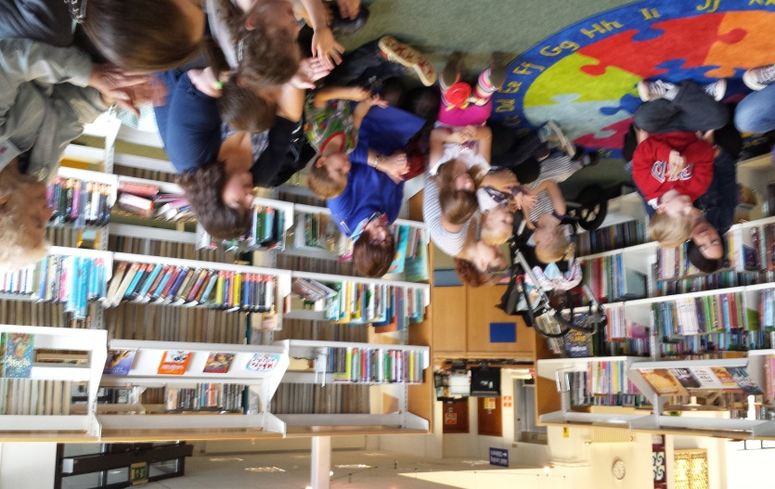
Paediatric First Aid
Speech & Language
Active Schools
Baby Massage
Childsmile
Road Safety
Baby weigh in, weaning, breastfeeding
Eye screening
Positive Behaviour
Play Talk Read
Top Tots
Loan Parent Advisor
Healthy weight/healthy food/healthy mind

In line with the National Parenting Strategy, activities should be arranged in consultation with and according to the needs of, parents in each local area to build their confidence, self-esteem and overall health and wellbeing to help support them as parents e.g.

Art therapy
Reiki
Yoga
Massage
Smoking cessation
Home safe
Fuel efficiency
Gardening club
Money Advice
Adult literacy/numeracy

Additional information on Child Development can be accessed from local colleges i.e. Clydebank and/or Argyll College UHI

By building partnerships and a shared understanding between parents, ELC providers and agencies we aim to promote wellbeing, learning and attachment of children and families in our communities.

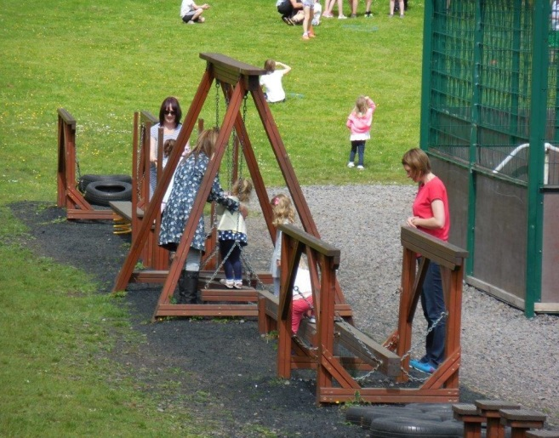
Time is precious and in order to change attitudes we need to understand the importance of children in society and the role of the family. Positive early experiences help build firm foundations for our future parents.

It takes time, effort, willingness, partnerships and commitment to build stronger communities through family learning.

