Argyll and Bute Family Pathway
Rationale and Implementation Plan
2015-17

Date: August 2014
Project Name: Argyll and Bute Family Pathway

What are we trying to accomplish?
Create coherence in support for children pre-birth – school entry and their families through the development of a family pathway, and in doing so we aim to:
- Develop consistency with transitions between named persons -
Midwife – health visitor
Health visitor – headteacher
- Ensure the well-being of our children and their families is maintained and improved (pre-birth – school entry) using the shared language of Girfec and the wellbeing indicators
- Develop the use of the shared language of Girfec with all parents through an asset based approach rather than based on identifying deficits

How will we know a change is an improvement?
Through the use of the Family Pathway, there will be more effective communication between agencies resulting in better outcomes for children and families. Testing will be focused on the use of the wellbeing indicator tools at each stage along the Pathway – improvement will be evident when scoring within each tool reduces from low to high.

Measurements that will be affected: Current Level

- Increase in number of families engaged within Family Pathway
- Increase in the number of child’s plans identified through early intervention
- Improved outcomes for children - % of children who achieve developmental milestones
- Robust communication at hand over / transition point
(What changes can we make that could result in improvement?)

Resource bank/ tool kit to go with each WBI Tool – eg. ‘Safe’ issues tool kit would relate to home safety information, resources and who to contact list.
Originator:
K. Johnston P Renfrew
People to Involve:
C Dreghorn, R Reid, L Bridgewater, F Semple

Version: 04/12/2013
Engagement of families
Quality of provision
EYC Methodology
Girfec Process
Engagement of practitioners
Education and Training
Communication between named persons
Systems and processes within each workstream
Information travels seemlessly from one workstream to another
Tool to meet the needs of each workstream
Targeted actions to ensure developmental milestones are reached at the start of primary school
Theory of what drives developmental milestones
Secondary Drivers
Primary Drivers
What are the main issues?
Stretch Aim
What are we aiming to achieve?
Argyll & Bute CPP – Family Pathway
Sharing and owning the EYC vision
Communication
Tool to gather information
90% of all Argyll & Bute children will have reached their developmental milestones at the time they start primary school by the end of 2017
Relevant information is shared for 90% of children at each transition stage of the pathway by end of 2017
Quality of provision - meeting all needs
Model for Improvement used to test change and measure improvements
Girfec model implemented effectively
Staff have clarity of and confidence in systems within each workstream
Spreading the EYC word through media and face-to face- home and away
Asset based approach – working WITH families
Transition of information at start of primary school
Transition of information from 27 -30 month check
Transition of information at 10 days old
Tests of change are developed to target the stretch aim within each workstream
Each workstream develops an effective tool around the wellbeing indicators
Use of Wellbeing Indicators as a shared language from Prebirth - 5

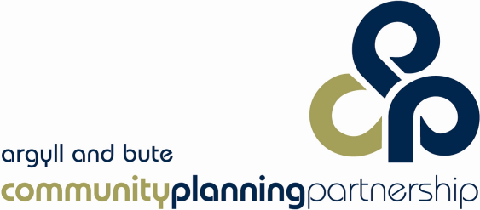
Argyll and Bute Family Pathway – Achieving Excellence and Equity
GIRFEC
Children & Young People’s Act
- Poverty related attainment gap
- Scottish Attainment Challenge
- National Improvement Framework
- Education Bill (inequalities)

- Universal HV Pathway
- Early Learning & Childcare
- Realigning Children’s Services
- Improvement in Child Protection
- Family Nurse Partnership
- Improving Family Learning

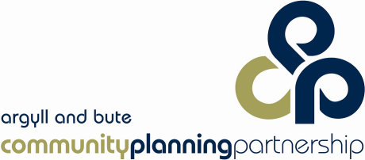
Argyll and Bute Family Pathway Governance Structure
Locality Family Pathway Champions oversee implementation of national and CPP priorities within their local area, as well as identify local priorities which respond to local opportunity and need. This group supports local projects and testing and supports use of the Model for Improvement. Progress and impact is reported on once a quarter (along with relevant data), through liaison with the ‘Family Pathway Steering Group’
The Family Pathway Steering Group ensures national and CPP priorities are implemented within the Family Pathway structure through representation within ‘Argyll and Bute’s Children and the EYC Leadership Group. The group liaises with each locality pathway group and provides specialist subject support as and when required. Quarterly progress and impact is reported to the EYC Leadership Group and Argyll and Bute’s Children.
The EYC Leadership Group is comprised of senior leaders from a range of multi-agency organisations within the CPP. This group is responsible for implementation of relevant national Early Years priorities. The Leadership Group oversees implementation of the Argyll and Bute Family Pathway and reduces potential barriers to progress. This group also analyses data and impact.

Proposed Spread Plan for Argyll and Bute Family Pathway
Jan – March 2017
October -December 2016
June 2014-15
January – June 2016
August –October 2016
