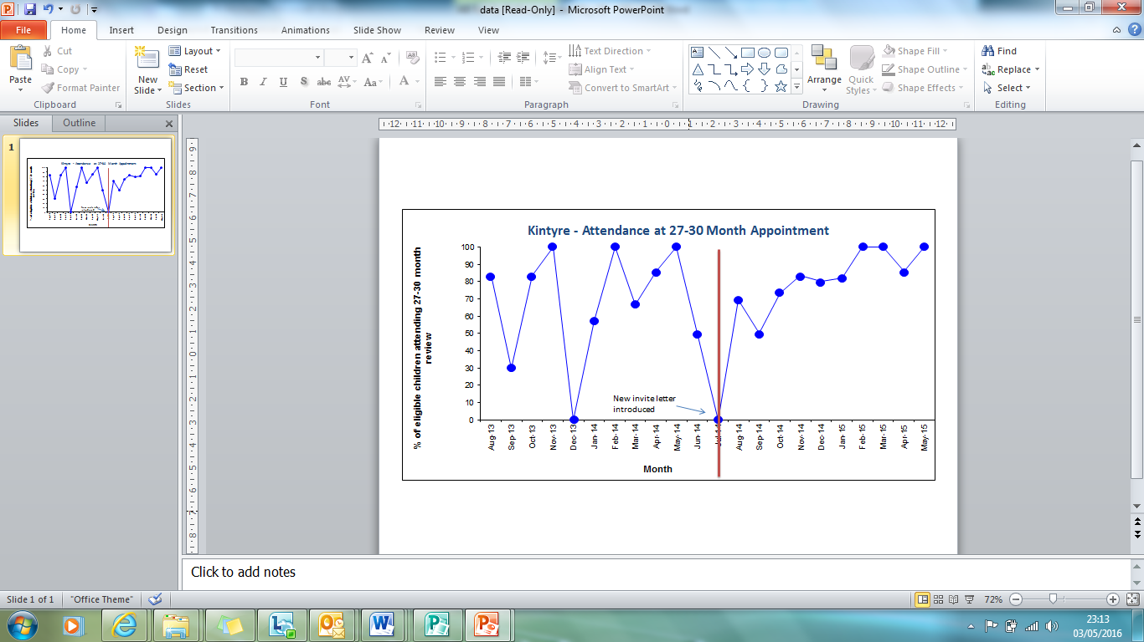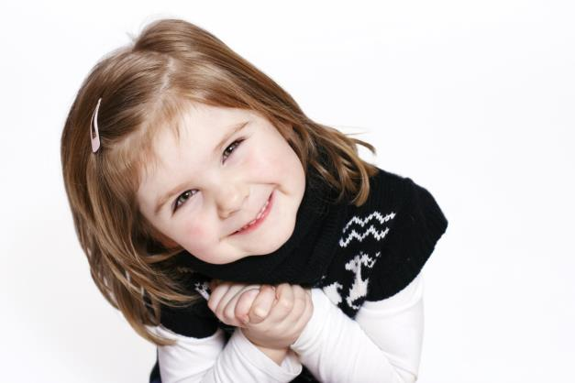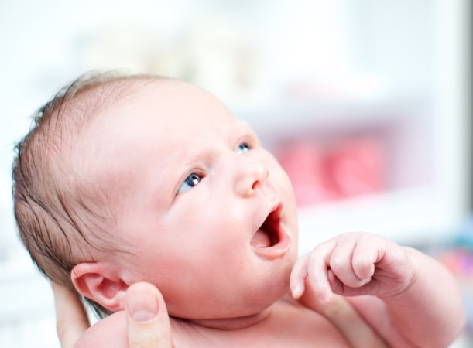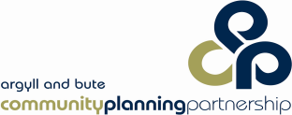

**GIRFEC**

**Children & Young People’s Act**

The Pathway provides a strong framework to link national priorities and makes them relevant within a local context. It empowers communities to make the change they want to see. It also uses the shared language and system of GIRFEC for all children and families

*Conclusion*

**27-30 months**

*When the data shows significant impact, it is time to scale up to another area of Argyll & Bute! We aim to have full implementation by December 2017*

* Information was shared for 100% of children starting nursery - March 2015
* 85% of children achieved their developmental milestones starting P1 in August 2015
* Speech and Language and Social,

Emotional and Behavioural milestones

are areas of priority for 2016-17

Before Change

After Change

*Results*

**3-5 Years**

* Focus on one area of Argyll & Bute at a time
* Identify local ‘Pathway Champions’ to lead developments within each stage of the Pathway
* Work with local community to identify strengths and areas for development
* Together create a local pathway action plan
* Test change ideas using ‘Model for Improvement’
* Meet with ‘Champions’ every 6 weeks to review progress and liaise with ‘subject specialists to advise and support

*Method*

*Create coherence in support for children pre-birth – school entry and their families through the development of a family pathway, and in doing so we aim to:*

* Develop consistency with transitions between named persons: midwife – health visitor and health visitor – head teacher
* Improve the wellbeing of our children and their families (pre-birth – school entry) using the shared language of GIRFEC and the use of our *wellbeing indicator tool*
* Develop the use of the shared language of GIRFEC with all parents through an asset based approach –‘working with’ rather than ‘doing to’.

*Our Aim*

**12-15 months**

**3-4 months**

**Antenatal**

**16 weeks**

*Authors:*

*Patricia Renfrew – Consultant Nurse – Argyll & Bute, NHS Highland*

*Kathleen Johnston – Education Officer, Early Years, Argyll & Bute Council*

**Argyll and Bute Family Pathway**

*Working together to make Argyll and Bute the best place to grow up*