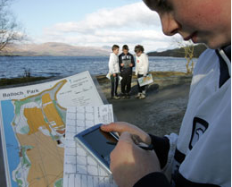
Opportunities for personal achievement

We do, or could, support our pupils to recognise achievement, discuss skills developed and where appropriate set targets within the following settings:
Other individual personal achievement e.g. outside locality, outside structured club environment etc. + stage
e.g. Regional Swimming Squad (one P6 pupil)
Private music tuition achievements (several pupils, P3-P7)

External organised clubs and activities in which our pupils develop skills and achieve + stage
e.g. Local shinty club P1-P7
Local Feis P3-P7
Other organised activities not included in subject areas and IDL in which our pupils develop skills and achieve + stage
e.g. Summer show Pre-5 to P7
Debating competition P6/7
After school/lunchtime clubs and organised activities in which our pupils develop skills and achieve + stage
e.g. After school cooking club P6/7
School Choir P4-7

