Ethos and life of the school
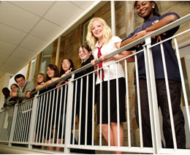

We do, or could, develop skills and recognise achievement and support our pupils to profile their achievements within the following areas of the life of our school. Where appropriate we do, or could, plan learning within these areas.
Contributing as leaders and role models + stage
e.g. Games leaders (Pre-5)
Pupil led lunchtime clubs (P6/7)

Participating responsibly in decision making + stage
e.g. Planning learning environment (Pre- 5)
Pupil Forum (P1-P7)

Offering support and service to others + stage
e.g. New P1 buddies (New P2 pupils)
Senior Citizen lunch club (all)
Playing an active part in putting the values of the school community into practice + stage
e.g. Clan Captains (P6/7)
New P1 buddies (New P2 pupils)

