The Edible School Garden

Kilbarchan Primary School

18th September 2014

Summary
This course is designed to give you the skills to set up a simple productive garden and manage the growing space seasonally throughout the year. You will also be taught how to pass on correct tool skills and garden safety to children. The course will encourage you to inspire your pupils to think scientifically in the edible school garden.
Objectives:
At the end of the course, you will have:

Practiced horticultural skills to sow and grow the RHS top 15 fruits, vegetables and herbs for the school garden, in order to provide a range of fresh, healthy produce throughout the school year.

Learnt the basic structure of fruit and vegetable plants; noted the part of the plant that you eat; and gained some tips on tasting and cooking to encourage healthy eating habits in pupils of all ages.

Learnt how to observe and record the way plants grow from a seed to a crop.

Key Stages targeted: Early to Senior Phase.

Cost: £85 per person. £150 if you book two separate courses or two places on the same course.

Experience: Suitable for beginners and those with some previous experience.

Venue
Kilbarchan Primary School
Meadside Avenue
Kibarchan
Renfrewshire
PA10 2LA

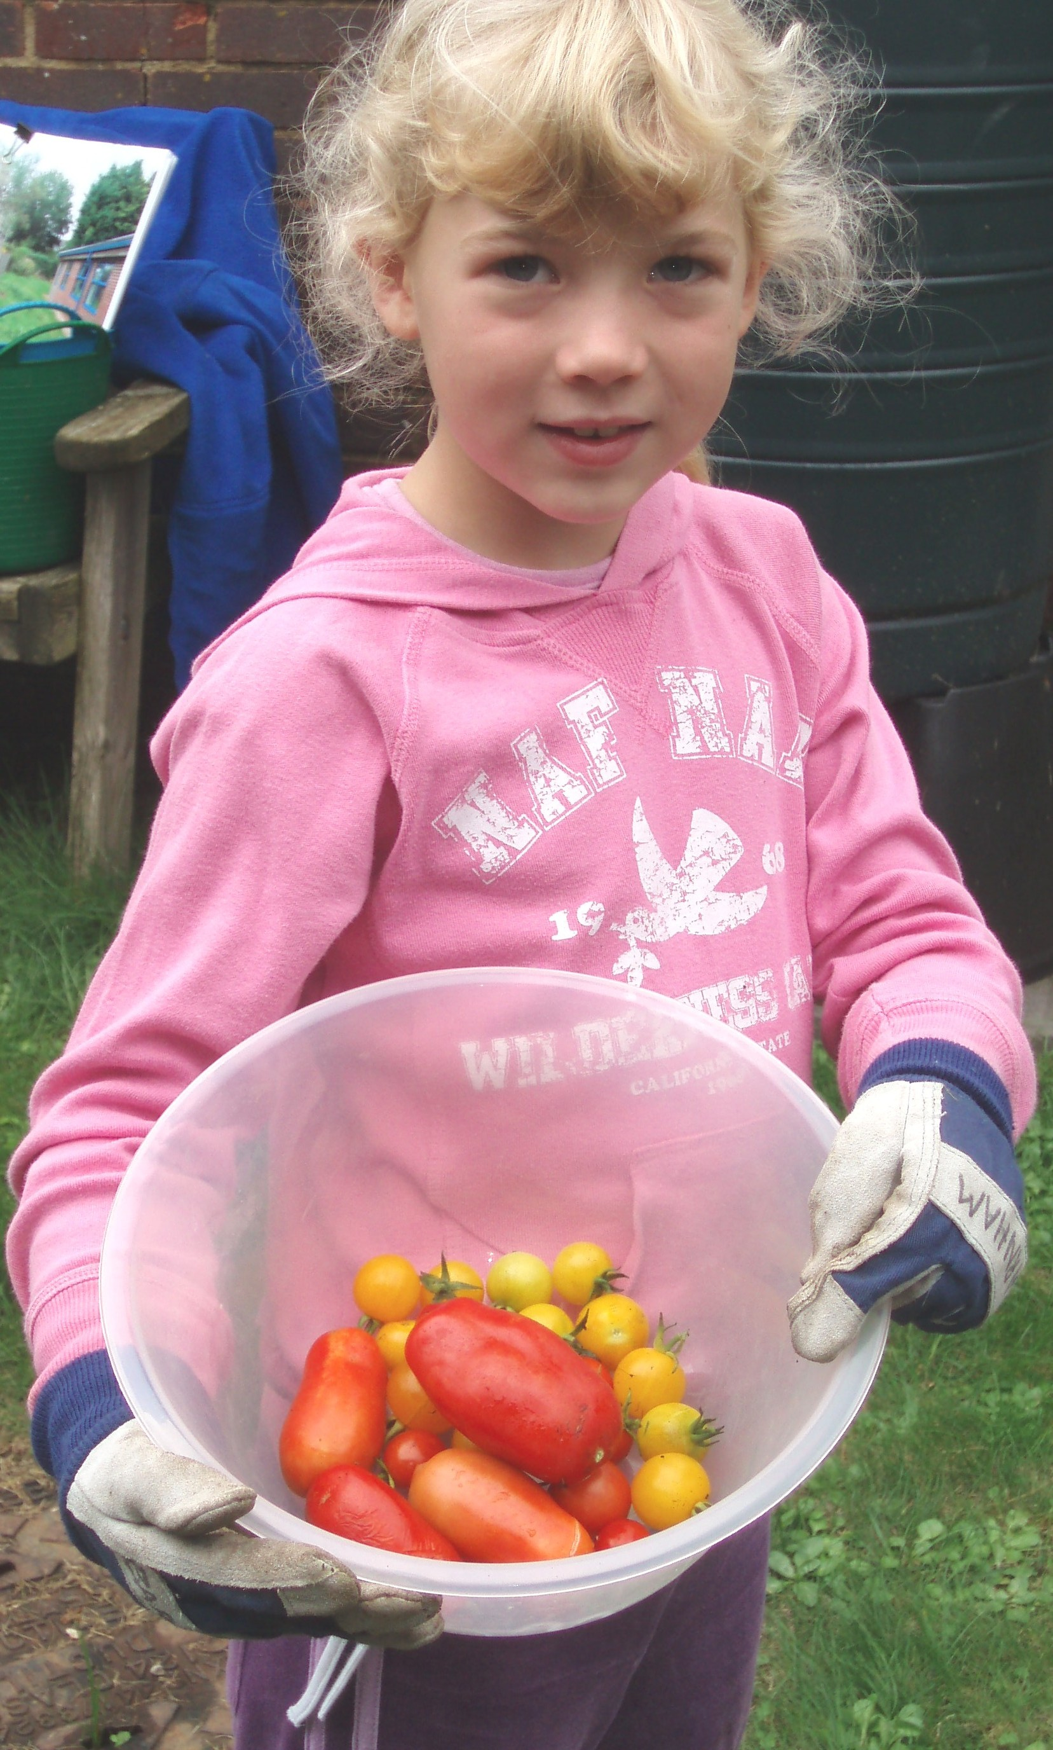

CPD Provider
Angela Smith
RHS Development Officer
Scotland

