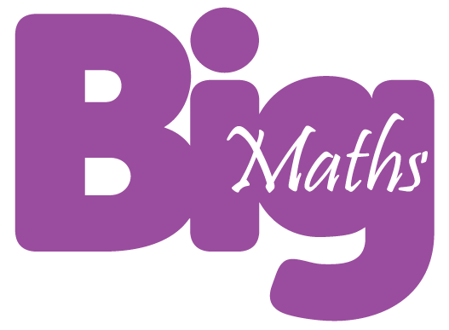
My level 1 progress Name _____________________

+ | addition |  |  | - | subtraction
1 | I know when to add some more |  |  | 1 | I know when to take some away
2 | I know how to find the total |  |  | 2 | I know to take some away, then count how many are left
3 | I add the right amount |  |  | 3 | I take away the right amount
4 | … and can count how many altogether |  |  | 4 | … and can count how many altogether
5 | I can add numbers of objects to 10 |  |  | 5 | I can take away numbers of objects to 10
6 | I can read a number sentence
- | subtraction |  |  | ÷ | division
1 | I know when to take some away |  |  | 1 | I can give out objects fairly
2 | I know to take some away, then count how many are left |  |  | 2 | I can count how many each person was given
3 | I take away the right amount |  |  | 3 | I can share an even number of objects between 2 people
4 | … and can count how many altogether
5 | I can take away numbers of objects to 10

