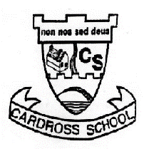

Cardross Primary and ELC

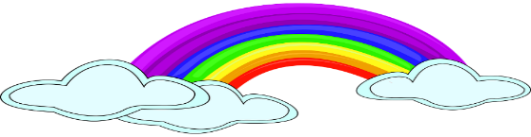
Virtual School Newsletter Issue One

Welcome to our first Virtual School newsletter. We will publish regular newsletters while school and the ELC is closed. We hope this and the weekly assembly will help maintain a sense of community for all our children and families who are missing their friends (and maybe even missing their teachers…).
To do this we need your help! Please email enquiries-cardross@argyll-bute.gov.uk with any items you’d like us to include. This could be photos of any fabulous artwork that has been produced, home learning workspaces, successes in learning, fun in the garden, or any other news that will keep spirits high.

Parent Information
I am sure like myself you have found the last two weeks a time to adjust to what is important for your family. As a school we fully support this and whilst teachers have been uploading daily activities and tasks, the school work is there to dip into when it suits your family, please do not become worried about having to complete everything every day. I know lots of families have been baking, doing arts and crafts, building things, going for walks and bike rides and working in the garden or on the farm and this is as equally important if not more so, to help maintain a healthy mental wellbeing for us all.
During the Spring break teachers will not be posting learning activities on Seesaw or Google classroom, this is an important time for your children to relax and have a break from academic learning. If children wish to decorate an egg or an Easter Bonnet during this time we look forward to seeing them on our return online on Monday 20th April.

School staff will continue to work in the local hub for Keyworker children during the break to support our NHS and other keyworkers.

I will be available throughout the break should anyone need to contact me on kelly.girling@argyll-bute.gov.uk

Early Learning Centre News
Claudine and Laura M have been busy working at the local ELC Hub for Keyworkers children, whilst Lynsey, Lauren and Laura have been busy keeping the ELC Seesaw page up to date, with activities stories and rhymes. After the Spring break we will be uploading activities specifically for our pre-school children, should families wish to take part in them.

Kelly Girling
#staysafe #stayin #exercise #bekind #rainbowofhope

