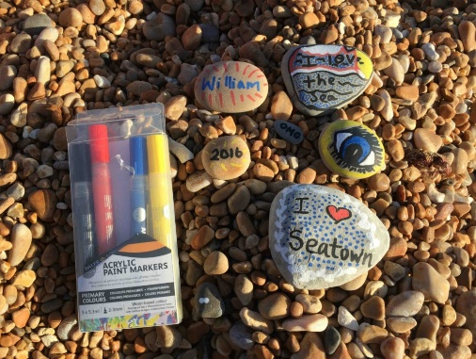
Here’s a fun activity kids can enjoy with a single pack of acrylic paint pens that is sure to keep little hands busy for hours. You can use this technique to make a creative story telling game. Great for passing the time.

Little fingers are great at weeding. Show them the easily identifiable weeds to pull.
Roll a log onto its side and discover all the critters living beneath it.

Make a crown out of leaves and twigs.

Float a log out to sea and then try and sink it by throwing stones at it.

You can recycle and transform cardboard tubes into the ultimate adventuring tool! What things can you see through your binoculars in the garden?

Make a fruit salad together.

Grow a sunflower or a tomato plant.

Play follow the leader

Stepping stones – create 11 pieces of paper each with a number from 0-10, place them on the floor. Have the child pretend the floor is oozy mud or a river. The child has to step on each stone reading out the number. Have the ‘stones’ at different spaces apart to encourage child to take different sized steps.

Bowling using plastic bottles and scrunched up paper.

