**Ideas for Loose Parts Play**

A loose part is anything that has not got a specific job ☺

What can you find in your house?

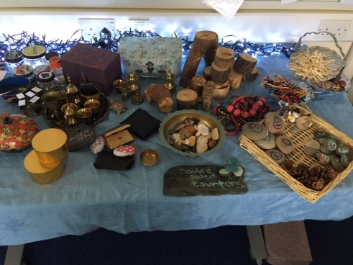

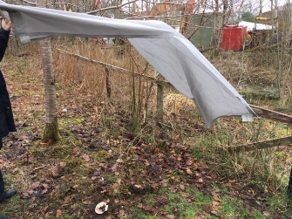Den building using an old curtain, a groundsheet or branches

Create and re-tell a story Make your name 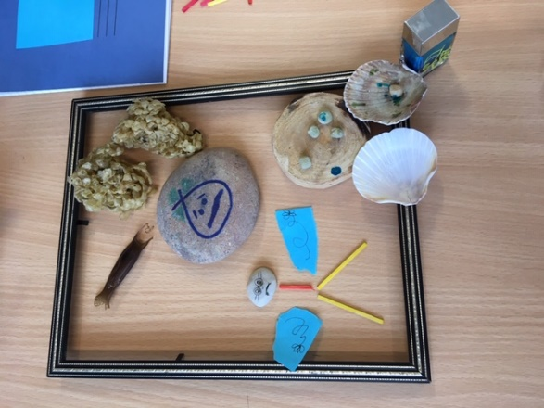[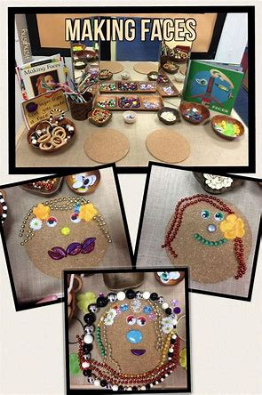](https://www.bing.com/images/search?view=detailV2&ccid=%2bmWff7w%2f&id=23648048DB3B96F994AE749160D07AC4C361A727&thid=OIP.-mWff7w_NuSNvFXrLk9N0wHaLH&mediaurl=https%3a%2f%2fi.pinimg.com%2foriginals%2fdb%2ff6%2fe8%2fdbf6e8368a4b1c090007044623532337.jpg&exph=1104&expw=736&q=loose+parts+activities+for+preschool&simid=608027301163696314&selectedIndex=9)

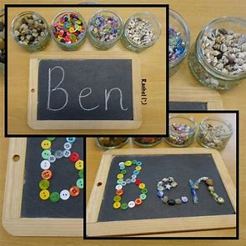

[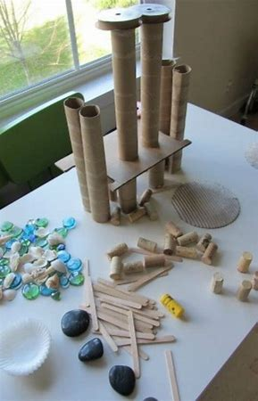](https://www.bing.com/images/search?view=detailV2&ccid=rdLBYOYB&id=43A39D97AC23586744AC8503F5CA47985ADCFD2D&thid=OIP.rdLBYOYBJhD8aabtbRF0yQHaLf&mediaurl=https%3a%2f%2fi.pinimg.com%2foriginals%2ff2%2f30%2f37%2ff23037431d7b1cce492149376ac9c802.jpg&exph=929&expw=599&q=loose+parts+activities+for+preschool&simid=608015571685475585&selectedIndex=22)Build anything! Stones Pasta

[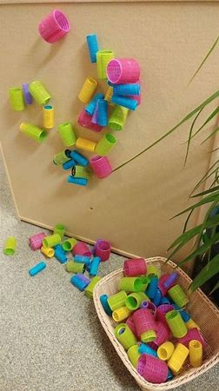](https://www.bing.com/images/search?view=detailV2&ccid=xN5bH8Nf&id=D9018450A52A1F48FBD63ECC64296A91161CA03F&thid=OIP.xN5bH8NfjnMPBEVlMk94-gHaNK&mediaurl=https%3a%2f%2fi.pinimg.com%2foriginals%2fcc%2fdf%2f7a%2fccdf7a02ac03f6f4f40309d3247e04c2.jpg&exph=987&expw=555&q=loose+parts+activities+for+preschool&simid=608000582210750016&selectedIndex=21)[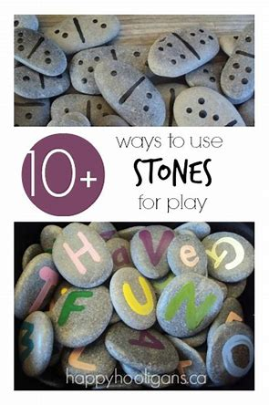](https://www.bing.com/images/search?view=detailV2&ccid=A2cj86B%2f&id=ADAEE7708EA54213DE3FBB25872866D55BEA7763&thid=OIP.A2cj86B_3DaUFYutJ1on_wHaLH&mediaurl=https%3a%2f%2fhappyhooligans.ca%2fwp-content%2fuploads%2f2014%2f05%2fstones.jpg&exph=560&expw=373&q=loose+parts+activities+for+preschool&simid=608024582494028881&selectedIndex=77)