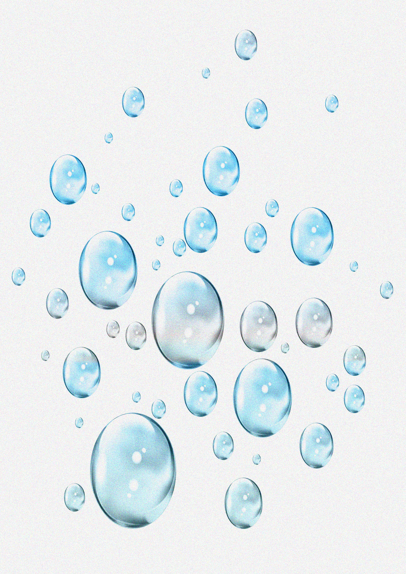
Homemade bubbles recipe.
Here are three different recipes for you to choose from:
Bubbles
Mix together:
18 fl oz water
2 fl oz washing-up liquid
4 teaspoons sugar.
Longer lasting bubbles
Mix together:
6 fl oz water
2 fl oz washing-up liquid
2 fl oz glycerine
1 tablespoon sugar
Frothy bubbles
Mix together:
Liquid detergent and water or bubble bath and water in a small bowl. For coloured bubbles add some food colouring.

Remember – Do not let your child swallow the bubbles.

