Our new eBook service has launched…
We have recently moved to Borrowbox, an exciting and innovative collection with a huge range of top titles. Borrowbox offers a fantastic, yet simple, customer experience with a bigger and better selection of ebooks and e-audiobooks to enjoy.
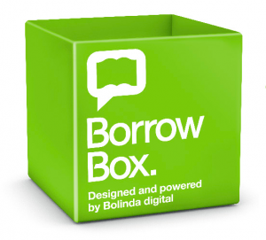
Fast Facts:
- Borrowbox is free to library members
- Download from a larger range of ebooks and e-audiobooks
- Simple browsing, downloading and reading/ listening
- No returns or late fees
- Customisable borrower preferences to make borrowbox work for you
- Dyslexic font available to increase readability
Whether you are an existing customer or are new to ebooks and e-audiobooks you will love this service – don’t miss out!

