Summary of resources available

Resource | Overview of the content/aims
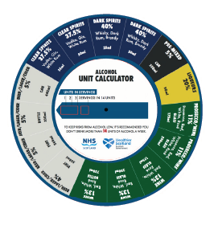  Drinks calculator | This is an interactive resource aimed to increase awareness of the unit content of different drinks as well as how many of those drinks make up 14 units. The resource is for members of the public and professional use.
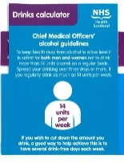  Drinks calculator | This is an interactive resource aimed to increase awareness of the unit content of different drinks. The resource helps people work out the number of units in different drinks and contains information around the low risk drinking guidelines.  The resource is for members of the public and professional use.
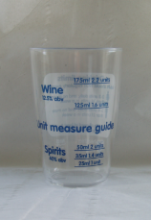  Unit Measuring Cup | This resource provides individuals with practical guidance to help measure alcohol at home. It has unit measurements for pouring spirits and wine and aims to help individuals monitor their alcohol consumption by measuring out their drinks. The cup also contains the low risk drinking guidelines. This resource is for members of the public and for professional use.
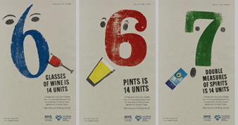  Count 14 Posters | These posters display the 3 main examples of drinks making up 14 units ; six pints of beer/cider, 6 medium glasses of wine and 7 double measures of spirits. They also contain the low-risk guidelines messaging around 14 units and spreading drinking over at least 3 days as well as the count14.scot website.
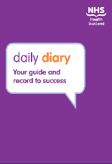  Daily Diary | This resource supports individuals to monitor and record their drinking and provides information around how to cut down/change their drinking. It also contains details of the low risk drinking guidelines. It is a useful resource for people to use if they are worried about their drinking or are looking to cut down on the amount they drink.  The resource is targeted at adults.
Making a Change | This resource encourages individuals to make informed, positive choices regarding their alcohol intake. It contains information about alcohol, the low risk drinking guidelines, and the benefits of change, building confidence and how to go about making a change.  The resource is targeted at adults and is also available in Polish.
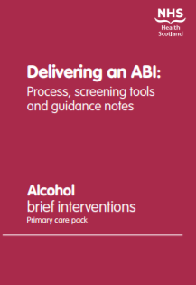  Alcohol Brief Intervention practitioner packs and associated briefings documents | These resources provide detailed information for practitioners around how to deliver Alcohol Brief Interventions in priority settings. They contain screening tools which can help facilitate a conversation with someone about their alcohol consumption and ways to build confidence to help people reduce their drinking, if they wish to do so.  The following resources are available:  - ABI Primary care professional pack  - ABI A&E professional pack  - ABI Antenatal professional pack  - Antenatal briefing paper  - ABI briefing paper  Please note these resources are currently only available in downloadable format.

