**You are going to create a page of a comic with your group.**

**Each person will create a page of a comic.**

**Your comic could have a theme and should have a front page.**

**S1 comics**

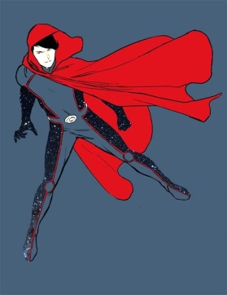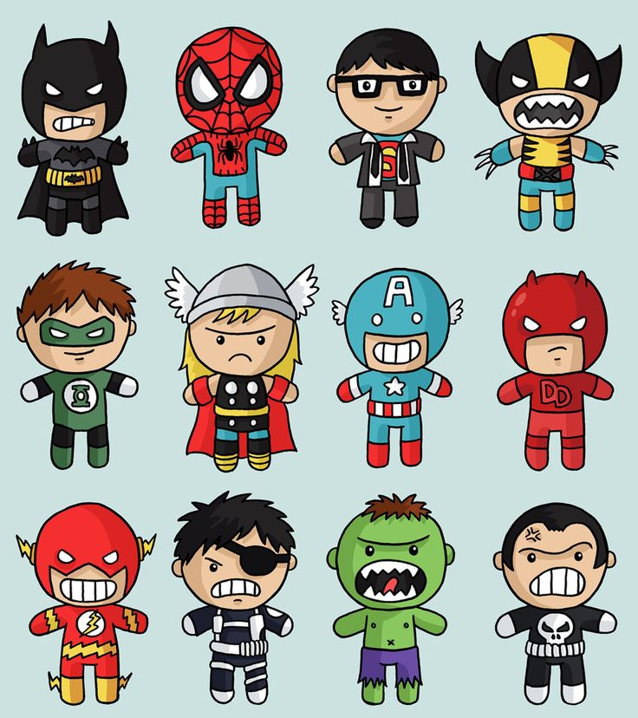

**I can check that my writing is accurate**

* **Knowledge about language**
* **Help from others**
* **Notes**
* **Help booklet**
* **Dictionary**
* **Success criteria**

**I am prepared to help others to check their work**

**Resources**

**Your jotter**

**Help booklet**

**Others in the class**

**A dictionary to check spelling and to look up a couple of words**