Les Bandes Dessinées – preparing to write your comic – Extra information

Qui est-ce? Look at the pictures below and match with the correct picture. Can you name the characters from the descriptions using their French names
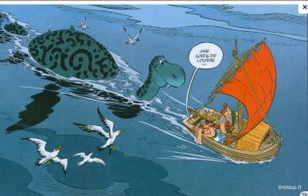
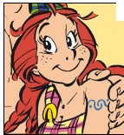
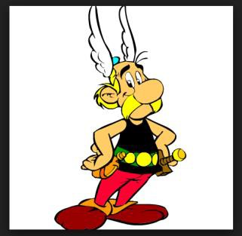
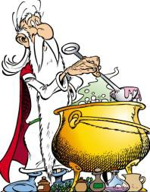
from the story?.
1.Il est petit. Il porte une grande moustache. Il est très fort. Il est très courageux
2. Il est grand et très fort. Il porte une grande moustache et il est un peu gros. Il est le meilleur ami d’Astérix.
3. Il est vieux et mince. C’est le druide qui fait la potion magique. Il porte une longue barbe blanche.
4. Il est le chef de la tribu et il est gros avec les cheveux roux.

Activity1-1.mp3

Activity1-2.mp3

Activity1-3.mp3

Activity1-4.mp3

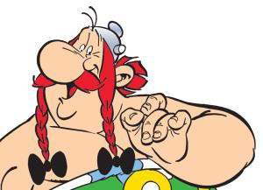
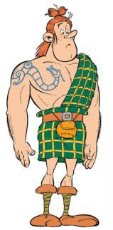
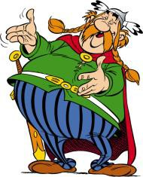
7. C’est un grand animal qui habite dans le lac.
5. Elle est la petite amie de MacOloch. Elle est belle avec les cheveux longs et roux.
6. Il est grand et jeune. Il porte
un kilt et il est écossais.
Activity1-5.mp3

Activity1-6.mp3

Activity1-7.mp3

Now fill in the gaps to translate the French
4. He is the _______of the tribe and he is fat with _______ hair
3 He is ____ and _____. He is the druid who makes the _____ potion. He wears a long, white ________.
2. ____ ____ tall and very strong. He wears a big moustache and he is ___ _____ fat.

He is the _______ friend of Asterix.
- He is ______. He wears ____ _____ moustache. ___ is ______ strong . He is very ____________.

7. It’s a big _______ who ________ in a ______.
6. He is tall and _______. He wears __ ______ and he is __________.
5. _____ is the girl friend of MacOloch. She is _______ with long, red hair.

