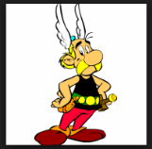

Activité 4: On recherche
MacOloch’s family back in Caledonia are very worried about his disappearance and decide to put up some posters in the local area in an effort to find him.
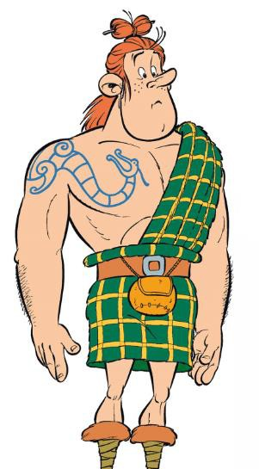
Can you make a poster for them? Remember you will need to describe him in some detail, hair, height, clothes etc! Your class teacher will help you with this. There are some phrases below to get you started.

On recherche

Il s’appelle | He is called | les yeux | eyes
Il a | He has | les cheveux | hair
Il est | He is | un tatouage  un kilt | a tattoo
Il mesure…. | He is…….tall | grand/petit | big/small
Il porte | He is wearing | bleu/vert/gris | blue/green/grey
 |  | noir/roux/blond | black/red/blonde

