The Allen family are planning to have a holiday in the Oban and Lorn area. The family is made up of mum and dad and their two children Lexi 10 and Roan 7.
Task 1
Using the OS map come up with some ideas of what the family can do together on holiday.
Activity/place to visit | Draw symbol/give place name | OS Grid Reference  6 Figure G.R | Explain your choice

Task 2
The family have booked a horse riding session at the Achanlarig stables (675306). They would like to walk from Station Square at (857298). How many kilometres is it in a straight line approximately?

Task 3
Give the family detailed directions on how to get to the stables on foot from Station Square. Remember to use place names, compass directions and grid references.

Task 4
The family would like to walk up to the Chapel remains at (883326) from Dunbeg. However they worry it might be too steep for the children. Draw a cross section from Dunbeg village to the Chapel remains. Do you think it is suitable? Explain your answer.

DIFFERENTIATED TASK
The Allen family are planning to have a holiday in the Oban and Lorn area. The family is made up of mum and dad and their two children Lexi 10 and Roan 7.
Task 1
Using the OS map come up with some ideas of what the family can do together on holiday.
Activity/place to visit | Draw symbol/give place name | OS Grid Reference  4 Figure G.R | Give a reason for your choice

Task 2
The family have booked a horse riding session at the Achanlarig stables (6730). They would like to walk from Station Square at (8529). How many kilometres is it in a straight line approximately?
Remember this is a 1:25 000 map so 1cm is equal to 250m or 1/4 Km in real life. You need to measure the distance between the two places using a ruler. Then multiply the distance measured by 250 to work out the real life distance in meters.

Answer_____________________________________________________________________

Task 3
Give the family detailed directions on how to get to the stables on foot from Station Square. Remember to use place names, compass directions and grid references.
Writing frame
Head out of Oban Square towards Argyll Square along the A_________. Turn ______at the post office and ________________. You are now walking in a ___________________ direction. Just past the __________________(8729) there is fork in the road take the _______________ hand turn continuing walking ______________(look at the contour lines). You will pass a _____________ (8730) on the right hand side,on your ______ is the stables.

Task 4
The family would like to walk up to the Chapel remains at (8832) from Dunbeg. However they worry it might be too steep for the children.
Below is a sketch of the map showing the contour lines between Dunbeg village and the chapel remains. Draw a cross section to show the family how steep the walk would be in the blank box on the following page.
Sketch Map of Chapel Remains
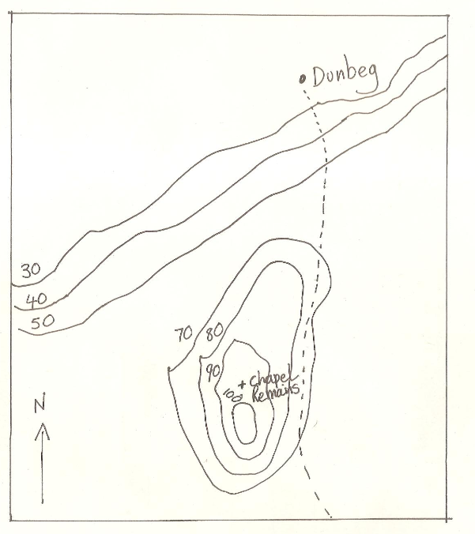

TOPIC PLANNER FOR S1 MAPPING
CfE Experiences and Outcomes | Benchmarks
People and Place  I can use a range of maps and geographical information systems to gather interpret and present conclusions and can locate a range of features within Scotland, UK, Europe and the wider world. SOC 3-14a  I can use specialised maps and geographical information systems to identify patterns of human activity and physical processes. SOC 4-14a | People and Place  - Reviews at least two simple graphical sources to interpret information and form a conclusion, for example, a map and a graph.  - Uses relevant numeracy and digital technology skills to interpret at least two sources of data from maps and graphical information systems.  - Locates increasingly complex features such as different physical landscape features and human features on maps of Scotland, the UK, Europe and the wider world for example, hills, mountains, valleys, population.
Numeracy  I can round a number using an appropriate degree of accuracy, having taken into account the context of the problem.  MNU 3-01a  I can show how quantities that are related can be increased or decreased proportionally and apply this to solve problems in everyday contexts. MNU 3-08a | - Rounds decimal fractions to three decimal places.  - Use rounding to routinely estimate the answers to calculations.  - Solves problems in which related quantities are increased or decreased proportionally.

Lesson | Learning Intentions/Success Criteria | Activities | Resources | Assessment | Key Skills | Homework
1 | We are learning the world’s Continents and Oceans  I can accurately label a map to shows the names of all the continents and Oceans | Pupils label a blank map to show the continents and oceans | Blank map of world can be issued and continents and oceans labelled | Exit pass, naming the continents and oceans | Listening  Talking  Remembering
2 | We are learning about the different types of maps found in an atlas.  We are learning how you use the contents and index of an atlas to find places and features in it.  I can accurately locate places around the world using an Atlas. | Pupils learn about the different maps found in an Atlas and complete a series of tasks about each map type.  Pupils look up different places in the atlas | Power point  Atlas | Teacher to use Atlas and test for pupils understanding by performing a quiz which is on a power point on the server. | Listening  Reading  Understanding  Information handling
3 | We are learning to be able to give accurate compass directions  We are learning to use a compass to work out direction  I can accurately work out compass directions on a map  I can accurately use a compass to work out the direction I am walking in. | Pupils complete a range of activities on a PowerPoint  Pupils go out into the playground and practise using a compass to work out real life direction. | PowerPoint  Compass | Exit pass- getting pupils to work out compass direction on a map of Scotland | Listening  Remembering  Applying
4 | We are learning to be able to recognise basic OS map symbols  I can recognise a wide range of OS map symbols on an OS map. | Pupils play the OS map symbols game. | PowerPoint  OS map symbols and symbol cards  Colouring pencils | 36 completed symbols in their jotters.  Plenary  OS map symbol Quiz | Listening  Writing  Remembering
5 | We are learning to confidently and accurately give 4 fig G.Rs  I can accurately and confidently work out a four figure grid reference from a map | Pupils learn and practice giving 4 fig G.Rs | PowerPoint  People and Place textbook |  | Number processes and measurement
6 | We are learning to confidently and accurately give 6 fig G.Rs  I can accurately and confidently work out a six figure grid reference from a map | Pupils learn and practice giving G.Rs | PowerPoint  6 Fig G.Rs consolidation work sheet  Extension sheets | Assess confidence in using 6 fig G.Rs through the homework. | Number processes and measurement | Issue G.R homework sheet
7 | We are learning to interpret an OS map  I can accurately read and interpret an OS map. | Pupils practice their OS map skills answering questions using an OS map | PowerPoint  OS map of Cambridge | Pupils mark their own answers | Number processes and measurement  Applying
8 | We are learning to be able to work out real life distances from a map.  I can accurately work out real life distances from an OS map. | Pupils get to work out real life distances using a map | PowerPoint  People and Place textbook  Rulers | Teacher marks jotter answers | Number processes and measurement | Issue Design your own map homework
9 | We are learning how height is shown on OS maps  I can accurately draw a cross section. | Pupils practise constructing cross-sections | PowerPoint  Mapping workbook  Square paper  Ruler | Teacher marks completed cross sections | Number processes and measurement
NB- A number of extension sheets are available for pupils who finish tasks quickly.

Holistic Assessment Using same Es and Os as taught in the unit.
Criteria | Differentiated | Undifferentiated
Pupil will be able to identify a range of activities for the family to do and justify their choice. | Four figure grid references used.  At least 3 activities identified with a simple explanation  e.g. Mccaig’s Tower at 8630, because the family will get a good view of the Bay | Six figure grid references used.  At least 5 activities identified with a detailed explanation  e.g Boat Trips at 8530 because the younger children will find it exciting to be out in a boat. They will be able to spot many different types of wildlife e.g. seals.
Pupil is able to work out the real life distance by using the scale on the map | Pupil will be able to work in out using the instructions provided  7-8cm = 1.75-2km | Pupil will be able to work it out by themselves.  7-8cm = 1.75-2km
Pupil is able to give directions to a named place using an OS map | A very simple description is given for the directions.  Head south along A816, at the church turn left and head NE on a secondary road. You will pass the golf course on the right. Keep going the stables are further along the road on the right hand side. | A more complex description is provided, mentioning G.Rs, place names and direction and may even estimate distances.  Head south along A816, at the church turn left and head NE on a secondary road, it is also known as cycle path 78. You pass through a residential area for about a ¼ of a km. Keep going straight, eventually you will pass the clubhouse on your right hand side. You still have about 1.25km to go. You will come to a fork in the road go left, you will shortly pass a forest on the right hand side, just past the forest on the left is the stables.
Pupil is able to construct a cross section | Pupil can construct cross section using a simplified contour map and template graph. | Pupil can construct a cross section using an OS map and graph paper with no assistance.

