

**EDUCATION GUIDANCE**

**GUIDANCE on: The Early Acquisition of Numeracy in Primary 1**

**Produced: May 2018**

**Due for Review: December 2018**

**Owner: Pauline Inglis and Maria McArthur**

|  |  |
| --- | --- |
| **CONTENTS** | **PAGE NUMBER** |
| 1. **GLOSSARY** | **3** |
| 1. **RATIONALE** | **4** |
| 1. **THE NATIONAL CONTEXT** | **4** |
| 1. **THE LOCAL CONTEXT** | **5** |
| 1. **RECOMMENDATIONS** | **5** |
| 1. **ASSESSMENT** | **6** |
| 1. **ENVIRONMENT** | **7** |
| 1. **TALKING ABOUT NUMBER** | **9** |
| 1. **ACTIVE IN LEARNING** | **15** |
| 1. **CONCRETE MATERIALS** | **19** |
| 1. **PARENTAL ENGAGEMENT** | **20** |
| 1. **NUMERACY OUTDOORS** | **21** |
| 1. **APPENDICES 1 to 5**  * **Bibliography** * **ELC Numeracy and Mathematics Number Progress Tracker** * **SEAL Diagnostic Assessment** * **SEAL Planners** * **Numeracy rich environment toolkit** | **23**  **23**  **24**  **35**  **39**  **39** |

**GLOSSARY**

**Conservation of number**: Pupil understand that the quantity of a given numbers of objects is the same regardless of how it is arranged.

**Emergent**: Refers to the first stage of SEAL (see below). An emergent counter is characterised as being unable to count visible items, know the numbers words and cannot coordinate the number words with items.

**Manipulatives**: Manipulatives are physical objects that are used as teaching tools to engage pupils in the hands-on learning of mathematics. They can be used to introduce, practice or remediate a concept.

**Number sentences**: In mathematics education, a number sentence is typically an equation or inequality expressed using numbers and common schools i.e. 6 + 7 + 13

**One-to-one correspondence**: In early counting development, one-to-one correspondence refers to the matching of one object or number word to another corresponding object or number word that are the same elements of a collection i.e. Assigning a number word or symbol (1, 2, 3, 4, etc.) with a collection of objects.

**Perceptual**: Refers to the second stage of SEAL (see below). A perceptual counter can count items they can see but not those in concealed collections.

**Place value**: This is the value of each digit in a number i.e. 582 is made up of 500, 80 and 2, rather than 5, 8 and 2.

**SEAL**: This refers to the Stages of Early Arithmetical Learning, a progression of strategies that children need to develop for a strong number sense

**Subitizing**: This is the ability to ‘see’ a small amount of objects and know how many there are without counting. Subitizing is the skill that allows us to know instantly the number rolled on a six-sided dice, for example.

**Rationale**

This document provides guidance for P1 teachers in Argyll and Bute on the early acquisition of numeracy in Primary 1. It has been developed in light of the publication of “Transforming Scotland into a Maths Positive Nation: The Final Report of the Making Maths Count Group” which states as one of its recommendations:

All sectors of education should promote access to high-quality career-long professional learning (CLPL) to increase staff confidence and enhance professional practices in teaching maths to children, young people and adult learners.”

Creating this guidance will allow all practitioners in Argyll and Bute the opportunity to reflect on their own teaching and learning in Numeracy and Mathematics. Linked to current developments in Argyll and Bute including Stages of Early Arithmetical Learning (SEAL), Number Talks and Numicon, these guidelines support the authority’s *Our Children, Their Future* document, *Guidance on: The Early Acquisition of Literacy in Primary 1* and *The Learning and Development Framework 0-5 years* (incorporating the *ELC Literacy Tracker*). Practitioners should read these documents in conjunction with this advice.

**The National Context**

The first two key priorities of the National Improvement Framework are as follows:

* Improvement in attainment, particularly in literacy and numeracy;
* Closing the attainment gap between the most and least disadvantaged children.

In addition, it is important that we remember the features of effective learning and teaching in mathematics, as laid out in the Mathematics: Principles and Practice document published by Education Scotland:

“From the early stages onwards, children and young people should experience success in mathematics and develop the confidence to take risks, ask questions and explore alternative solutions without fear of being wrong. They will enjoy exploring and applying mathematics concepts to understand and solve problems, explaining their thinking and presenting their solutions to others in a variety of ways.”

It also states in Building the Curriculum 1:

“To face the challenges of the 21st century, each young person needs to have confidence in using mathematical skills, and Scotland needs both specialist mathematicians and a highly numerate population.”

Finally, the Making Maths Count group published their final report in September 2016, and one of the key ways in which they propose to transform Scotland into a Maths positive nation is by, “improving confidence and fluency in maths for children, young people, parents and all those who deliver maths education to raise attainment and achievement across learning.” Through this, “all schools and nurseries should use a wide range of effective learning and teaching approaches to promote positive attitudes and develop high expectations, confidence and resilience in maths.”

Any developments taken forward across the authority in terms of Numeracy and Mathematics have these principles and recommendations at their heart.

**The Local Context**

Argyll and Bute is the second largest council in Scotland (by area). There are 89 schools in the authority – 10 secondary schools, 78 primary schools and 1 school for ASN. School rolls within the authority can vary from one pupil to approximately 1260. There is a wide range of environments ranging from urban to isolated and rural. The authority also has the largest number of inhabited islands in Scotland. This diversity has to be kept in mind when planning and delivering training to our practitioners.

In 2017 Argyll and Bute Council published its education vision and strategy, ***Our Children, Their Future*** which outlined its six keys objectives as follows:

* Raise educational attainment and achievement for all;
* Use performance information to secure improvement for children and young people;
* Ensure children have the best start in life and are ready to succeed;
* Equip young people to secure and sustain positive destinations and achieve success in life;
* Ensure high quality partnership working and community engagement;
* Strengthen leadership at all levels.

**Key Recommendations**

As part of this vision, the following recommendations are being made for the teaching of Numeracy and Mathematics in our Primary One classrooms:

* Teachers should use assessment to build on individual pupils’ existing knowledge and understanding;
* Each class should be a numeracy rich environment and there should be a culture of numeracy across the whole school;
* Pupils should be talking about number every day to develop their number sense and need time to embed their learning;
* Pupils should be introduced to a variety of methods for solving numerical problems;
* The principles of being active in learning, enjoyment and pace should underpin all planning for numeracy activities;
* Concrete materials should be used at all times within the class, both to support the introduction of new concepts and to enhance pupils’ understanding of and confidence in numeracy;
* There should be planned parental engagement where numeracy practices are shared and parents know how to support their child.

**Assessment**

**Ongoing observation, learning conversations and teacher professional judgement should be at the heart of all assessment in numeracy.**

Teaching involves intensive, ongoing observation by the teacher and continual micro-adjusting or fine-tuning of teaching on the basis of his or her observation.

**“Teaching Number: Advancing children’s skills and strategies”: Wright et al, 2002**

Upon arrival in P1, every child should have a completed *ELC Numeracy Tracker*, along with their *Developmental Milestone Overview* and *Literacy Tracker*. This will have been completed by the appropriate EY worker during the ELC stage. This will give practitioners a picture of the child’s developmental journey thus far in relation to numeracy and provide a starting point for Primary 1.

The tracker outlines key skills which are aligned with the early level Experiences and Outcomes and Benchmarks. Upon entry to P1, teachers should note continuing areas for development and use these to prioritise activities. The tracker could continue to be used with selected groups of pupils to ensure progress in numeracy in P1.

Ongoing assessment identifying pupil’s strengths and weaknesses should inform the planning and focus for targeted support. ‘The most important single factor influencing learning is what the learner already knows. Ascertain this and teach him accordingly,’ David Ausubel 1968. Ongoing daily assessment is at the heart of effective classroom practice:

Highest impact elements for effective learning and teaching:

* Ensuring pupils know what they are meant to be learning
* Find out about prior learning and build on
* Effective feedback which improves learning
* Pupils help each other learn – co-operative learning
* Developing pupil’s ability to monitor and assess their own learning.

If practitioners are feeling unsure about where a child is in relation to their numerical knowledge then the SEAL diagnostic assessment provided (please see Appendix) can be used. This allows practitioners to pinpoint exactly where a learner is in terms of their early arithmetical learning. It also allows practitioners to observe HOW a learner is answering a question and which skills they are using i.e. one to one correspondence. The diagnostic assessment is included in the appendix and is also available to download on [SALi](https://blogs.glowscotland.org.uk/ab/sali/2017/12/14/stages-of-early-arithmetical-learning/).

**Environment**

**Each class should be a numeracy rich environment and there should be a positive culture of numeracy across the whole school.**

When considering the numeracy environment and culture it can be helpful to think about 4 areas:

* Challenging fixed mind-sets;
* Learning across the curriculum;
* School culture.

**Challenging fixed mind-sets**

Significant evidence points to the importance of students knowing they are on a growth journey and that learning is a process of hard work and takes time (Boaler, 2016, Blackwell et al, 2007, Dweck, 2006). It is important to emphasize growth and learning in maths and teach our pupils’ resilience so that they can tackle activities they find difficult. To do this it is important that practitioners are also displaying a growth mindset in their dealings with their pupils:

We need to model our own growth mindset and love of learning by emphasising processes of learning, the importance and excitement of meeting challenges, putting in effort and using strategies which help us learn[1]

There is evidence that fixed mind-sets are associated with lower achievement (Blackwell et al, 2007; Dweck 2006):

Teachers with a fixed mindset often give lower achievers less demanding work in order to preserve their self-esteem – making sure they succeed, telling them how clever they are … and dooming them to fall further behind. This approach also ensures that these pupils will only feel successful when they can do things easily … With a growth mindset, you tell pupils the truth. If they don’t have skills or knowledge, or if they are underachieving, this is not a sign of something shameful, but a sign that they need to work harder or be helped to find new strategies.[2]

This type of classroom environment is particularly important when we consider the impact that mathematics anxiety can have on children and adults.

**Learning across the curriculum**

Throughout Primary 1, learners should be allowed opportunities to explore number in ways that promote enjoyment, engagement and independence. Links to numeracy should be made wherever possible. For example, PE is an excellent time to be reinforcing forward and Backward Number Sequences, clapping in rhythmic patterns, monotonic sequences and sounds or arhythmical sequences and sounds.

During story time, choose stories that reference numbers and number facts for example:

“How Big is a Million” by Anna Millbourne

“Eat Your Peas” by Kes Gray & Nick Sharratt

“The Bad-Tempered Ladybird” by Eric Carle

“The Great Pet Sale” by Mick Inkpen

Link to stories for maths – <https://www.amazon.co.uk/Story-Maths-Finding-different-places/dp/1847850227>

**School Culture**

It is important to create a supportive and encouraging classroom environment where mistakes are valued as learning opportunities. Omand (2014) states, ‘It is important to ensure the ground rules are discussed, agreed and established early on so that all children understand what is required of them … working in this way provides opportunities for dialogue and thinking to be explored in a supportive, motivating and encouraging climate.’[3]

A positive learning environment includes:

* A classroom climate of mutual respect, partnership and valuing one another;
* A positive, supportive culture of asking questions and taking time to carefully listen to pupils’ answers, giving informative feedback and developing confidence;
* The use of wait time when listening to pupil responses;
* Activities which are a focus for asking questions for clarification and understanding of the task;
* Questions which are rich and promote higher order thinking, what if……
* Opportunities for discussion, developing ideas, solving problems, creativity and thinking skills in an exciting, motivating and purposeful learning environment;
* Talking positively and enthusiastically about number.

Developing a numeracy rich culture across our schools is perhaps the most important part of creating a numeracy rich environment. This can be done by developing a whole school understanding of numeracy and how staff and pupils wish this to be displayed. Some key questions to consider might include the following:

* How many displays around the school have a numeracy focus?
* How does the school celebrate Maths Week Scotland each year?
* How positive are practitioners about the teaching and learning of numeracy and mathematics?

Jo Boaler states that many teachers, “teach mathematics with their own fear of the subject.”[4] To avoid this, it is important that all members of the school community share the joy of mathematics by modelling behaviours of mathematicians. Think aloud about mathematics by questioning learners throughout their learning:

* “How do you know that?”
* “Why is that happening?”
* “What if we change this?”

Additionally, think about using positive language about mathematics at all times and encouraging parents to do the same thus developing a positive numerical culture within the school.

**Talking about Number**

**Pupils should be talking about number every day to develop their number sense and need time to embed their learning.**

There should be a progressive plan allowing for 10 minutes of focussed discussion incorporating number sense, developing understanding and increasing use of strategies every day.

It is expected in classrooms today that teachers will encourage their pupils to reason and communicate their ideas, building on their intuitive thinking, so that they gain the confidence that will be needed for tackling mathematical problems.

**Developing Number Sense: Progression in the Middle Years”: J. Anghileri, 2007**

The idea that numeracy and mathematics is about maths memorisation and speed equates to pupils being ‘good at maths’ still needs to be challenged in many classrooms and homes across Scotland (and indeed the world). As Jo Boaler cites in her book ‘Mathematical Mindsets’ research is showing there is a difference between pupils who use maths memorisation and those who develop their number sense:

Students were given number problems, such as adding or subtracting two numbers. The researchers found an important difference between the low- and high-achieving students. The high-achieving students solved the questions by using what is known as number sense – they interacted with the numbers flexibly and conceptually. The low-achieving used no number sense and seemed to believe that their role was to recall and use a standard method even when this was difficult to do. **Mathematical Mindsets: J. Boaler, 2016**

Pupils need significant time using strategies to imitate, internalise and independently apply strategies. Discussion and dialogue are useful tools for developing metacognition but pupils need to be taught how to engage in discussion. Pupils need to be able to talk about their answers, communicating their reasoning and choice of strategy.

What is essential is that any dialogue should evoke thoughtful reflection in which all pupils can be encouraged to take part.

**Inside the Black Box: Raising Standards through Classroom Assessment: Black and William (1998)**

  
All learners should be introduced to numbers in a variety of different ways, not simply numeral recognition. Dominoes, pairs patterns, random arrays, double sided counters should be introduced alongside the numeral. In addition, it is important that learners are clear about how many different ways a number can be made, as is seen in the illustration.

An excellent method of doing this is by using the Number Talks approach – this resource was issued to all Argyll and Bute schools in 2016/2017. At the early stages of this approach pupils are visualising numbers through the use of dot images and developing their subitising skills. Questioning is vitally important here and practitioners facilitate the discussions that pupils are having around number through such key phrase as “How do you know?” “What do you see?” “Can you see that in another way?” It is important that the practitioner is not leading the learning – the pupils should be in charge of this. Also, ensure that there are no visual hints or tips that pupils can pick up one i.e. facial expressions or tone of voice. The use of this approach also ensures that pupils are developing accuracy, efficiency and flexibility in their computational thinking:

Accuracy denotes the ability to produce an accurate answer; efficiency refers to the ability to choose an appropriate, expedient strategy for a specific computation problem; and flexibility means the ability to use number relationships with ease in computation.[5]

In addition, using the Number Talks approach creates a classroom environment where mistakes are valued and where pupils have daily opportunities to explain, question and discuss ideas and strategies, therefore significantly increasing their understanding of mathematical concepts. For further details on Number Talks please see [Sharing Argyll Learning Ideas](https://blogs.glowscotland.org.uk/ab/sali/category/professional-development/number-talks-and-mental-agility/).

The tables following are a suggested progression for talking about number. **Every day the whole class should spend about 10 minutes talking about number, supported and facilitated by the practitioner.** Following this progression will allow pupils to develop skills and build on their previous knowledge. Doing this will also allow practitioners to make a professional judgement about how secure pupils are within their numerical knowledge – can they articulate their understanding of 3? Etc.

**RESOURCES REQUIRED FOR TALKING ABOUT NUMBER**

|  |  |
| --- | --- |
| RANDOM ARRAYS | DICE PATTERNS/DOMINOES |
|  |  |

REKENREKS:

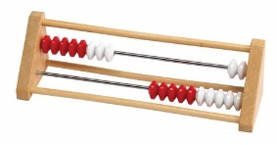

FIVE FRAMES: TEN FRAMES:

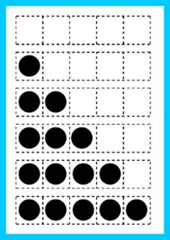 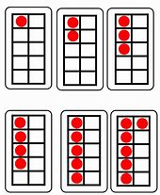

**PROGRESSION FRAMEWORK FOR TALKING ABOUT NUMBER**

**TERM ONE**: Please refer to “**Number Talks: Helping Children Build Mental Math and Computation Strategies**” by Sherry Parrish, Chapter 4, pages 70 to 96

|  |  |  |
| --- | --- | --- |
| **What are we learning?** | **How are we doing it?** | **Which skills are pupils developing?** |
| **Fluency with 3**  As each dot image is shown ask pupils ‘How many dots do you see? How do you see them?’  When using the rekenrek with pupils ‘How many beads do you see? How do you see them?’  When using the five and ten frames ask pupils ‘How many dots do you see? How do you see them?’ | Dot images: random arrays, domino patterns, dice patterns  Rekenreks  Five-Frames: different combinations  Ten-Frames: different combinations | Conservation of number: Pupil understand that the quantity of a given numbers of objects is the same regardless of how it is arranged.  One-to-one correspondence: Pupils are able to count a set of objects while understanding how a given quantity correlates to a specific number.  Subitizing: Immediately recognise a collection of objects as a single unit i.e. roll a die and know automatically that you have rolled a 3 |
| **Fluency with 4** | Dot images  Five-Frames  Rekenreks  Ten-Frames | Conservation of number  One-to-one correspondence  Subitizing |
| **Fluency with 5** | Dot images  Five-Frames  Rekenreks  Ten-Frames | Conservation of number  One-to-one correspondence  Subitizing |
| **Fluency with 6** | Dot images  Ten-Frames  Rekenreks | Conservation of number  One-to-one correspondence  Subitizing |
| **Fluency with 7** | Dot images  Ten-Frames  Rekenreks | Conservation of number  One-to-one correspondence  Subitizing |
| **Fluency with 8** | Dot images  Ten-Frames  Rekenreks | Conservation of number  One-to-one correspondence  Subitizing |
| **Fluency with 9** | Dot images  Ten-Frames  Rekenreks | Conservation of number  One-to-one correspondence  Subitizing |
| **Fluency with 10** | Dot images  Ten-Frames  Rekenreks | Conservation of number  One-to-one correspondence  Subitizing |

**PROGRESSION FRAMEWORK FOR TALKING ABOUT NUMBER**

**TERM TWO – Revise concepts from Term One**

Please refer to “**Number Talks: Helping Children Build Mental Math and Computation Strategies**” by Sherry Parrish, Chapter 4, pages 97 to 113

|  |  |  |
| --- | --- | --- |
| **What are we learning?** | **How are we doing it?** | **What skills are pupils learning?** |
| **Addition: Counting all and counting on to 15**  As each dot image is shown ask pupils ‘How many dots do you see? How do you see them?’  When using the rekenrek ask pupils ‘How many beads do you see? How do you see them?’  When using double ten-frames ask pupils ‘How many dots do you see? How do you see them?’ | Work with numbers individually first and then mix and match e.g. 11, 12, 13, 14, 15 and then combinations  Dot images: domino patterns and random arrays  Rekenreks  Double Ten-Frames: using two ten-frames with different combinations of dots in each | Counting All: Pupils need to count every object individually to be sure that they have the correct amount  Counting On: Pupils are able to count on from a given number i.e. 4 + 3, pupil counts on from 4.  One-to-one correspondence: Pupils are able to count a set of objects while understanding how a given quantity correlates to a specific number.  Subitizing: Immediately recognise a collection of objects as a single unit i.e. roll a die and know automatically that you have rolled a 3 |
| **Addition: Counting all and counting on to 20** | Dot images  Rekenreks  Double Ten-Frames | Counting all  Counting on  One-to-one correspondence  Subitizing |
| **Addition: Doubles/Near Doubles**  When using the rekenrek ask pupils ‘How many beads do you see? How do you see them?  When using double ten-frames ask pupils ‘How many dots do you see? How do you see them? | Rekenreks i.e. 3 on top, 3 on bottom; 4 on top, 3 on bottom; 3 on top, 2 on bottom  Double Ten-Frames i.e. | Subitizing  Counting all  Counting on  Fluency  Concept of place value |

**PROGRESSION FRAMEWORK FOR TALKING ABOUT NUMBER**

**TERM 3 – Revise concepts from Terms 1 and 2 and introduce number sentences which should always be written horizontally.**

Please refer to “**Number Talks: Helping Children Build Mental Math and Computation Strategies**” by Sherry Parrish, Chapter 4, pages 106 to 118

|  |  |  |
| --- | --- | --- |
| **What are we learning?** | **How are we doing it?** | **What skills are pupils learning?** |
| **Addition: Making tens**  When using the rekenrek ask pupils ‘How many beads do you see? How do you see them?’  When using ten frames and ask pupils questions such as ‘How many did you see? How do you see seven?’ Move on to asking ‘How many more to make ten?’  Also ask ‘How many are left after removing three?’ | Rekenreks  Ten-frames with missing dots  Double ten frames  Complete ten frames and covers | Subitising  Fluency  Subitising  Concept of place value  Computation – applying mathematical calculations |
| **Addition: Counting all and counting on to 10**  If pupils are ready extend number sentences to 14 | Number Sentences – start within 10 and build up to within 14 i.e.  3 + 6 4 + 6 9 + 1  3 + 7 7 + 4 9 + 3  3 + 8 4 + 8 9 + 5  4 + 9 | Computation – applying mathematical calculations  Pupils should be applying strategies from previous learning |
| **Addition: Doubles/Near Doubles to 10**  If pupils are ready extend number sentences to 14 | Number sentences – start within 10 and build up to within 20 i.e.  2 + 2 3 + 4 5 + 5  2 + 3 4 + 3 5 + 6  3 + 2 4 + 4 6 + 6  3 + 3 4 + 5 6 + 7 | Computation – applying mathematical calculations  Pupils should be applying strategies from previous learning |

**PROGRESSION FRAMEWORK FOR TALKING ABOUT NUMBER[6]**

**TERM 4 – Revise concepts from Terms 1, 2 and 3**

Please refer to “**Number Talks: Helping Children Build Mental Math and Computation Strategies**” by Sherry Parrish, Chapter 4, pages 97 to 118, focusing on sections labelled **Number Sentences**.

|  |  |  |
| --- | --- | --- |
| **What are we learning?** | **How are we doing it?** | **What skills are pupils learning?** |
| **Addition to 20: Making Tens**  When using double ten-frames ask pupils ‘How many dots do you see? How do you see them? | Double ten-frames: using two ten frames with different combinations of dots in each | Subitising  Fluency  Concept of place value |
| **Addition to 20: Making Tens**  Can pupils recognise that 9 + 1 is 10 and then they add on 3? Are they still using counting all strategy or are they now using counting on? | Number sentences i.e.  9 + 1 5 + 5  9 + 3 + 1 5 + 5 + 4  9 + 5 + 1 5 + 3 + 5 | Computation – applying mathematical calculations  Pupils should be applying strategies from previous learning |
| **Addition: Counting all and counting on to 20**  If pupils are ready extend number sentences to 24 | Number Sentences – start within 20 and build up to within 24 i.e.  6 + 4 7 + 3 9 + 11  6 + 6 7 + 7 9 + 13  6 + 8 7 + 9 9 + 15  6 + 9 7 + 5 | Computation – applying mathematical calculations  Pupils should be applying strategies from previous learning |
| **Addition: Doubles/Near Doubles to 20**  If pupils are ready extend number sentences to 24 | Number sentences – start within 20 and build up to within 24 i.e.  7 + 7 8 + 8 10 + 10  7 + 6 8 + 9 10 + 11  7 + 8 9 + 9 11 + 11  8 + 8 9 + 10 11 + 12  12 + 12 | Computation – applying mathematical calculations  Pupils should be applying strategies from previous learning |

**Active in Learning**

**The principles of being active in learning, enjoyment and pace should underpin all planning for numeracy activities.**

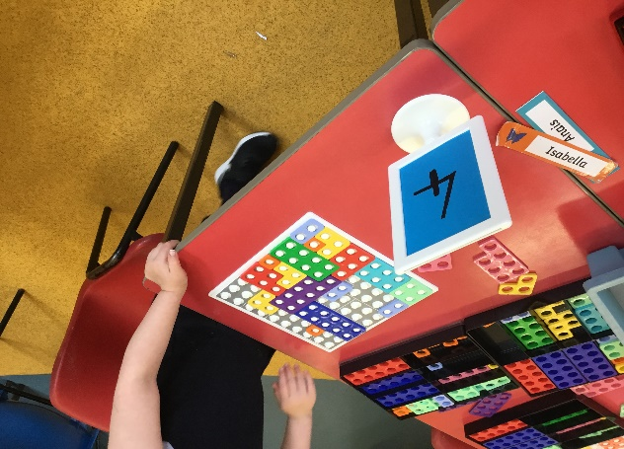Throughout the school learners should be provided with lots of opportunities to experience number, problem solving and mathematical learning without making explicit links, especially during the first term of Primary One:

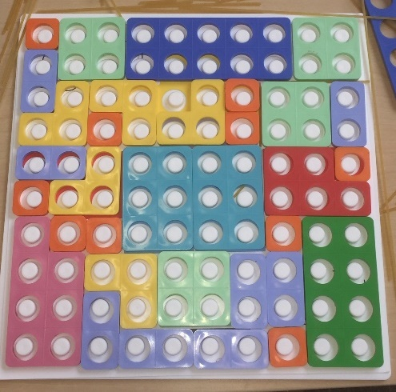

***Pupils using Numicon shapes to make a pizza – developing their skills in working with pattern and in problem solving. Challenge can be provided by providing only certain Numicon shapes***.

Allow pupils the opportunity to explore using the concrete materials in a variety of ways before formalising the link with numbers and counting – some examples of how this can be done in the early stages of Primary One are shown below. This type of activity also encourages development of fine motor control as discussed in the *Early Acquisition of Literacy in Primary 1.*

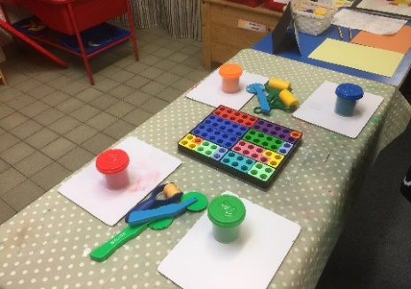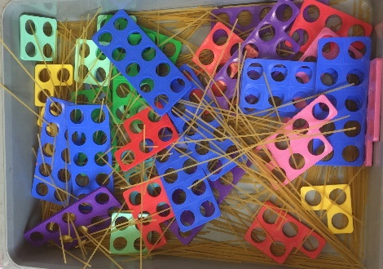 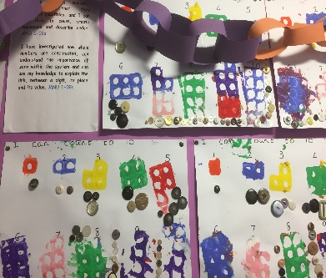

The Early Years Mathematics and Numeracy Rich Environment Tool can be used by staff to help identify strategies and resources for experiencing number and numeracy that are already in place and also identify areas for further development. ***See SALi for further information.***

Remember that learning environments should be used to stimulate quality interactions: we want to develop our pupils’ curiosity and their ability to investigate and make discoveries. To this end pupils should have access to water play, sand play, outdoor spaces and care should be taken when choosing resources for interacting with.

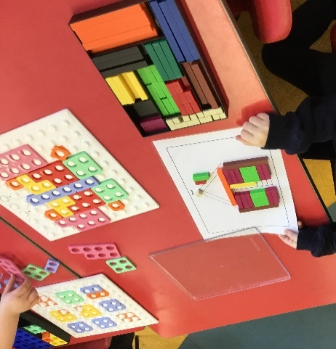

Cuisenaire rods can also be introduced at this stage – children can create a picture with guidance or use the rods to make their own patterns. Again, pupils are developing their fine-motor control, hand/eye coordination and algebraic thinking.

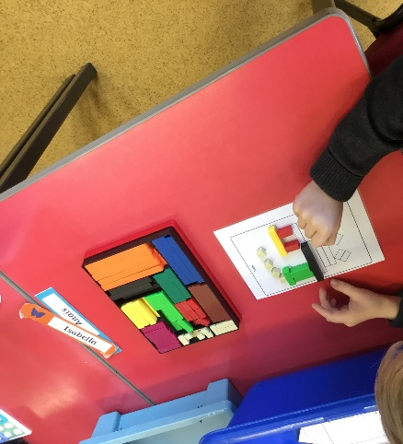Pace and repetition are very important elements, for example, until a child is totally secure in a particular concept (i.e. numeral recognition to 10) they should continue to practice this until they are. However it is essential that they are provided with a wide variety of activities which will allow them to build their own understanding, and not presented in just one way which would result in memorisation of facts but no conceptual understanding.

According to Robert J. Wright et al the following are some of the key attributes of problem-centred whole-class teaching:

* Teachers use problem-centred tasks that are designed to engage all the children and these tasks are targeted just beyond the limit of pupils’ current number knowledge;
* Pupils will routinely verbalize their thinking and the strategies they use to solve problems;
* Teachers show genuine interest in pupils’ explanations therefore creating a supportive environment where children are encouraged to think;
* Teaching includes both whole-class teaching and pupils working independently in small groups.[7]

The SEAL planners (available to download on SALi) are designed to work with all of these attributes and allow for pace and repetition, as well as ensuring pupils build strong foundations for understanding of numbers. It would be expected that pupils would complete the activities on the Emergent and Perceptual planners by the end of Primary 1. The following is a compressed table detailing the activities to complete for each of these stages. This describes whether the activities are suitable for the whole class or with smaller groups and also the resources required to complete them. It will also allow practitioners to develop activities of their own based around each skill. For further information refer closely to Chapters 5 and 6 of “Teaching Number: Advancing children’s skills and strategies” Robert Wright et al. Further information on using SEAL, including a report on the impact of using SEAL in Primary 1, can be found on [Sharing Argyll Learning Ideas](https://blogs.glowscotland.org.uk/ab/sali/2017/12/14/stages-of-early-arithmetical-learning/).

|  |  |  |  |  |  |  |
| --- | --- | --- | --- | --- | --- | --- |
| Teaching the Emergent Child – See Chapter 5 of “Teaching Number: Advancing children’s skills and strategies”: Wright et al, 2002  WORKING WITHIN 20 | | | | | | |
| **Concepts being taught** | **Forward and Backward Number Word Sequences** | **Numerals and numeral sequences in the range of 1 – 10** | **Counting visible items** | **Subitising** | **Finger patterns** | **Temporal patterns and sequences** |
| **Resources required** | N/A | Numeral flashcards  Numeral track | Double-sided counters | Domino, pairs and random array cards | Hands and fingers | Hands for clapping and chopping |
| **Top tips** | Don’t always start at 1 when counting – vary your starting point regularly. Also, when counting backwards stop at different numbers each time. Ask pupils to copy you and also to say alternate words i.e**. *I will say two, then you say three, then I will say four then you say five and so on.*** This should lead to them saying the next number. Do this for both Forwards and Backwards sequences.  Best for whole class activities | Start by placing out numeral sequences in order and asking pupils to count them forward and backward. Move on to numerals being randomly arranged and asking pupils to identify them. Also, use a numeral track with numerals covered and uncovered.  Good for group activities | Start with pupils counting small amounts of counters in one colour, before moving on to groups of counters of two colours. Also encourage pupils to count them both forwards and backwards. Lay out large amounts of counters (around 30) and ask pupils to give you x amount out of the group (up to 20).  Good for group activities | As discussed during the talking about number section – use different types of flashcards and ask  the class ‘What do you see?’ and also ‘How do you see them?’  Good for whole class activities | Encourage pupils to use their fingers to make patterns for the number sequences – start with sequential patterns for 1 to 5, raising one finger at a time. Move on to pupils doing this with their hands held above their heads (bunny ears). Move on to doing this up to 10.  Good for whole class activities | Encourage pupils to copy and count different hand movements, both clapping and chopping motions. Alternate with different speeds: deliberate chopping motions; clapping rhythmically; clapping slowly; clapping irregularly.  Good for whole class activities |
| Teaching the Perceptual Child – See Chapter 6 of “Teaching Number: Advancing children’s skills and strategies”: Wright et al, 2002  WORKING WITHIN 30 | | | | | | |
| **Concepts being taught** | **Forward and Backward Number Word Sequences** | **Numerals and numeral sequences in the range of 1 – 20** | **Counting visible items** | **Subitising** | **Finger patterns** | **Equal groups and sharing** |
| **Resources required** | N/A | Numeral flashcards  Numeral track | Double-sided counters and screens | Domino and pairs patterns to 6, ten frames. | Hands and fingers | Counters and variety of small toys |
| **Top tips** | Always vary starting and ending point when counting. Ask pupils to copy the word after the number and also the number word before i.e. *I’m going to say a number and I want you to say the number just before the one I say. Ready …*  Best for whole class activities | As before, extending the sequence to 20 this time. Ask pupils to count forwards and backwards, sequence numbers, recognise and identify numbers. Initially have all of the numeral track uncovered and then proceed to covering up selected numerals. If pupils appear ready, this can be extended to using a numeral roll up to 50.  Good for group activities | At this stage start to screen first one collection of counters, then the next and finally screen both collections i.e.  **Place out x red counters.** *Here are x red counters.* **Place out y yellow counters**. *Here are y yellow counters. I’m going to cover these y yellow counters.* **Place a screen over the yellow counters**.  *X and y, how many counters are there altogether? … Would you like to check?*  Good for group activities | As discussed during the talking about number section – use different types of flashcards and ask  the class ‘What do you see?’ and also ‘How do you see them?’  Ask about both dots and spaces.  Good for whole class activities | Start with sequential patterns for 6 to 10, raising five fingers on one hand and 1 finger on the other. How many raised altogether? Do as seen and unseen.  Introduce doubles plus one: *Put your hands on your head. Show me 2 and 2 on your fingers. What does that make? Put up one more finger. What do you have now?*  Good for whole class activities | Encourage pupils to describe, organise and make equal groups: *Place out 8 plastic cows. Here are some cows. The farmer wants the cows put in twos. Can you put the cows in twos?*  Next encourage pupils to describe, organise and partition into equal shares: *Place out 3 teddies and 12 biscuits. The teddies are sharing the biscuits. Can you share out the biscuits for them?*  Good for group activities |

**Concrete Materials**

**Concrete materials should be used at all times within the class, both to support the introduction of new concepts and to enhance pupils’ understanding of, and confidence in, numeracy.**

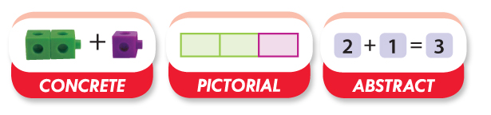

It is now widely recognised that the use of manipulatives, or concrete materials, is a vital tool in the teaching toolkit and that the concrete-pictorial-abstract cycle should underpin the learning and teaching of numeracy. [8] However, various studies have highlighted that whilst teachers are aware of the need to use manipulatives they are confused about which manipulatives to use in specific contexts. Also, a certain manipulative may be used to teach a given concept and then disappear, never to be used again. This serves to make learners associate this manipulative with one specific numerical task, rather than seeing it as a vehicle with which they can solve a wide range of problems.[9] As Mike Askew states:

While there is general agreement about the importance of ‘models and images’ in helping children learn mathematics, there is less clarity about why they are important and how to work with them. It is not the models of images themselves that are important, but the way that these support children’s mathematical activity. Models and images have to be worked with, not simply presented to the children.

**“Transforming Primary Mathematics”: M. Askew, 2016**

There should be planned, purposeful and appropriate use of concrete materials throughout numeracy and mathematics lessons. Remember to use manipulatives and concrete materials for multiple purposes. For example Cuisenaire rods can be used to support number development, measurement concepts and graphing models. In this way pupils won’t associate a concept with only one manipulative. Also, these manipulatives should be available to pupils at all times so that there is no stigma attached to the need to use these to understand a mathematical concept.

The use of concrete materials allows practitioners to develop a wide variety of activities for their pupils to develop a particular concept and to repeat and revisit this numerous times so that they can become proficient and strategic with the concept being taught. For example activities can be created for pupils around creating different combinations of 6 with a wide variety of materials:

* Blank ten frames that can be filled with a variety of resources i.e. leaves, acorns, stones, shells, gems;

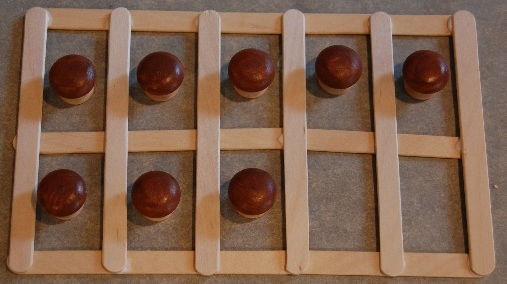

* Double-sided counters;

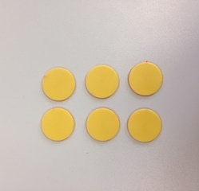 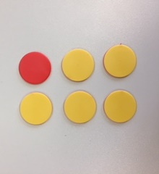 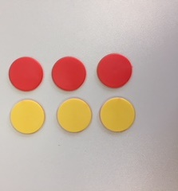

* Numicon shapes;
* Pegs;
* Cuisenaire rods;
* Lego;
* Rekenreks.

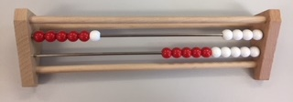 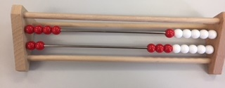

**Parental Engagement and Family Learning**

**There should be planned parental engagement where numeracy practices are shared and parents know how to support their child.** It is a statutory requirement that schools improve learning at home, home/school partnerships and parental representation. Scottish Schools (Parental Involvement) Act 2006.[10] For further information and ideas of how to support the development of this within your establishments it is well worth reading over HGIOS4, QI 2.5, Family Learning which provides challenge questions around engaging families in learning, early intervention and prevention and the quality of family learning programmes.[11]

Providing information, practical support and developing strategies for supporting parents to help them engage with the setting and their children’s learning is a key priority.

**Engaging Parents and Families, Education Scotland.**

What parents can do with their children at home has far greater significance than any other factor open to education influence. **K. Tucker, Mathematics through play in the early years, 2010**

Family learning opportunities need to be planned and be part of the improvement journey. Some ideas may include:

* Family learning numeracy events, led by the pupils providing information about approaches to numeracy;
* Lending library of numeracy games and numeracy themed story books -<https://www.amazon.co.uk/Story-Maths-Finding-different-places/dp/1847850227>;
* Consideration of home learning, providing exciting opportunities for number in context;
* Use family maths scrapbooks, created to reflect ongoing learning;
* Develop a maths trail, supported by parents;
* Numeracy after school club;
* Maths week competitions;
* Parental volunteers for number games, sharing skills and expertise;
* Number sacks used for home school link;
* Use the Bookbug P1 Family Bag as a family link resource;
* Provide useful guides regarding current learning and how parents can support their child.

**It is essential that parents know what their child is learning and how they can be supported at home, therefore regular communication will need to be provided.** This may take the form of home/school diary, class newsletter, numeracy noticeboard etc.

Numeracy can be promoted and highlighted with parents in a number of ways:

* Assemblies/Sports Days highlighting a numeracy theme;
* Numeracy parental notice board;
* Numeracy focus weeks;
* Reinforced, positive messages promoting the joy of number;
* Use of QR codes to share work;
* Numeracy focused social events – bingo, beetle etc.;
* Promotion of websites such as:

Read, Write Count <http://www.readwritecount.scot/count/>,

Parentzone <http://www.educationscotland.gov.uk/parentzone/>,

Count us in <http://education.abc.net.au/home#!/search/_SRC:ABC%20Count%20Us%20In/-/F>

BBC <http://www.bbc.co.uk/schools/websites/4_11/site/numeracy.shtml>

In addition Education Scotland have developed a maths resource for families to learn together called “I am a Mathematician” featuring the characters Multiplying Milli and Dividing Dec which has many useful suggestions and ideas for family learning and may be worth considering for use as homework activities:

<https://education.gov.scot/parentzone/Documents/IAmAMathematician120517.pdf>

The Argyll and Bute Early Years Team has also produced the Talking Maths Kit for the Early Years which would also provide many helpful ideas and activities.

**Numeracy Outdoors**

The vision for outdoor learning is:

• All children and young people are participating in a range of progressive and creative outdoor learning experiences which are clearly part of the curriculum;

• Schools and centres are providing regular, frequent, enjoyable and challenging opportunities for all children and young people to learn outdoors throughout their school career and beyond;

• Teachers and educators embed outdoor learning in the curriculum so that learning in the outdoor environment becomes a reality for all children and young people.

**Curriculum for Excellence through outdoor learning**

In Argyll and Bute we are fortunate to have a rich and beautiful environment for our children.Providing outdoor learning allows learners to deepen and contextualise their understanding in numeracy and to link learning across the curriculum. All aspects of numeracy and mathematics can and should be developed outdoors as often as possible.

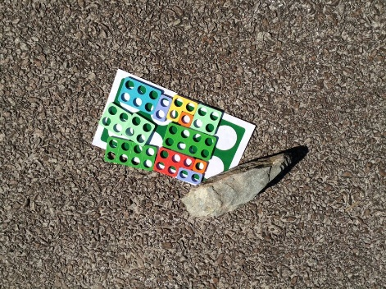  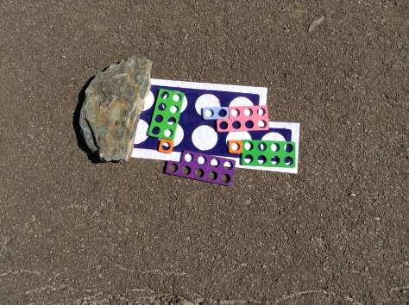

**A Numicon treasure hunt outside with levels of challenge easily built in – pupils can leave 1 shape, 2 shapes or 3 shapes depending on learning.**

The reading lists and website links below will support outdoor learning in numeracy.

**Recommended reading**

“Messy Maths: A Playful, Outdoor approach for Early Years” by Juliet Robertson

“Dirty Teaching: A Beginner’s Guide to Learning Outdoors” by Juliet Robertson

**Recommended websites**

[**http://creativestarlearning.co.uk/c/maths-outdoors/**](http://creativestarlearning.co.uk/c/maths-outdoors/)

[**https://thirdspacelearning.com/blog/13-outdoor-maths-activities-early-years-year-6-plus-bonus-ages/**](https://thirdspacelearning.com/blog/13-outdoor-maths-activities-early-years-year-6-plus-bonus-ages/)

**[Maths Trails from thinkingchild.org.uk](http://www.google.co.uk/url?sa=t&rct=j&q=&esrc=s&source=web&cd=10&ved=0ahUKEwii4IWEtNPbAhUhBcAKHZbRD2AQFghlMAk&url=http%3A%2F%2Fwww.thinkingchild.org.uk%2Fwp-content%2Fuploads%2F2013%2F11%2FFree-Maths-Trails-pages-from-Thinking-Child.pdf&usg=AOvVaw1iuVAISgQkD8SCVtrqb-qI)**

[**https://www.countrysideclassroom.org.uk/storage/resource/downloads/daaf7986-2bb6-46a9-a66d-2714a7e9d4b0/original/maths-outdoors-natural-connections.pdf**](https://www.countrysideclassroom.org.uk/storage/resource/downloads/daaf7986-2bb6-46a9-a66d-2714a7e9d4b0/original/maths-outdoors-natural-connections.pdf)

**Appendix 1: Bibliography**

**Documents to download:**

“Transforming Scotland into a Maths Positive Nation: The Final Report of the Making Maths Count Group”: <http://www.gov.scot/Publications/2016/09/3014/0>

Our Children, Their Future:

[*https://www.argyll-bute.gov.uk/sites/default/files/argyll_bute_vision_strategy_final_web.pdf*](https://www.argyll-bute.gov.uk/sites/default/files/argyll_bute_vision_strategy_final_web.pdf)

Guidance on: The Early Acquisition of Literacy in Primary 1:[*https://blogs.glowscotland.org.uk/glowblogs/able/*](https://blogs.glowscotland.org.uk/glowblogs/able/)

The Learning and Development Framework 0-5 years:[*https://blogs.glowscotland.org.uk/ab/sali/2016/12/20/learning-and-development-framework/*](https://blogs.glowscotland.org.uk/ab/sali/2016/12/20/learning-and-development-framework/)

Building the Curriculum:

[*https://education.gov.scot/scottish-education-system/policy-for-scottish-education/policy-drivers/cfe-(building-from-the-statement-appendix-incl-btc1-5)/Building%20the%20Curriculum*](https://education.gov.scot/scottish-education-system/policy-for-scottish-education/policy-drivers/cfe-(building-from-the-statement-appendix-incl-btc1-5)/Building%20the%20Curriculum)

Improving Mathematics in Key Stages 2 & 3:

[*https://educationendowmentfoundation.org.uk/tools/guidance-reports/maths-ks-two-three/*](https://educationendowmentfoundation.org.uk/tools/guidance-reports/maths-ks-two-three/)

Concrete Materials and Teaching for Mathematical Understanding:

[*http://pat-thompson.net/PDFversions/1994Concrete.pdf*](http://pat-thompson.net/PDFversions/1994Concrete.pdf)

How good is our school? 4th Edition

<https://education.gov.scot/improvement/Documents/Frameworks_SelfEvaluation/FRWK2_NIHeditHGIOS/FRWK2_HGIOS4.pdf>

Engaging Parents and families: A toolkit for practitioners:

[*https://education.gov.scot/improvement/learning-resources/Engaging%20parents%20and%20families:%20A%20toolkit%20for%20practitioners*](https://education.gov.scot/improvement/learning-resources/Engaging%20parents%20and%20families:%20A%20toolkit%20for%20practitioners)

Curriculum for Excellence through Outdoor Learning:

[*https://education.gov.scot/Documents/cfe-through-outdoor-learning.pdf*](https://education.gov.scot/Documents/cfe-through-outdoor-learning.pdf)

**Books and publications:**

“Teaching Number: Advancing children’s skills and strategies”: Wright et al, 2002

“Educational Psychology: A Cognitive View”, D. Ausubel, 1968

“Storyline: creative learning across the curriculum”, C. Omand, 2014

“Mathematical Mindsets” by Jo Boaler

“Implicit theories of intelligence predict achievement across an adolescent transition: A longitudinal study and an intervention”, L. Blackwell et al, 2007

“Mindset: The New Psychology of Success”, C. Dweck, 2006

“Active Learning through Formative Assessment”, S. Clarke, 2008

“Developing Number Sense: Progression in the Middle Years”: J. Anghileri, 2007

“Inside the Black Box: Raising Standards through Classroom Assessment”, P. Black and D. Wiliam, 1998

“Number Talks: Helping children build mental math and computation strategies”, S. Parrish, 2014

“Transforming Primary Mathematics”: M. Askew, 2016

“Mathematics Through Play in the Early Years”: K. Tucker, 2010

**Appendix 2: ELC Numeracy and Mathematics Number Progress Tracker**

Learning and Development Profile – Young Child

UPDATED SEPTEMBER 2017

Monitoring and Tracking Progress in ELC Numeracy and Mathematics

Incorporating Education Scotland ‘Numeracy and Mathematics Benchmarks’

[](http://www.google.co.uk/url?sa=i&rct=j&q=&esrc=s&source=images&cd=&cad=rja&uact=8&ved=0ahUKEwja78aOqZPWAhUB1hQKHdnVAogQjRwIBw&url=http://www.hampsteadaupairs.com/123-blocks/&psig=AFQjCNE-3Kf6DyuZ_cppVoQZbKnSvcpJ1A&ust=1504881778427698)

and the City of Edinburgh Council’s ‘Numeracy Assessment and Planning Tracker’.



**Context**

Education Scotland has placed a greater emphasis on planning for progression and expect ELC settings to have a clear strategy for the development and assessment of children’s numeracy skills to ensure smooth progression and achievement. This tool will enable you to do this. The skills are based on the ‘Numeracy and Mathematics benchmarks – Early Level. This should help you to make clear informed decisions about children’s progression.

Guidelines for completing this tool

* This tool should be completed by practitioners over the course of a child’s time in their ELC setting.
* As a guide, children’s progress should be updated in the June of their first year of ELC and in the December and June of the child’s second year of ELC. However, it is up to each individual unit to decide how often they track individual children’s progress
* The tracker will be passed onto the receiving primary school as part of the transition process.
* Information should be gathered over time generally through observation, although sometimes practitioners may need to set up a specific small group or individual activity to fully assess a child’s progress.
* An overview of the child’s progress in each area should be given in the ‘date’ boxes. Practitioners should ensure that the boxes in all areas are completed prior to the child moving to primary one.
* It is important to involve parents in this process and share the information with them. This could be done through sharing progress within each child’s PLP.
* Practitioners should be mindful of a child’s additional support needs when completing the tool and ensure they fully capture the skills a child shows. Any activities to measure a child’s skills should be adapted in line with their particular needs e.g. allowing a child to indicate a response by pointing or gesture if their language skills are delayed.

A key for indicating a child’s progress within the skill could be used as follows:

|  |  |
| --- | --- |
| Level of Skill | Coding |
| Has engaged in some experience of the skill | GivingSeedling.pdf1 |
| Skill is shown sometimes but is not consistent yet | 2 |
| Skill is shown regularly and spontaneously | 3 |

Next steps and using this tool in your practice

* Practitioners should use the information collected using this tool to plan next steps in a child’s learning and to monitor their progress on an ongoing basis. The tool should also be used to plan focussed learning experiences based on the experiences and outcomes to provide progression, depth and challenge.
* Evaluate children’s progress through effective observations on an ongoing basis through short, concise notes to help planning for next steps in learning.
* By completing the tool on several occasions practitioners should be able to gain a picture of the child’s progress over time.
* Moderate assessment judgements through discussing standards and the progression of individual children. This can be done at weekly team meetings and from time to time with colleagues from other establishments to ensure a shared understanding across settings
* If a child is showing early development in a lot of areas, but is not making progress over time or practitioners have other concerns about their development, consider involving relevant support services such as Health Visitor, Speech and Language Therapy Service, Area Principal Teacher, Educational Psychology Service.
* It is very important that this tool is used appropriately to track each child’s progress and plan effective and meaningful next steps. It should not be used to ‘tick off’ all of the Experiences and Outcomes (Es and Os) separately – as stated in Educations Scotland’s ‘Curriculum for Excellence – A Statement for Practitioners from HM Chief Inspector of Education’ (August 2016)
* The tool has been designed to track progress within the ‘Curriculum Organisers’ for Numeracy and Mathematics to ensure practitioners are not tracking and recording progress against individual Es and Os’:
* Estimation and rounding
* Number and number processes
* Fractions, decimal fractions and percentages
* Money
* Time

Numeracy overviews should be included in each child’s PLP as a summary of progress and achievement and to identify next steps in learning. The tool should also be used to support transition.

The tool should be used as part of the ‘Learning and Development Framework 0-5 Years’ (incorporating the Developmental Milestone Tool)

Thanks to City of Edinburgh Council

Developing Early Maths Through Play

Children’s experience of early mathematics begins at home. In and around the home children are involved in a variety of early mathematical activities and their awareness of number and its importance is developed through everyday activities in family life such as shopping, setting the table or cooking. These are rich mathematical contexts which introduce them to a variety of mathematical concepts and can give a secure basis on which to build their future skills.

Before starting school or nursery many children can already:

• Count

• Recognise numerals

• Represent quantities

• Share things out

• Sort and match items

• Understand the language for comparing and ordering objects

• Do very simple addition and subtraction

For young children learning is holistic and not divided into subject headings. They encounter mathematical concepts as part of the whole process of finding out about and making sense of the world around them. As with everything else children’s knowledge and understanding has to be based on experiential learning using their senses to explore the concrete world before they can deal with abstract ideas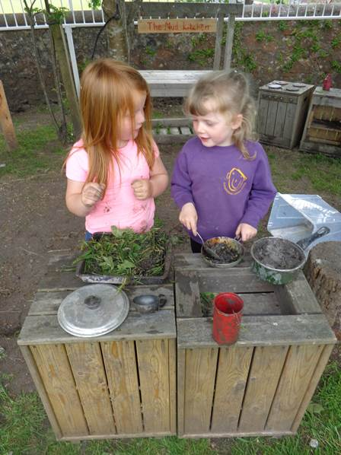.

Children have individual experiences and interests and learn at different rates. But the way they learn follows a similar pattern as they:

• Explore the world around them

• Discover patterns in what they see and do

• Repeat actions and test the patterns they have recognised

• Add their new understanding to what they already know about what the world is like and how it works

• Use words to make clear what they kno

Why Play?

One of the most powerful and self-motivating contexts for early mathematics is play. Through play children can repeat, rehearse and refine skills,

using skills already gained and practising new skills.

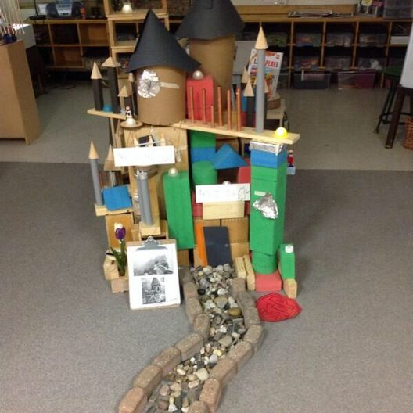Learning maths through play offers several advantages:

• It has a purpose – it’s fun!

• It is set within a meaningful context

• It gives the child responsibility and control

• It provides time to repeat, practise and gain mastery

• It is a practical activity and natural to young children’s holistic learning

Through well-planned play children are continually:

• Making decisions

• Imagining

• Reasoning

• Predicting

• Planning

• Experimenting with strategies

• Recording

All these processes, integral to play, are essential for mathematical thinking.

The best learning starts with the interests of the child and provision for children should be based on an understanding of how children learn maths.

It is important that maths experiences are meaningful to children and not abstract ideas and concepts unrelated to children’s previous experiences. Children have to make meaning and connections with other aspects of the world around them.

Practitioners need to recognise the powerful contribution that play makes to children’s learning and take advantage of play situations to ensure that opportunities to develop maths ideas and skills are available daily.

We also must ensure there is a balance between adult-directed activities and child- initiated play. It is important to introduce children to new concepts and ideas in small groups or individually but then allow them to consolidate their learning through free flow play activities.

Creating a Maths Rich Environment

Creating a stimulating, learning environment that offers a rich variety of experiences for all children is central to high quality provision.

Practitioners should ensure that the playroom offers play opportunities for children to:

• Develop powers of observation using the senses

• Recognise patterns, shapes and colour

• Be aware of daily time sequences, identify and use numbers

• Sort and categorise things into groups

• Count

• Recognise some properties of materials such as hard / soft / rough / smooth

• Solve problems

• Use words to describe measurement

• Collect, organise, display, interpret

Resources may vary in different settings. Nevertheless there will be a wide range of resources that children can use to develop their mathematical skills. To support organisation of resources, many centres set up a maths area but there can be opportunities to promote the development of maths skills in all areas of the playroom.

Possible resources:

**For sorting, classifying, ordering and counting:**

Shells, pebbles, cars, shapes, buttons, pegs, plastic numbers, cotton reels, boxes, feathers, keys, shiny gift bags, fir cones, sorting circles, sorting trays, conkers, baskets, cubes

**Exploring pattern and shape:**

Tap-tap shapes, pegs, pegboards, linking chains, laces and beads, beads and ribbons, building blocks, shape sorters, magnetic shapes and numbers, shape / pattern games.

**For measuring:**

Rulers, number lines, balances, scales, tape measures, stop clocks, sand / water timers, graded containers, height charts

**Number**

Dominos, counters, dice, board / track games, number snakes, cubes, calculators, an abacus, number lines, magnetic numbers, painted stones / wooden discs

Routines and storage systems can significantly influence children’s mathematical learning. For example in the home corner:

• Kitchen equipment is more appealing if hung along the wall for the children to match this will enable children to develop their understanding of shape, size and colour.

• Templates can also be used on horizontal surfaces for matching activities with cups and plates

• Numbered egg cups and eggs will encourage one-to-one correspondence and number ordering

• Routines such as knocking four times as you enter the home corner will encourage counting

• Where appropriate, resources should be ‘real’ – eg real crockery, pots and pans as opposed to plastic toys

It is important to give children lots of opportunities to see and use numbers around the playroom. Visual displays of numbers that are meaningful promote the recognition of the numerals and number order. Where appropriate, use environmental numbers and shapes – eg road signs, numbers on houses, shapes in the environment.

Number lines can be created through displays, with real objects, on doors, trays, with photographs on ‘washing lines’ and on shapes or signs.

Examples are:

• Cover small tubs with plain paper and label each with a number. These can then be hung from hooks on the wall. Leave a tray of objects, relevant to the current context for learning, for children to count into the tubs.

• Create number trails of large footprints across the floor. These can also be used as pathways to areas within the playroom. E.g. ‘how many footprints is it to the sand tray?’

• Resource trays or boxes can also be labelled with numbers for the children to recognise. ‘Can you put this back in the tray with number 6 on it?’

• Wheeled toys can be numbered and the bays they are to be ‘parked’ in.

• Cover a biscuit tin and label it with numbers (Tins that are hexagonal in shape are good as they have flat sides). Fill the tin with clothes pegs and the children have to clip pegs to the edge of the tin matching the correct number of pegs to the correct label.

Number Rhymes and Songs are plentiful and support counting forwards, backwards, addition and subtraction.

Remember it is important to find ways of making the children aware of the concept of number during rhyme

activities by having concrete examples available e.g. five toy ducks for the ‘Five Little Ducks’ rhyme.

It is also useful to create maths boxes or sacks based around a rhyme for children to take home and share with parents.

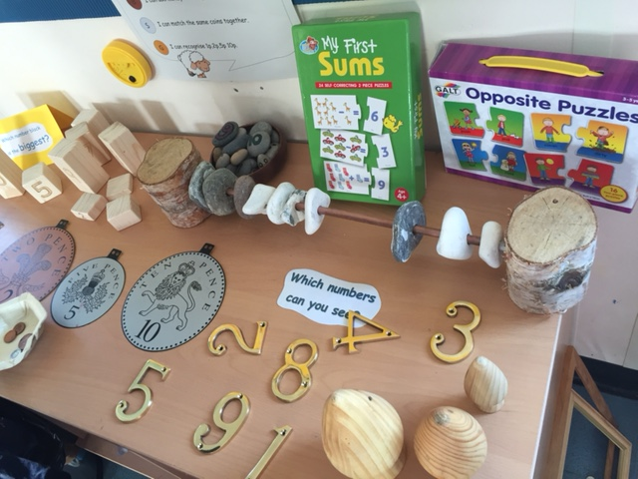Children should also be given meaningful reasons for writing numbers. For example:

• Collecting information, such as how many children have had their snack

• Scoring for games

• Number plates for wheeled toys

• Shopping lists and price labels

• Recipes

• Telephone numbers

• Appointment times in the doctor’s surgery

• Menus and price lists in the café

• Tickets for buses and trains

Any early attempts at writing numbers should be valued and encouraged.

Providing opportunities for children to add and take away objects can develop the concepts of addition and subtraction. For example, only five children in the group have drinks how many more do we need? How many cups altogether? One child has finished we can take the cup away, how many are left?

Children enjoy ordering, sorting and matching objects as part of their play. In the small world area they will sort and classify furniture, model animals and cars in a variety of ways, by colour, shape, size and purpose. There are lots of commercially produced resources for sorting but ‘real’ objects such as leaves, pebbles, feathers etc are just as exciting to young children.

Opportunities to develop children’s ability to recognise pattern and sequence should be provided in all curricular areas, for instance, shape and design in the construction area, shapes and patterns made by words, shapes and patterns made by dough, creativity in art and craft and movement sequences in physical play.

Measuring activities can support children’s understanding of weight, length, time, volume and capacity. The sand and water trays are ideal resources to provide purposeful play and develop their language and understanding of this concept.

Children should be encouraged to recognise coins by looking at the different colours and shapes. Opportunities to use money and develop an understanding of the purpose of money can easily be provided through a range of contexts in the role-play area.

The Role of the Adult

Adults have a crucial role to play in developing children’s mathematical thinking and language. Conversations should introduce new vocabulary and create challenges and problems for the children to solve.

The adult role includes:

• Modelling appropriate talk and a range of vocabulary by putting children’s actions into words. E.g.’ I can see you are making a long row of cars……..now you’re adding one more. How many are you going to add?’

• Modelling the use of numbers and counting in everyday situations.

• Writing numerals for a range of purposes.

• Effective questioning to develop, extend and sustain children’s play. E.g. ‘What shall we do now?’ ‘What if we tried filling up this bottle?’ ‘I wonder what will happen if we add one more?’

• Encouraging children to think out loud as they take part in mathematical activities. E.g. ‘I wonder if those will fit in there.’ Will the lid still fit on?’ ‘What do you think?’

• Recognition of individual learning skills and planning for both more focused adult- led activities and providing the resources to enable high quality child-initiated play that extends learning.

To develop children’s problem solving and thinking skills, adults have to stretch children’s thought processes by encouraging them to be creative in thinking up solutions and identifying problems in all areas of learning. Children should be encouraged to make links between previous experiences and learning, and new problems or challenges.

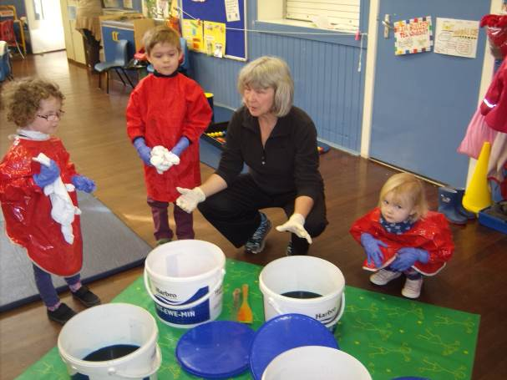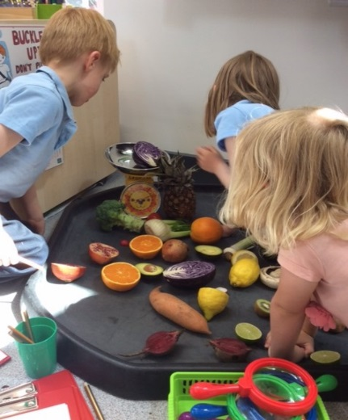

Planning for Mathematical Play

Observing children at play and recording observations of children’s skills, understanding and previous experiences will help to inform future plans. Once we have identified the next steps in learning for children we can then consider how these might be addressed creatively, and which play opportunities and resources can be offered to support them. When establishing a creative context for learning we may ask ourselves the following questions:

• What are our mathematical learning intentions to enable children to extend their learning?

• What are the children’s current interests or the current outcomes for learning?

• What mathematical opportunities does this offer? (What could the children measure, count, weigh, make patterns with or buy? What information could they find out and what problems could they solve?)

• What links are there with other areas of the curriculum and previous experiences? (Will they be exploring materials or growing things? Will they be listening to a poem, story or song? Will they be finding out about other places or people?)

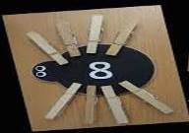• Will this stimulate independent play in a variety of contexts both indoors and outdoors?

• What resources are needed and how might the children use these resources?

• What enquiry and key questions will stimulate play and promote learning?

• Do the activities encourage co-operative learning and talk amongst the children?

The well-resourced ELC setting contains a rich variety of activities and opportunities, which will have

the potential to stimulate young children’s mathematical development. It is the adult’s role to recognise

the mathematical potential of each activity, resource and situation and to structure it so it’s engaging

and learning does take place.

Engaging Parents

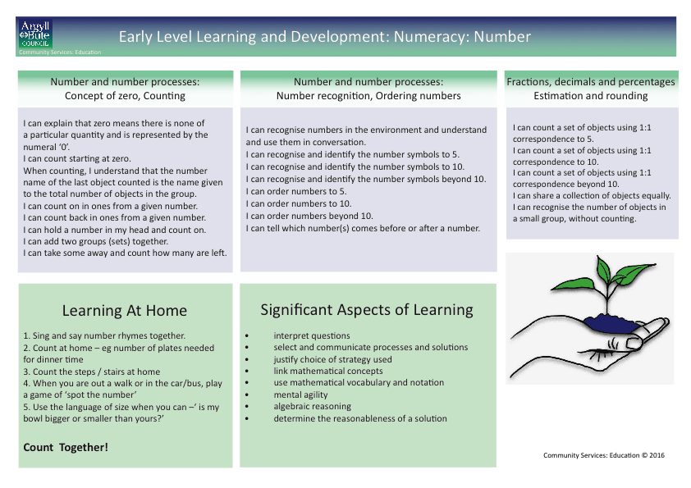Parents are children’s first and continuing educators. It is important to build real partnerships based on two-way conversations between home and ELC. We must regularly share children’s significant achievements with parents, our planned programmes of activities and learning intentions to support next steps in learning. In this way we can encourage parents to engage in their child’s learning by recognising and making the most of the rich mathematical opportunities that can arise in everyday life.



**Appendix 3: SEAL Diagnostic Assessment**

|  |  |  |  |
| --- | --- | --- | --- |
|  | Addition and Subtraction | Hinge Questions for pupil | Comments |
| E  M  E  R  G  E  N  T | Emergent Chapter 5: Nurturing Perceptual Counting | | |
| Can count perceived items.  This may involve seeing, hearing and feeling items. | Give me 7.  Give me 14.  Lay out 12. How many? |  |
| Can count 2 or more perceived collections together. This may involve seeing, hearing and feeling items. | I have 8 here and 4 here. How many do I have altogether? |  |
| P  E  R  C  E  P  T  U  A  L | Perceptual Chapter 6: Nurturing Figurative Counting | | |
| Can count items in two screened collections. | I have 7 hiding under this screen and 5 more here. How many do I have altogether? ( 7 + 5 )  CHECK |  |
| I have 9 hiding under this screen and 4 under this screen. How many do I have altogether? ( 9 + 4 )  CHECK |  |
| F  I  G  U  R  A  T  I  V  E | Figurative Chapter 7: Nurturing Initial Number Sequences (counting in ones) | | |
| Can count on rather than count from ‘one’ to solve addition and missing addend tasks e.g.  6 + _ = 9 | I have 12 hiding under this screen and 4 under this screen. How many do I have altogether? ( 12 + 4 )  CHECK |  |
| I have 6 hiding under this red screen and some more hiding under this yellow screen. I have 14 altogether. How many are hiding under the yellow screen? (6 +? = 14 )  CHECK |  |
| Figurative Chapter 7: Nurturing Intermediate Number Sequences ( most efficient count-by-one strategies) | | |
| Use a CDF strategy to solve removed item tasks (e.g. 17 – 3 as 16, 15, 14, answer is 14). | I have 16 hiding under this screen. I have taken away 7. How many do I have left?  ( 16 – 7 = ) |  |
| Use a CDT strategy to solve missing subtrahend (e.g. 15 - _ = 11) and written tasks such as 17 – 14 (16, 15, 14, answer is 3). | I have 12 hiding under this screen. I have taken some away and now I have 8 left. How many did I take away?  ( 12 - _ = 8 ) |  |
| Can choose the most efficient from count-by-one strategies (including CDF/CDT strategies)  Can choose the most efficient from count-by-one strategies (including CDF/CDT strategies) | Adding Collections  11 + 5 = |  |
| Missing Addends 1  _ + 12 = 18  9 + _ = 14 |  |
| Missing Addends 2  2 + _ = 19  _ + 2 + 14 |  |
| Removed Item 1  19 – 6 = |  |
| Removed Item 2  19 – 17 = |  |
| Missing Subtrahend 1  14 - _ = 9 |  |
| Missing Subtrahend 2  12 - _ = 2 |  |
| Missing Minuend 1  ­_ - 15 = 3 |  |

|  |  |  |  |  |  |
| --- | --- | --- | --- | --- | --- |
|  | Addition and Subtraction | Hinge Questions for pupil | | | Comments |
| C  O  U  N  T  I  N  G  O  N | Counting On Chapter 8: Nurturing Facile Number Sequences to 20 ( Facile Number Sequences to 20 – non count-by-one strategies to 20) | | | | |
| Can use understanding of number structures to develop and explain a range of non-count-by-one strategies to solve tasks within 20 such as: compensation, using a known results, adding to ten, partitioning using 5 and 10 as a base (5-wise) commutativity, subtraction as the inverse of addition, awareness of the ‘ten’ in a teen number, using doubles and near doubles | Compensation  Using a known result | Look for this throughout. | |  |
| Add to ten  Subtract from ten | 7 + _ = 10  10 - _ = 6 | |  |
| Partitioning using 5 and 10  Adding/  subtracting through 10 | 7 + 5  9 + 4  8 + 6  13 – 5  14 – 6  15 – 7 | |  |
|  |
| Commutativity | 2 + 9  4 + 8 | |  |
| Subtraction as the inverse of addition | 6 + 9 =  So what is 15 – 6? | |  |
| Awareness of ten in the teen number | 10 + 6  18 – 8 | |  |
| Using doubles and near doubles | 6 + 6  7 + 6  9 + 9  18 – 9 | |  |
| F  A  C  I  L  E | Facile Chapter 9: Nurturing Facile Number Sequence to 100 | | | | |
| Can use their understanding of number structures to develop and explain their own range of non-count-by-one strategies to solve two digit addition and subtraction tasks within 100  Key:  JS = Jump Strategy  P = Partitioning numbers to simplify problem | Addition of tens | | 23 + 40  53 + 30 |  |
| Addition of tens and ones | | 23 + 42  54 + 42 |  |
| Addition of tens and ones through decade | | 54 + 37  36 + 48 |  |
| Subtraction of tens | | 65 – 20  87 – 40 |  |
| Subtraction of tens and ones | | 58 – 45  87 – 45 |  |
| Subtraction of tens and ones through decades | | 45 – 28  65 – 46 |  |
| Use knowledge of partitioning to simplify the problems | | 84 – 19  49 + 31 |  |

Glossary of terms:

Addend = A number to be added. In 8 + 6 + 14, 8 and 6 are addends, and 14 is the sum.

CDF = Counting Down From = A strategy used by children to solve Removed Items tasks, for example 11 remove 3 – “eleven, ten, nine – eight”. Also referred to as counting-off-from or counting-back-from.

CDT = Counting Down To = Regarded as the most advanced of the counting-by-ones strategies. Typically used to solve missing subtrahend tasks, e.g. have 11, remove some, and there are eight left – “eleven, ten, nine – three”. Also referred to as counting-back-to.

Jump Strategy = A category of mental strategies for 2-digit addition and subtraction. Strategies in this category involve starting from one number and incrementing or decrementing that number by tens or ones.

Minuend/Subtrahend = In subtraction of standard form, e.g. 12 – 3 = 9, 12 is the minuend, 3 is the subtrahend and 9 is the difference. Thus the difference is the answer obtained in subtraction, the subtrahend is the number subtracted and the minuend is the number from which the subtrahend is subtracted.

Non-count-by-ones = A class of strategies which involve aspects other than counting-by-ones and which are used to solve addition and subtraction tasks. Part of the strategy may involve counting-by-ones but the solution also involves a more advanced procedure. For example 6 + 8 is solved by saying 6 + 6 = 12, then 13, 14.

Partitioning = An arithmetical strategy involving partitioning, or breaking up, a number into two parts without counting, e.g. partitioning 6 into 5 and 1.

**Appendix 4: SEAL planners**

**Appendix 5: Numeracy rich environment checklist and toolkit**

Due to the size and layout of these documents it is not possible to include them in this guidance. They are available to download here:

SEAL planners:

<https://blogs.glowscotland.org.uk/ab/sali/2017/12/14/stages-of-early-arithmetical-learning/>

Numeracy rich environment checklist and toolkit:

<https://blogs.glowscotland.org.uk/ab/sali/2016/12/20/numeracy-across-learning/>

1. Active Learning Through Formative Assessment, Clarke, S., 2012
2. Active Learning Through Formative Assessment, Clarke, S., 2012
3. Storyline: creative learning across the curriculum, Omand, C., 2014
4. Mathematical Mindsets, Boaler J., 2016
5. Number Talks: Helping children build mental math and computation strategies, Parrish, S., 2010
6. Number Talks: Helping children build mental math and computation strategies, Parrish, S., 2010
7. “Teaching Number: Advancing children’s skills and strategies”: Wright et al, 2002
8. IMPROVING MATHEMATICS IN KEY STAGES TWO AND THREE Guidance Report, EEF, 2017
9. Concrete Materials and Teaching for Mathematical Understanding, Thompson, P.W, 1994
10. NB this legislation has been subject to review in 2017 and therefore it is anticipated that it will be updated and amended in the course of 2018.
11. “How good is our school? 4th Edition”, Education Scotland 2015