Adding Up in Chunks/Counting On  37 + 48  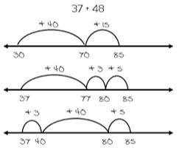 | Reordering  25 + 26 + 75  100 + 26 = 126 | Place Value - Partitioning  116 + 127  100 + 100= 200  10 + 20 = 30  6 + 7 = 13  200+30+13=243 | Making Tens/Bridging through 10  49 + 38  1 7  50 + 37= 87
Compensation  67 + 28  +2  67 + 30 = 97  97-2 = 95 | Doubles/Near Doubles  16 + 17  16 1  16 + 16= 32  32 + 1 = 33 | Friendly Numbers  2 8 + 4 7  +2 -2  30 + 45= 75 | Bridging through 60  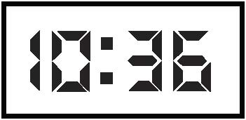  How many minutes is it to the next hour?  