Mental Maths/Number Talks Strategies
Subtraction

Removal or Counting Back  123 - 69  123 - (20+40+3+6)  123 – 20 = 103  103 – 40 = 63  63 – 3 = 60  60 – 6 = 54 | Reordering  25 - 6 - 5  20 - 6 = 14 | Place Value - Partitioning  367 - 154  367 – 100 = 267  267 - 50 = 217  217 - 4 = 213  367 – 100 – 50 – 4 = 213 | Adding Up/Bridging through 10  23 - 16  16 + 4 = 20  20 + 3 = 23  7  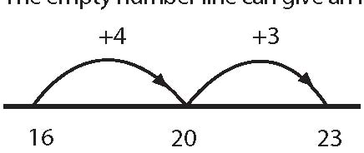
Place Value & Negative Numbers  399 - 254  (300+90+9) – (200+50+9)  300 + 90 + 9  - 200 + 50 + 4  100 + 40 + 5  = 145 | Adjusting for Easier Numbers  123 - 59  +1  123 – 60 = 63  63 + 1 = 64 | Keep a Constant Difference  151 – 98  (151 + 2) – (98+2)  153 – 100 = 53  151 – 98 = 53

