Mental Maths/Number Talks Strategies
Multiplication & Division

Friendly Numbers  9 x 15  10 x 15 = 150  150 – 15 = 135  Don’t forget to ‘undo’ your change! | Repeated Addition  6 x 15  15+15+15+15+15+15  15 + 15 = 30  30 + 15 = 45  45 + 15 = 60  60 + 15 = 75  75 + 15 = 90 | Partial Products  6 x 125  6 x (100 + 20 + 5)  (6x100) + (6x20) + (6x5)  600 + 120 + 30 = 750 | Doubling and Halving  24 x 8  x2 ÷2  48 x 4  x2 ÷2  96 x 2  x2 ÷2  192
Breaking Factors into Smaller Factors  12 x 25  2 x 6  2 x 25 = 50  50 x 6 = 300 | Grid Method  35 x 7  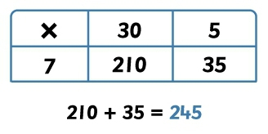 | Partial Quotients  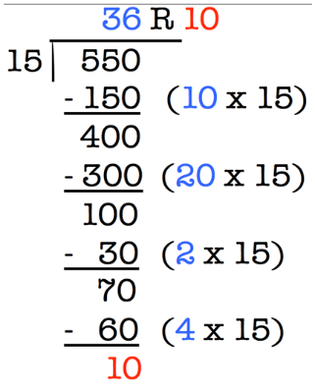 | Multiplying Up  72 ÷ 8 8 x 5 = 40  8 x 4 = 32  (5 + 4) = (40 + 32)  8 x 9 = 72
Repeated Subtraction

24 ÷ 6 24 – 6 – 6 – 6 – 6 6 x 4 = 24 so 24 ÷ 6 = 4

