
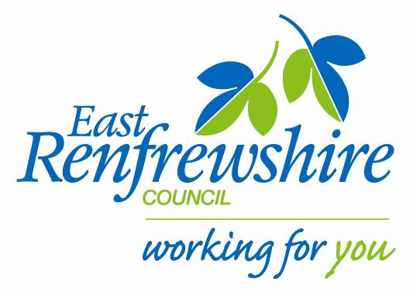


Strategies to Support Bilingual Learners in Nursery and Primary at Stages 1-4 of English Language Acquisition

Stages of English Language Acquisition
The concept of stages of English language acquisition is established within the field of bilingualism.

Language development is described by dividing the process into five stages:

- Stage 1 new to English
- Stage 2 becoming familiar with English
- Stage 3 becoming confident as a user of English
- Stage 4 a competent user of English in most social and learning contexts
- Stage 5 a competent user of English.

Each stage is described by listing the key features of language in each of four areas:

- communication
- accessing the curriculum
- technical aspects of language
- support requirements.

Learning in 2+ Languages, Learning and Teaching Scotland, 2005

The use of the stages is a helpful way of describing a bilingual learner’s English language development. However, the following points should be noted:

- the descriptions are not prescriptive but contain some key features of English language acquisition
- pupils may demonstrate features of more than one stage simultaneously
- some of the key features are more relevant to children at certain ages and stages
- progression from one stage to another is not always linear
- learners may plateau at a particular stage, if not sufficiently challenged, or may regress when facing unfamiliar learning demands
- other features such as content of the curriculum, methodology, the knowledge and expertise of staff in relation to the use of effective strategies of support, school / classroom ethos, the maintenance of high expectations and pupil’s entry point to the Scottish school system can affect pupil progress.

The stage of English language acquisition is determined by considering the overall profile of the pupil and how that matches up to the descriptors on a ‘best fit’ basis. A professional judgement based on a range of evidence should be made over which stage(s) best describe an individual’s language development, taking into account age, ability and length of time learning English.
Support for Literacy Development
Support for the literacy development of bilingual learners should aim to:

- help the learners to understand, e.g. a particular written text or engage in a specific writing task

- teach transferable strategies which the learner will be able to employ when working independently

- extend the learner’s ability to understand and use English.

For more detailed information on assessment and planning, staff should refer to the authority guidelines:

- Meeting the Needs of Bilingual Learners, and
- Learning and Teaching Strategies to Support Bilingual Learners.

The general strategies and the specific strategies related to listening and talking, reading and writing detailed in this guide will provide appropriate support for all bilingual learners. There are some strategies which remain appropriate for learners at all stages of acquiring English as an additional language. These represent good practice and change only in the degree of sophistication required as the learner grows more fluent.

Staff must recognise that the needs of bilingual pupils will change as they progress through education and they may require specific language support to develop higher order skills.

The purpose of each of these support strategies is to develop learner independence.

Key to all these strategies is high quality adult-learner interaction and learner-learner interaction.
General Strategies
- Ensure that bilingual learners understand the learning intention and success criteria of the lesson and are aware of the order of topics. It is helpful if throughout the lesson it is clear when one topic has ended and the next is beginning. Allow time for a plenary session.

- Check comprehension throughout the lesson.

- Make sure that all the curriculum support materials really are supportive.

- First-hand experiences provide the most effective context for learning language.

- Use accessible texts and materials that suit children’s / young people’s ages, experiences and levels of learning.

- Pay specific attention to the language structures and vocabulary of English.

- Offer a variety of types of dictionaries, e.g. picture, illustrated topic glossaries. Use of a bilingual dictionary should be encouraged if appropriate. Pupils may be allowed a bilingual dictionary in some examinations. Pupils should be made to feel confident about using a dictionary in the classroom. If pupils use a bilingual dictionary indicate key words to look up.

- Present an overview of the lesson and briefly outline the topic on the board. Discuss work that has just been covered. This will familiarise pupils with the language of the topic. Remember, too much oral discussion can be difficult during the early stages of language acquisition. You can recap on work covered using a range of non-verbal strategies, e.g. sequencing a timeline of events.

- Write clearly on the board. Pupils with little experience of written script in English (e.g. Urdu, Hebrew, Chinese) may have difficulty with ‘joined-up’ writing.

- When eliciting responses from the class, repeat or paraphrase responses which are unclear or quiet.

- No pressure should be applied to elicit an oral response, but try to create a relaxed environment where the pupil feels able to contribute when ready. Be vigilant for possible anxiety or social isolation.

- Allow pupils to hear the answer structure being modelled by others before being asked for their response, e.g. The number after 6 is 7. The number after 5 is 6. What is the number after 3?
General Strategies Continued
- When ready to give a talk, the pupil might find it easier to speak to a small group rather than the whole class. Try to ensure the topic is culturally accessible and provide a framework as appropriate.

- Language can be acquired and taught effectively through playing games. Games will enhance self-esteem through providing a vehicle for successful interaction. For example:

- auditory discrimination games will support their speaking and listening skills

- turn taking games will allow pupils to watch, listen and learn from the responses of others having had the opportunity to learn the rules and rehearse responses

- games that do not require a verbal response will allow less confident pupils to participate

- guessing games will help pupils to practise the skills of formulating questions and can be easily adapted to be age and stage appropriate.
Strategies to Support Listening and Talking at Stage 1: New to English
- Use gesture / visuals / objects.
- Allow pupil time to listen and absorb.
- Talk through & demonstrate actions / events as they happen, highlighting key words.
- Teach names of adults and peers.
- Use peers to model routines / language.
- Plan quality time (daily) with pupil.
- Model social language conventions.
- Play games with repetitive language.
- Use paired / small group activities with supportive peers (mixed ability / same language etc.).
- Highlight key words related to classroom activities and routines.
- Use audio / visual props and ICT to provide language contexts.
- Encourage pupil to make links with home language.
- Refer to classroom displays.
- Give clear instructions with consistent use of key words and phrases (repeated if necessary).
- Plan time for free talk and to talk about work.
- Play games (including oral, board, card, track games).
- Respond in words that extend and model.
- Encourage pupil to respond in words and phrases e.g. Can I have?
- Ask: closed questions; either / or questions; 1 word answer questions.
- Give thinking time for pupil to mentally rehearse words.
- Focus on pupil’s meaning rather than the words used.
- Provide the words the pupil needs (as long as it doesn’t pre-empt pupil’s responses).
- Expand and extend what pupil says.
- Send on simple errands / messages with partner (check outcome).
- Set up home / school communication system. Where possible send word lists / key texts home.
- Encourage parents to: talk about school at home; continue to develop home language; discuss school work / reading book in home language.
Strategies to Support Listening and Talking at Stage 2: Becoming Familiar with English
- Teacher modelling / rephrasing sentences and questions.
- Provide models of different language functions e.g. describing, explaining.
- Group with pupils who can provide good models of English.
- Provide sentence starters using visual cues.
- Respond in words that extend and model / recast pupil’s utterances in correct form.
- Allow time for child to mentally rehearse words / contributions.
- Whole class reading (modelled by teacher) of fiction / non fiction with contextual support.
- Ask oral gap-fill and either / or questions and encourage pupil to refer to visual cues.
- Games to practise language using set phrases.
- Promote use of home language for learning.
- Encourage parents to discuss homework in home language.
- Information seeking activities e.g. simple questionnaires.
- Clarify / explain curricular language e.g. key words.
- Paired feedback at plenary sessions.
- Provide beginnings of responses.
- Display key curriculum vocabulary & concepts / topics.
- Provide collaborative tasks.
- Retell story / activity (e.g. investigation) through sequencing pictures.
- Extend child’s experience of working in groups, allocating specific role to ensure participation.
- Opportunities for drama / role play.
- Opportunities to plan / talk in groups.
- Opportunities for paired problem solving and feedback.
- Frameworks to scaffold pupil’s talk.
- Provide a purpose for listening e.g. use framework to record information to answer pre-set questions / responses to text etc.
- Use buddies / pair work.
- Encourage the use of picture dictionaries.
- Work closely with the family.
Strategies to Support Listening and Talking at Stage 3: Becoming Confident as a User of English
- Devise collaborative tasks such as problem solving / information seeking activities.
- Support extended listening with tape and book.
- Set up problem solving activities.
- Give independent feedback at plenary.
- Check pupils’ understanding by questioning.
- Provide activities to model and practice language for different settings and audiences.
- Provide opportunities for: giving explanations, explaining processes, predicting probabilities.
- Enable contributions to presentations and demonstrations.
- Engage pupil in informal conversation to develop fluency and confidence.
- Use role play and drama.
- Provide time for pupils to initiate talk.
- Give thinking time for responses.
- Encourage partner talk and reporting back (think, pair, share).
- Continue to pair or group with good language model peers for collaborative activities.
- Provide opportunities for pupils to ask questions for varied roles e.g. interviews / enterprise tasks etc.
- Play games to practise positional & descriptive language.
- Provide keyword cards as aide memoirs for listening and retelling.
- Extend range of vocabulary through homework activities (in home language and English).
- Teacher modelling.
- Guided questioning.
- Make language topic displays and word banks.
- Provide a range of thesauruses and dictionaries.
- Highlight and encourage the recording of keywords and sentence structures for all lessons.
- Provide opportunities for pupils to rehearse and consolidate new language structures orally in pairs / groups.

Strategies to Support Listening and Talking at Stage 4: Competent in Most Social and Learning Contexts
- Devise collaborative tasks that will necessitate extended speaking.
- Support extended listening with tape and book.
- Set up problem solving activities.
- Give independent feedback at plenary.
- Check pupils’ understanding using formative assessment strategies.
- Provide activities to model and practise language for different settings and audiences.
- Provide opportunities for: giving explanations, explaining processes, predicting probabilities.
- Enable contributions to presentations and demonstrations.
- Engage pupil in informal conversation to develop fluency and confidence.
- Use role play and drama.
- Provide time for pupils to initiate talk.
- Give thinking time for responses.
- Encourage partner talk and reporting back (think, pair, share).
- Continue to pair / group with good language model peers.
- Ask questions for varied roles e.g. interviews / enterprise tasks etc.
- Provide opportunities for pupils to play games to practise positional and descriptive language.
- Extend range of vocabulary through homework activities (in home language and English).
- Teacher modelling as required.
- Guided questioning.
- Make language topic displays, word banks and glossaries.
- Provide a range of thesauruses and dictionaries.
- Encourage maintenance of personal vocabulary jotter.
- Be aware of the language needed for academic success (including assessments).

General Strategies to Support Reading
- Be aware of the language demands of texts – concepts, technical and specialist vocabulary, grammatical structures, genre, text types etc.

- Provide a range of reading genres that demonstrate the different ways in which English is used.

- Be aware that some texts assume particular cultural knowledge.

- Represent the ideas in a text through storyboards, diagrams, flow charts, and pictures. Use these as the basis for writing about the ideas.

- Extend pupils’ knowledge about the word families which might be used in the text. Use conventional and topic dictionaries to build up word families.

- Reduce or simplify text if necessary, but avoid reducing the cognitive demand if possible.

- Encourage the pupil to pass on the information derived from the text in a different form, e.g. to a different audience, for a different purpose, in a different format.

- Make use of any visual support available before reading text. Using titles, paragraph headings, pictures etc., discuss with pupils what they already know about the topic and note familiar vocabulary and phrases. Relate what they already know about the topic and the language.

- Encourage pupils to think about the purpose of their reading. Teach learners what to look for and remember as they read.

- Enable the pupil to understand inferences and the author’s point of view and encourage learners to compare this with their own experience and opinion.

- Encourage pupils to clarify the meaning of words from context.

- When reading a novel or play, give a summary of the plot before reading each section.

- Encourage pupils to be content with understanding the gist of a passage when this is appropriate.
Strategies to Support Reading at Stage 1: New to English
- Share reading (books with illustrations).
- With younger pupils choose books which have repetitive, predictable patterns of language and are visually well supported.
- Ask pupil to find / match / highlight letters in words, words in texts, phrases in texts.
- Model following print with finger / pen.
- Model letter names and sounds.
- Synchronise spoken with written word.
- Provide talking texts – on tape / CD Rom.
- Provide dual language books / dictionaries / ICT to demonstrate or explain words and phrases.
- Provide visual cues, use props / actions / puppets etc. as appropriate.
- Have a rich, clearly contextualised print environment (cross curricular).
- Establish peer modelling.
- Read back any writing, pupil and teacher.
- Ask for / provide / demonstrate meanings of words.
- Play word games e.g. word pairs / word & picture ‘bingo’ etc.
- Ask pupils to work collaboratively to sequence pictures with simple written text.
- Ask pupils to work collaboratively to sequence words in sentence / sentences / instructions / processes / stories.
- Ask pupils to choose between True / False statements to show understanding of text.
- Annotate text with translations of key words / phrases into first language.
- Make picture dictionary/word bank in English and home language.
- Label diagrams / texts / pictures / illustrations with prepared cards (words and phrases).
- Pre teach key words prior to meeting in text.
- Ensure word level work is appropriate.

Talk about text.

Strategies to Support Reading at Stage 2: Becoming Familiar with English
- Display signs, posters, keywords backed up with clear visuals.
- Illustrate signs.
- Provide opportunities to talk about text pictures / illustrations with a partner.
- Teach alphabet rhyme.
- Use Jolly Phonics / multi sensory approach to the teaching of sounds.
- Use ICT programmes.
- Label pictures and illustrations.
- Provide sentence starters using visual cues.
- Create cloze procedures with key vocabulary and / or visual cues.
- Provide support to enable pupils to match sentence beginnings to endings.
- Model / rephrase sentences and questions.
- ICT e.g. Kidspiration / Clicker 4.
- Provide activities to revisit and reinforce key language.
- Ask focused questions to check or confirm understanding of text.
- Make links across curriculum areas.
- Provide support and encourage pupils to make own books and word banks in English and / or home language.
- Set up paired reading e.g. with fluent reader or pupil who shares home language.
- Encourage the ongoing use of picture / dual language / English dictionary as appropriate.
- Ask for verbal summary of reading.
- Encourage prediction about text content using visual and contextual cues.
- Ask pupil to transfer information from a text into a key visual by completing tables, classifying information, sequencing of key points.
- For older pupils provide character lists and summaries of longer class texts / novels etc.
- Use collaborative reading activities e.g. information gap, jigsaw reading etc.

Talk about text.

Strategies to Support Reading at Stage 3: Becoming Confident as a User of English
- Pick out key words (e.g. underlining, highlighting, text marking) to help understanding.
- Preview text (e.g. introduce key vocabulary, ideas, subject matter, share similar stories, concept maps, word weaving, brain storm relevant topic etc).
- Encourage re-reading use teacher / adult led shared reading strategies.
- Encourage shared reading in groups and pairs (e.g. set up ‘jigsaw’ reading activities etc).
- Scaffold questions leading to how / why questions.
- Listen to taped stories for intonation / developing reading stamina.
- Listen to others on tape.
- Set up role play activities / act out play scripts.
- Explain cultural references / nuances.
- Provide dictionary / thesaurus work.
- Reinforce subject specific language.
- Use highlighters to track ideas at paragraph / text level.
- Use visual / audio / video support for text.
- Provide an interactive visual display around text.
- Provide opportunities to link reading to personal experience.
- Practise hot seating characters.
- Provide a framework to ask / answer questions about the text e.g. who, what, where grid.
- Write book reviews.
- Discuss homonyms.
- Make cross-curricular references, links and glossaries (mono and bilingual).
- Ask pupils to restructure text by remodelling information from a text into a different format (e.g. flow chart, diagram, list etc).
- Use cloze to consolidate newly learned key vocabulary and structures.
- Ask pupils to sequence sentences into paragraphs / paragraphs into chapters etc to show understanding.

Talk about text.

Strategies to Support Reading at Stage 4: Competent in Most Social and Learning Contexts
- Explain cultural references / nuances.
- Make cross-curricular references, links and glossaries (mono and bilingual).
- Ask specific skimming questions.
- Ask specific scanning questions.
- Use colour coding / numbering etc to identify different types of information in text.
- Discuss ambiguous phrases.
- Discuss and teach idiomatic language.
- Explain hidden and actual meanings of texts.
- Discuss figures of speech, simile, metaphor, personification.
- Discuss symbolism / allegory.
- Ask pupils to match headlines to pictures / titles to texts e.g. in text books, newspapers.
- Ask pupils to identify topic sentences of paragraphs.
- Use DARTS activities (directed activities related to text).
- Use Reciprocal Reading techniques (predicting, clarifying, questioning and summarising) to engage pupils with text giving each a role / responsibility within a group reading task.
- Use vocabulary building strategies: word banks at appropriate level, crosswords, word searches, matching vocabulary with definitions etc.
- Ask pupils to underline words they don’t understand, match sentences to pictures / diagrams.
- Use cloze procedure, true / false or fact / opinion statements.
- Cut up and jumble the words / sentences / paragraphs of a known text and ask pupils to sequence.
- Ask pupils to underline / text mark key facts or events.
- Ask pupils to transfer information from a text onto a grid / table or label a diagram.
- Ask pupils to identify and use information in a text to predict / anticipate / hypothesise.
- Identify and highlight specific language structures associated with particular types of text / genres to support pupils’ understanding and control of style / tone / genre etc.
- Encourage pupils to look for bias and recognise different perspectives of a common event.

Talk about text.

General Strategies to Support Writing
- Staff should refer to the authority guidelines Writing 3-15, in particular:

Talking / Listening to Write Pages 15-16 Social Processes
Reading to Write Pages 16-18 Cognitive Processes
Talking / Listening to Write Pages 15-16 Linguistic Processes

- Encourage pupils to think about the aim and audience for their writing. Teach how to construct a written text and which form of writing to use.

- Extend pupils’ knowledge about the type of structures and patterns of organisation needed, e.g. for expressing cause and effect, classifying, describing historical events or natural, industrial processes. Use different types of texts as models for writing.

- Encourage pupils to keep a record of new vocabulary, phrases and sentence structures from their reading and use them in their in writing.

- Relate new writing to what they already know about the topic and language.

- Expect the pupil to do some writing at his / her own level when the class is writing. Support frames or models could be provided.

- Use ‘write on’ sheets for note making or photocopies for cutting and pasting to reduce the amount of writing required.

- Encourage the pupil to edit written work, alone or with a friend. Make use of a word processor to facilitate editing / redrafting.

- Adopt a sensitive approach to correction. Expect errors and view them as a ‘learning stage’. If a few sentences are very confused, you might supply the English for what you think the pupil is trying to say. Recurring patterns of inaccuracy in written work should be discussed with older pupils and the correct rule introduced. Use language targets to determine which errors should be addressed.
Strategies to Support Writing at Stage 1: New to English
- Use individual whiteboards and pens.
- Model the writing for the pupil.
- Show / provide examples of different types of writing.
- Provide key word / common word lists linked to writing tasks.
- Clearly organise information on the board.
- Devise shared group writing tasks with opportunities to ‘have a go’.
- Ask pupil to copy short text that has been explained and discussed.
- Provide opportunities for talk as rehearsal and the use of talking partners prior to starting writing tasks.
- Provide support for pupils to match simple sentence starters to sentence endings, then ask pupil to copy complete sentences.
- Ask pupil to sort / sequence simple jumbled sentences.
- Use gap fill exercises.
- Provide sentence starters.
- Play simple writing / alphabet card games and puzzles.
- Ask pupils to copy words matched to pictures / diagrams.
- ICT.
- Encourage pupil to write in first language (as appropriate).
- Prepare differentiated tasks for the pupil to complete while the others work independently.
- Encourage the use of picture / dual language dictionary as appropriate to age and skills.

Talk about writing / use talking as an activity to prepare for writing.

Strategies to Support Writing at Stage 2: Becoming Familiar with English
- Encourage peer modelling in small groups.
- Scribe for individuals.
- Devise paired writing tasks.
- Use storyboards.
- Talk about writing as it is done.
- Link the writing activity to the preceding talk or reading.
- Ask pupil to label pictures / diagrams with initial letter cues and use word lists.
- Ask pupil to write short phrases of two or more words.
- Create cloze procedures.
- Use writing frames from across the curriculum.
- Make literacy activities and games to teach phonics.
- Use interactive, collaborative tasks.
- Develop word banks with illustrations / translations.
- Encourage the pupil to write in first language.
- ICT.
- Build semantic web / top web of related vocabulary.
- Provide example paragraphs and ask pupils to substitute a new set of information.
- Build in writing activities to consolidate new language e.g. writing crossword clues on key topic vocabulary.
- Encourage the ongoing use of picture / dual language English dictionary as appropriate.

Talk about writing / use talking as an activity to prepare for writing.

Strategies to Support Writing at Stage 3: Becoming Confident as a User of English
- Provide visual stimuli for pupils to write from e.g. photos, video, artefacts.
- Discuss context for writing.
- Talk about the structure of English and possible similarities and differences with other languages e.g. different word order, articles etc.
- Provide opportunities to rehearse before writing.
- Encourage paired word and peer evaluation.
- Play games / provide activities to help understanding and use of prepositions, match nouns and pronouns, and teach articles.
- Provide sentence starters.
- Support planning by sequencing key words and phrases prior to writing.
- Model writing for the pupil.
- Use writing frames to scaffold first attempts.
- Introduce different connectives / conjunctions e.g. because, so, then, but, however etc.
- Provide writing frames e.g. to practise connectives / conjunctions.
- Customise known text.
- Provide simple grids or tables for pupils to complete.
- ICT.
- Encourage pupil to learn from their mistakes.
- Ask pupil to read back the sentences to see if they ‘sound right’.
- Provide interactive display e.g. of new or key words.
- Encourage the ongoing use of dual language / English to English dictionary as appropriate.

Talk about writing / use talking as an activity to prepare for writing.

Strategies to Support Writing at Stage 4: Competent in Most Social and Learning Contexts
- Establish writing partners.
- Show good examples of texts and stories to demonstrate final outcome.
- Talk about language within the context of the text e.g. parts of speech.
- Discuss the differences between spoken and written English.
- Brainstorm ideas in pairs / groups prior to writing.
- Use highlighters to track ideas.
- Use writing frames to scaffold writing in different genres / styles.
- Provide classroom displays to highlight the literacy focus.
- Devise activities to broaden the vocabulary around a theme.
- Use dictionaries and thesaurus.
- Demonstrate and encourage the use of spider graphs / mind maps to organise writing.
- Model use of bullet points / note making.
- Encourage awareness of word families e.g. photograph, photographer, photography.
- Develop semantic awareness e.g. ‘volume’ in music and science.
- Develop activities to incorporate ideas from source materials into own texts e.g. changing genre and register to fit own writing.
- Demonstrate and encourage the use of punctuation to show clause and sentence structure and clarify meaning.
- Encourage pupils to practise using paragraphs to separate and connect ideas.
- Encourage pupils to practise writing extended texts.
- Continue to model writing and text convention.
- Support the use of subject specific language.
- Use texts to develop figurative language e.g. metaphor, idiom etc.
- Continue opportunities to rehearse ‘out loud’.
- Re-read work to check flow and continuity.
- Continue activities to broaden vocabulary choices.
- Games and activities to develop the use of adjectives, adverbs, determiners.
- Use word order grids and cards.
- Use shared activities to improve selected sentences / texts.
- Provide feedback on an individual basis so pupil can understand how correct form clarifies meaning.
- ICT.
- Encourage the ongoing use of dual language / English to English dictionary as appropriate.
Talk about writing / use talking as an activity to prepare for writing.

Peer / Teacher Support

- Make effective use of a ‘buddy’ to help the child / young person settle into the school. Ensure the buddy has good communication skills and is friendly and outgoing. Buddying approaches help learners feel secure and welcomed.

- Allow the pupil opportunities to work in groups / pairs with a clear focus on interactive, co-operative learning activities with plenty of opportunity for talking. This will provide learners with the opportunity to monitor their own language use and learning and for teachers to gain useful formative feedback.

- Small group collaborative work is beneficial for all learners. Collaborative activities provide learners with opportunities to try out new language and work out new concepts. Cognitive skills are developed by discussing, demonstrating, explaining and justifying. It also allows learners to engage orally in the language of the subject in a supportive situation. Monolingual learners also benefit from having a developing bilingual learner in their group since it helps their cognitive skills when required to discuss, explain and justify etc.

- Position bilingual learners beside pupils who will be supportive and provide good language role models of English, i.e. confident, capable, friendly and articulate pupils. Bilingual pupils learn a lot of new language from their peers.

- Allow pupils to work in a variety of different groupings / pairings to give access to different language models.

- Fellow pupils with the same language might act as interpreters for the pupil new to English.

- Pupils who share the same home language can also extend each other’s conceptual development.

- Take care not to over correct. Effective communication is much more important than accuracy. One word responses are quite acceptable in the early stages.
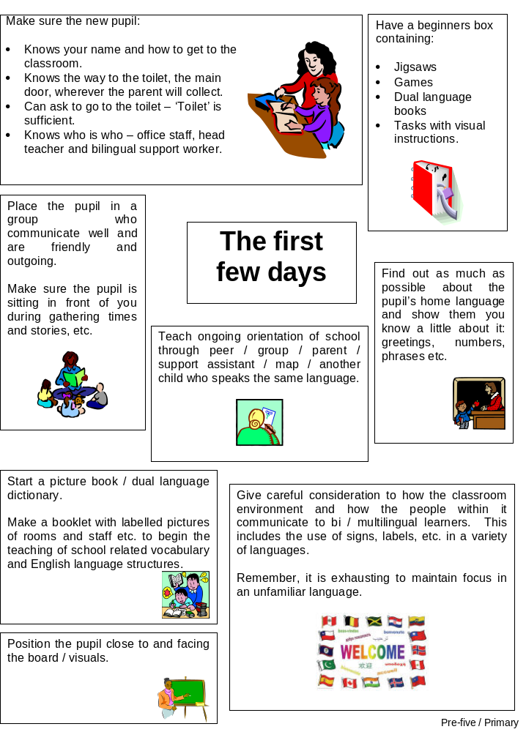

Spot Check

- Am I aware of the English language skills bilingual pupils in my group / class currently have?

- Have I built in opportunities to develop their language acquisition skills to support their progress in English language acquisition?

- Do I know their prior knowledge or experience of this activity / topic / subject?

- Do bilingual pupils in my class understand the learning intention(s) and success criteria of the lesson?

- Have I used visuals / objects / gesture to help understanding?

- Have I or another adult or pupil modelled the key language structures for the activity / lesson?

- Have I highlighted / written on the board the key words and phrases for this activity / lesson?

- Are bilingual pupils using a dual language dictionary and / or recording key words in a word book?

- Have I used supportive questions to talk through their understanding?

- Are bilingual pupils communicating purposefully in this activity / lesson?
Supportive Question Types in Order of Linguistic Challenge

- Questions requiring a yes / no or true / false answer e.g. “Is this shape a circle?”

- Questions containing alternative answers e.g. “Is this shape a circle or triangle?”

- Questions containing multiple choice answers e.g. “Is the table made of wood, plastic or metal?”

- Closed questions requiring the learner to make a one word answer e.g. “When was the Battle of Culloden?”

- Closed questions requiring the learner to form a longer answer e.g. “What causes an earthquake?”

- Open questions requiring a certain level of thinking skill e.g. 'What do you think will happen next?”
The 3 underpinning elements of successful additional language acquisition are:

- Time
- Modelled language
- Opportunities to practise newly acquired language.

Acknowledgements to: City of Edinburgh Council, EAL Service, Profile of Competence

