Cànan a’ chlas
Classroom language
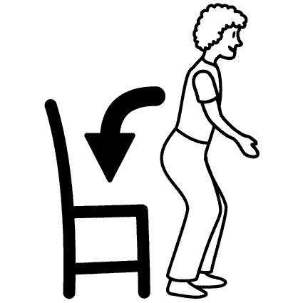

Task
Working either on your own or with a partner, demonstrate your knowledge of classroom language in any way you like (poster, booklet, video etc.).

Success Criteria
Your chosen text should:
- include at least 4 different classroom language phrases
- include accurate spelling and/or pronunciation
- be creative
- have appropriate images for each phrase.

Significant Aspects of Learning
Writing and/or Talking

Experiences and Outcomes
I can apply my knowledge about language, intonation and pronunciation to:
- ensure that others can understand me when I pronounce familiar words or phrases
- help me work out how to pronounce unfamiliar words
- read a short text aloud with accuracy and confidence.
LGL 3-07a

I can check the accuracy of my writing using my knowledge about language, the support of others, and appropriate reference materials including success criteria.
LGL 3-13a

Rubric
Progressing to Achieved | Achieved | Achieved with Merit | Achieved with Excellence
Less than 4 different classroom language phrases included.  3 or more errors in spelling and/or pronunciation.  Lacking creativity.  Some images appropriate for their phrase. | 4 different classroom language phrases included.  2 errors in spelling and/or pronunciation.  Quite creative.  Most images appropriate for their phrase. | 5 different classroom language phrases included.  1 error in spelling and/or pronunciation.  Creative.  All images appropriate for their phrase. | 6 or more different classroom language phrases included.  No errors in spelling and/or pronunciation.  Very creative.  All images very appropriate for their phrase.

Pupil Comment

Peer Comment

Teacher Comment

