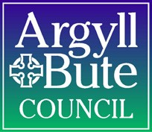

Developmental Milestone Progress Tracker / Transition Record
Community Services: Education
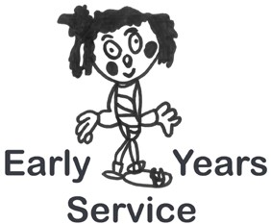

CHILD’S NAME
DATE
PRACTITIONER
ELC SETTING
CHILD’S PLAN?

Developmental Milestone | Stage One  Tick if Achieved | Stage Two  Tick if Achieved | Comment/Area for Development
Social / Emotional / Behavioural
Speech and Language / Attention
Sensory / Cognitive
Fine Motor Skills
Gross Motor Skills
Other Agencies involved – please list details:

