Argyll & Bute Council: Customer Services
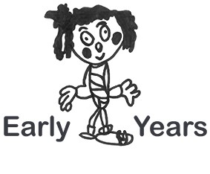

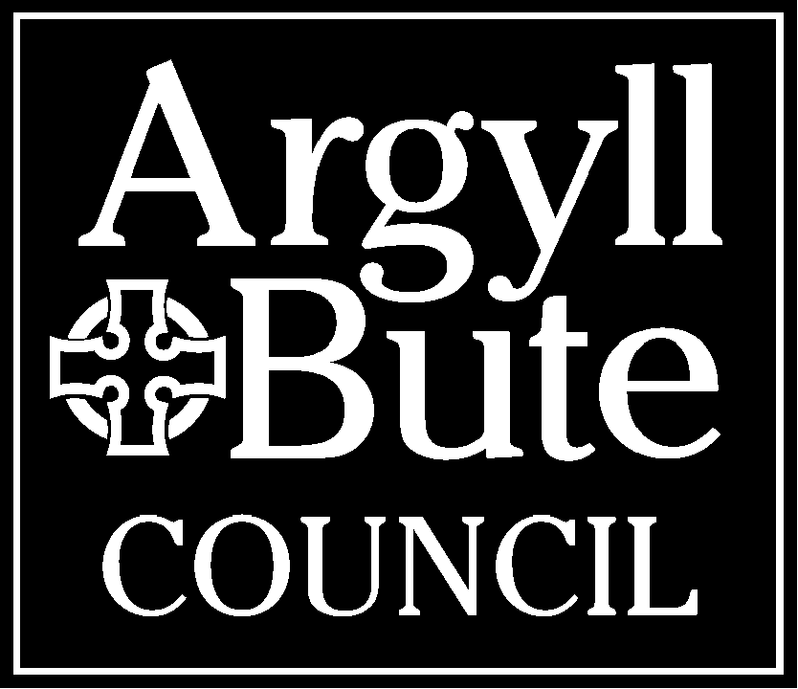
Early Years
Funded Partner Childminders

INTRODUCTION

The provision of a good quality Early Learning and Childcare experience builds on the valuable learning that takes place in and around the home before children start Primary School. It also develops the learning and other essential skills that they will rely on in later life.

Some 2 year old children are eligible to Early Learning and Childcare (ELC). It will help young children gain vital language and learning skills, improve their social development and help them do better at school when it comes. It will also support parents to work, train or study. ELC for eligible 2 year olds can be provided by a range of services including Playgroups, Nurseries, Local Authority ELC providers and Childminders.

Eligible 2 year olds will start the term after their 2nd birthday as outlined below:

Born between | Term
1 March – 31 August | August term*
1 September – 31 December | January term
1 January – 28/29 February | Easter term

* Children whose birthday falls after the first day of term in August (including in-service days) will start in the January following their 2nd birthday.

Eligible 2 year olds can currently receive up to 600 hours of ELC (pro rata, depending on their start date). The Scottish Government has announced that this will rise to 1140 hours by 2020. More information is available on the Argyll and Bute website. It is intended that children take up their entitlement at times that best support their learning and support the needs of parents.

Please refer to the Parent Information Booklet (page 5) for further information on what 2 year olds are eligible, how parents of eligible 2 year olds can apply and how places are offered.

Full details of the Council’s policy on Early Learning and Childcare are contained in the Education Management Circular, available through Sharing Argyll Learning Ideas (SALi - https://blogs.glowscotland.org.uk/ab/sali/early-years/). Also contained within SALi are lots of other relevant resources and information, a great place for sharing good practice and useful material.

Please don’t hesitate to contact the Early Years Team if you require advice or guidance in regards to any aspect of Early Learning and Childcare. Early Years maintain a helpline, Monday to Friday, 9-5pm.

See below for ways of getting in touch:

Early Years Helpline | 01369 708503 Monday-Friday 9-5pm
Family Information Service | 01369 708517 Monday-Friday 9-5pm
Email | earlyyears@argyll-bute.gov.uk
Address | Argyll House, Alexandria Parade, Dunoon, PA23 8AJ
Sharing Argyll Learning Ideas (SALi) | https://blogs.glowscotland.org.uk/ab/sali/early-years
Web page | www.argyll-bute.gov.uk/early-years

