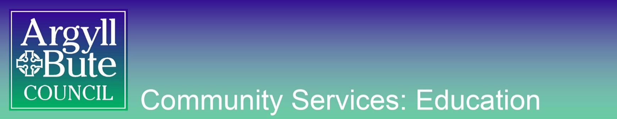

EDUCATION GUIDANCE

GUIDANCE on: Assessment is for Learning

Produced: December 2018
Due for Review: June 2020
Owner: Gillian Cathro

Making Effective Use of Formative Assessment

Formative Assessment – or Assessment is for Learning – is about making use of evidence of student learning to adapt teaching and learning to meet students’ needs. Dylan Wiliam defines the key areas of Formative Assessment as:
- “clarifying and understanding learning intentions and criteria for success
- engineering effective classroom discussions, questions and tasks that elicit evidence of learning
- providing feedback that moves learners forward
- activating students as instructional resources for each other, and
- activating students as owners of their own learning”.

Thus, a “Good Lesson” should include some or all of the following strategies:

At the start:
- Learning Intentions
- Success Criteria
- Prior learning

In the middle:
- Effective questioning
- Feedback
- Collaborative learning
- Differentiation
- Self and peer assessment

At the end:
- Plenary

Each of these elements are explored in more detail below.
Practical advice for embedding AifL in schools, Learning Walk observation sheets and useful resources can be found at the end.

Learning Intentions
Learning Intentions are what learners should know, understand or be able to do by the end of the lesson or series of lessons.
Effective Learning Intentions should:
- Be presented at or near the start of a lesson and be referred to throughout.
- Be visible throughout the lesson (for both pupils and teachers to refer to).
- Be based on the Experiences & Outcomes at BGE.
- Be context-free so pupils realise there are many reasons for learning the concept.
- Focus on what learners will learn, not what learners will do.
- Be written in language that learners will understand.
- Use words that centre on learning and skills, like:
- We are learning to…
- We will be able to…
- We will know…
Here are some examples of improved Learning Intentions, based on Shirley Clarke’s work:
Unclear LI | Improved LI | Improvement
To present an argument for and against euthanasia | To be able to present a reasoned argument including “for” and “against” positions | Using learning based language (“to be able to”); context (“euthanasia”) free
To know what the local minister does | To know the duties of a religious leader | Removing context (“the local minister”)
We will write a letter of complaint to the council about the lack of bins in the park | We are learning to use the correct features of a formal letter | Focussing on knowledge (“We are learning to use”) rather than product; based on a genre of writing outlined by E&Os (“formal letter”); and context free

Effective Ways of Using Learning Intentions
- As a Prior Knowledge/Planning tool – give upcoming Learning Intentions to pupils; ask pupils to share everything they know, then base lesson content around what they don’t know or extending their existing knowledge further.
- As a Plenary tool – pupils can assess themselves based on their learning for that lesson; have they achieved it? How would they traffic light themselves?
- Part of wall displays to reinforce and remind later – pupils can be reminded that they have been able to do something beforehand; this is particularly effective if Learning Intentions are context-free.
- Long and short term Learning Intentions – long term LI can be displayed for weeks at a time, with the short term LI changing day to day; this will help pupils grasp the big picture of their learning.
- As a discussion starter – “How could we learn about this/find this out/achieve this?”
Success Criteria
Success Criteria are the measures used to determine whether and how well a learner has met the Learning Intention. The pupils’ learning should be assessed against the Success Criteria.
Effective Success Criteria…
- Are linked to the Learning Intention.
- Are co-created with pupils.
- Are written in language that learners understand.
- Provide a scaffold and focus for learners while engaged in the activity.
- Are used as the basis for teacher feedback, peer feedback and self-assessment.
- Are limited in number so learners are not overwhelmed by the scope of the task.

Success Criteria should give pupils a guide to the correct process they need to go through, rather than just telling them the product they will finish with:

Product Success Criteria | Process Success Criteria
What pupils will be able to do or have by the end of the lesson(s); eg:  - You will have written a persuasive essay. | What key steps pupils need to take in order to fulfil the Learning Intention; eg:  Things to remember:  - Use an engaging opening (for example, a shocking statistic, a question, an anecdote)  - Include persuasive writing techniques throughout (CARPETS)  - Include and explain evidence  - Use an effective conclusion (for example, a challenge to the reader, a reference to the introduction, a positive tone)

Product Success Criteria | Process Success Criteria
What pupils will be able to do or have by the end of the lesson(s); eg:  - You will know how to use the correct formula when calculating the area of a triangle. | What key steps pupils need to take in order to fulfil the Learning Intention; eg:  Method:  - Identify and measure the base and height  - Multiply the base by the height and divide by 2  - Record in appropriate units

Knowing the steps they should take to achieve the product of their learning is far more useful than only knowing what the product will be.
For non-negotiable Success Criteria, like “Check your working” or “Proofread for spelling and punctuation mistakes”, these do not necessarily need to be included in your Success Criteria for individual tasks (unless these were the focus of the learning). Instead, these can be viewed as “Expectations”; for commonly occurring tasks, Success Criteria could be stuck on the wall constantly (eg. “What makes good writing?”; “Every time we do Maths”).
Involving pupils in coming up with Success Criteria is effective, as it gives them ownership and helps them understand their task.
We can generate Success Criteria with pupils using the following methods:
- Look at the Learning Intention and discuss how we will know we have achieved it.
- Look at an exemplar of work first and discuss its strengths – these then form the Success Criteria.
- Give two pieces of work of different quality and use these to generate a list of what makes one of them better (demonstration– https://www.shirleyclarke-education.org/video/art-self-portraits/).
- Do the task yourself and have pupils note what you are doing as you do it.
- Give possible answers to a question, then get pupils to pick which are right and wrong, and discuss why this is.
- Let pupils attempt the activity first, and then get them to explain their step by step process.
- If you end up with an extremely long list of criteria, discuss with pupils which are the most important; some Success Criteria can be like a pick and mix menu – not every single one needs to be used.

Success Criteria can be used effectively throughout the learning process. We could:
- Draw attention to them throughout the pupils’ working time, to ensure they stay focussed on them.
- After a five minute warning, stop the class, draw attention to one criteria, and have pupils traffic light their work for this criteria. “Green pupils” could pair up with “amber pupils” and help them; meanwhile the teacher could work with those who considered their work red.
- Have pupils peer assess each other’s Success Criteria to check for understanding before they have properly started the task.
- To differentiate, everyone has same criteria but some are identified (by teacher or class) as vital; everyone focuses on these ones, while more able or adventurous pupils focus on them all – pupils can take ownership of this and decide themselves. The teacher can intervene if a pupil is not challenging themselves appropriately.
- Have pupils assess their own or a peer’s work against the criteria before they submit the piece; if the Success Criteria is a set list of required ingredients, this gives pupils a chance to spot anything they have missed.
- Return to Success Criteria at the end of a block of work and amend – did anything end up not being important? Did something occur that was crucial during the process?
- Base feedback on criteria and give specific instructions on how work can be improved.

Prior Learning

To ensure pace and challenge, it is crucial that pupils’ prior knowledge is used. In the long term, planning collaboratively can help with this. In primary schools, this could mean stages/whole staff planning together to ensure that skills are built on; in secondary schools, it could mean departments plan their course outlines together, then share these with other departments to see where links could be made for pupils – for example, if History are expecting pupils to write persuasively, they may wish to plan to do this after English have taught persuasive writing skills.
In the short term, check for prior learning at the start of a lesson or series of lessons while linking back to recent previous lessons. Some practical means of doing this in an engaging way at the start of lessons include using one of these starter tasks:
Starter | Example
Range of answers | What is Skellig? Imaginary friend; owl; human; ghost; angel  (Include answers that are definitely correct, ones that are definitely incorrect, and ones that can be discussed/debated. Two or three possible answers works too.)
Statement | These shapes are the same. Agree or disagree?
Odd one out | (Show three similes and one metaphor.)
What went wrong? | 10 – 2 = 12
Put in order | Characters from bravest to most cowardly.
Differing examples | Why is this a healthy meal, but this is not?
Opposing statement | If you read a magazine without paying, is that stealing? Discuss.
True or false | Prime numbers are divisible by 2.

(These activities are based on Shirley Clarke’s training materials.)
Pupils discuss the question with a partner or group; the teacher moves around, eavesdropping and then takes answers. The teacher can then use the responses to decide what happens next – continue with the lesson as planned? Tweak it slightly? Or throw the lesson out entirely, because the pupils are not ready or are already comfortable with the content of this lesson? Obviously, we would hope that the latter option does not happen often or at all, but it is entirely possible that sections of a lesson need to be condensed or extended; or perhaps there is a wide breadth of prior knowledge in the class, and the teacher can use more knowledgeable pupils to assist them.
These question styles are examples of effective questioning too, as they require pupils to analyse, apply and evaluate.
Effective questioning
Effective questioning should involve:
- Pupil thinking time.
- All pupils.
- Higher Order Thinking Skills.
- Appropriate teacher responses.

Pupil thinking time / Involving all pupils
If a pupil is trying to think of an answer, hands shooting up around them will be distracting and disheartening; constantly experiencing this may lead to pupils opting out of class discussion.
Instead, some simple rules for effective classroom discussion are:
- Give pupils at least three seconds of thinking time before taking answers or giving hints. (It has been recommended that pupils in early stages should be given ten seconds and pupils in primary stages seven seconds. For more complex questions, a blanket thinking time of ten seconds for all pupils would be appropriate.)
- Give pupils something to do in their thinking time – like write an answer down, or discuss it with a talk partner.
- Combine these ideas using Think – Pair – Share (pupils think themselves for a few seconds; pupils then share their ideas with a partner; we then discuss the pairs’ ideas as a class).
When gathering pupil responses, it is crucial that all pupils know they can be called upon, so that teachers can find out what their pupils have learned. All pupils must be engaged in discussion – those who are and who are thinking constantly and considering answers will be learning and developing all the time; those who opt out and don’t pay attention will not be.
Ways to ensure everyone is engaged include:
- A “no hands up” policy, where the teacher calls upon pupils randomly to answer questions. Ideally, this should be agreed upon and consistently applied by all teachers in a school to ensure pupils get used to not raising their hands.
- Giving pupils a structure to their thinking. Making Thinking Visible strategies are discussion methods (often using images as inspiration) designed with this in mind and include:
  - Think – Pair – Share.
  - What do you see? What makes you say that?
  - I used to think… Now I know…
  - See, Think, Wonder – What do you see? What do you think about that? What does it make you wonder?
  - More questioning strategies, which can be found on SALi and here.
- A big/hinge question, where the teacher can find out whether everyone in the class has understood what they have been learning about. The question shouldn’t take longer than a minute to ask, two minutes to respond to, or 30 seconds for the teacher to analyse responses, and all pupils should be able to answer simultaneously. A practical way to achieve this is by giving the class multiple choice answers for the question and having them answer by:
  - Raising fingers to correspond to answers (ie. one finger = A, two fingers = B, etc.).
  - Going to a corresponding corner of the room, with the corners labelled A, B, C, D. The teacher must encourage and support pupils to avoid simply following their peers to a corner.
  - Writing their answer on a show me board.
- Making effective use of talk partners; Shirley Clarke’s research suggests that ideally these should:
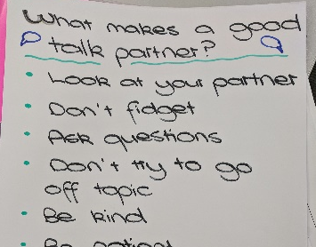
  - Change regularly (weekly if possible) so that pupils don’t get used to relying on the same people for help.
  - Be assigned by the teacher (so that no-one gets left out).
  - Be paired randomly (rather than by ability, friendship, gender, etc; this has been found to be the most effective means, as it gives pupils a chance to socialise with different people).
  - Have a class-made Success Criteria for a good talk partner for pupils to refer to.
These methods ensure that every student has to give the teacher some information. If every student has responded correctly to a question, the teacher moves on; if no-one gets the question right, they might teach the topic again, in a different way; if there is a lot of variation in the students’ answers, the students can be directed to talk about their answers with their neighbours.
In these ways, every pupil has to think about the question, engage with the discussion, and the teacher can quickly see pupils’ understanding and respond to it.

Higher Order Thinking Skills
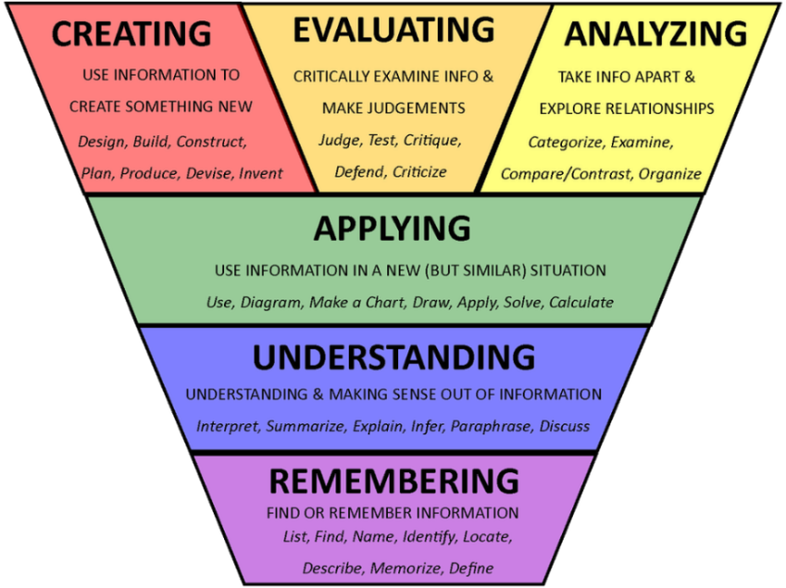
Use of Bloom’s Taxonomy helps to generate more challenging questions and tasks for pupils:

Visual reminders in the classroom about these skills and the vocabulary associated with them are also effective. Examples of these in use in schools include:
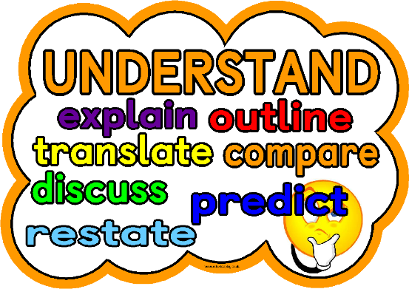

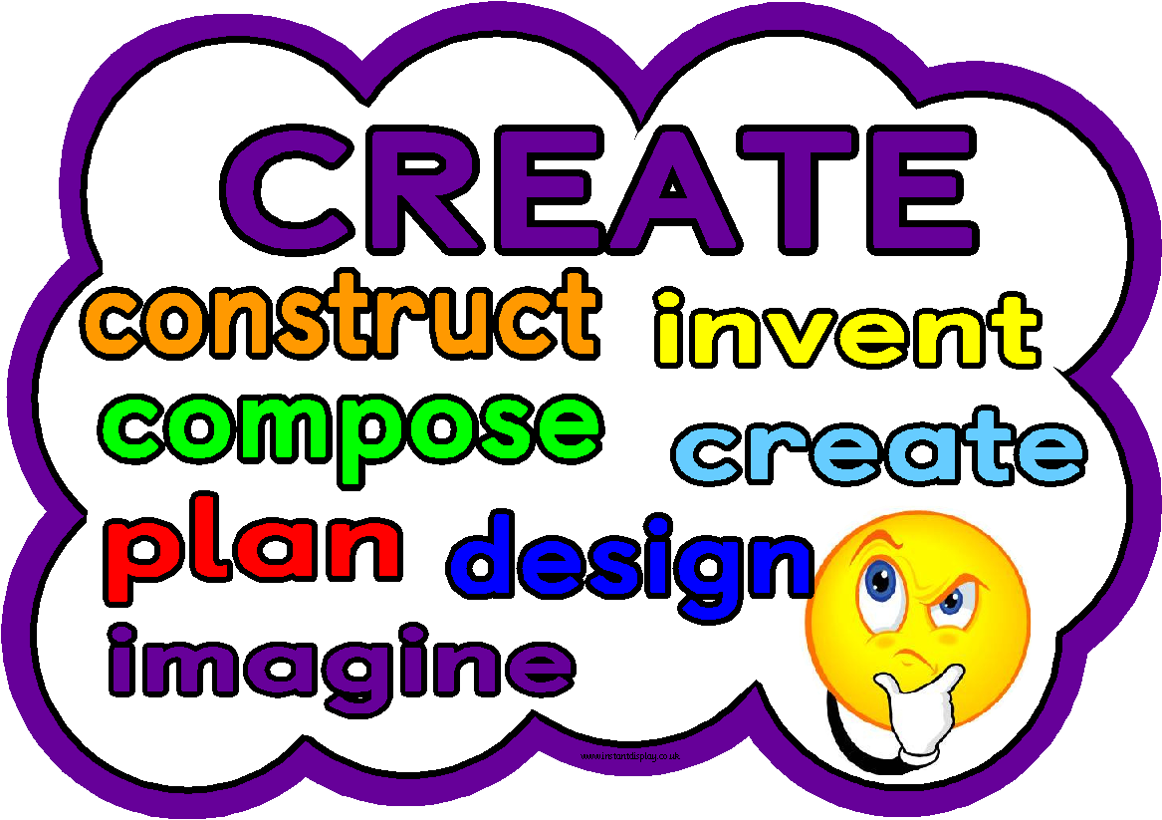
The complete set of these images can be found in the resources list at the end of this document and on Sali.
These visuals are useful for teachers and pupils – teachers because the smaller words give inspiration for challenging questions; pupils because it shows them the different skills they are making use of. It is helpful for questions to be devised in the planning stage, so that staff do not need to come up with complex questions off the top of their head. Staff could include in their topic and lesson planning HOTS questions.

Teacher response (to incorrect answers)
An important part of developing a growth mind-set culture is removing the stigma around making mistakes. When taking answers from the class, teachers should take care with their responses in order to promote a positive attitude to errors. Some means of doing this are:
- Gathering additional answers – “Okay – does anyone have anything they can add to this?”
- Asking for explanation of wrong answers – “What makes you say that?”
- Offering additional information – “What if I told that…? Would that make a difference?”
- Stalling to give pupils reflection time – “Hold that thought and we’ll come back to that.”
- No pressure – “What do you think? Anything at all.”
- Thanking pupils for mistakes – “Thank you for that, actually, because it means we can discuss this more…”

Feedback
Effective feedback should:
- Link to Success Criteria.
- Be specific and understandable.
- Be based on achievements the pupil has made.
- Focus on pupil effort as well as technique.
- Come from pupils themselves and their peers.
- Be acted upon by the pupil.
- Be timely.
Effective feedback should not:
- Focus on natural ability.
- Focus on the speed or ease with which the pupil completed a task.
- Focus on admin or presentation, unless this is part of the Success Criteria.

In lesson feedback
Feedback is most effective when pupils are able to immediately respond to it. Just reading comments means they are less likely to remember it weeks later than if they actually engage with the feedback there and then.
Practical means of providing “live”, in lesson feedback include:
- The teacher moving around, while pupils work, checking understanding and giving specific advice.
- Following verbal feedback, the learner makes some kind of record of what they discussed with the teacher. Obviously what the learner does depends on their age. This involves pupil reflection and creates a record of feedback.
- Stopping pupils mid-lesson, drawing attention to the Success Criteria and asking them to traffic light their work; greens can then work with ambers and the teacher can work with reds to improve work.
- Selecting one pupil’s work at random, making it visible to the class (using a visualiser or by taking a picture of it) and stopping the whole class to discuss it; discuss the best parts and have pupils make specific suggestions on how to improve it. The rest of the class can then use the remaining time to assess their own work in the same way.
- Self and peer assessment (discussed further in a later section).

Post lesson feedback
Recent research (from John Hattie and Shirley Clarke in “Visible Learning: Feedback”) suggests that writing a detailed comment for a completed piece of work does not necessarily provide the most meaningful feedback. Pupils often do not read comments properly and get distracted by scores or corrections; even if they do read the comment, without doing anything about it they are unlikely to retain the advice. Instead, in the next lesson (or a lesson very soon after) pupils should act on their next steps.
Similarly, marking load can be huge and prevent teachers from giving timely feedback. Practical, time saving means of post lesson feedback could involve the teacher checking work and then:
- Writing numbers or symbols on the work, which then relate to typed or written feedback on the board, which pupils should copy onto their work:
- Highlighting or underlining in set colours to indicate strengths and areas for improvement (“Think pink”, “Brilliant blue”, etc.).
- Putting jotters in piles depending on what pupils need to work on.
- Giving whole class feedback (ie. “Most of you did a good job with… Something most of you forgot about was… Common spelling errors were…”).
- Marking exercises using closed skills as a class.
- Traffic lighting pieces of work.
- Marking only one part of pupils’ responses (like the first question or the first paragraph of a writing piece) so pupils can check the rest for similar errors
- Marking in relation to previous work – if the latest work is of the same quality as the last, it receives an “=”; if it is better it receives a “+”; and if it is not as good it receives a “–”.
- Telling the learners the number of answers that were wrong and giving them time in class/a group to find and correct their mistakes.
- Simply acknowledging you have read it, if the pupil has received in class feedback already (ie. a tick, a signature).
Then, pupils can spend this lesson or some of this lesson acting on the feedback. Only using every second page of their jotter, leaving the left hand side blank for teacher comments and their own additions and improvements, will help pupils to do this.
Comments should only be written by the teacher if they will deepen and further learning. “Two stars and a wish” or “What went well/Even better if” are effective. Research suggests marks are not helpful to pupil progress and should be avoided if possible. Instead, pointing out areas for improvements and giving pupils time to act on them is more important. Teachers should keep a note of marks/grades for their own information, and could even give them to the pupils belatedly, after they have digested and acted upon their feedback. Practitioners should be given opportunities to moderate the feedback they give to pupils to ensure it is specific and helpful to the pupil, not focussed on admin, and linked to Success Criteria.

Thinking about Feedback
Building in regular class time to think about feedback is important. Many schools use Personal Lesson Plans or similar to bring structure to this. An example of regular reflection time occurring in schools is every Friday, classes discuss what they have worked on each day, what they have learned and what skills they have used. The teacher supports this as required, making notes on the board and leading discussion. Pupils then note down what they have learned with an example of this learning (eg. “We learned about verbs,” followed by a sentence with underlined verbs; the pupil can decide how to present their learning; younger pupils could draw something to demonstrate their learning if necessary) or they could write down that they did not understand this. This allows the pupils to focus on their learning individually while helping the teacher see who needs extra support. A feedback jotter or booklet solely dedicated to this would be helpful. Some schools – particularly secondary – may find it more meaningful to do this on a monthly or termly basis, rather than weekly.
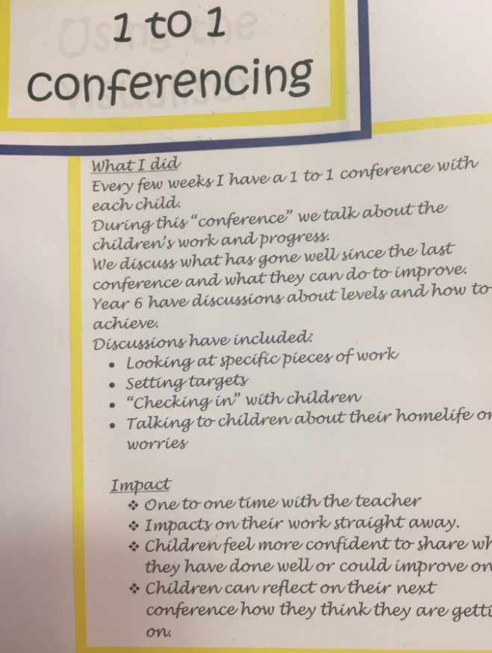
An extension of this could be one to one discussions, especially with Literacy work. The teacher points out good qualities of the pupil’s work and suggests ways to improve it, but they also ask for the pupil’s opinions. These five/ten minute conversations could really help to provide pupils with next steps and means to improve their work.
Ideally, while the rest of the class do other work, like finishing off or thinking about their own learning for the week, the teacher can talk with five or so pupils individually; the whole class will then be spoken to over six weeks. Even biannual conversations would be of benefit.

(image from Shirley Clarke’s twitter)

Cooperative Learning
Cooperative (or collaboration) learning is when pupils work together in a small group where everyone participates in a collective task. It is a chance for pupils to learn from each other and for teachers to access pupils’ understanding through their interactions and individual input to the task. For cooperative learning to be an effective AifL strategy there must be individual accountability for each pupil.

Some general rules for effective cooperative learning are:

- Pupils will not be able to work together well automatically – they will need support and practice.
- Tasks need to be planned carefully so that the work is effective and efficient, otherwise some pupils will try to work on their own.
- Competition between groups can be effective but take care that pupils don’t focus more on the competition element than the task itself.
- Decide in advance how groups will be formed – a mix of ability works best – and what size they will be.
- Change groups throughout the year so that pupils get experience working with different learners.
- Group roles (like scribe, resource manager, speaker, leader, encourager, etc.) and requiring each pupil to write in a different colour or complete a different part of a larger task will help to ensure individual accountability.

Some collaborative activities from Dylan Wiliam’s work include:
Best composite answer – pupils create a composite answer by taking the best features of each of their individual answers, helping them recognise strengths and weaknesses across the original individual answers. Learners who did not originally understand some aspects of the question learn a lot from their peers.
Jigsaw – one person in each group is responsible for reading a particular extract or completing a particular task, and for reporting back to the group. This works well when a lot of reading or multiple tasks are to be completed. Expert groups can also be created, where pupils with the same focus get together to discuss their activity, and then feedback to their own groups.
Numbered heads together – group members are numbered 1 to 4. A question is given, usually requiring HOTS. Students discuss the answer and make sure that everyone understands it. The teacher asks for a given number to answer on behalf of the team.
Assessment review – following an assessment, pupils discuss how they tackled each question, either with or without their marked answers in front of them. This gives them a chance to remedy some gaps in understanding before going over the test as a class. This saves time, improves the understanding of the learner who is doing the explaining, and provides advice in accessible pupil language.
Pupils write the questions – this will deepen their understanding of the content being studied as well as providing information to the teacher about gaps in learning, which may lead to re-teaching or revising certain topics.
Differentiation
Recent studies indicate that grouping pupils by ability is not an effective means of supporting every pupil to achieve their best:
- “Ability grouping has minimal effects on learning outcomes and profound negative equity effects.” J. Hattie, 2009
- “The evidence is robust and has accumulated over at least 30 years of research… If schools adopt mixed ability, they are more likely to use inclusive teaching strategies and to promote higher aspirations for their pupils.” Sutton Trust Report, 2011
- “These studies have repeatedly found that the more schools group by ability, the lower the pupil performance overall.” PISA Studies 2012
Research by Jo Boaler of Stanford University has found that able pupils in top sets sometimes struggle to keep up with the relentless pace and ethos that they shouldn’t need to ask for help; similarly, she has found that pupils in low sets are not pushed to improve.
So we must think about how we can use differentiation effectively in mixed ability classes. Many teachers are using some form of “Chilli Challenges”. All pupils are involved in the initial teaching of a concept, and then are given a choice (or a menu) of three tasks of different “chilli levels” – mild, spicy or hot. This gives pupils some ownership of their learning, helps them to gauge their own level of understanding, and some research suggests that pupils are more likely to challenge themselves when given a choice. If pupils realise over the course of the task that they are finding it too easy or too hard or if the teacher feels they are not pushing themselves, the pupil can move to a different task. Here is an example:
LI: We will be able to find a percentage of a whole number.
Mild  Find:  - 4% of 400  - 9% of 500  - 8% of 800  - 23% of 500  - 37% of £900  - 64% of 300g  - 33% of 1300m  - 54% of 200 € | Spicy  Find:  - 22% of 70  - 69% of 1400  - 18% of 66  - 46% of £70  - 42% of 1.2kg  Which of these are bigger?  - 37% of 500 or 41% of 600?  - 66% of 250 or 72% of 220?  - 92% of 640m or 84% of 790m? | Hot  Are the following statements true or false? How do you know?  - 34% of 500 is greater than 42% of 600.  - 69% of 490 is less than 71% of 450.  - 83% of £3000 is more than 87% of £2900.  Answer the following:  - A coat is on sale. The original price of the coat is £450, but has a 34% reduction. What is the new price?  - A puppy costs £220. The owner has said if you buy two, you can have a 28% discount. How much would two puppies cost?
(Exemplar from Shirley Clarke resources)
Self and Peer Assessment
With training, pupils can provide and receive meaningful feedback on their own or others’ work, giving them a deeper understanding of their own progress and letting them learn from others. To do this, teachers must make use of Learning Intentions to provide areas for pupils to focus on, Success Criteria as a guide for pupils to refer to, and modelling and exemplification so that pupils know what standard they and their peers are aiming for. Over time, pupils will be able to come up with successes and areas for improvement for their own and others’ work, so that every time a teacher marks a piece of work, it will already have been assessed and up-levelled by the pupil. An ethos of “plan – do – review” for all pieces of work will help pupils take responsibility for their own learning.
An effective way to introduce peer and self-assessment would be to show pupils a video on YouTube called Austin’s Butterfly – this should help them understand the power of peer feedback and constructive critique based on Success Criteria.

Learning Intentions to provide areas for focus
Pupils can self-assess their own progress and learning using traffic lights. At the start and end of a block of work, pupils can traffic light their knowledge, like in this example adapt from a secondary school Science classroom reference in Shirley Clarke’s work:
Use traffic lights to assess what you know now, and at the end of the unit. | Start | End
I am able to name three things the mouth does to food.
I am able to describe what the stomach does to food.
I am able to explain how the small intestine is specifically adapted to do its job.
I know and can describe what the gall bladder and pancreas do in the digestive system.
I know and can name the three main types of enzymes and their jobs.

This will give pupils clear targets for revision and moving forward.

Using Success Criteria as a check
For closed skills, where pupils can follow a set process and quality doesn’t vary (like using capital letters, finding the area of a shape, etc.) ticking off or colour coding Success Criteria as a spot check is effective. Pupils can spot their own or their peers’ mistakes by following the Success Criteria like a “final check”.

Modelling
In open skills, where quality can vary (like persuasive or creative writing, performing a song, etc.), it is harder to use Success Criteria like a check list. Instead, once pupils have attempted a task, show them a range of exemplars of differing quality and, together, put them in order of quality. This could be a paragraph of writing, a Maths solution, a musical performance, a piece of artwork, etc. Discuss why some are better than others, and then give pupils time to decide where their work or their peer’s work falls in this continuum. They can then spend time working to improve their work, using the good exemplification as inspiration.
Similarly, one pupil’s work can be selected at random and the whole class stopped to discuss it. The class should discuss the best parts and make specific suggestions on how to improve it. The rest of the class can then use the remaining time to assess their own work in the same way.

Identifying successes and areas for improvement
As a training exercise, do some peer-assessment as a whole class using an anonymised piece of work.
Then, when pupils are ready, introduce self-assessment by following these steps:
- Firstly, with clear Learning Intentions (like ones based on knowledge or skills) pupils can identify their own strengths by circling or highlighting examples.
- Then, pupils can begin to identify places for improvement in their work with a different symbol or colour. The teacher then gives a suggestion for improvement, which the pupil acts on in the next lesson.
- Eventually, pupils will be able to identify successes, places for improvement and the improvements themselves, and act upon these.
How long is spent at each stage will depend on the age of the pupils. Once used to doing this on their own, they could do peer assessment using the same methods.

Peer Assessment
Most of the above methods can be used for peer-assessment as well as self-assessment. Obviously, an added issue with peer-assessment is if pupils are reluctant to share their work with others. Some suggestions for sensitively using peer-assessment include:
- Pupils should have time to check their own work before their partner reads it.
- To help the listener take the work in, the writer should read their work aloud where possible.
- Pupils should discuss work together, instead of swapping jotters, reading silently and writing on their peer’s jotter – this means the writer can explain their choices, consider the peer’s suggestions, ask for clarification, etc.
- The writer holds the pen and makes the changes themselves.
- Peers should try to start with a positive comment.

An example of peer assessment can be seen here: https://www.shirleyclarke-education.org/video/literacy-instructions-4/

Indicating where corrections have been made (by putting a star or note next to them if it’s not obvious) is good practice too, as it shows the teacher pupils are assessing and improving their work, and helps to reduce the desire to “hide” mistakes.
Plenary
An effective plenary should:
- Show both the pupils themselves and their teacher whether or not they have understood the content of the lesson.
- Draw attention to the Learning Intention and Success Criteria and give the pupils time to consider whether they have achieved them.
- Give the teacher an honest picture of individual pupil learning.
- Allow the teacher to assess every pupils’ understanding at once.

Plenaries should be planned into a lesson where appropriate to summarise learning and this is not necessarily at the end. Mini plenaries can be used as an effective form of assessment at transition points within a lesson. “The big question/hinge question” discussed earlier in Effective questioning is a good example of this.
An effective plenary should highlight a pupil’s misconceptions; once identified they need to be addressed either at the time or within the lessons that follow. For example, if pupils bring over their exit passes while they are packing up, the teacher can immediately gauge their understanding and, in certain circumstances, immediately correct it and send the pupil back to fix their mistake; if this isn’t possible, the teacher can use the exit passes in the next lesson to address misconceptions, perhaps by pairing up pupils who understood with those who did not or by re-teaching something that lots of pupils misunderstood.
Plenaries can also give pupils opportunity to reflect on what and how they have learned.
Useful techniques for plenaries include:
- Exit passes / Show me boards / Socrative (a website/app) – pupils write down something they’ve learned or answer a question related to the lesson content.
- Gimme Five – pupils indicate their own understanding by holding up their fingers: the more fingers, the better the understanding.
- End of lesson summary – a learner provides a short written summary of what they think they were expected to learn during a lesson.
- Gots and needs – learners write on a post-it note or card something they understood (“got”) in the lesson and/or something they still do not understand (“need”).

Embedding Formative Assessment in Schools
It is up to schools and practitioners to decide which aspects of formative assessment they prioritise and embed:
“The important thing is that teachers need to adapt any technique that anyone else might show them to make it work in their local context. This creates ownership and shares responsibility for learning with the teacher. The key requirements of these techniques are that they must be grounded in deep cognitive principles about learning, they must be relevant to teachers’ practice, teachers must see them as feasible… and they must be acceptable within the wider context.” (Dylan Wiliam)
Teachers will be well aware of many of these techniques and the theory behind formative assessment. It is important that practitioners are given time and support to make use of them, adapt them for their own context and classroom, and reflect on them with their colleagues.
Practical ways of developing formative assessment across the school include:
- Establishing aims and sharing interpretations of these aims.
- Celebrating existing successes and formalising instinctive good practice.
- Prioritising and focusing on one aspect of formative assessment at a time (ie. monthly), so that staff can use it in a variety of lessons, share practice with their peers, reflect on the progress being made, adapt anything which isn’t working, etc., until this particular aspect becomes embedded in their practice in a way that works for them.
- Giving teachers the opportunity to reflect on their practice together (perhaps in TLCs, departments, or a Learning and Teaching Group).
- Using Learning Walks in supportive, constructive ways, focussing on areas the observed teacher has identified.
- Peers observing peers and providing feedback (perhaps in the form of Lesson Study).
- Supporting teachers in the early stages of their career differently to those who are further along.
- Conducting reviews by asking all involved, including children.
(Adapted from Shirley Clarke’s training)

The remaining pages are Learning Walk observation sheets which can be used to focus on individual aspects of formative assessment and a list of useful resources. The checklist on page 25 encompasses all aspects of AifL and can be used for longer lesson observations.
Learning Walk
AifL Focus: Learning Intentions and Success Criteria
Area of interest | Observed? | Comments
Introduced near start of lesson
Visible and referred to throughout
Pupil friendly language
LI context free
LI using language of learning (ie. “We are learning to / will be able to / will know / can”)
Referred to at end of lesson
SC constructed with pupils
SC process based, rather than product based
SC linked to LI
Feedback based on SC
Learning Walk
AifL Focus: Feedback
Area of interest | Observed? | Comments
Evidence of verbal and written feedback
Feedback linked to Success Criteria
Peer / self-assessment
Specific, manageable feedback
Pupil friendly language used
Pupils given opportunity to act on/respond to feedback
Feedback provided throughout lesson
Achievements celebrated
Next steps provided
Pupils aware of their own strengths and areas for development

Learning Walk
AifL Focus: Effective Questioning
Area of interest | Observed? | Comments
At least three seconds of thinking time
Prior learning assessed and acted on
HOTS used to generate challenging questions – creating, evaluating, analysing and applying
Talk partners used effectively
All pupils involved in discussion
Appropriate teacher responses to incorrect answers – ie. gathering additional answers, thanking pupil for helpful mistake, etc.
Effectively framed questions

Learning Walk
AifL Focus: Independent learning
Area of interest | Observed? | Comments
Effort / use of stuck strategies praised
Differentiated materials used
Pupils encouraged to think through difficulties themselves
Opportunities for self-assessment
Achievements noted / celebrated

AifL Focus: Collaborative learning
Area of interest | Observed? | Comments
Individual accountability
Appropriate task planned
Pupils supported / already clearly trained in working together
Learning Walk
AifL Focus: Self / Peer Assessment
Area of interest | Observed? | Comments
LI and SC understood and used by pupils
Exemplification used for support when appropriate
Pupils encouraged to identify successes and possible improvements
Pupils given training / support in how to self / peer assess
Peer assessment – pupils discuss work together, but owner has final say and makes changes
Changes are celebrated / not hidden

Learning Walk
AifL Focus: Plenary
Area of interest | Observed? | Comments
LI and SC referred to
All pupils involved
Teacher able to access a genuine picture of all pupils’ understanding
Teacher able to act upon any misunderstandings immediately/soon
Allows pupils to reflect on own learning

Learning Walk – AifL General Focus
Area of interest | Observed? | Comments
LI – evident, being referred to, context-free, language focussed on learning (ie. “be able to”, “know”, “learning to”)
SC – evident, co-constructed, helpful to pupils
Active engagement – mix of peer and group work, self and peer assessment, teacher who is circulating and engaging with pupils
Independent and confident pupils who can discuss their progress
Higher order questioning, pupils encouraged to ask questions, pupils’ responses are used effectively

Feedback being provided throughout lesson (verbally or in writing) which relates back to SC; pupils aware of next steps
Think time given; talk partners in use when appropriate

Plenary used which allows teacher to act on findings quickly/soon

Useful resources / References:
- https://www.shirleyclarke-education.org/
- https://twitter.com/shirleyclarke_
- Formative Assessment in Action: Weaving the Elements Together – Shirley Clarke (2005)
- Formative Assessment in the Secondary Classroom - Shirley Clarke (2005)
- Visible Learning: Feedback – Shirley Clarke and John Hattie (2018)
- Assessment for Learning: why, what and how – Dylan Wiliam talk at Cambridge Assessment Network Conference (transcript available online)
- https://educationendowmentfoundation.org.uk/public/files/Publications/Campaigns/Metacognition/EEF_Metacognition_and_self-regulated_learning.pdf
- Austin’s Butterfly video – https://www.youtube.com/watch?v=hqh1MRWZjms
- Making Thinking Visible PowerPoint (available on Sali)
- Bloom’s Thought Bubbles (created and kindly shared by St Columba’s Primary):

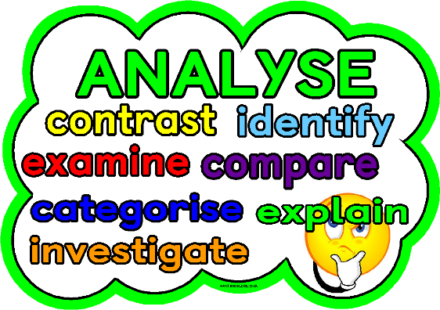
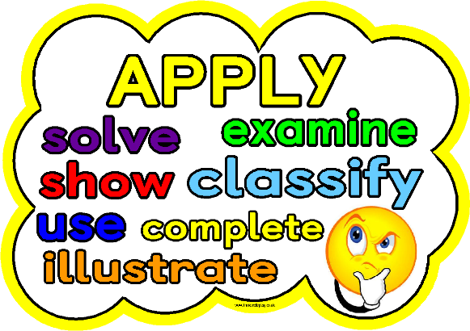

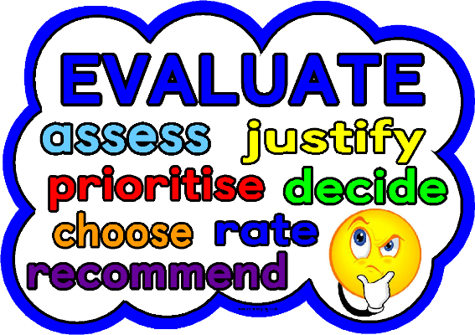

However, in certain courses (like Social Subjects, Sciences) specific reference to context, like euthanasia, would be appropriate, as knowledge and understanding about particular topics is part of the course.

