An Introduction to Analysing SNSA Data

Introduction to the SNSA long scales:

From the 2018/19 session, instead of “low”, “medium” and “high”, pupils will be assigned a band from a 12 point scale, 12 being the highest. They receive different bands for numeracy, reading and writing.

There are six possible bands per stage:
- P1: Bands 1 to 6
- P4: Bands 4 to 9
- P7: Bands 6 to 11
- S3: Bands 7 to 12

Pupils who do extremely well in their assessment will receive a band of “x or above”, eg. “6 or above”; a pupil who performs badly will receive a band of “x or below”.

How to access data reports:

- Log into your SNSA account (through the website or Glow)
- Select Learners tab
- Pupils’ names should load
- Use the magnifying class next to each heading to filter groups of learners – you may wish to do this by stage, class or a particular tag (eg. SIMD, gender, ASN, etc.).
- Click on Select all ____ learners
- Click on Generate report
- Choose the type of report you want to see. It is helpful to start by analysing Group Diagnostic Reports, to get a sense of the whole class/stage/selected group.
- Choose the relevant assessment and assessment form from the drop down menu:

- Click on Generate then View report

Tips and suggestions when analysing data:

Summary Mode
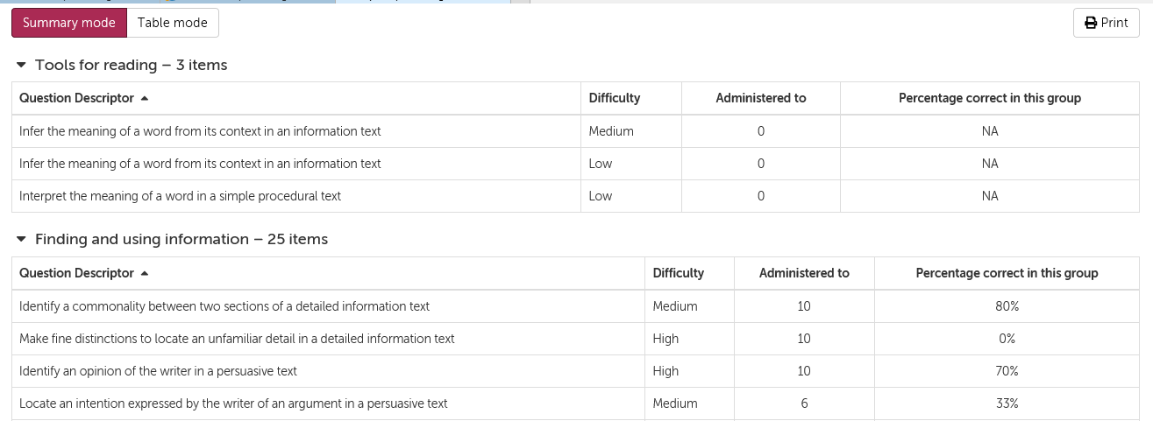

In summary mode, you can see, by organiser, each question descriptor, its difficulty level, how many pupils each question type was administered to (not every pupil gets every question type) and how many pupils got each question correct. This gives staff a good overview of which areas their class have done well in and which areas could be focussed on.

Tip – sorting these descriptors by “Administered to” lets you see the questions which all/a majority of your class faced and how they coped with them. If there were any questions that at least 50% of pupils faced and at least 50% of them got wrong, this would be a sensible area to look at. By tackling these particular areas, the teacher can make a high impact difference.

Table Mode
In table mode, you can see how each pupil fared with each question type.

Tip – look out for large blocks of red indicating that lots of pupils got lots of questions wrong in a particular organiser, particularly when there seems to be no reasoning for it (ie. both pupils who did well and pupils who did poorly overall getting the same questions wrong). In these cases, staff should consider:
- Is this an issue across the cohort?
- Is this due to a resource which has been used but doesn’t seem to be working?
- Have these skills been established in earlier stages?
- If these results contradict professional judgement, have the assessments that staff previously used been moderated and quality assured?
Individual Reports

Access individual reports by clicking on a pupil’s name.

In the first section of the individual reports, pupils receive a band (but not a score) and a short summary of their responses.

Pupils have to have answered at least five questions from an organiser for it to be mentioned in the summary.

Common terms and their meanings are:
  - ‘demonstrated strength’ means that the child has performed beyond what is expected of a learner who has demonstrated that capacity
  - ‘performed as appropriate’ means that the child has performed as expected for the capacity band that they have achieved
  - and ‘needs to concentrate on’ means that the child has not performed as expected for the capacity band that they have achieved

The next section shows an individual’s position on the long scale; their band; and a description of what is demonstrated, typically, by a child achieving within that band.

Then we see a breakdown of each question descriptor the pupil answered and how they got on:

Tip – Look out for when a pupil who has done well but got questions from lower bands in their stage wrong (as Freddie has here with “Solve a word problem involving division…”), as this may suggest a gap in this pupil’s learning. In these cases teachers may wish to look at the class’ group summary to see if other pupils have also struggled in this area too and tackle the issue as a class.

Comparative Scales

At the end of each individual report, it is possible to see how a child is achieving and progressing in comparison to their peers at class, school and national level.

Box plots are used for this:

Two norming periods to allow for pupils to sit the SNSAs at different points in the year. Teachers are advised not to be tempted to compare their pupils’ results to the greyed out national average, as it is not a relevant comparison.
Different shades indicate:
- The top 20% of pupils.
- The middle 50% of pupils.
- The bottom 20% of pupils.

Pupils are indicated by a dot. This pupil, Freddie, has clearly done very well and is in the top 5% of his class, school and country.

The lowest 5% of scores and the highest 5% of scores are not included, to give a sense of how almost all children achieve, compared to the national norms.
Pupils appear on the box plot as a dot. If a pupil has performed in the top or bottom 5%, their dot will appear floating outside of the box plot.

Tip – look carefully at how your class’ shaded blocks match up with the rest of the school and country. In this example, while the top end of Freddie’s class is consistent with the rest of his school, the middle 50% of pupils perform better; why is this? What could the rest of the school learn from Freddie’s class? Perhaps it is that Freddie is in the “top set” but there may be more to it. Similarly, the lowest 5% of pupils in Freddie’s class outperform the rest of the school.
However, while the middle 50% of Freddie’s class is consistent with the rest of the country, the top 5% of his class performs about half a band lower than the national average. This may be something for the class teacher and school to consider and try to address.

Tip – remember that a pupil who has done particularly well or particularly poorly can pull the results in either direction. Also, a pupil towards the bottom of the top 20% may have performed very similarly to a pupil near the top of the middle 50%.

Aggregate Reports

The Aggregate Report gives an overview of the whole class/stage/selected group by splitting the cohort into the bands they achieved. This is particularly helpful for school leaders to judge the success of interventions or patterns within groups of learners. The report allows comparisons between different subgroups against the wider group. For example, we can generate a report for all children with ASN and then, by using tags, we can highlight those within the cohort who receive specific support.

Statistically, we would expect the results of a standardised test to resemble a bell curve. It is likely that the majority of young people would achieve within the mid-range of the bands covered at their stage. For example, in P7, where the range of bands is from 6 to 11, we would expect a peak in Bands 8 and 9, and we would expect greater numbers of young people in P7 in Bands 7 and 10 than we would in Bands 6 and 11. We see this below:

The data in this form allows schools to immediately see whether their learners follow typical trends or whether they have an atypical number of pupils achieving below or above their stage.
This can also be overlaid with data about a particular group of learners to see how they compare with the wider group. Any information carried over from SEEMIS (gender, SIMD, ASN, etc.) or tags related to in-house interventions or other factors can be used to highlight learners.
To do this:
- Click on No learners highlighted.
- Select the group whose data you would like to see.

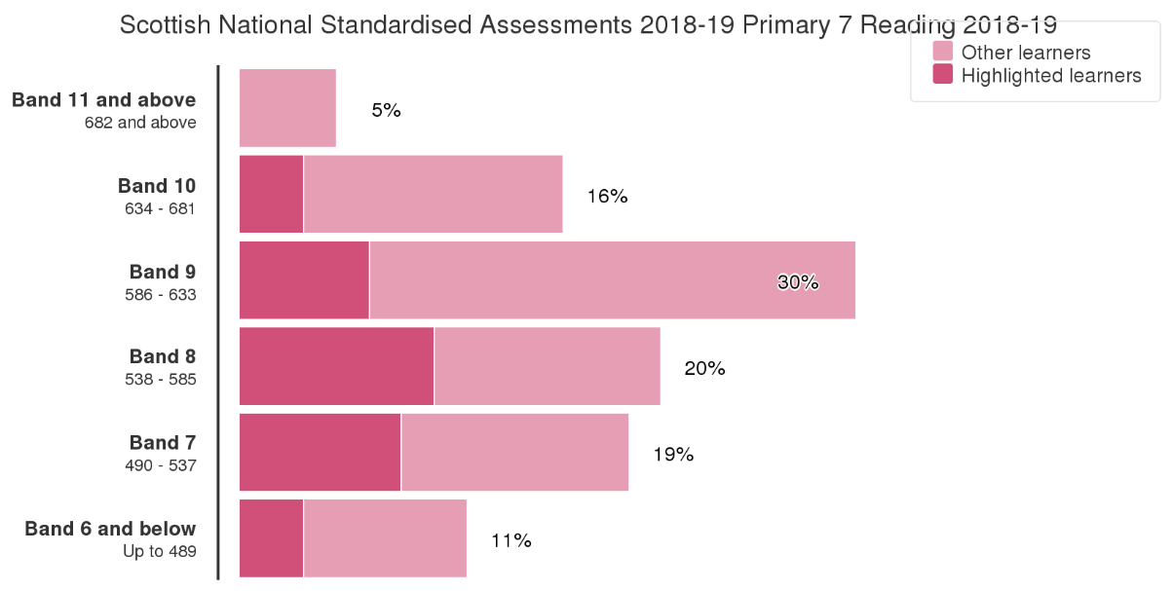
In general, we would want to see equal representation for any targeted group. So, for example, if your aggregate report shows the data for the whole cohort and you overlay this with the data of female students, you would want to see their data making a bell curve too. In the example above, we can see that whoever the highlighted learners are, they follow the curve mainly but concerns may be raised about bands 11 and 9 – why are these learners not achieving in the highest band at all? Why have they performed so atypically at band 9? Of course, depending on class sizes, the “band 11 and above” may only account for one or two pupils, and so class size must be kept in mind when using any of this data.
The aggregate report can also be filtered to show only certain types of learners, and then be overlaid with pupils who have experienced some interventions. So, if the aggregate data shows all ASN pupils and the overlaid data shows a small group who completed a reading recovery scheme, a school can consider how effective the scheme has been.
Tip – when considering the success of any intervention, it is helpful to look at the data of pupils who just missed out on being involved in the intervention, to gauge the results of not taking part in the intervention (for example, comparing pupils in SIMD 6-10 to pupils in SIMD 1-5, if the latter have been involved in an intervention).

Conclusion
The information gathered from SNSAs is just a part of the range of evidence practitioners should be gathering to determine their pupils’ progress and achievement. The advice above should be used as schools and head teachers see fit. Practical ways of analysing the data without spending copious amount of time would be to focus on the following:
- Group Diagnostic Reports to consider how a whole cohort/stage/class have done and to spot any obvious gaps in learning which can then be targeted
- Individual reports for pupils who have particularly surprised you, either by doing better or worse than expected
- Group aggregate reports to consider the success of interventions (ie. ASN pupils doing a reading recovering scheme) or particular groups (ie. boys, SIMD 1 – 5 etc.)
More information, including videos showing how to access information, can be found here:
https://schools.standardisedassessment.gov.scot/help/snsa-training

