These holistic assessment tasks have been created specifically for training purposes and are deliberately of varying quality.
Reflect on the key features of a holistic assessment task and discuss with colleagues which of these you feel are high quality examples, which clearly do not meet the standard of a good quality holistic assessment and those which ‘could be improved’. Traffic light these accordingly, recording reasons for each response, and make suggestions for improvements for those you have labelled as ‘amber’.

Experiences and Outcomes |  | Holistic Assessment Task
Reading  Writing | I regularly select and read, listen to or watch texts for enjoyment and interest, and I can express how well they meet my needs and expectations and give reasons, with evidence, for my personal response.  I can identify sources to develop the range of my reading.  LIT 3-11a  Using what I know about the features of different types of texts, I can find, select, sort, summarise, link and use information from different sources.  LIT 3-14a / LIT 4-14a  I can make notes and organise them to develop my thinking, help retain and recall information, explore issues and create new texts, using my own words as appropriate.  LIT 3-15a / LIT 4-15a  To show my understanding across different areas of learning, I can:  - identify and consider the purpose, main concerns or concepts and use supporting detail;  - make inferences from key statements; and  - identify and discuss similarities and differences between different types of text.  LIT 3-16a  I can use notes and other types of writing to generate and develop ideas, retain and recall information, explore problems, make decisions  or create original text.  I recognise when it is appropriate to quote from sources and when I should put points into my own words. I can acknowledge my sources appropriately.  LIT 3-25a  By considering the type of text I am creating, I can independently select ideas and relevant information for different purposes, and organise essential information or ideas and any supporting detail in a logical order. I can use suitable vocabulary to communicate effectively with my audience.  LIT 3-26a / LIT 4-26a | 1.) Climate Change  Watch and make notes on the Al Gore documentary film on climate change. Go on to select, read and makes notes on the climate change articles, and news reports on this year’s hurricane season in the Caribbean.  Referring to your notes, write an article for the school newsletter in which you persuade the reader that the events in the Caribbean are or are not due to climate change.  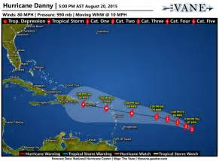
These holistic assessment tasks have been created specifically for training purposes and are deliberately of varying quality.
Reflect on the key features of a holistic assessment task and discuss with colleagues which of these you feel are high quality examples, which clearly do not meet the standard of a good quality holistic assessment and those which ‘could be improved’. Traffic light these accordingly, recording reasons for each response, and make suggestions for improvements for those you have labelled as ‘amber’.

Experiences and Outcomes |  | Holistic Assessment Task
Reading | Through developing my knowledge of context clues, punctuation, grammar and layout, I can read unfamiliar texts with increasing fluency, understanding and expression.  ENG 2-12a / ENG 3-12a / ENG 4-12a  I can select and use the strategies and resources I find most useful before I read, and as I read, to monitor and check my understanding.  LIT 3-13a  Using what I know about the features of different types of texts, I can find, select, sort, summarise, link and use information from different sources.  LIT 3-14a / LIT 4-14a | 2.) Cloze procedure:  Read the following passage and complete the blanks using the list of words at the bottom of the page.  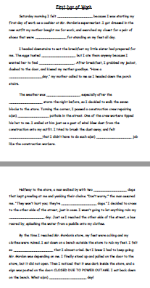
These holistic assessment tasks have been created specifically for training purposes and are deliberately of varying quality.
Reflect on the key features of a holistic assessment task and discuss with colleagues which of these you feel are high quality examples, which clearly do not meet the standard of a good quality holistic assessment and those which ‘could be improved’. Traffic light these accordingly, recording reasons for each response, and make suggestions for improvements for those you have labelled as ‘amber’.

Experiences and Outcomes |  | Holistic Assessment Task
Reading  Listening and Talking | I regularly select and read, listen to or watch texts for enjoyment and interest, and I can express how well they meet my needs and expectations and give reasons, with evidence, for my personal response.  I can identify sources to develop the range of my reading.  LIT 3-11a  Using what I know about the features of different types of texts, I can find, select, sort, summarise, link and use information from different sources.  LIT 3-14a / LIT 4-14a  I can make notes and organise them to develop my thinking, help retain and recall information, explore issues and create new texts, using my own words as appropriate.  LIT 3-15a / LIT 4-15a  To show my understanding across different areas of learning, I can:  - identify and consider the purpose, main concerns or concepts and use supporting detail;  - make inferences from key statements; and  - identify and discuss similarities and differences between different types of text.  LIT 3-16a  When listening and talking with others for different purposes, I can:  • communicate information, ideas or opinions;  • explain processes, concepts or ideas; and  • identify issues raised, summarise findings or draw conclusions.  LIT 3-09a  I am developing confidence when engaging with others within and beyond my place  of learning. I can communicate in a clear, expressive way and  I am learning to select and organise resources independently.  LIT 2-10a / LIT 3-10a | 3.) World cities  Choose a major world city to research and present information on in a way that you consider most appropriate. Select texts from the school library; watch any relevant documentaries and carry out online research from the librarian’s list of suggested websites. Make notes based on your research and organise these under those headings you consider most appropriate e.g. demographics, local employment etc. Use your research to create a PowerPoint presentation, detailed mind map or illustrated poster about your chosen city.  Go on to prepare a short talk in which you convey what you have learned to the rest of your group.  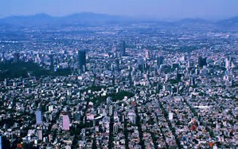
These holistic assessment tasks have been created specifically for training purposes and are deliberately of varying quality.
Reflect on the key features of a holistic assessment task and discuss with colleagues which of these you feel are high quality examples, which clearly do not meet the standard of a good quality holistic assessment and those which ‘could be improved’. Traffic light these accordingly, recording reasons for each response, and make suggestions for improvements for those you have labelled as ‘amber’.

Experiences and Outcomes |  | Holistic Assessment Task
Reading | I regularly select and read, listen to or watch texts for enjoyment and interest, and I can express how well they meet my needs and expectations and give reasons, with evidence, for my personal response.  I can identify sources to develop the range of my reading.  LIT 3-11a  Through developing my knowledge of context clues, punctuation, grammar and layout, I can read unfamiliar texts with increasing fluency, understanding and expression.  ENG 2-12a / ENG 3-12a / ENG 4-12a  I can select and use the strategies and resources I find most useful before  I read, and as I read, to monitor and check my understanding.  LIT 3-13a  I can make notes and organise them to develop my thinking, help retain  and recall information, explore issues and create new texts, using my own words as appropriate.  LIT 3-15a / LIT 4-15a  I can:  - discuss and evaluate the structure, characterisation and/or setting using some supporting evidence;  - identify the main theme of the text and recognise the relevance this has to my own and others’ experiences; and  - identify and comment  on aspects of the writer’s style and other features appropriate to genre using some relevant evidence.  ENG 3-19a | 4.) The Carnegie Medal Shadowing  Choose one of the Carnegie Medal shortlisted books (from any year), available from the school library/English department. As you read, make notes that will enable you to write a review of the text in which you evaluate the story i.e. discuss those aspects you did/did not enjoy. You may wish to focus on the following:  - A plot summary  - Main characters/relationships  - Setting in time and place  - Theme – what message does the author convey?  - The author’s style and how it is used to particular effect  Referring to your notes, participate in a group discussion on the text with other members of your book group.  Go on to write your book review, giving reasons why you would/would not recommend the text to others.  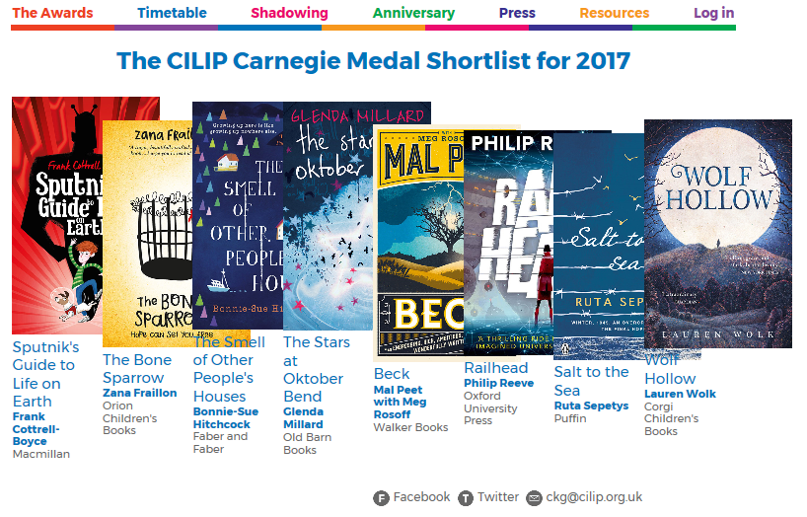
These holistic assessment tasks have been created specifically for training purposes and are deliberately of varying quality.
Reflect on the key features of a holistic assessment task and discuss with colleagues which of these you feel are high quality examples, which clearly do not meet the standard of a good quality holistic assessment and those which ‘could be improved’. Traffic light these accordingly, recording reasons for each response, and make suggestions for improvements for those you have labelled as ‘amber’.

Experiences and Outcomes |  | Holistic Assessment Task
Reading  Writing | I regularly select and read, listen to or watch texts for enjoyment and interest, and I can express how well they meet my needs and expectations and give reasons, with evidence, for my personal response.  I can identify sources to develop the range of my reading.  LIT 3-11a  I can make notes and organise them to develop my thinking, help retain and recall information, explore issues and create new texts, using my own words as appropriate.  LIT 3-15a / LIT 4-15a  I can:  - discuss and evaluate the structure, characterisation and/or setting using some supporting evidence;  - identify the main theme of the text and recognise the relevance this has to my own and others’ experiences; and  - identify and comment  on aspects of the writer’s style and other features appropriate to genre using some relevant evidence.  ENG 3-19a  I can persuade, argue, evaluate, explore issues or express an opinion using a clear line of thought, relevant supporting detail and/or evidence.  LIT 3-29a | 5.) Film Review  After watching the film E.T. (directed by Steven Spielberg), study the opening scene and, using the template provided, make detailed notes on the following:  - Diegetic sounds: shouting, footsteps, car exhaust, screeching tyres etc.  - Non-diegetic sounds: music; sound effects  - Lighting: soft, blue-white light, harsh flashlights  - Director’s use of camera shots/camera angles  By focusing on the opening scene, write about how the director inverts the stereotypical idea of aliens, as they are usually conveyed in popular culture.  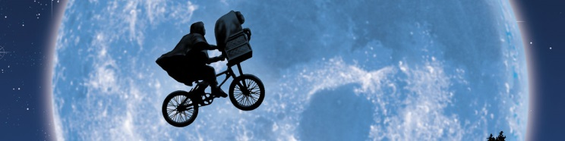
These holistic assessment tasks have been created specifically for training purposes and are deliberately of varying quality.
Reflect on the key features of a holistic assessment task and discuss with colleagues which of these you feel are high quality examples, which clearly do not meet the standard of a good quality holistic assessment and those which ‘could be improved’. Traffic light these accordingly, recording reasons for each response, and make suggestions for improvements for those you have labelled as ‘amber’.

Experiences and Outcomes |  | Holistic Assessment Task
Reading  Writing | Using what I know about the features of different types of texts, I can find, select, sort, summarise, link and use information from different sources.  LIT 3-14a / LIT 4-14a  I can make notes and organise them to develop my thinking, help retain and recall information, explore issues and create new texts, using my own words as appropriate.  LIT 3-15a / LIT 4-15a  To show my understanding across different areas of learning, I can:  - identify and consider the purpose, main concerns or concepts and use supporting detail;  - make inferences from key statements; and  - identify and discuss similarities and differences between different types of text.  LIT 3-16a  To help me develop an informed view, I am exploring the techniques used to influence my opinion. I can recognise persuasion and assess the reliability of information and credibility and value of my sources.  LIT 3-18a  I can convey information, describe events, explain processes or concepts, and combine ideas in different ways.  LIT 3-28a | 6.) John Muir Trust  As part of your wider achievement activities with the John Muir Trust, research the purpose and aims of the Trust by reading:  - The John Muir Trust website  - John Muir Trust promotional literature  - Written and video reports from last year’s John Muir Trust participants  Next, devise a set of questions with which to interview your S6 wider achievement leader and coordinating teacher.  Go on to design an informative leaflet and illustrated poster that promote the work of The John Muir Trust and the school based activities in which you are participating this year. You should include quotations from the interviews you have carried out.  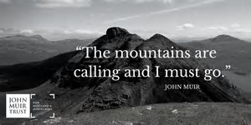
These holistic assessment tasks have been created specifically for training purposes and are deliberately of varying quality.
Reflect on the key features of a holistic assessment task and discuss with colleagues which of these you feel are high quality examples, which clearly do not meet the standard of a good quality holistic assessment and those which ‘could be improved’. Traffic light these accordingly, recording reasons for each response, and make suggestions for improvements for those you have labelled as ‘amber’.

Experiences and Outcomes |  | Holistic Assessment Task
Reading | Using what I know about the features of different types of texts, I can find, select, sort, summarise, link and use information from different sources.  LIT 3-14a / LIT 4-14a  I can make notes and organise them to develop my thinking, help retain  and recall information, explore issues and create new texts, using my own words as appropriate.  LIT 3-15a / LIT 4-15a  To show my understanding across different areas of learning, I can:  - identify and consider the purpose, main concerns or concepts and use supporting detail;  - make inferences from key statements; and  - identify and discuss similarities and differences between different types of text.  LIT 3-16a | 7.) Democracy in Scotland  Read the chapter of the textbook titled ‘Democracy in Scotland’ (page 57). After reading, discuss the advantages and disadvantages of proportional representation electoral systems, before giving your own opinion. Include examples of different forms of proportional representation in your answer. You should think carefully about the best way to present your learning.  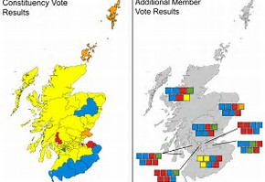  .
These holistic assessment tasks have been created specifically for training purposes and are deliberately of varying quality.
Reflect on the key features of a holistic assessment task and discuss with colleagues which of these you feel are high quality examples, which clearly do not meet the standard of a good quality holistic assessment and those which ‘could be improved’. Traffic light these accordingly, recording reasons for each response, and make suggestions for improvements for those you have labelled as ‘amber’.

Experiences and Outcomes |  | Holistic Assessment Task
Reading | I can select and use the strategies and resources I find most useful before I read, and as I read, to monitor and check my understanding.  LIT 3-13a  Using what I know about the features of different types of texts, I can find, select, sort, summarise, link and use information from different sources.  LIT 3-14a / LIT 4-14a  I can make notes and organise them to develop my thinking, help retain  and recall information, explore issues and create new texts, using my own words as appropriate.  LIT 3-15a / LIT 4-15a  To show my understanding across different areas of learning, I can:  - identify and consider the purpose, main concerns or concepts and use supporting detail;  - make inferences from key statements; and  - identify and discuss similarities and differences between different types of text.  LIT 3-16a  To help me develop an informed view, I am exploring the techniques used to influence my opinion. I can recognise persuasion and assess the reliability of information and credibility and value of my sources.  LIT 3-18a | 8.) The era of the Great War  Causes, effects and consequences of the First World War upon Scottish society.  Read the various sources of evidence on the impact of war on life at home during the Great War i.e. rationing, the changing role of women; propaganda; conscription and conscientious objectors; casualties and deaths.  Consider the reliability of each source in turn and discuss whether each is mainly based on fact or opinion. Use the grid provided to record your conclusions and to summarise the points made by each source.  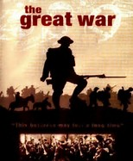

These holistic assessment tasks have been created specifically for training purposes and are deliberately of varying quality.
Reflect on the key features of a holistic assessment task and discuss with colleagues which of these you feel are high quality examples, which clearly do not meet the standard of a good quality holistic assessment and those which ‘could be improved’. Traffic light these accordingly, recording reasons for each response, and make suggestions for improvements for those you have labelled as ‘amber’.

Experiences and Outcomes |  | Holistic Assessment Task
Reading  Writing | I can make notes and organise them to develop my thinking, help retain and recall information, explore issues and create new texts, using my own words as appropriate.  LIT 3-15a / LIT 4-15a  To show my understanding across different areas of learning, I can:  - identify and consider the purpose, main concerns or concepts and use supporting detail;  - make inferences from key statements; and  - identify and discuss similarities and differences between different types of text.  LIT 3-16a  To help me develop an informed view, I am exploring the techniques used to influence my opinion. I can recognise persuasion and assess the reliability of information and credibility and value of my sources.  LIT 3-18a  I can convey information, describe events, explain processes or concepts, and combine ideas in different ways.  LIT 3-28a | 9.) JFK  Write a newspaper article describing the events around the assassination of President Kennedy. You should base the information in the article on notes you have made from:  - Watching the documentary on JFK  - Watching extracts from the film ‘JFK’  - Completing the timeline and factfile on the assassination  - The PowerPoint presentation on Russian communism and the events around the Bay of Pigs, Cuba  - Group discussion of the president’s domestic allies and enemies  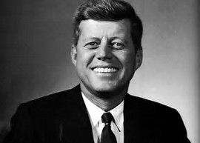
These holistic assessment tasks have been created specifically for training purposes and are deliberately of varying quality.
Reflect on the key features of a holistic assessment task and discuss with colleagues which of these you feel are high quality examples, which clearly do not meet the standard of a good quality holistic assessment and those which ‘could be improved’. Traffic light these accordingly, recording reasons for each response, and make suggestions for improvements for those you have labelled as ‘amber’.

Experiences and Outcomes |  | Holistic Assessment Task
Reading  Writing | I can select and use the strategies and resources I find most useful before  I read, and as I read, to monitor and check my understanding.  LIT 3-13a  Using what I know about the features of different types of texts, I can find, select, sort, summarise, link and use information from different sources.  LIT 3-14a / LIT 4-14a  I can make notes and organise them to develop my thinking, help retain  and recall information, explore issues and create new texts, using my own words as appropriate.  LIT 3-15a / LIT 4-15a  To help me develop an informed view, I am exploring the techniques used to influence my opinion. I can recognise persuasion and assess the reliability of information and credibility and value of my sources.  LIT 3-18a  I can convey information, describe events, explain processes or concepts, and combine ideas in different ways.  LIT 3-28a | 10.) RMPS: Belief in Action  Read the detailed case studies of the lives of Bishop Desmond Tutu of South Africa and Archbishop Oscar Romero of El Salvador.  In your own words, summarise the main ideas of each case study and go on to create a series of questions that could be asked in modern day television interviews with Desmond Tutu and Archbishop Romero.  Next, swap questions with another member of your group and, by assuming the role of Bishop Tutu and Archbishop Romero, produce written responses to each other’s questions. The questions and your responses should be based on your understanding of the circumstances described in each case study.  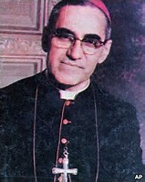  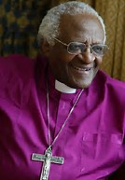
These holistic assessment tasks have been created specifically for training purposes and are deliberately of varying quality.
Reflect on the key features of a holistic assessment task and discuss with colleagues which of these you feel are high quality examples, which clearly do not meet the standard of a good quality holistic assessment and those which ‘could be improved’. Traffic light these accordingly, recording reasons for each response, and make suggestions for improvements for those you have labelled as ‘amber’.

Experiences and Outcomes |  | Holistic Assessment Task
Reading  Writing | I can select and use the strategies and resources  I find most useful before I read, and as I read, to monitor and check my understanding.  LIT 3-13a  I can make notes and organise them to develop  my thinking, help retain and recall information, explore issues and create new texts, using my own words as appropriate.  LIT 3-15a / LIT 4-15a  I can convey information, describe events, explain processes or concepts, and combine ideas in different ways.  LIT 3-28a  I can persuade, argue, evaluate, explore issues or express an opinion using a clear line of thought, relevant supporting detail and/or evidence.  LIT 3-29a | 11.) Technical Education  Product evaluation report:  Analyse a piece of furniture or household appliance and choose suitable areas to investigate. Research and evaluate these design features so that conclusions can be drawn. Produce your evaluation in the form of a report which provides test results and conclusions. Use these to display a product specification for the next version of the item.  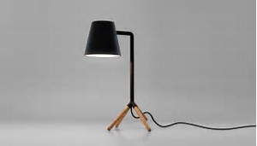
These holistic assessment tasks have been created specifically for training purposes and are deliberately of varying quality.
Reflect on the key features of a holistic assessment task and discuss with colleagues which of these you feel are high quality examples, which clearly do not meet the standard of a good quality holistic assessment and those which ‘could be improved’. Traffic light these accordingly, recording reasons for each response, and make suggestions for improvements for those you have labelled as ‘amber’.

Experiences and Outcomes |  | Holistic Assessment Task
Reading | Through developing my knowledge of context clues, punctuation, grammar and layout, I can read unfamiliar texts with increasing fluency, understanding and expression.  ENG 2-12a / ENG 3-12a / ENG 4-12a  I can select and use the strategies and resources I find most useful before  I read, and as I read, to monitor and check my understanding.  LIT 3-13a  I can make notes and organise them to develop  my thinking, help retain and recall information, explore issues and create new texts, using my own words as appropriate.  LIT 3-15a / LIT 4-15a  To show my understanding, I can comment, with evidence, on the content and form of short and extended texts, and respond to literal, inferential and evaluative questions and other types of close reading tasks.  ENG 3-17a  I can:  - discuss and evaluate the structure, characterisation and/or setting using some supporting evidence;  - identify the main theme of the text and recognise the relevance this has to my own and others’ experiences; and  - identify and comment  on aspects of the writer’s style and other features appropriate to genre using some relevant evidence.  ENG 3-19a | 12.) Choose a section of the narrative poem ‘The Highwayman’ by Alfred Noyes to annotate, paying particular attention to incident, rhythm, rhyme and the poet’s use of language to dramatise the narrative.  Come up with a set of textual analysis questions that can be given to another member of the class in order to test his/her understanding of the content, structure and language of the section.  After answering the questions provided by your partner, discuss your answers and add to your notes on the poem.  