These holistic assessment tasks have been created specifically for training purposes and are deliberately of varying quality.
Reflect on the key features of a holistic assessment task and discuss with colleagues which of these you feel are high quality examples, which clearly do not meet the standard of a good quality holistic assessment and those which ‘could be improved’. Traffic light these accordingly, recording reasons for each response, and make suggestions for improvements for those you have labelled as ‘amber’.

Experiences and Outcomes |  | Holistic Assessment Task
Reading | Through developing my knowledge of context clues, punctuation, grammar and layout, I can read unfamiliar texts with increasing fluency, understanding and expression.  ENG 2-12a / ENG 3-12a / ENG 4-12a  Before and as I read, I can apply strategies and use resources independently to help me read a wide variety  of texts and/or find the information I need.  LIT 4-13a  I can make notes and organise them to develop my thinking, help retain and recall information, explore issues and create new texts, using my own words as appropriate.  LIT 3-15a / LIT 4-15a  To show my understanding, I can give detailed, evaluative comments, with evidence, on the content and form of short and extended texts, and respond to different kinds of questions and other types of close reading tasks.  ENG 4-17a | 1.) The poetry of Carol Ann Duffy  Choose one of the verses from Carol Ann Duffy’s poem ‘In Mrs Tilscher’s Class’. Annotate your chosen verse, paying attention to Duffy’s use of word choice, structure, imagery, setting and/or symbolism to bring the poem to life.  Create a set of textual analysis questions that can be given to another member of the class in order to test his/her understanding of the use of poetic techniques.  After answering the questions provided by your partner, discuss your answers and add to your notes on the poem.  IN MRS TILSCHER’S CLASS  You could travel up the Blue Nile  with your finger, tracing the route  while MrsTilscher chanted the scenery  Tana. Ethiopia. Khartoum. Aswan.  That for an hour, then a skittle of milk  and the chalky Pyramids rubbed into dust.  A window opened with a long pole.  The laugh of a bell swung by a running child  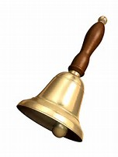
These holistic assessment tasks have been created specifically for training purposes and are deliberately of varying quality.
Reflect on the key features of a holistic assessment task and discuss with colleagues which of these you feel are high quality examples, which clearly do not meet the standard of a good quality holistic assessment and those which ‘could be improved’. Traffic light these accordingly, recording reasons for each response, and make suggestions for improvements for those you have labelled as ‘amber’.

Experiences and Outcomes |  | Holistic Assessment Task
Reading  Writing | Before and as I read, I can apply strategies and use resources independently to help me read a wide variety  of texts and/or find the information I need.  LIT 4-13a  Using what I know about the features of different types of texts, I can find, select, sort, summarise, link and use information from different sources.  LIT 3-14a / LIT 4-14a  I can make notes and organise them to develop my thinking, help retain and recall information, explore issues and create new texts, using my own words as appropriate.  LIT 3-15a / LIT 4-15a  I enjoy creating texts of my choice and I am developing my own style. I can regularly select subject, purpose, format and resources to suit the needs of my audience.  LIT 3-20a / LIT 4-20a  I can use a range of strategies and resources independently and ensure that my spelling, including specialist vocabulary, is accurate.  LIT 4-21a  As appropriate to my purpose and type of text, I can punctuate and structure different types of sentences with sufficient accuracy,  and arrange these to make meaning clear, showing straightforward relationships between paragraphs.  LIT 3-22a / LIT 4-22a  Throughout the writing process, I can review and  edit my writing independently to ensure that it meets its purpose and communicates meaning clearly at first reading.  LIT 4-23a  I can justify my choice  and use of layout and presentation in terms  of the intended impact  on my reader.  LIT 4-24a | 2.) Understanding the world of business  Produce a guide for your peers with the title ‘All You Need To Know About Marketing’. Include the following sections:  - Market research, targeting and segmenting  - The marketing mix  - Branding  - Consumer legislation  In researching these aspects of marketing, you should refer to your notes and to relevant sources such as newspaper and magazine articles, television programmes and the internet.
These holistic assessment tasks have been created specifically for training purposes and are deliberately of varying quality.
Reflect on the key features of a holistic assessment task and discuss with colleagues which of these you feel are high quality examples, which clearly do not meet the standard of a good quality holistic assessment and those which ‘could be improved’. Traffic light these accordingly, recording reasons for each response, and make suggestions for improvements for those you have labelled as ‘amber’.

Experiences and Outcomes |  | Holistic Assessment Task
Reading  Writing | I regularly select and read texts for enjoyment and interest, and I can express how well they meet my needs and expectations and give reasons, with evidence, for my personal response.  I can independently identify sources to develop the range of my reading.  LIT 4-11a  I can make notes and organise them to develop my thinking, help retain and recall information, explore issues and create new texts, using my own words as appropriate.  LIT 3-15a / LIT 4-15a  To show my understanding across different areas of learning, I can:  - clearly state the purpose, main concerns, concepts or arguments and use supporting detail;  - make inferences from  key statements and state these accurately in my own words; and  - compare and contrast different types of text  LIT 4-16a  I can:  - discuss and evaluate the effectiveness of structure, characterisation and/or setting using some supporting evidence;  - identify how the writer’s main theme or central concerns are revealed and can recognise how they relate to my own and others’ experiences; and  - identify and make a personal evaluation of the effect of aspects of the writer’s style and other features appropriate to genre using some relevant evidence and terminology.  ENG 4-19a  I enjoy creating texts of my choice and I am developing my own style. I can regularly select subject, purpose, format and resources to suit the needs of my audience.  LIT 3-20a / LIT 4-20a  I can use a range of strategies and resources independently and ensure that my spelling, including specialist vocabulary, is accurate.  LIT 4-21a  As appropriate to my purpose and type of text, I can punctuate and structure different types of sentences with sufficient accuracy,  and arrange these to make meaning clear, showing straightforward relationships between paragraphs.  LIT 3-22a / LIT 4-22a  Throughout the writing process, I can review and edit my writing independently to ensure that it meets its purpose and communicates meaning clearly at first reading.  LIT 4-23a  I can use notes and other types of writing to generate and develop ideas, retain and recall information, explore problems, make decisions, or create original text.  I can make appropriate and responsible use of sources and acknowledge these appropriately.  LIT 4-25a  I can persuade, argue, evaluate, explore issues or express and justify opinions within a convincing line of thought, using  relevant supporting detail and/or evidence.  LIT 4-29a | 3.) Media analysis  After watching the film ‘Dead Poets Society’, directed by Peter Weir, analyse the opening scene in detail, making notes on:  - Diegetic sound: quiet preparations for the opening ceremony, bagpipe and organ music, applause etc.  - Mise-en-scene  - Lighting and colour: the contrast of light and shade e.g. the candles (the ‘light of knowledge’), the Principal’s academic gown.  - The director’s use of camera shots/camera angles e.g. long shots and close ups  Go on to write an analysis of the ways in which the director establishes and reinforces the ‘four pillars’ on which the school is founded i.e. ‘Tradition, Honor, Discipline, Excellence’.  Next, choose another key scene from the film and analyse the techniques Peter Weir uses to challenge one or more of the ‘four pillars’.  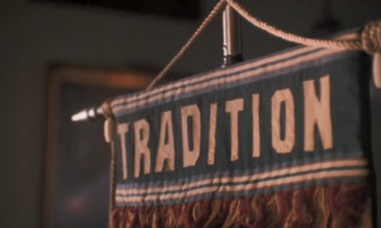  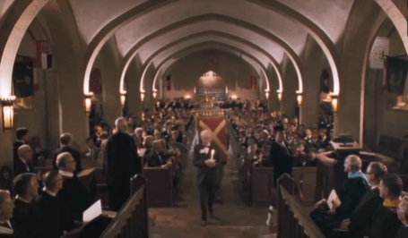
These holistic assessment tasks have been created specifically for training purposes and are deliberately of varying quality.
Reflect on the key features of a holistic assessment task and discuss with colleagues which of these you feel are high quality examples, which clearly do not meet the standard of a good quality holistic assessment and those which ‘could be improved’. Traffic light these accordingly, recording reasons for each response, and make suggestions for improvements for those you have labelled as ‘amber’.

Experiences and Outcomes |  | Holistic Assessment Task
Reading | Before and as I read, I can apply strategies and use resources independently to help me read a wide variety of texts and/or find the information I need.  LIT 4-13a  Using what I know about the features of different types of texts, I can find, select, sort, summarise, link and use information from different sources.  LIT 3-14a / LIT 4-14a  I can make notes and organise them to develop my thinking, help retain and recall information, explore issues and create new texts, using my own words as appropriate.  LIT 3-15a / LIT 4-15a | 4.) Health and Food Technology  This term you have learned about the processes of fermentation and caramelisation. Now go on to research one of the following topics and create a PowerPoint presentation and accompanying talk to deliver to the rest of your group:  - Gelatinisation  - Bulking  - Glazing  - Coagulation  In researching your topic, you should refer to the textbook, wall posters, relevant webpages, cookbooks or any other relevant source of information.  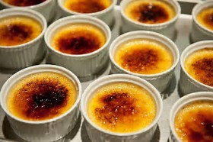  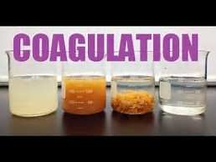
These holistic assessment tasks have been created specifically for training purposes and are deliberately of varying quality.
Reflect on the key features of a holistic assessment task and discuss with colleagues which of these you feel are high quality examples, which clearly do not meet the standard of a good quality holistic assessment and those which ‘could be improved’. Traffic light these accordingly, recording reasons for each response, and make suggestions for improvements for those you have labelled as ‘amber’.

Experiences and Outcomes |  | Holistic Assessment Task
Reading | I regularly select and read texts for enjoyment and interest, and I can express how well they meet my needs and expectations and give reasons, with evidence, for my personal response.  I can independently identify sources to develop the range of my reading.  LIT 4-11a  Before and as I read, I can apply strategies and use resources independently to help me read a wide variety of texts and/or find the information I need.  LIT 4-13a  Using what I know about the features of different types of texts, I can find, select, sort, summarise, link and use information from different sources.  LIT 3-14a / LIT 4-14a  I can make notes and organise them to develop my thinking, help retain and recall information, explore issues and create new texts, using my own words as appropriate.  LIT 3-15a / LIT 4-15a | 5.) Biology  Carry out an investigation into the following topics:  - Cell structure and transport across cell membranes  - Genetic engineering  - Photosynthesis  - Anaerobic respiration  - Biodiversity  Write a science report on your research, remembering to record sources.  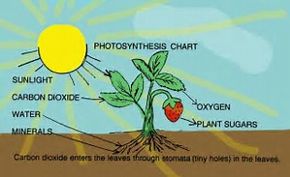
These holistic assessment tasks have been created specifically for training purposes and are deliberately of varying quality.
Reflect on the key features of a holistic assessment task and discuss with colleagues which of these you feel are high quality examples, which clearly do not meet the standard of a good quality holistic assessment and those which ‘could be improved’. Traffic light these accordingly, recording reasons for each response, and make suggestions for improvements for those you have labelled as ‘amber’.

Experiences and Outcomes |  | Holistic Assessment Task
Reading  Writing | Using what I know about the features of different types of texts, I can find, select, sort, summarise, link and use information from different sources.  LIT 3-14a / LIT 4-14a  I can make notes and organise them to develop my thinking, help retain and recall information, explore issues and create new texts, using my own words as appropriate.  LIT 3-15a / LIT 4-15a  I can use a range of strategies and resources independently and ensure that my spelling, including specialist vocabulary, is accurate.  LIT 4-21a  As appropriate to my purpose and type of text, I can punctuate and structure different types of sentences with sufficient accuracy,  and arrange these to make meaning clear, showing straightforward relationships between paragraphs.  LIT 3-22a / LIT 4-22a  Throughout the writing process, I can review and edit my writing independently to ensure that it meets its purpose and communicates meaning clearly at first reading.  LIT 4-23a  I can use notes and other types of writing to generate and develop ideas, retain and recall information, explore problems, make decisions, or create original text.  I can make appropriate and responsible use of sources and acknowledge these appropriately.  LIT 4-25a  By considering the type of text I am creating, I can independently select ideas and relevant information for different purposes, and organise essential information or ideas and any supporting detail in a logical order. I can use suitable vocabulary to communicate effectively with my audience.  LIT 3-26a / LIT 4-26a  I can convey information and describe events, explain processes or concepts, providing substantiating evidence, and synthesise ideas or opinions in different ways.  LIT 4-28a | 6.) Physical environments – coastlines of erosion and deposition  Research and make notes under the following headings:  The role of rock type on the landscape  The role of geological strata controlling cliff shape and form  The impact of future sea level changes on coastal landscapes  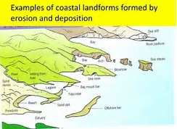  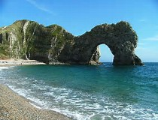
These holistic assessment tasks have been created specifically for training purposes and are deliberately of varying quality.
Reflect on the key features of a holistic assessment task and discuss with colleagues which of these you feel are high quality examples, which clearly do not meet the standard of a good quality holistic assessment and those which ‘could be improved’. Traffic light these accordingly, recording reasons for each response, and make suggestions for improvements for those you have labelled as ‘amber’.

Experiences and Outcomes |  | Holistic Assessment Task
Reading  Writing | Before and as I read, I can apply strategies and use resources independently to help me read a wide variety of texts and/or find the information I need.  LIT 4-13a  Using what I know about the features of different types of texts, I can find, select, sort, summarise, link and use information from different sources.  LIT 3-14a / LIT 4-14a  I can make notes and organise them to develop my thinking, help retain and recall information, explore issues and create new texts, using my own words as appropriate.  LIT 3-15a / LIT 4-15a  To help me develop an informed view, I can recognise persuasion and bias, identify some of the techniques used to influence my opinion, and assess the reliability of information and credibility and value of my sources.  LIT 4-18a  I enjoy creating texts of my choice and I am developing my own style. I can regularly select subject, purpose, format and resources to suit the needs of my audience.  LIT 3-20a / LIT 4-20a  I can use a range of strategies and resources independently and ensure that my spelling, including specialist vocabulary, is accurate.  LIT 4-21a  As appropriate to my purpose and type of text, I can punctuate and structure different types of sentences with sufficient accuracy,  and arrange these to make meaning clear, showing straightforward relationships between paragraphs.  LIT 3-22a / LIT 4-22a  Throughout the writing process, I can review and edit my writing independently to ensure that it meets its purpose and communicates meaning clearly at first reading. LIT 4-23a  I can justify my choice and use of layout and presentation in terms of the intended impact on my reader.  LIT 4-24a  I can use notes and other types of writing to generate and develop ideas, retain and recall information, explore problems, make decisions, or create original text.  I can make appropriate and responsible use of sources and acknowledge these appropriately.  LIT 4-25a  By considering the type of text I am creating, I can independently select ideas and relevant information for different purposes, and organise essential information or ideas and any supporting detail in a logical order. I can use suitable vocabulary to communicate effectively with my audience.  LIT 3-26a / LIT 4-26a  I can convey information and describe events, explain processes or concepts, providing substantiating evidence, and synthesise ideas or opinions in different ways.  LIT 4-28a | 7.) Russia 1894 - 1921  You will shortly begin studying the history of Russia between 1894 and 1921. In preparation, and by using the research skills you have developed and practised this year, read and make notes on a range of source material before going on to produce an informative piece of writing which describes: Tsarist Russia prior to the revolution; the role of Russia in World War One; the events of the revolution of February 1917 and the provisional government and the birth of communism.  Your writing should be as informative and engaging as possible. Consequently, you should plan the best way in which to present it. For example, you may wish to add illustrations, maps and timelines as appropriate.  The writing you produce will act as a reference point throughout the class’ study of this topic.  Remember to acknowledge your sources.  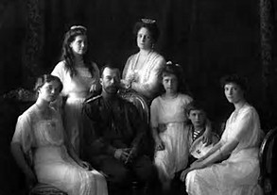  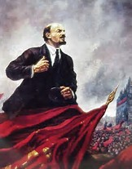
These holistic assessment tasks have been created specifically for training purposes and are deliberately of varying quality.
Reflect on the key features of a holistic assessment task and discuss with colleagues which of these you feel are high quality examples, which clearly do not meet the standard of a good quality holistic assessment and those which ‘could be improved’. Traffic light these accordingly, recording reasons for each response, and make suggestions for improvements for those you have labelled as ‘amber’.

Experiences and Outcomes |  | Holistic Assessment Task
Reading  Listening and Talking | Before and as I read, I can apply strategies and use resources independently to help me read a wide variety of texts and/or find the information I need. LIT 4-13a  Using what I know about the features of different types of texts, I can find, select, sort, summarise, link and use information from different sources. LIT 3-14a / LIT 4-14a  I can make notes and organise them to develop my thinking, help retain and recall information, explore issues and create new texts, using my own words as appropriate.  LIT 3-15a / LIT 4-15a  To help me develop an informed view, I can recognise persuasion and bias, identify some of the techniques used to influence my opinion, and assess the reliability of information and credibility and value of my sources. LIT 4-18a  When I engage with others I can make a relevant contribution, ensure that everyone has an opportunity to contribute and encourage them to take account of others’ points of view or alternative solutions. I can respond in ways appropriate to my role, exploring and expanding on contributions to reflect on, clarify or adapt thinking.  LIT 4-02a  When listening and talking with others for different purposes, I can:  - communicate detailed information, ideas or opinions  - explain processes, concepts or ideas  with some relevant supporting detail; and  - sum up ideas, issues, findings or conclusions.  LIT 4-09a  I can communicate in a clear, expressive manner when engaging with others  within and beyond my place of learning, and can independently select and organise appropriate resources as required.  LIT 4-10a | 8.) Social issues in Scotland and the UK  In groups, you are going to prepare and hold a debate on health inequalities in Scotland and the UK. The debate will be based around:  The causes and consequences of health inequality in Scotland and the UK  Plans by the Scottish and UK governments to reduce these inequalities.  By accessing relevant websites e.g. The Scottish Government, UK Government, NHS and the Joseph Rowntree Foundation websites, research the issues around health inequalities, making notes of those points for and against the motion: “This house believes that not enough is being done to address the growing health inequalities in our society”.  Remember, you should use the interpretation of health data in the arguments you make.  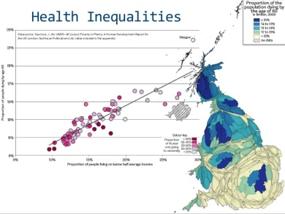  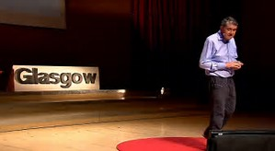
These holistic assessment tasks have been created specifically for training purposes and are deliberately of varying quality.
Reflect on the key features of a holistic assessment task and discuss with colleagues which of these you feel are high quality examples, which clearly do not meet the standard of a good quality holistic assessment and those which ‘could be improved’. Traffic light these accordingly, recording reasons for each response, and make suggestions for improvements for those you have labelled as ‘amber’.

Experiences and Outcomes |  | Holistic Assessment Task
Reading  Writing | I regularly select and read texts for enjoyment and interest, and I can express how well they meet my needs and expectations and give reasons, with evidence, for my personal response.  I can independently identify sources to develop the range of my reading.  LIT 4-11a  Before and as I read, I can apply strategies and use resources independently to help me read a wide variety of texts and/or find the information I need.  LIT 4-13a  Using what I know about the features of different types of texts, I can find, select, sort, summarise, link and use information from different sources.  LIT 3-14a / LIT 4-14a  I can make notes and organise them to develop my thinking, help retain and recall information, explore issues and create new texts, using my own words as appropriate.  LIT 3-15a / LIT 4-15a  I can:  - discuss and evaluate the effectiveness of structure, characterisation and/or setting using some supporting evidence;  - identify how the writer’s main theme or central concerns are revealed and can recognise how they relate to my own and others’ experiences; and  - identify and make a personal evaluation of the effect of aspects of the writer’s style and other features appropriate to genre using some relevant evidence and terminology.  ENG 4-19a  I enjoy creating texts of my choice and I am developing my own style. I can regularly select subject, purpose, format and resources to suit the needs of my audience.  LIT 3-20a / LIT 4-20a  I can use a range of strategies and resources independently and ensure that my spelling, including specialist vocabulary, is accurate.  LIT 4-21a  As appropriate to my purpose and type of text, I can punctuate and structure different types of sentences with sufficient accuracy,  and arrange these to make meaning clear, showing straightforward relationships between paragraphs.  LIT 3-22a / LIT 4-22a  Throughout the writing process, I can review and edit my writing independently to ensure that it meets its purpose and communicates meaning clearly at first reading.  LIT 4-23a  I can use notes and other types of writing to generate and develop ideas, retain and recall information, explore problems, make decisions, or create original text.  I can make appropriate and responsible use of sources and acknowledge these appropriately.  LIT 4-25a  By considering the type of text I am creating, I can independently select ideas and relevant information for different purposes, and organise essential information or ideas and any supporting detail in a logical order. I can use suitable vocabulary to communicate effectively with my audience.  LIT 3-26a / LIT 4-26a  I can persuade, argue, evaluate, explore issues or express and justify opinions within a convincing line of thought, using  relevant supporting detail and/or evidence.  LIT 4-29a | 9.) Personal reading programme  As part of your personal reading, choose a novel from the class or school library, or from any other source (e.g. personal recommendation or community library).  As you read, create notes in any way you choose on significant aspects of the text such as the:  - Plot  - Main characters/relationships  - Setting in time and place  - Author’s style and how it is used to particular effect  - Theme  Once finished, write a book review in which you evaluate the effectiveness of these aspects of the text, giving reasons why you would or would not recommend the text to your peers.  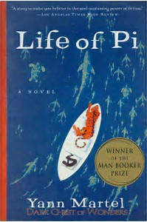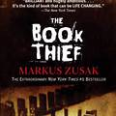  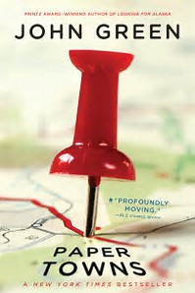
These holistic assessment tasks have been created specifically for training purposes and are deliberately of varying quality.
Reflect on the key features of a holistic assessment task and discuss with colleagues which of these you feel are high quality examples, which clearly do not meet the standard of a good quality holistic assessment and those which ‘could be improved’. Traffic light these accordingly, recording reasons for each response, and make suggestions for improvements for those you have labelled as ‘amber’.

Experiences and Outcomes |  | Holistic Assessment Task
Reading | I regularly select and read texts for enjoyment and interest, and I can express how well they meet my needs and expectations and give reasons, with evidence, for my personal response.  I can independently identify sources to develop the range of my reading.  LIT 4-11a  Before and as I read, I can apply strategies and use resources independently to help me read a wide variety  of texts and/or find the information I need.  LIT 4-13a  Using what I know about the features of different types of texts, I can find, select, sort, summarise, link and use information from different sources.  LIT 3-14a / LIT 4-14a  I can make notes and organise them to develop my thinking, help retain and recall information, explore issues and create new texts, using my own words as appropriate.  LIT 3-15a / LIT 4-15a  To show my understanding across different areas of learning, I can:  - clearly state the purpose, main concerns, concepts or arguments and use supporting detail;  - make inferences from  key statements and state these accurately in my own words; and  - compare and contrast different types of text  LIT 4-16a | 10.) RMPS: The Meaning of Love  Read and make notes on the case studies provided on the lives of: Mahatma Ghandi, Martin Luther King and Nicky Cruz. Go on to add to these notes by carrying out your own research.  Write a persuasive monologue in which you adopt the persona of one of these leaders and, as well as describing your life, sum up the key spiritual messages you would like to share with the world.  Next, read your monologue to the rest of your group and, by playing the role of your chosen religious leader, answer any questions your group might have on your beliefs, actions and motivation.  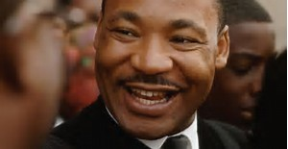  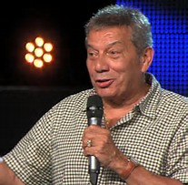
These holistic assessment tasks have been created specifically for training purposes and are deliberately of varying quality.
Reflect on the key features of a holistic assessment task and discuss with colleagues which of these you feel are high quality examples, which clearly do not meet the standard of a good quality holistic assessment and those which ‘could be improved’. Traffic light these accordingly, recording reasons for each response, and make suggestions for improvements for those you have labelled as ‘amber’.

Experiences and Outcomes |  | Holistic Assessment Task
Reading | Before and as I read, I can apply strategies and use resources independently to help me read a wide variety  of texts and/or find the information I need.  LIT 4-13a  Using what I know about the features of different types of texts, I can find, select, sort, summarise, link and use information from different sources.  LIT 3-14a / LIT 4-14a  I can make notes and organise them to develop my thinking, help retain and recall information, explore issues and create new texts, using my own words as appropriate.  LIT 3-15a / LIT 4-15a | 11.) Organic Chemistry investigation  Each member of your group should take responsibility for finding out about one of the following:  - Formation of crude oil  - Fractional distillation of crude oil  - Alkanes, alkenes and cycloalkanes  - Isomers  - Saturated and unsaturated hydrocarbons  - Alkanols and alkanoic acids  - Distillation  Sources of information should include the textbook and Google.  Make notes on your findings and create a mind map that can be displayed on the classroom wall.  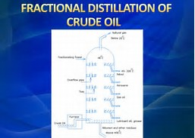
These holistic assessment tasks have been created specifically for training purposes and are deliberately of varying quality.
Reflect on the key features of a holistic assessment task and discuss with colleagues which of these you feel are high quality examples, which clearly do not meet the standard of a good quality holistic assessment and those which ‘could be improved’. Traffic light these accordingly, recording reasons for each response, and make suggestions for improvements for those you have labelled as ‘amber’.

Experiences and Outcomes |  | Holistic Assessment Task
Reading | Before and as I read, I can apply strategies and use resources independently to help me read a wide variety  of texts and/or find the information I need.  LIT 4-13a  Using what I know about the features of different types of texts, I can find, select, sort, summarise, link and use information from different sources.  LIT 3-14a / LIT 4-14a  I can make notes and organise them to develop my thinking, help retain and recall information, explore issues and create new texts, using my own words as appropriate.  LIT 3-15a / LIT 4-15a  To show my understanding across different areas of learning, I can:  - clearly state the purpose, main concerns, concepts or arguments and use supporting detail;  - make inferences from key statements and state these accurately in my own words; and  - compare and contrast different types of text  LIT 4-16a | 12.) Dementia Friends – Wider achievement  As part of your wider achievement activities with Dementia Friends, research the purpose and aims of Alzheimer’s Scotland.  Next, devise a set of questions with which to interview your classmates, S6 wider achievement leader and coordinating teacher about their experience of participating in the wider achievement programme.  Go on to design an informative piece of writing to be included in the school newsletter or blog, in which you describe and promote the work of the organisation. You should include information from your reading; a description of the Dementia Friends wider achievement programme and quotations from the interviews you have carried out.  